Contents
1. Introduction and deliverables overview 2
2. Environment access 3
3. Agent resource directory tool setup and usage 4
4. Share your agent’s ID information 9
I. Agent overview URL 9
II. Schema name 9
III. SharePoint agent directory URL 10
5. Deliverable I: ThinkingBox 10
I. Agent level information 10
II. Knowledge corpus 11
III. Mock MCPs to represent tools 11
IV. Set of queries + evaluation rubric 11
V. Document ranking 11
VI. Multi-turn conversations 12
VII. YAML resources representation: Set of queries + query metadata + evaluation rubric + ground truth + file metadata 12
6. Deliverable II: Agent creation in MCS 12
Connecting MCP Server to Agent 12
Connection to Connectors (outlook, sharepoint, dataverse, team, etc) 12
Adding Knowledge corpus 13
General Knowledge 13
7. Deliverable III: Excel Data Entry Template 13
Excel worksheet tabs 13
Full vs. abridged templates 14
Excel Template Field Validation: 14
Handling of multiple turns / intents 15
Additional Instructions for specific field annotation 15
8. Solution file creation process 16
9. Acceptance Review 19
Appendices 20
Appendix 1: Agent design criteria 20
Appendix 2: Knowledge Corpus Requirements 21
Appendix 3: User queries criteria 22
Appendix 4: Best Practices 24
Guidelines for defining rubrics / success criteria for orchestration 25
Appendix 5: Submission Checklist 25
Appendix 6: Out of scope 26
Judge Functions 26

Introduction and deliverables overview
This guide explains how vendors should produce the full set of deliverables for agent evals for Copilot Studio. These include:
- ThinkingBox git repo:
  - Set of agents (full config: instructions, tools, knowledge)
  - Knowledge corpus for each agent uploaded as raw files
  - Mock MCPs to represent tools
  - Python functions for: Set of queries + evaluation rubric
  - YAML representation of: Set of queries + query metadata + evaluation rubric + ground truth + File metadata

- In Copilot Studio environment:
  - Agents full config, including the following components. These agents are the *same* agents as in ThinkingBox.
    - Instructions
    - Microsoft connectors (e.g. SharePoint, Dataverse, Outlook, Teams, Dynamics 365)
    - Mock MCP APIs for non-MS connectors (e.g. Salesforce, ServiceNow, SAP)
    - Knowledge from Bing, SharePoint and file upload

- Evaluation of retrieved snippets
  - For each query that require searching a knowledge corpus, the Microsoft team will provide the 20 snippets that are retrieved. The vendor will rate the snippets in terms of relevance (from 0 to 4).

- Excel spreadsheet to gauge product performance today- template to be provided by MSFT that will require the following:
  - Agent definition*
  - Test queries*
  - Query metadata*
  - Evaluation rubric*
  - Ground truth*
  - Agent output
  - Human annotation of output
*We will likely phase out (a)-(e) afer we gain confidence that these items are captured well in YAML

- Out of scope:
  - Automated evaluation of outputs using vendor-generated rubric-- MSFT will build this component

Environment access
Purpose: Here are the steps to get access to the environment you are given by the MCS team
Contact: @Andrew Fowler
To log in to MCS for the vendor data project, a shared Aurora account must be used. This account uses certificate-based authentication. Follow these steps:
- Go here: https://portal.microsoftaurora365.com/TenantUserDetails
- If you cannot access that page, first request access to this entitlement: https://coreidentity.microsoft.com/manage/entitlement/entitlement/aurora365por-yvem
- Once the TenantUserDetails page loads, download a certificate for tenant Test_Test_CAP_Integration_01 and select the user account that you were given: aurorauser##@capintegration01.onmicrosoft.com
- Open the downloaded file. In the Certificate Import Wizard that pops up, select Current User as the Store Location and click Next.
- Click Next again
- On the password screen, do not type a password. Click Next again.
- Make sure "Automatically select the certificate store" is selected and click Next again.
- Click Finish
- In a private browser window, visit the MCS URL that has been shared with you
- Use this username to log in: aurorauser##@capintegration01.onmicrosoft.com
- Use the certificate with this exact name: aurorauser##.capintegration01.dv-epics.azclient.ms
- You should now have access to the Copilot Studio front-end

Agent resource directory tool setup and usage
Purpose: Setup tooling for agent directory and template preparation
Contact: @Peter Cools
Login to your environment - Click on the button in the upper left
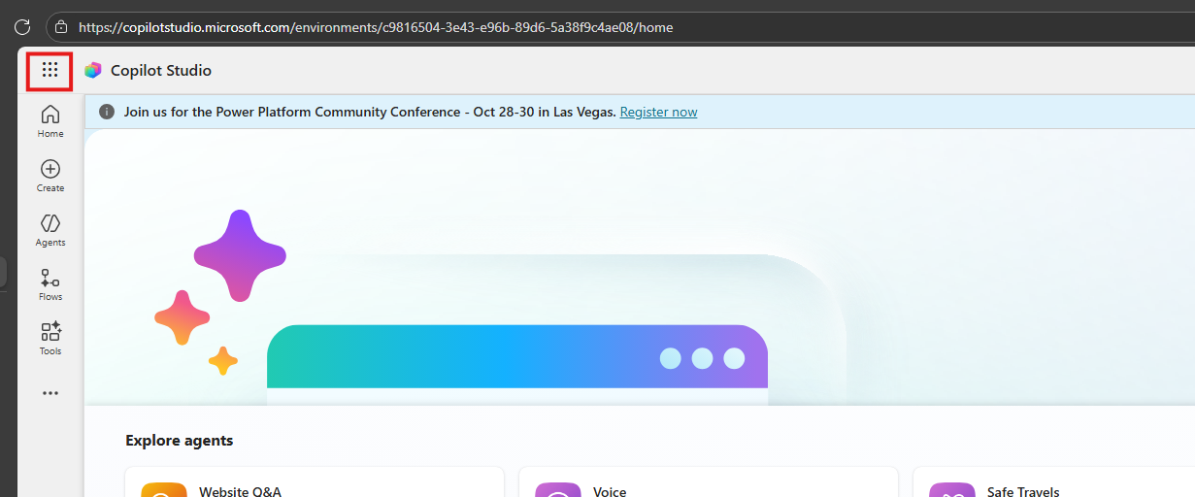
Select “SharePoint”
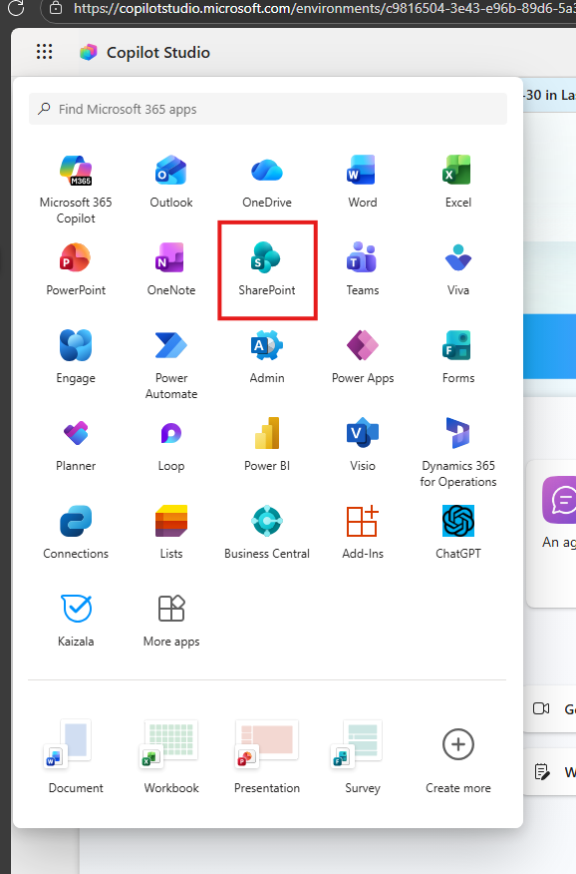
Then select the site name that you were given.
In this example “TestAgentDirectory”
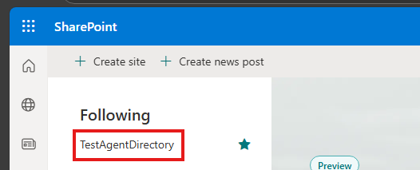
Select the “Documents” tab
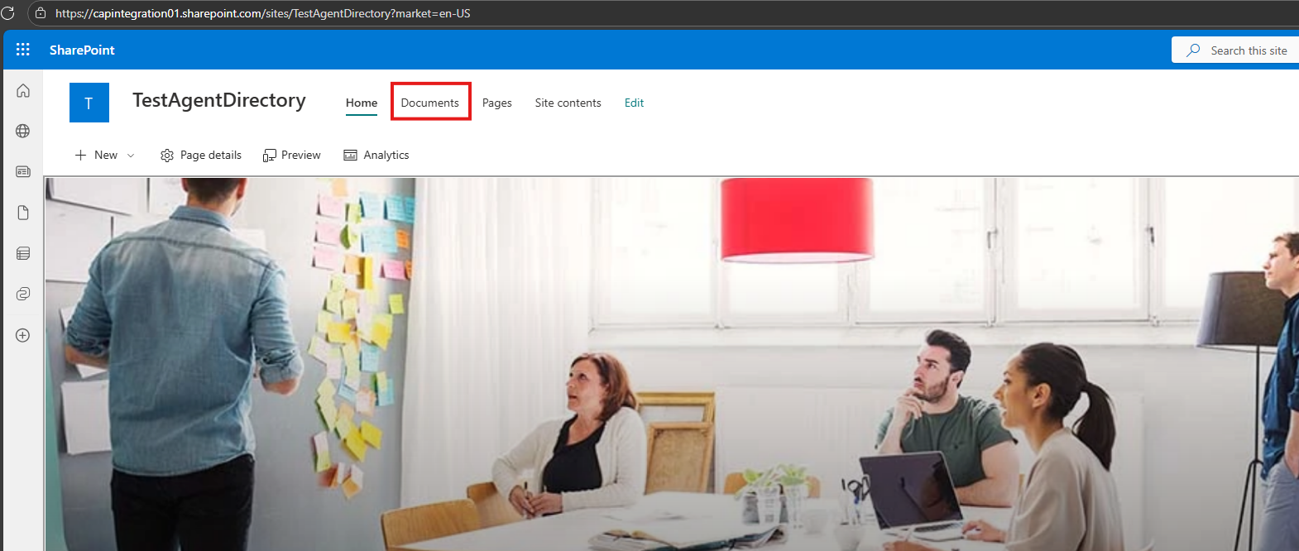
Click the “Sync” button to get a link to Microsoft OneDrive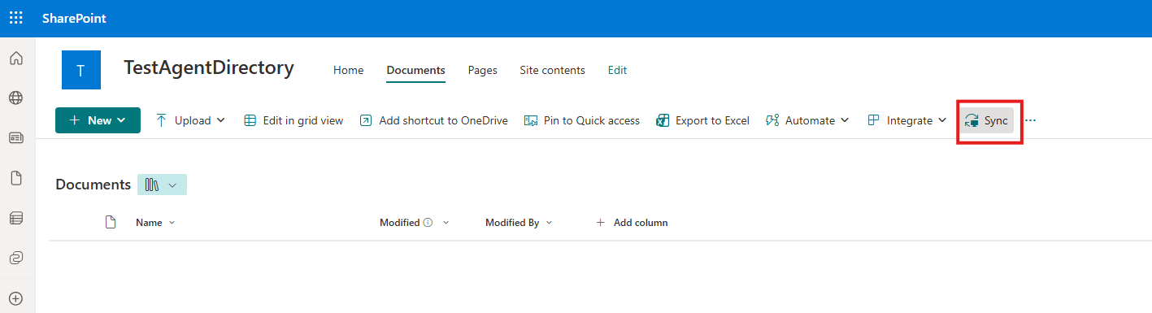
Click “Open”
You can click “Close” on the “We’re syncing your files” message.
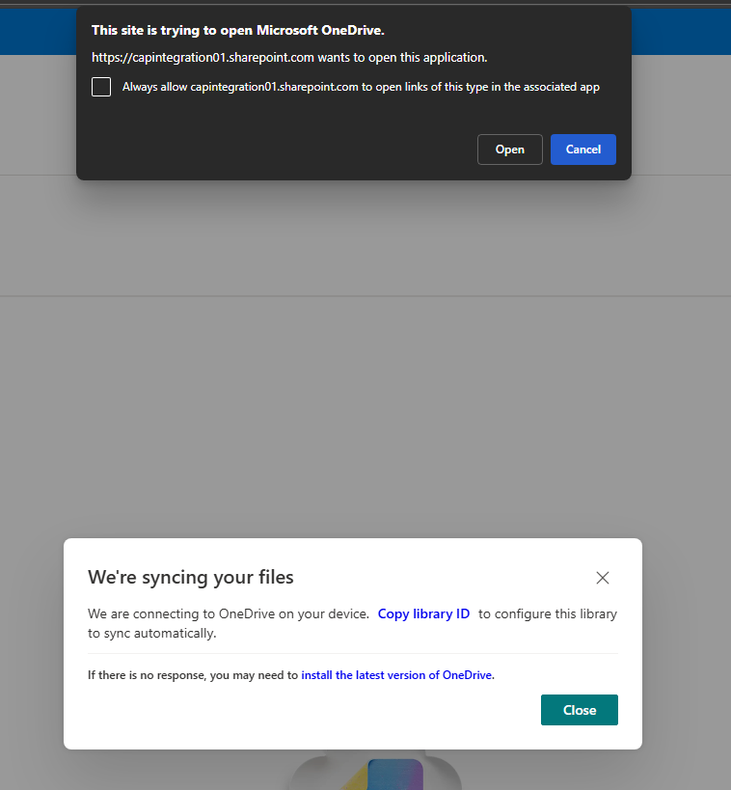
In your Windows Explorer go to the directory with the name of your SharePoint (in this case “Test_Test_CAP_Integration01”) and open the directory
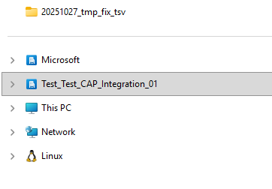
In there you will now see the directory pointing to your SharePoint site

Go to this GitHub location and download the contents
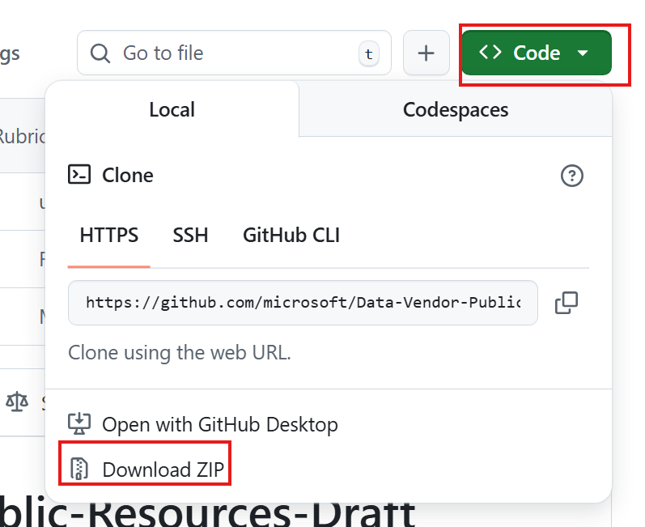
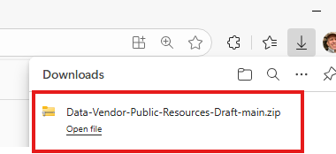
Unzip the downloaded file and copy the directory “create_agent_directory” to the synced SharePoint directory.
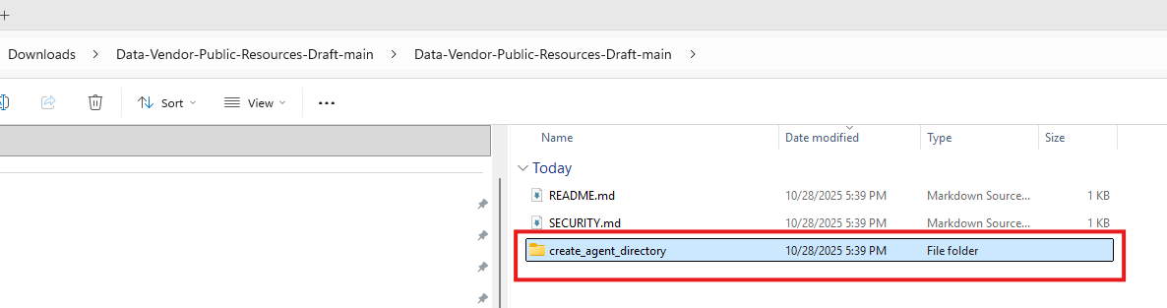
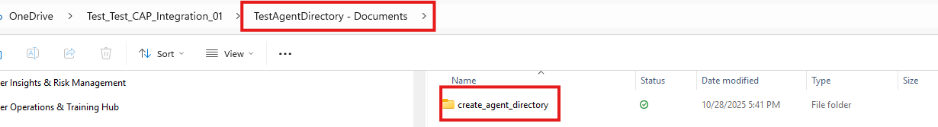
Start Window PowerShell and cd to the synced SharePoint directory (use double quotes if needed)
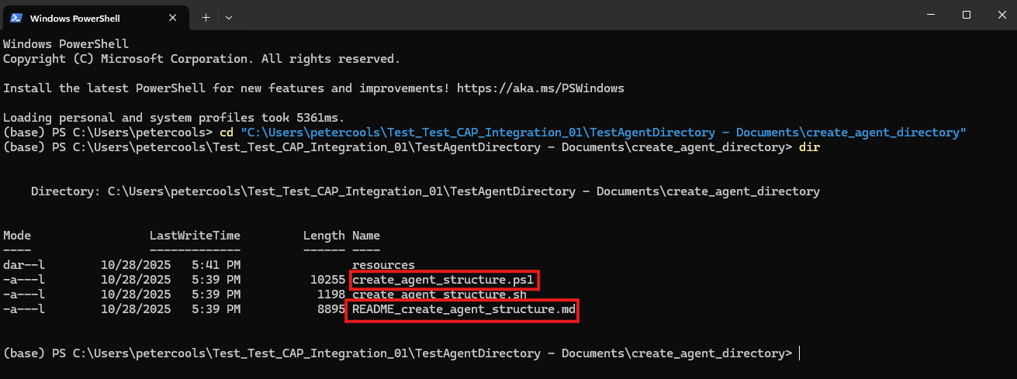
In this directory you find the README on how to use the script to create new agent resource directory structures and the actual script to use: “create_agent_structure.ps1”
The readme contains information on how to complete the setup needed based on the environment you are working in, troubleshooting guidelines and command line options.
Depending on the agent type you can select to generate a “full” (-t “f”) or “abridged” (-t “a”) Excel macro template.
Here is a sample command for Windows:
pwsh ./create_agent_structure.ps1 -d "C:\Users\petercools\Test_Test_CAP_Integration_01\TestAgentDirectory - Documents\agents" -s "cr3bf_salesAssistant" -t "f"
Or in case you face issues you can use:
powershell -ExecutionPolicy Bypass -File ./create_agent_structure.ps1 -d "C:\Users\petercools\Test_Test_CAP_Integration_01\TestAgentDirectory - Documents\agents" -s "cr3bf_salesAssistant" -t "f"
Here is the screen output:
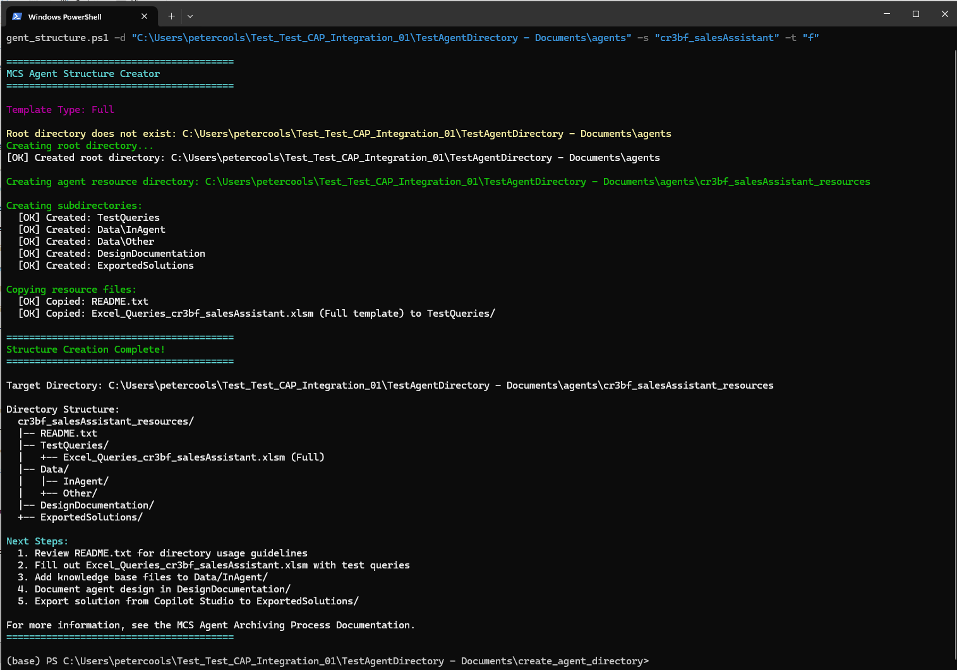
The result is a new directory in the main directory:
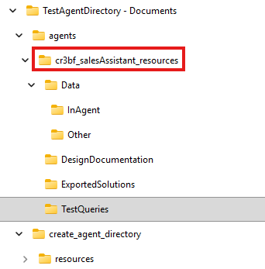
The main directory contains a README.txt file with instructions
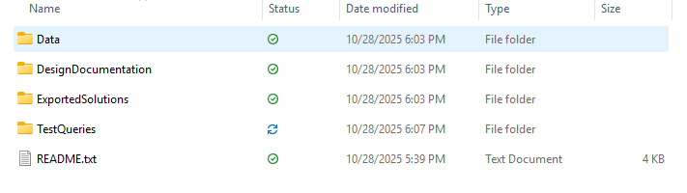
And in the TestQueries directory, you will find the Excel Macro template that you can use to enter your data.


Share your agent’s ID information
Purpose: Trigger transcript retrieval process
Contact: @Peter Cools, @Steven Hoskins
For each of your agents - after you have set up the initial draft version – either in MCS or in ThinkingBox - please send us the following three agent informations (before end of one business week):

Agent overview URL
Copy the URL from your agent’s overview page address bar:
https://<domain>.microsoft.com/environments/<environment id>/bots/<bot id>/overview

Schema name
- Click “Settings”
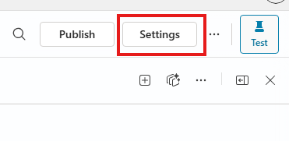
- Click “Advanced”
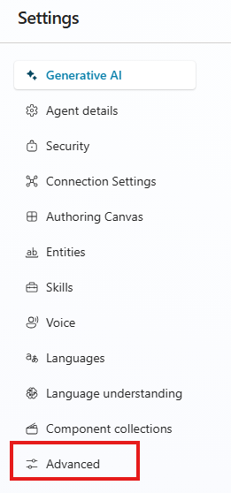
- Click “Metadata”
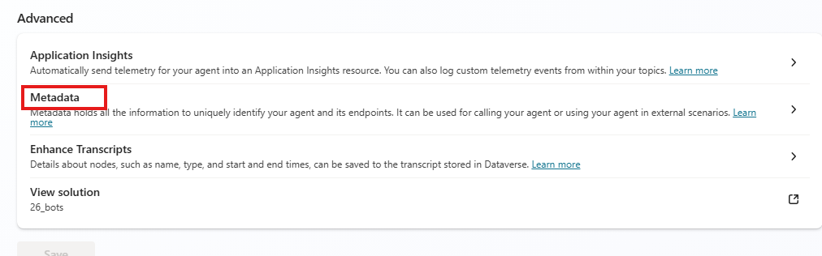
- Click the copy symbol besides the “Schema name”
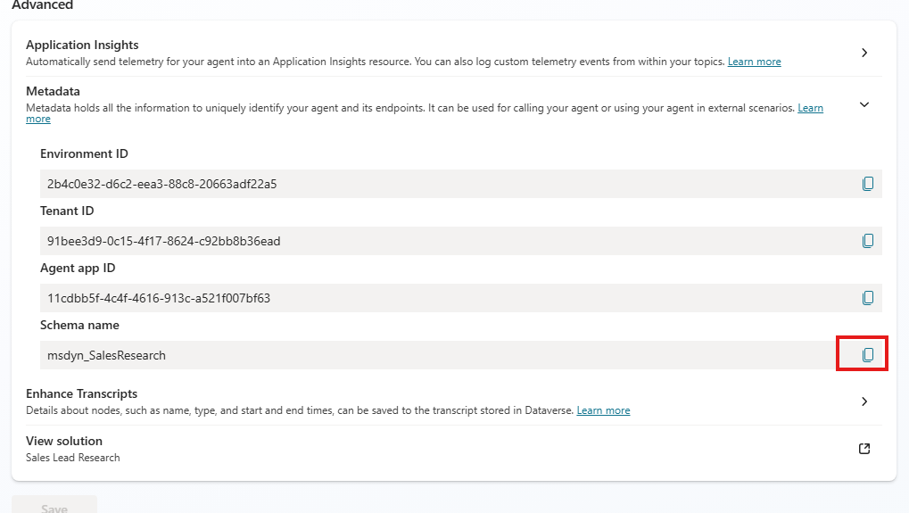

SharePoint agent directory URL
This is the URL that points to the directory that contains the sub-directories with the knowledge data, Excel data entry templates etc for the respective agent.

Deliverable I: ThinkingBox

Agent level information
For agent level information, they should be stored as a yaml file under: AI.ThinkingBox.Data/dataset/scenario/
Here is an example of that yaml file: techno_marketing.yaml - permalink
Each YAML file should include the following sections:
- world_state – maps the documents that are associated with the agent
- in-agent: List of documents (URIs) linked to the agent that are standalone
- For folders, please state the folder name and files under that folder (including subfolders if any)
- external_links: Webpages/websites that have been added as a source
- bot_instructions: Description of the agent's purpose, capabilities, and limitations
- response_formatting_instructions: Guidelines for how the agent should format responses
- metadata: url to the yaml file with all the dataset information and document location
- tools

See Appendix 1: Agent design criteria.

Knowledge corpus
- Organize documents in a structured folder (e.g. undersupport/knowledge_base/<agent_name>/documents)
- Knowledge corpus criteria are captured in Appendix 2: Knowledge Corpus Requirements

Mock MCPs to represent tools

Set of queries + evaluation rubric
Note: the Excel data entry templates “Documentation” worksheet show the “golden truth” explanation for all rubric fields.
Evaluation rubric criteria:
  - Number of evaluation criteria per rubric: Depends on the solution complexity
    - Simple questions: at least one positive and one negative criterion
    - Complex question: Larger number of criteria
  - Criteria should have a mix of negative and positive rubrics (the mix can change depending on the question and need not always be 50-50)
  - Each criterion must include a score (range: -10, + 10)
  - For an agent response to be considered as success:
    - First calculate the scores based on the rubric and calculate the sum.
    - If the sum >=80% of maximum score, then it is a pass.
    - We expect a failure rate of at least 40%.

For any questions on evaluation rubric please reach out to Jianyu Fan

Document ranking
Guideline on Citation Discounted Cumulative Gain (citeDCG) - citeDCG_Guidelines.docx

Multi-turn conversations
This document shows a series of multi-turn scenario examples: Multi-turn scenarios.docx

YAML resources representation: Set of queries + query metadata + evaluation rubric + ground truth + file metadata
Here is an example of what the yaml file for query metadata+ evaluation rubric + ground truth + file metadata looks like: techno_marketing.meta.yaml - permalink.
File level metadata (references): techno_marketing_reference_files.yaml - permalink.
The techno_marketing.meta.yaml file is an example of what that would look like.
It contains information in two formats:
- test cases in the form of a yaml list
- test cases in the form of conversation history
There is a script called multi_turn_conversion_script.py that helps convert the yaml list format to the conversation history format.
The only aspect to be added is tool response (If you search 'Please fill in the tool response details’ you can find the places details need to be added)

Deliverable II: Agent creation in MCS
Purpose: This is a guideline to help create your MCS agent and get around known issues.
Contact: Arvind Akpuram Srinivasan, Jean-Francois Lavallee

Connecting MCP Server to Agent
- We highly recommend adding model context protocol directly in Copilot Studio directly instead of creating custom connector in PowerApps to avoid external dependency
Go to agent -> go to “Tools” tab -> click “Add a Tool” -> select “Model Context Protocol” -> click “New tool” -> click “Model Context Protocol” -> follow the on-screen instructions.

Connection to Connectors (outlook, sharepoint, dataverse, team, etc)
- Create new connections instead of reusing existing connections created earlier in other agent solutions

Adding Knowledge corpus
- SharePoint – at least 3 SharePoint libraries. Each with at least 2 Word (docx), 2 PowerPoint (pptx) and 2 Excel (xlsx) documents
- Bing – Enumerate the public websites

General Knowledge
- Depending on the Agent scenario you may choose to enable general knowledge or not

Deliverable III: Excel Data Entry Template
MCS: The vendor should run queries in Copilot Studio and manually annotate outputs in an Excel template which is provided.
Open the Excel Macro data entry template created by the process described in “Agent resource directory tool setup and usage” and click the “Enable content” to use the automatic validation functionality.
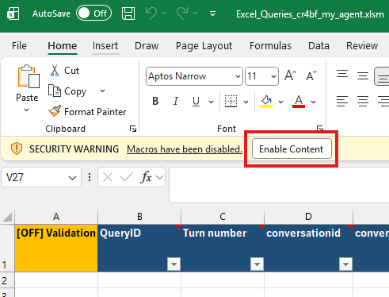
When the following message appears, click “Yes”
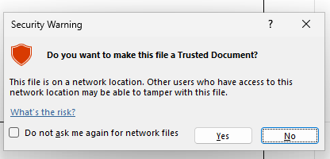

Excel worksheet tabs
- Documentation: Contains a listing of all columns with explanations and examples. This sheet is protected and can only be viewed!
- Data Entry: This is the sheet where you enter your data.
You can see the column explanations by hovering over the respective header field.
A tool tip note will show up with the same content as the description field on the Documentation work sheet.

Full vs. abridged templates
- Once we are confident that yaml file is being filled correctly (we will look at the first few agents) we will phase out using the “full” version of the Excel sheet for most of the columns will be present in the yaml file.
- However, we then will still need an Excel template for human evaluation, as yaml files will not contain that information.
For this purpose, you should run the agent resources directory creation script with the “-t a” option to obtain the abridged version of the Excel template.
This version has only a sub-set of the columns.

Excel Template Field Validation:
The Excel template has a validation macro running in the background.
After having entered some data you can switch the validation ON and OFF by double clicking the field A1.
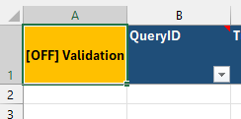 double click à 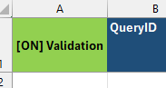
In the case where values do not meet the requirements, the field shows yellow highlighting and a tool tip warning / error explanation.
When you double click the “Validation” toggle field in A1 again, the error highlighting is removed again.
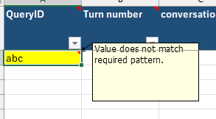
The validation process differs depending on the field values and data types.
Besides the data entry range (B2:<end of table>) the validation also will report changes to the header fields.
Header fields should never be adapted.
If you want to use a column with temporary contents e.g. as a helper column, you can add any additional columns. As long as they don’t have any of the field names from the “Documentation” worksheet they will not be covered by the validation (nor being used in any following process step).
For a more detailed description and best practices of the validation macro refer to the README.md file in the directory where your Excel Queries xlsm files are stored (result of the step done in “Agent resource directory tool setup and usage”.

Handling of multiple turns / intents
- We understand “turn” as a new intent of the user, i.e., a query that the user performs on their own initiative, not because of being asked by the agent. (We will eventually rename the corresponding column to “intent number”).
- Slot filling questions (i.e., asking the user for the value of a tool parameter) and follow up questions (i.e., clarifying the user’s intent) can be annotated with the same turn number as the previous row. In this case, tool names / parameter names / expected response fields can be left blank. (Since the distinction of what constitutes slot-filling / follow-up can be blurry, this is a “can”, not a “must”).
- The number of turns to be counted towards the required number as per the contract is the maximum turn number, i.e., if rows reuse turn numbers, those do not count towards the contractual requirement
- It is allowed to evaluate custom rubrics only on conversation level (i.e., for the last turn in a conversation). Note that this applies to GenOrchestration ONLY, pure GenAnswers test cases need to have turn-level custom rubrics.
- Tool names and parameters must be annotated for each turn in a conversation. E.g., if the user first asks to send an email and then to schedule a meeting, the email tool should be annotated in the first turn and the meeting tool in the second turn

Additional Instructions for specific field annotation
- For tool names in fields “Expected tool selection” and “Expected tool parameters and values”, Please follow below instruction to use the right tool name format
  - Go to agent page
  - Go to Tools tag
  - Select the target tool -> click “…” -> click “Open code view”, which will load tool schema on the page like below
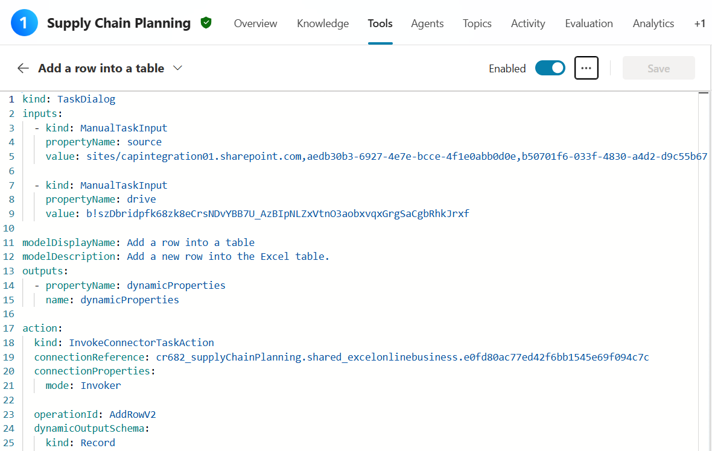
  - Use “modelDisplayName” field for tool name annotation.

Solution file creation process
One of the deliverables of an MCS agent is the so-called solution zip file.
Here are the steps to create this file:
- Publish your agent by clicking the “Publish” button. (Alternatively, you can click “publish” in the solution creation step).
- From your MCS agent environment go to the “solutions” section:
  - Click the three dots besides the “Settings” button an select “Export agent”
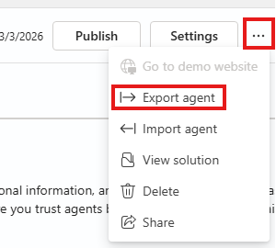
  - Alternatively you can take the initial part of your agent’s URL and replace bots/… by solutions/
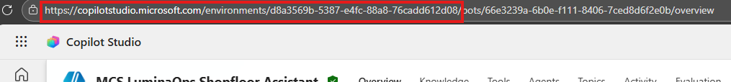
- In the solutions page:
  - click “New solution” 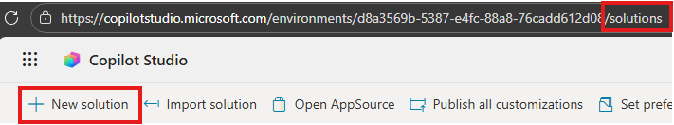
  - Enter a name that indicates the agent’s name tag and creation date. 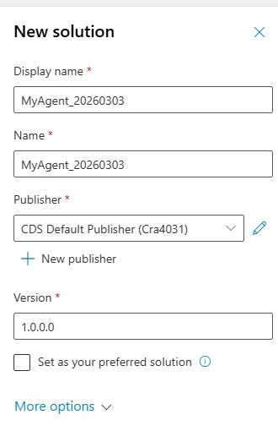
  - Click the “Create” button at the bottom of the tab.
  - In the following window click “Add existing”, select “Agent”
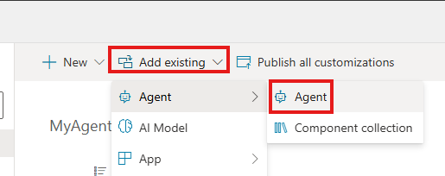
  - Finally select your agent and click “Add”.
  - Wait until the agent details appear, then click “Back to solutions” and then leave the “solutions” area (click the arrow on the left)
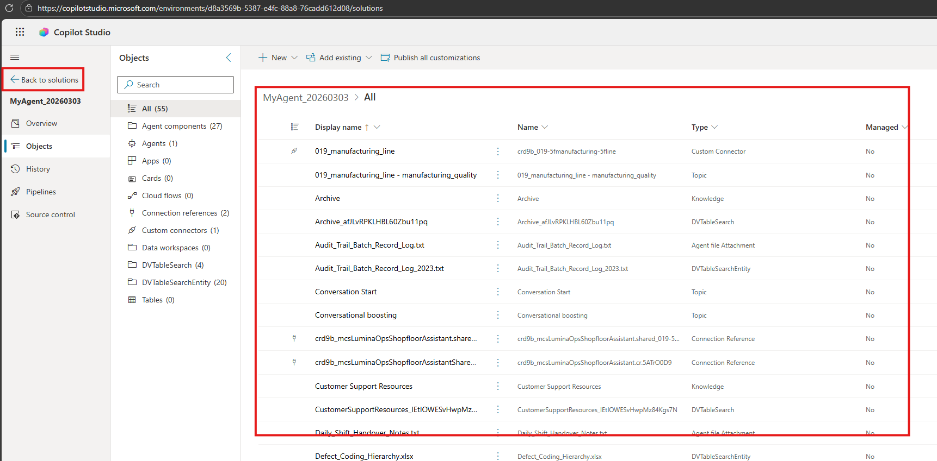
- Now click the three dots (…) besides the solution that you just created and select “Export solution”
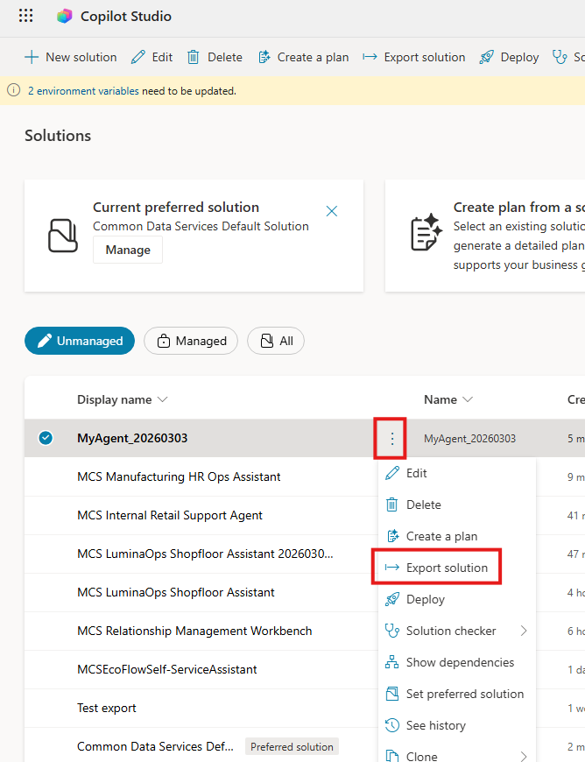
- In the next window you get the second opportunity to publish your agent, in caseyou didn’t publish at the start of the process – if you already did publish earlier, you can directly click “Next”
- In the following window select “unmanaged”, select the right version number (not very important).
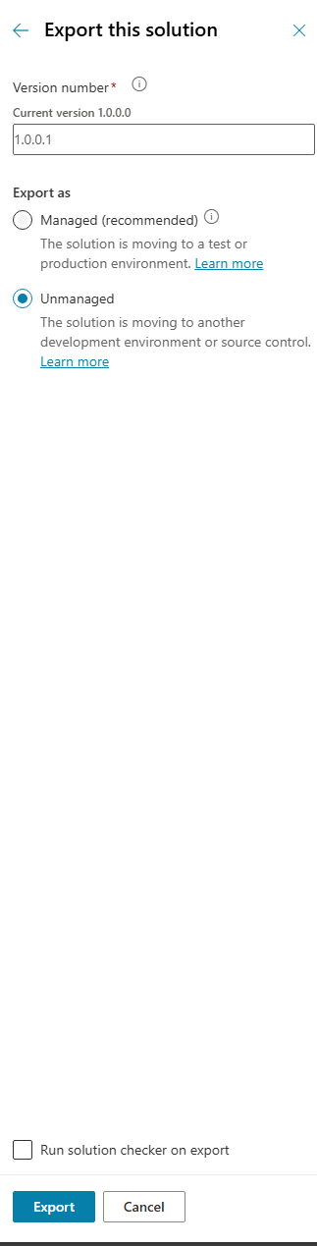
- Finally click “Export” – you will see something like this at the top of the solutions page:

- After the export is complete it will show green and you can download the solution file – download button at the right side:

Acceptance Review
Purpose: To signal the agent plus annotation is done and ready for acceptance review
Contact: @Peter Cools, @Steven Hoskins
Once the agent development and annotation are complete, and the data is ready for acceptance review, please share this information in the designated team channel/chat.
For the case of first agent and the first multi-agent, in addition please also share this data as soon as the first few queries are complete, so we can dry run the full process!

Appendices

Appendix 1: Agent design criteria
- Agent Instruction Diversity: Agents follow distinct instruction styles tailored to their use case.
- Explicit Orchestration Logic: Instructions should NOT reveal the orchestration solution.
- No Overfitting agent instructions to Test Cases. Instructions should be updated only to fix obvious blind spots. Instructions should not be tuned to pass specific test failures. 20% to 50% of tests should fail. Higher is not a problem if it is validated that it doesn’t come from poor instructions, agent setup or technical issues.
- Directness Variety: Some agents are open-ended; others have goals like upselling or claim denial; others are more directed and need to apply proper procedure for a situation, without providing detailed and explicit orchestration logic.
- Domain distribution and agent configuration should meet the target in the SOW. For example, representation of multi-turn conversations, reasoning.
- Tool volume and task complexity. Variety in complexity : (a) Simple agents (with no more than 5 tools per agent, perform simple tasks), (b) Intermediate agents (5-20 tools per agent, have moderate complexity, involving multiple features and some level of integration with other systems), (c) Complex agents (with more than 20 tools per agent, have extensive functionality, require significant integration with various systems, and involve complex workflows. When configuring tools, realistic, relevant and sufficient data should be populated into the corresponding instances, and the data should cover all tasks the agent is designed to perform (rather than being limited to test runs). Prompts will not be included in the count
- Autonomous agents requirements: Include multiple triggers per agent. Avoid using flows.
- 50-50 autonomous vs conversational agents split

Appendix 2: Knowledge Corpus Requirements
- Knowledge corpus size. 45 realistic files per agent, aligned with specs in the sections below
- File type diversity. For each agent include 3 files for each of the following content types:
  - Web pages : 3 web pages per agent. We will need to confirm that Microsoft has rights to use this content with our legal team. Please incorporate this confirmation step into the plan.
  - Word documents (DOC/DOCX): 3 Word documents per agent
  - PowerPoint (PPT/PPTX): 3 PowerPoints per agent
  - PDF files: 3 PDFs per agent
  - Excel (xls, xlsx): 3 Excels per agent
  - Text (txt, .md, .log): 3 text files per agent
  - HTML (html, htm): 3 HTMLs per agent
  - CSV (csv): 3 CSVs per agent
  - SharePoint site containing Plain text (ASPX file): 3 SharePoint with plain text per agent
  - SharePoint library: 3 Libraries per agent. Each library should contain at least 6 files with these min requirements: 2+ Word documents (DOC/DOCX), 2+ PowerPoint (PPT/PPTX), 2+ PDF files
  - Note on supported knowledge types: Note: Image, video, executables, and audio files can't be used as uploaded documents. Images are only supported when they're embedded in PDF files. Icons aren't supported. Files larger than 512 MB aren't supported. Files with encryption, such as sensitivity labels or password protection, aren't supported.
- Realistic, diverse document structure: The content within each file type should include structural variations, such as:
  - Textual body: At least 5 paragraphs of meaningful text. Each paragraph contains at least 5 lines
  - Header: One of the following two scenarios:
    - Simple Scenario: Title and one subheading
    - Complex Scenario: Nested headings (e.g., H1, H2, H3) organizing content across sections like introduction, methodology, results, etc.
  - Comments: Minimum of 1 per file
  - Tables with text and numbers: Simple scenario: At least 1 simple table with both text and numerical content. The table should be filling at least half a page. Complex scenario: At least 1 complex lengthy table showing varied data types (percentages, dates, formula etc). The table should be long enough to fill at least 1 page fully
  - Image (Images are only supported when they're embedded in PDF files.): At least 5 images in each PDF file only
  - Chart: At least 1
  - Lists: At least 1 bulleted or numbered list. Simple scenario: At least 1 simple list filling at least half a page. Complex scenario: At least 1 complex list should be long enough to fill at least 1 page fully. Should contain at least 3 simple and 2 nested bullets/numbered list.
  - Metadata: Include features like page numbers, titles, and document properties
- Varied file size: Each of the 15 content types in the knowledge corpus per agent should be represented in small, in medium, and in large file sizes (15 content types x 3 file sizes = 45 documents total).
  - For PDFs, Power Point, Word doc, Text, SharePoint library docs: Small sized file: 1 to 10 pages, Medium sized file: 11 to 50 pages, Large sized file: 51 pages or more.
  - For Excel, CSV: Medium complexity sized file: 1 worksheet or more, with 200 or more rows in at least 4 tables. Tables should have 10 to 100 rows with formatting inconsistencies, structural irregularities, nested headers, colors, and indent variations. Most of the tables should have noisy rows and color indentation issues. Files should include realistic noise and imperfections to better simulate real-world scenarios. High complexity Large sized file: 2 worksheets or more and 400 rows or more in each worksheet. At least 1 table. Files should include realistic noise and imperfections to better simulate real-world scenarios
- Realism noise simulation & Ambiguity. Files reflect real-world inconsistencies (e.g., conflicting names, merged cells, nested headers, typos, inconsistent units, formatting issues). Vendor should deliver a version of the clean knowledge source in addition to the noisy source, and a description of the noise that was introduced to the knowledge corpus. Sanitized or overly clean data that does not represent reality is not accepted.
- Public Webpage Indexing. Include web pages onboarded from public sources and indexed. Do not include private or inaccessible web pages.

Appendix 3: User queries criteria
- 1/3 of queries should require a knowledge search only; 1/3 should require chaining of tools; 1/3 should require a combination of knowledge search and tools. The latter category should have diversity in sequencing knowledge search and tool calling, e.g. one solution should require starting with a knowledge search followed by a tool call and then a second tool call. Another query might require first a tool call, then a knowledge search, etc.
- Natural Language Interaction. A realistic test case looks like “What are the sale numbers for last Monday?”, not like “What are the sale numbers for {day:8, month:September, year:2025}”
- Test cases are realistic and are aligned to target persona; they simulate real usage. Good: Questions match expected personas and tone. Bad: Bot-like, patterned questions.
- Answerability from Knowledge Corpus: we expect a balanced mix of answerability types: (a) Queries that can be answered using a single source document (~20%). (b) Queries that require synthesizing information across multiple documents in the agent’s knowledge corpus (~60%). (c) Queries that are unanswerable from the corpus, designed to test fallback behavior and hallucination resistance (~20%). The overall set should reflect realistic user behavior and retrieval complexity—ranging from straightforward lookups to deep synthesis across multiple files.
- Ensure knowledge queries target a variety of content types: textual body, headers, comments, tables (text and numeric), images in PDFs, charts, lists, metadata & folder structure. Use the following distribution:
  - Knowledge-only queries:
    - Textual Body – 12 questions
    - Header: One of the following two scenarios:
    - Simple Scenario: Title and one subheading – 1 question
    - Complex Scenario: Nested headings (e.g., H1, H2, H3) organizing content across sections like introduction, methodology, results, etc. – 1 question
    - Comments
    - User queries based on explanatory or reference notes at the bottom of pages – 1 question
    - Tables (text and numeric content)
      - Simple Tables: 2 questions
      - Complex tables: 2 questions
    - Images in PDFs:
      - 2 questions
    - Charts:
      - 2 queries that involve understanding visual data representations like graphs or plots.
    - List:
      - Simple scenario: 1 question
      - Complex scenario: 1 question
    - Metadata (e.g., page numbers, document titles, properties):
      - 1 question targeting structural or informational metadata in the file. (eg: page numbers, file names, folder structure etc)
    - Design queries that test the agent’s ability to understand and leverage SharePoint metadata and folder structure to provide contextually accurate answers.
    - Note: A single question could use multiple content structures, and you can double count in these cases. These specified numbers are just the minimum.
  - Combined Knowledge and Orchestration queries:
    - It would be ideal if you could follow the content structure requirements as specified for knowledge only as well. But if it is not feasible, then at the very least please ensure that at least half the questions use content structures apart from just textual.
    - Additionally ensure that we have at least 3 test cases using the each of following content structures – (a) Tables, (b) Images, (c) Charts
- For combined knowledge and orchestration test cases, include a mix of: (a) Knowledge-first flows (e.g., find policy → send via email), (b) Tool-first flows (e.g., calendar lookup → confirm with knowledge), (c) Interleaved flows (e.g., retrieve → summarize → send → follow-up)
- Vary user clarity: low, medium, high
- Vary user intent: distribute queries across the following categories: fact seeking, procedural, summarization, comparison, clarification, reasoning, status, resource-seeking, feedback/assistance, hypothetical, two-turn/multi-turn conversation query.
- Vary query patterns: question length (short, medium, long), include keyword-based queries, include document term overlap, include misspelled or noisy queries, include web-search-style queries. Also include multi-query conversations, where in a single conversation has multiple questions. Multi-turn conversations should be realistic, where turns are contextually linked. At least 20 questions per agent should be part of multi-query conversations.
- Test cases require an agentic solution: We shouldn’t be able to replace the agent with a simple deterministic tool and get the same accuracy. For example, “Take a claim id and check the status in the db (Could be done by a sql query)” is not a good test case. On the other hand, the following is: “Look at the claim and provide a suggestion with justification on either to refuse or accept it using the policy and send the information to the right department for review through teams.”
- High test coverage and diversity: Tests should have diversity and high coverage of various tool and Copilot Studio or agent features
- Multi-modal input: At least 5 queries per agent that include combined text + image as input
- Failure rate: For each category of knowledge/orchestration/combined knowledge-orchestration queries, include realistic queries that today result in failure. Let's aim for 20-50% query failure rate per agent. This way we can gauge meaningful areas where the product falls short today.

Appendix 4: Best Practices
- Use consistent indentation and valid YAML syntax
- Test YAML files for syntax errors before submission
- Always Reset Conversations for new sets of interactions. The only reason to resume a conversation would be for the case of multi-turn where there are follow-up questions to an earlier one. In cases where a conversation reset was forgotten, please repeat both the original and new interaction sets.
- Do not introduce artificial spelling mistakes in queries. Our AIs have decent spell correction and still understand certain requests, but this is not the focus of our collection effort, nor is it a valid way to increase the failure rate.
- Avoid artificial copy of terminology from documents into questions. The entities should be referenced naturally as a user would reference the terms. Bad: List the delivery due for {Months:11, Day:24, "year":2025}”; instead use natural language: "List the delivery due for November 24". Bad: “how much sales were there for the WD-45 Prefiltered Oil 451 (r/China version) in October”, instead use “how much sales were there for the WD-45 from China in October”
- Handling Queries with multiple reasonable answers. If such queries are added, make sure the rubric allows for all reasonable answers and for a response that requests disambiguation. E.g. A person in Phoenix asks: “What’s the weather in Paris?”, rubric should be: “Response should reference the city for which it is answering (Paris Texas, or Paris France) and the weather there, or it should ask which Paris the user is referencing”.
- System Errors should initiate a retry with a new conversationID via reset. Be careful to distinguish AI errors from system errors. AI errors are associated with the AI not smart enough, did not interpret a document well enough, misclassified a query as profane or dangerous, etc. System errors are where there is a timeout, memory overflow or network error, or a response that looks like "Sorry, something went wrong. Error code: SystemError." For system errors, we expect the same test case to be retried in a new conversation to see if those issues were transient. Persistent system errors should be escalated to us.
- Feel free to leave feedback in the Maker interface via thumbs-up or thumbs-down along with the optional short description. We can (if needed) recover these feedbacks and present these alongside other inputs in the Excel sheet.

Guidelines for defining rubrics / success criteria for orchestration
- Parameter names and values are annotated explicitly and separately. In many cases (e.g., send an email to a given address), an exact match is desired instead of an LLM judge assertion, as it is expensive and can miss small differences such as different spellings of a name: fweninger vs. fwenninger). Thus, it is not always desirable to use custom rubrics for checking parameters.
- Custom rubrics can be used to
  - Judge the quality of retrieval / knowledge search outputs
  - Judge the conversation flow and information given to the user (e.g., confirmation / summary sent)
  - Put additional weight on critical tool calls / parameter values (e.g., account numbers in banking agents)
- Do not assume world knowledge when designing the rubrics; “Agent provided the weather in Warsaw, Poland” is preferable over “Agent provided the weather in the current capital of Poland”
- Assume common sense in designing rubrics (e.g., require the agent to send confirmation even if not specified in the agent instructions)
  - Not requiring actions required by “common sense” (e.g., requiring that all actions to be performed are listed in the agent instructions) underchallenges the agent and does not test reasoning capabilities
It is important to consider that there can be multiple valid paths, e.g. confirming an appointment in the chat, sending an email, or both; otherwise, this can create ambiguous cases, resulting in low metrics stability and low agreement with human judges (and low inter-rater agreement)

Appendix 5: Submission Checklist
- All deliverables under ‘Deliverables overview’ are produced
- YAML file stored in the correct folder
- Required sections (in-agent, external_links, bot_instructions, response_formatting_instructions, metadata) are present
- Document URIs and URLs are valid
- Instructions are clear and concise
- YAML syntax is valid
- Test cases are in a dedicated .py file
- Each function tests one query
- Docstrings include query_id, query, expected_response, and ground truth references
- Rubric checks are clear and relevant
- YAML file references are valid and accessible

Appendix 6: Out of scope

Judge Functions
- judge.test_yesno_score(response, criterion, score): Checks if the response meets the criterion and assigns a score
- judge.llama_index_evaluation(response, ground_truth): Compares the response to ground truth data

