Chris Gray

# PROBE : DTrace

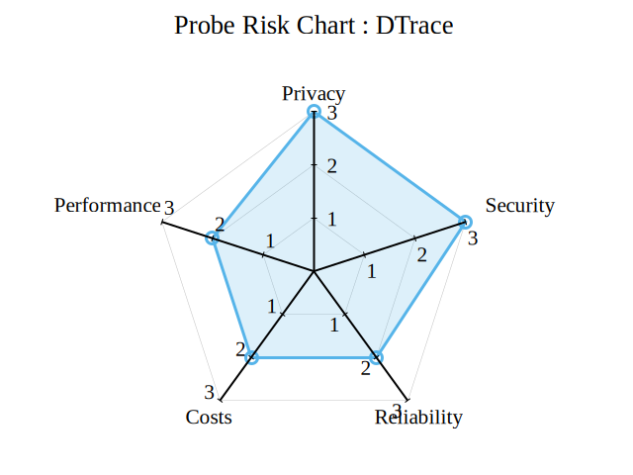

image

## Introduction to DTrace