Chris Gray

# PROBE : OpenTelemetry

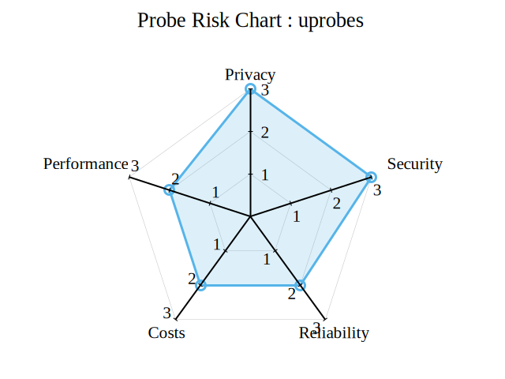

image