**Enable Power BI Reports in Power Pages Portal**

Contents

I. **Publish Power BI Report from Power BI Desktop**: 2

a) Open “K12-LearningStandards.pbix” file in Power BI Desktop. 2

b) Click on “Sign-in” on Top-Right corner. 2

c) Click on Publish as Highlighted. 3

d) Click on “Select” to start publishing the Report to Power BI. 4

e) Below Screen will appear once the Report is successfully Published to Power BI. 5

II. **Power BI Dataset configurations**: 5

a) Go to “Datasets + dataflows”. 6

b) Select “…” on the Dataset and go to “Settings”. 6

c) In Parameter section: 6

d) In Data Source Credentials section: 7

**III.** **Set up Power BI Integration with Portal** 9

a) Enable Power BI visualization in Portal. 9

b) Enable Power BI Embedded service 10

c) Create security group and add to Power BI account 12

1. Step 1: Create a security group 12

2. Step 2: Add a group member 12

**3.** Step 3: Power BI setup 14

**IV.** **Copy Report URL** 16

a) Get the path of a dashboard or report 16

V. **Environment Variables changes in CRM**: 17

a) Open browser and login to https://make.powerapps.com/ . 17

b) Update PowerBI Report URL in environment variable. 17

**VI.** **Power BI Report data refresh On-demand and Scheduled.** 18

a. Open browser and login to https://app.powerbi.com/ . 18

b. On-demand data refresh 18

c. Scheduled data refresh 19

# **Publish Power BI Report from Power BI Desktop**:

## Open “K12-LearningStandards.pbix” file in Power BI Desktop.

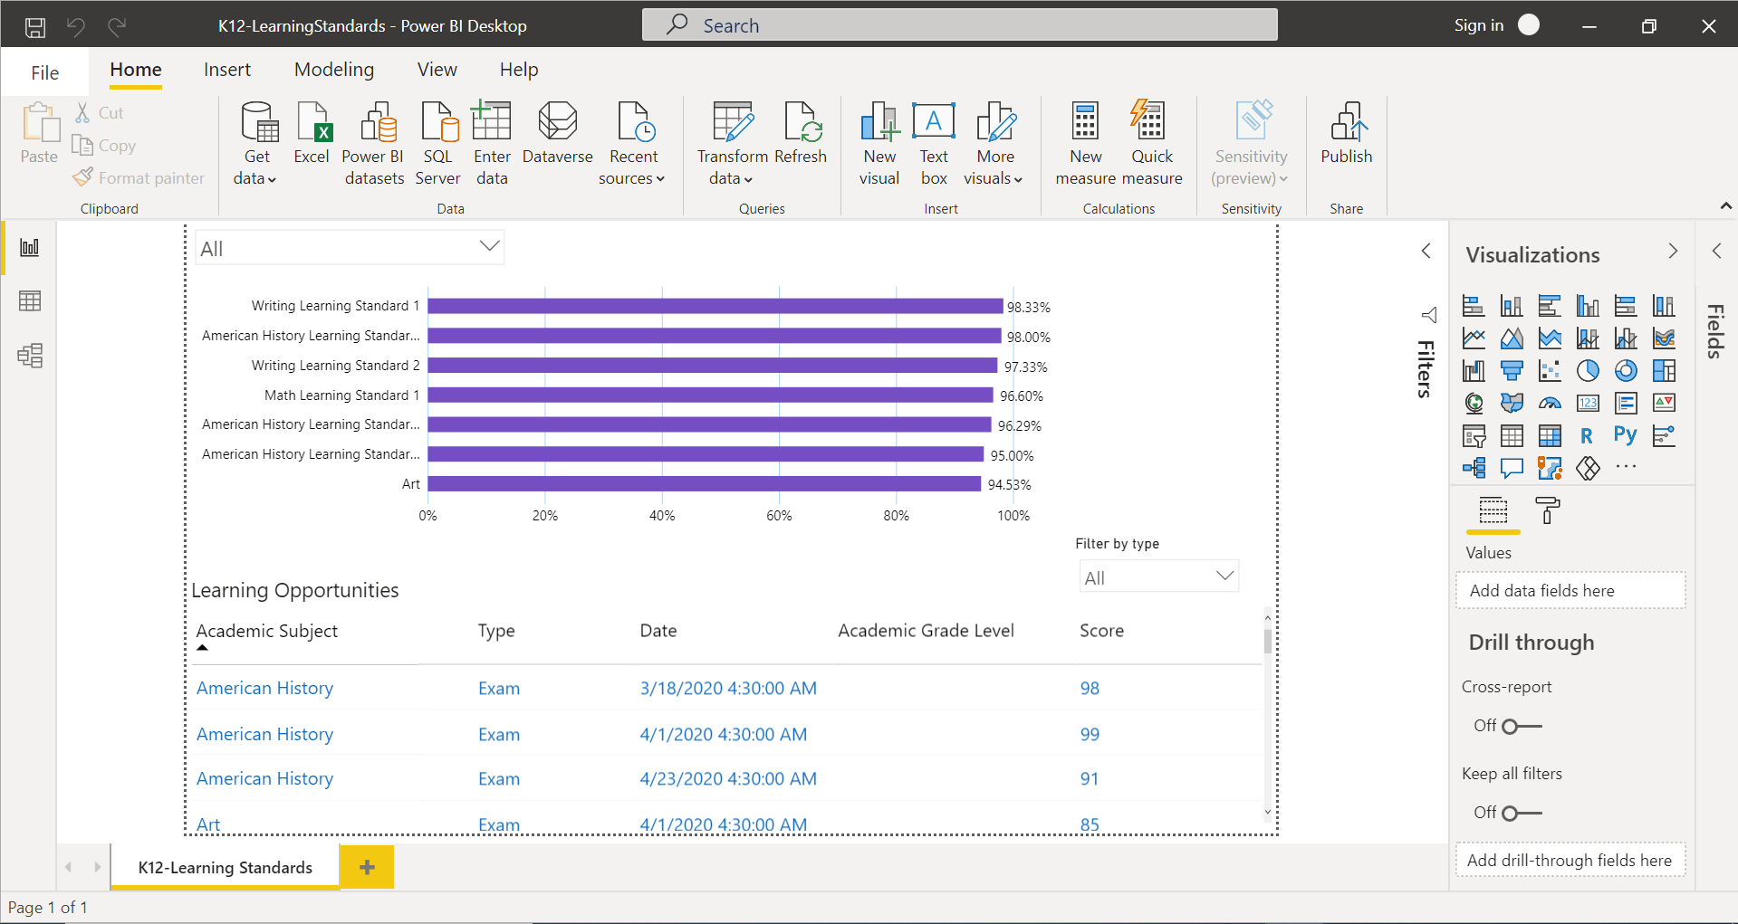

## Click on “Sign-in” on Top-Right corner.

Enter email address of a User having access to Power-Bi. Click “Continue” and follow the screens to login.

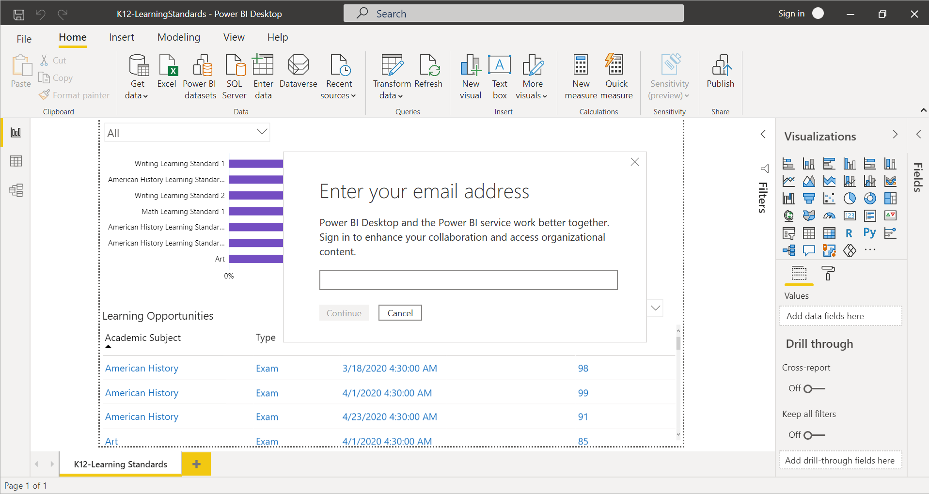

## Click on Publish as Highlighted.

Choose the “Workspace” from the list in which Power Bi Report shall be Published.

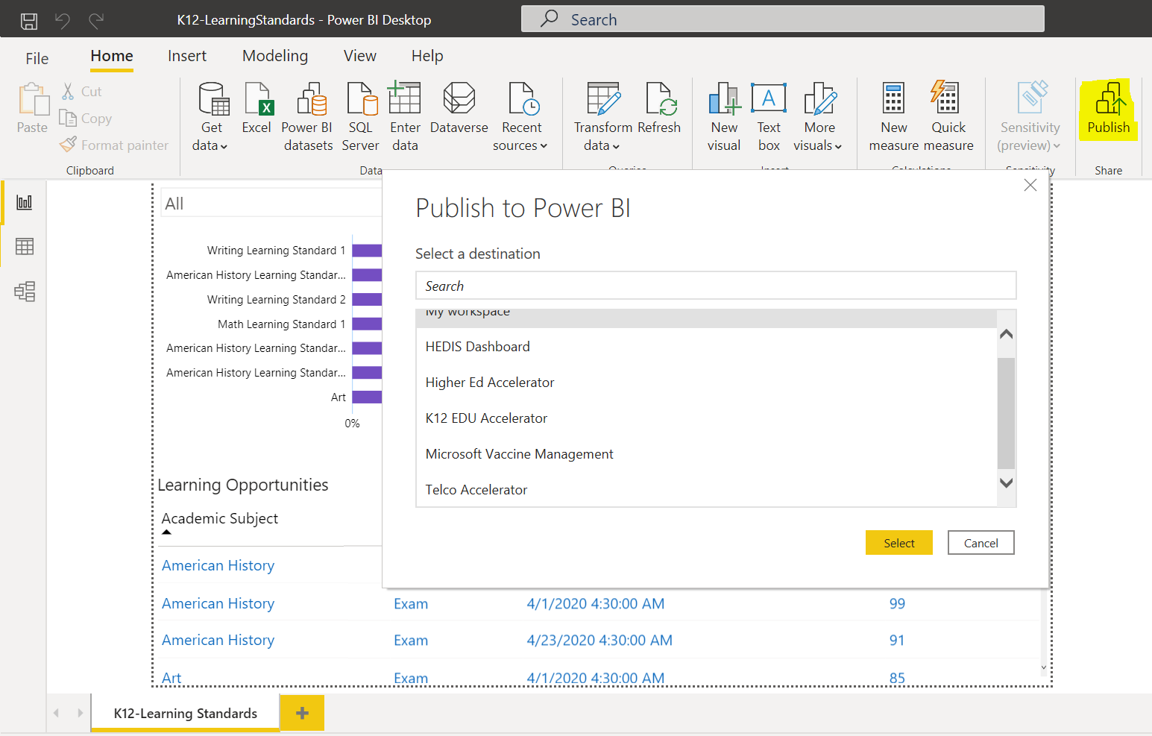

## Click on “Select” to start publishing the Report to Power BI.

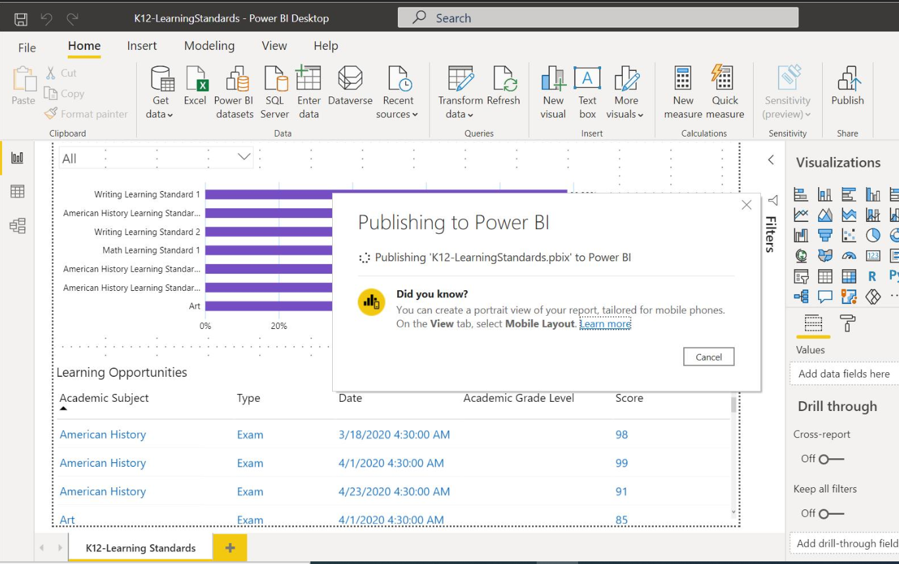

## Below Screen will appear once the Report is successfully Published to Power BI.

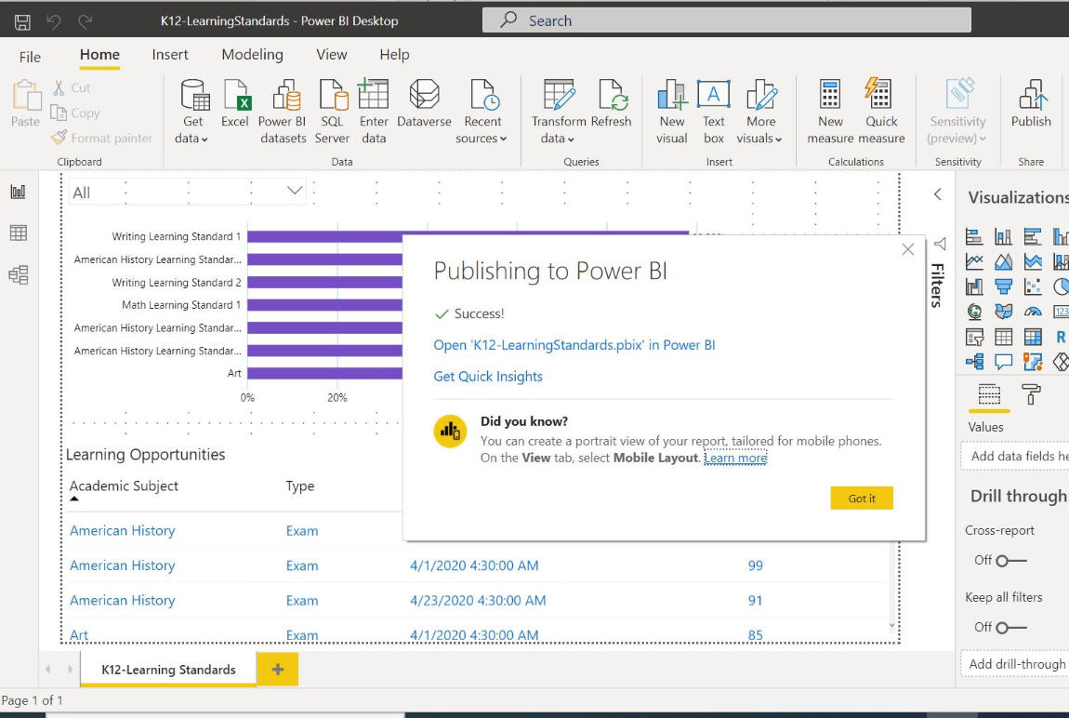

# **Power BI Dataset configurations**:

## Go to “Datasets + dataflows”.

A Dataset with name “K12-LearningStandards” will be available.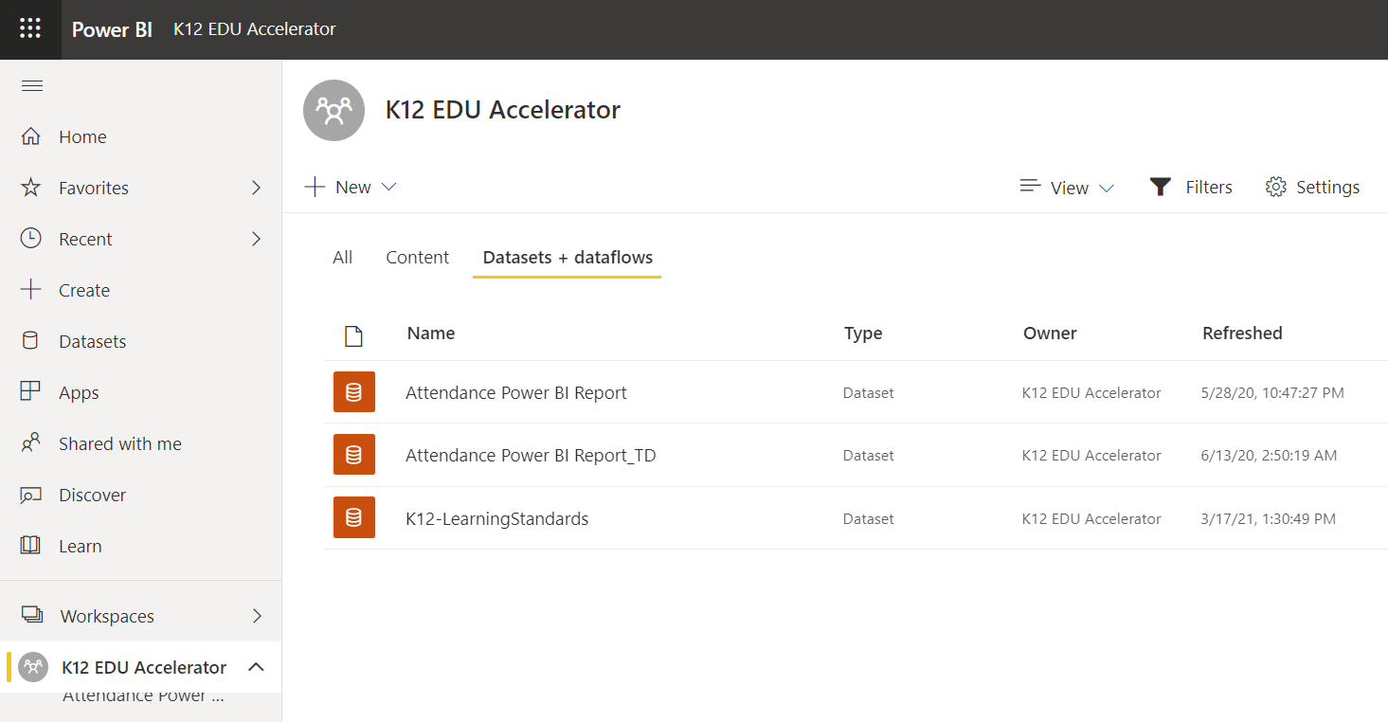

## Select “…” on the Dataset and go to “Settings”.

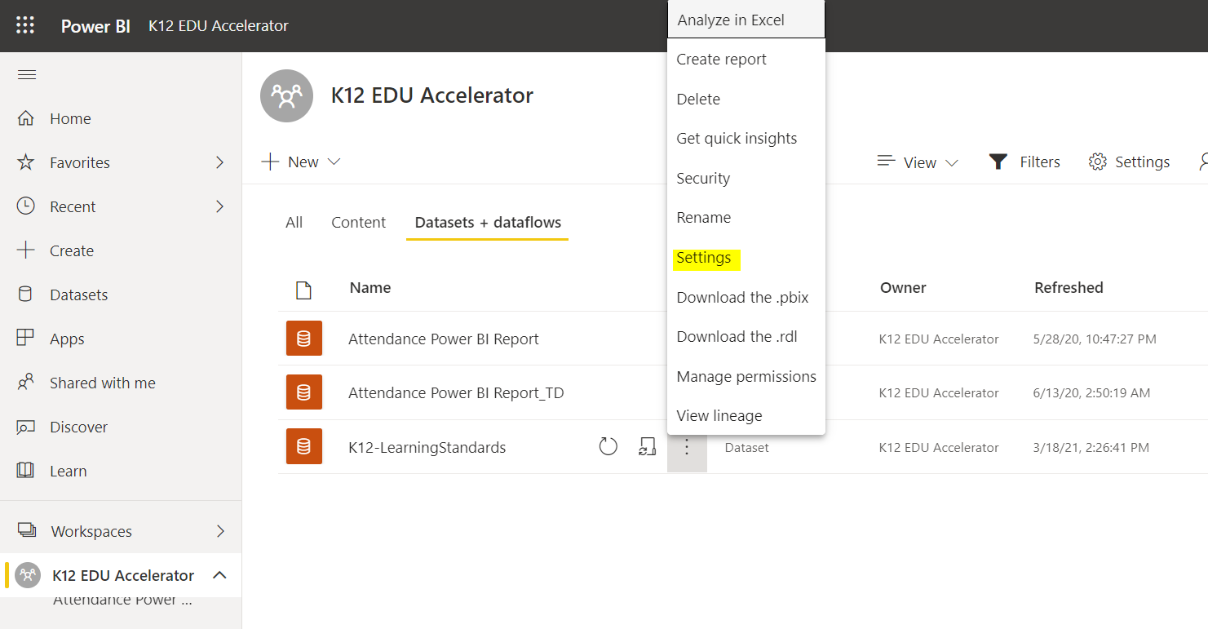

## In Parameter section:

Change the “EnvironmentURL” to the CRM instance URL from which data is required in Report.

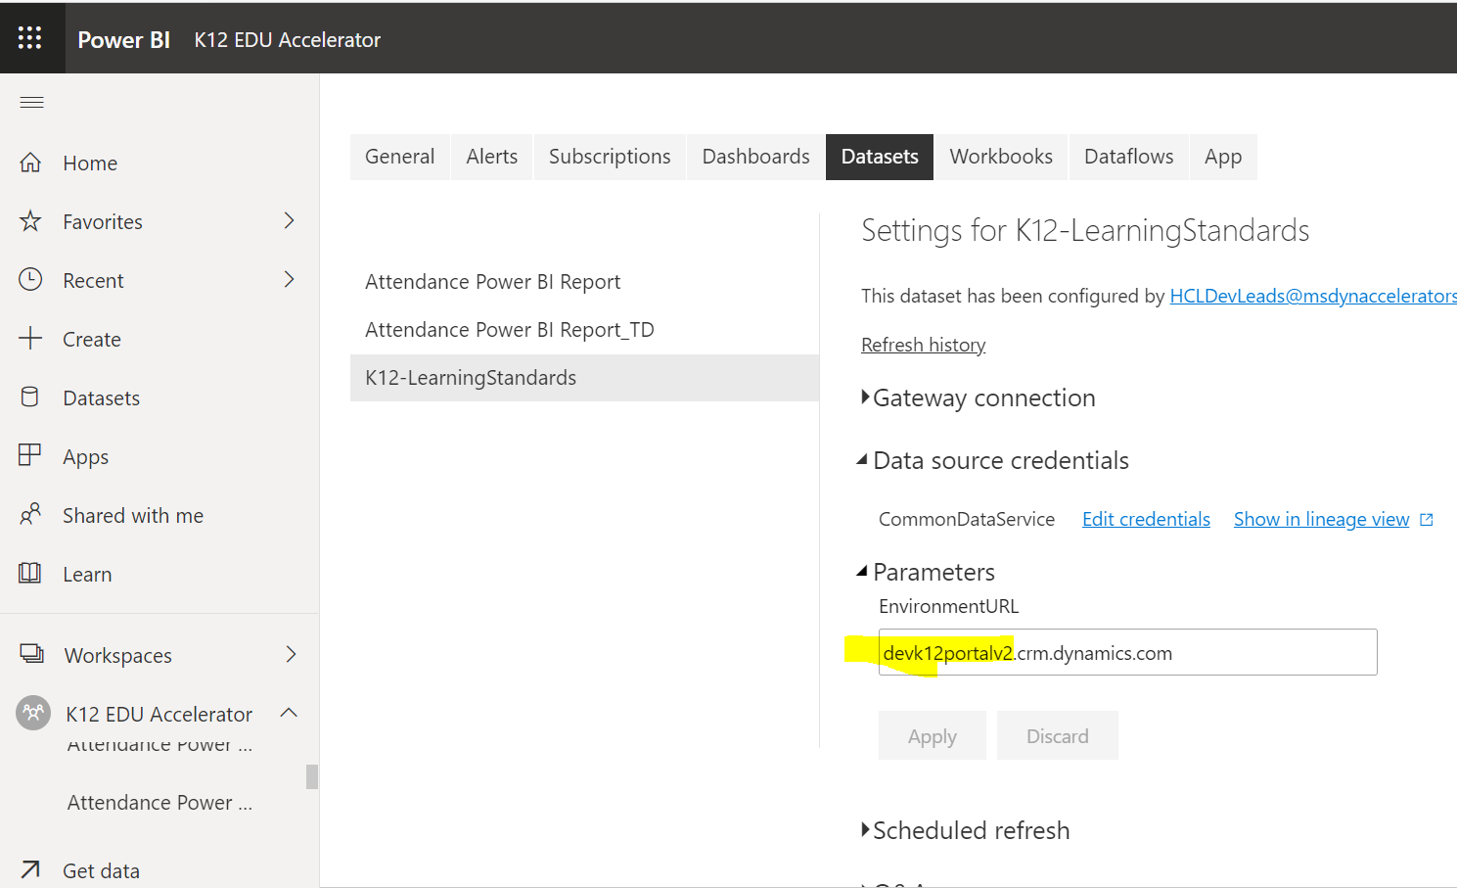

## In Data Source Credentials section:

Click on “Edit Credentials” and follow the screens to Sign-in with Authenticated User to the CRM instance URL from which data is required in Report

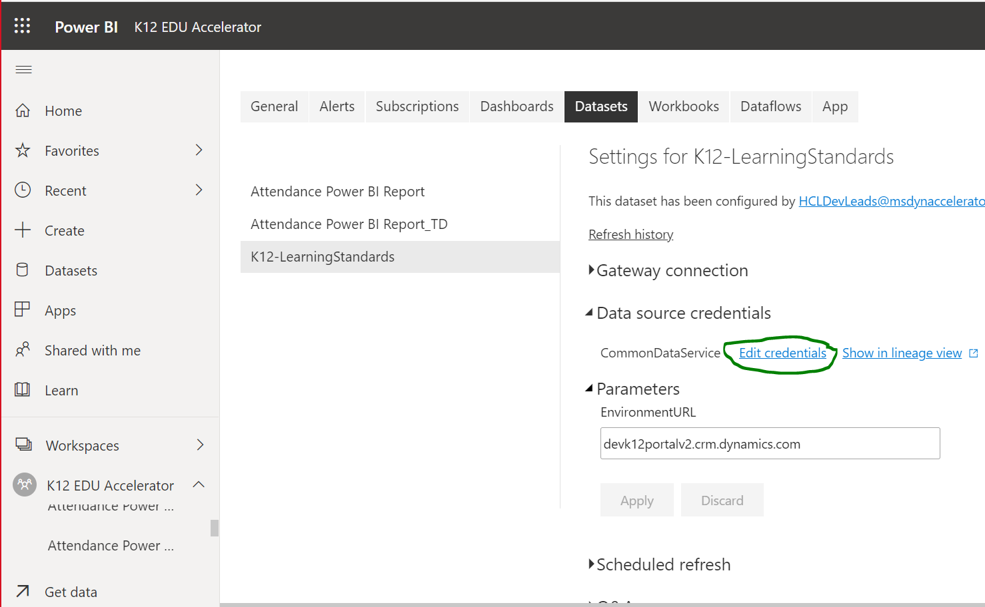

# **Set up Power BI Integration with Portal**

## Enable Power BI visualization in Portal.

* + 1. Open [Power Platform admin center (microsoft.com)](https://admin.powerplatform.microsoft.com/)
    2. Navigate to environment in which portal is hosted.

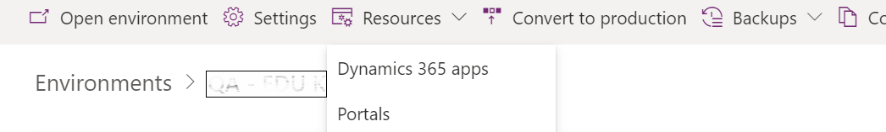

* + 1. Select “…” on the Portal and go to “Manage”.
    2. Go to **Set up Power BI integration** > **Enable Power BI visualization**.

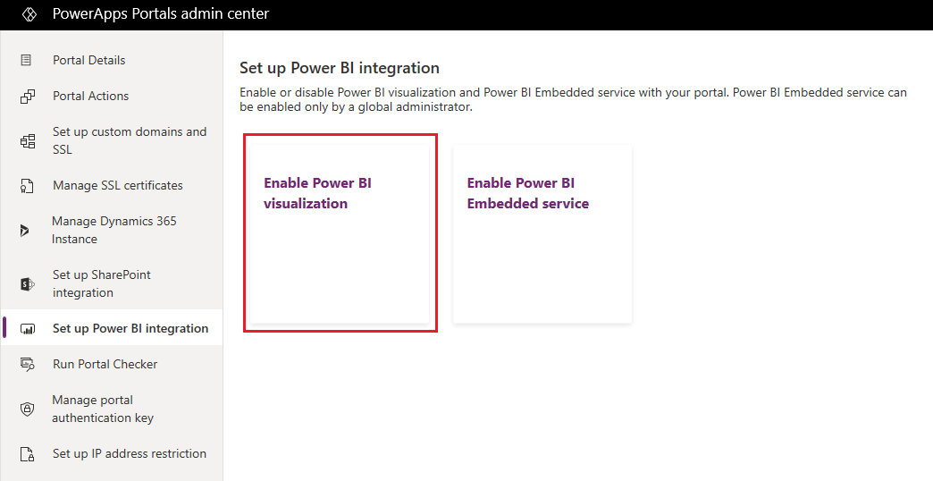

* + 1. Select **Enable** in the confirmation message. While Power BI visualization is being enabled, the portal restarts and will be unavailable for a few minutes. A message appears when Power BI visualization is enabled.

## Enable Power BI Embedded service

* + 1. Open [Power Platform admin center (microsoft.com)](https://admin.powerplatform.microsoft.com/) using a Global administrator account
    2. Navigate to environment in which portal is hosted.



* + 1. Select “…” on the Portal and go to “Manage”.
    2. Go to **Set up Power BI integration** > **Enable Power BI Embedded service**.

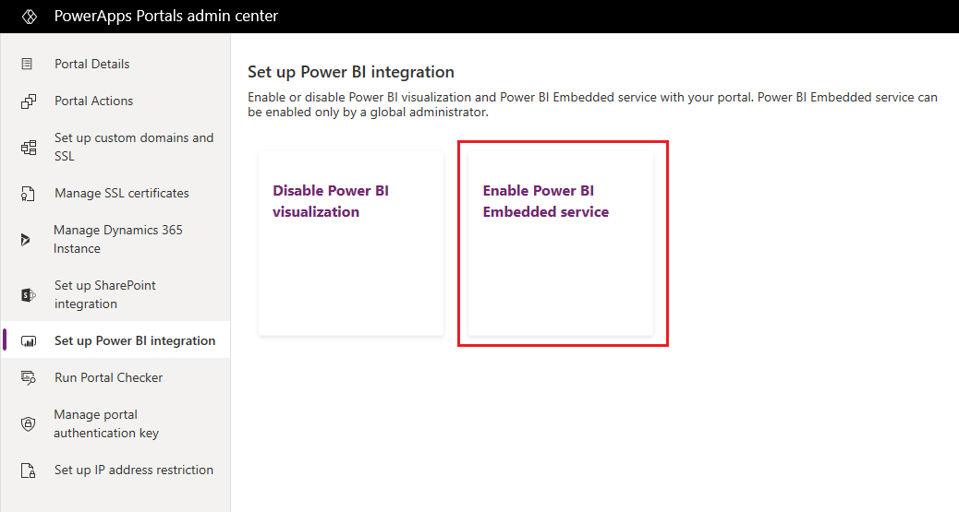

* + 1. In the Enable **Power BI Embedded service integration** window, select, and move the Power BI workspaces from which dashboards and reports need to be displayed in your portal to the **Selected workspaces** list.

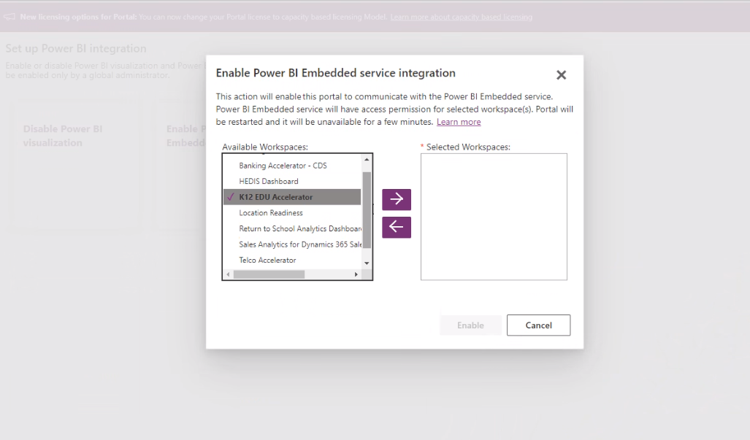

* + 1. Select **Enable**. While Power BI Embedded service is being enabled, the portal restarts and is unavailable for a few minutes. A message appears when Power BI Embedded service is enabled.

## Create security group and add to Power BI account

### **Step 1: Create a security group**

1. Sign in to the [Azure portal](https://portal.azure.com/) using a Global administrator account for the directory.
2. Select **Azure Active Directory**, **Groups**, and then select **New group**.
3. On the **Group** page, enter the following information:
   * **Group type**: Security.
   * **Group name**: Portal Power BI Embedded service.
   * **Group description**: This security group is used for Portal and Power BI Embedded service integration.
   * **Membership type**: Assigned.

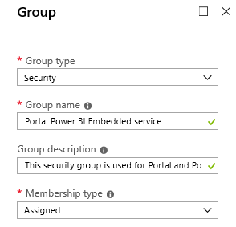

1. Select **Create**.

### **Step 2: Add a group member**

1. Sign in to the [Azure portal](https://portal.azure.com/) using a Global administrator account for the directory.
2. Select **Azure Active Directory**, and then select **Groups**.
3. From the **Groups - All groups** page, search for the **Portal Power BI Embedded service** group, and select it.

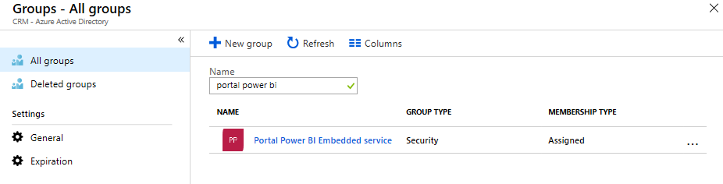

1. From the **Portal Power BI Embedded service Overview** page, select **Members** from the **Manage** area.
2. Select **Add members**, and enter the portal's application ID in the text box.

The portal's application ID is available on the **Portal Details** tab in [Power Apps portals admin center](https://docs.microsoft.com/en-us/powerapps/maker/portals/admin/admin-overview).

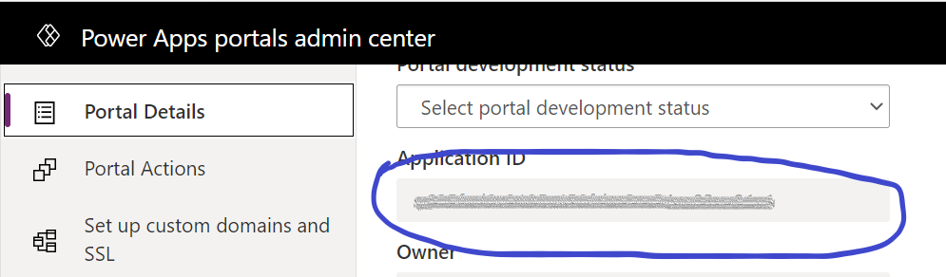

1. Select the member from the search result, and then choose **Select**.

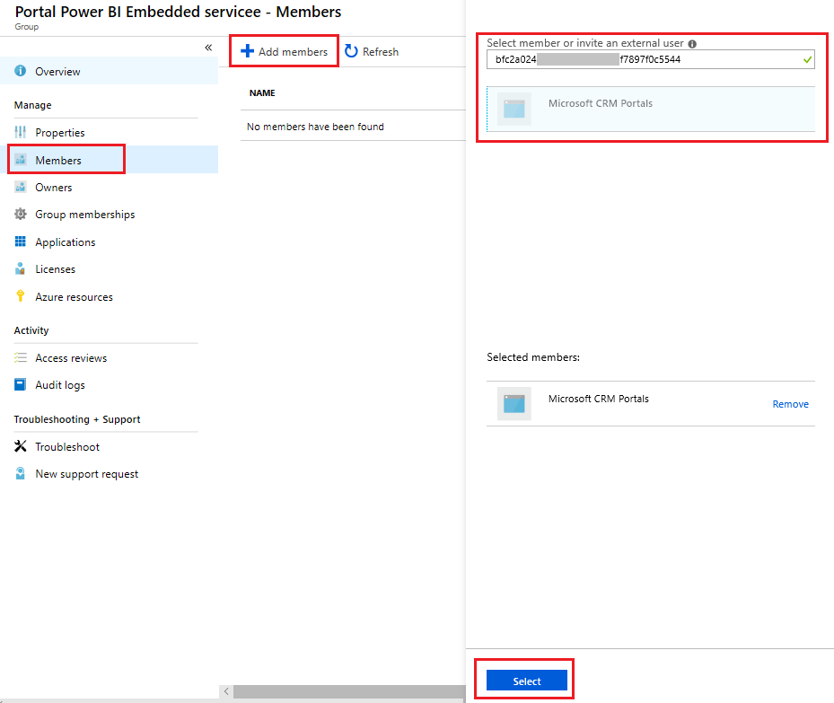

### **Step 3: Power BI setup**

1. Sign in to [Power BI](https://powerbi.microsoft.com/) using a Global administrator account for the directory.
2. Click on PowerBI Service option in top navigation.
3. Select **Settings** in the top right of the Power BI service, and choose **Admin portal**.

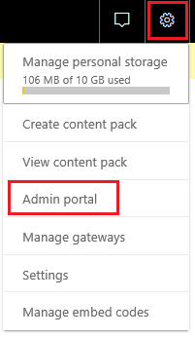

1. Select **Tenant settings**.
2. Under the **Developer settings** section, select **Allow service principals to use Power BI APIs**.
3. In the **Specific security groups** field, search for the **Portal Power BI Embedded service** group, and select it.

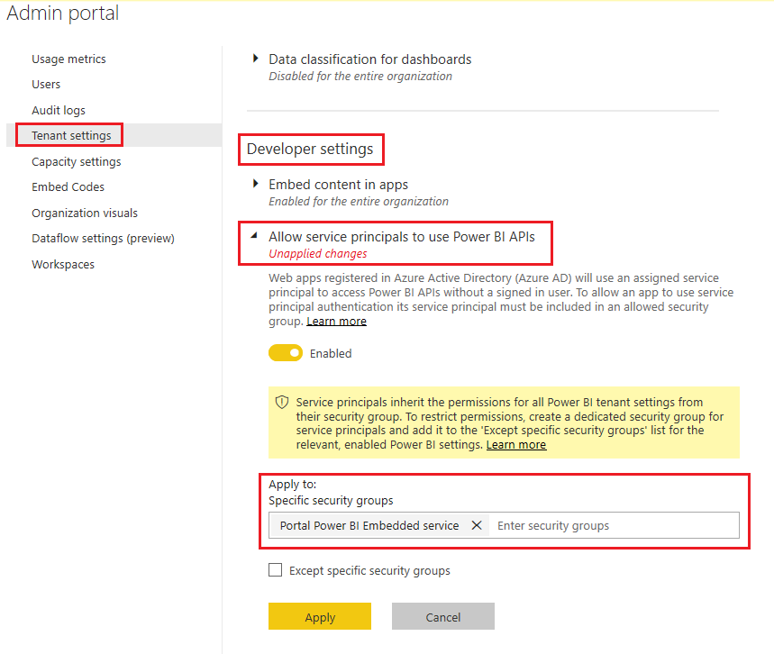

1. Select **Apply**.

# **Copy Report URL**

## Get the path of a dashboard or report

* + 1. Sign in to [Power BI](https://powerbi.microsoft.com/).
    2. Open the dashboard or report you want to embed in your portal.
    3. Copy URL from the address bar.

# **Environment Variables changes in CRM**:

## Open browser and login to <https://make.powerapps.com/> .

Select the CRM Instance in which Power BI dashboards are required to be available.

Go to “Solutions”.

## Update PowerBI Report URL in environment variable.

Click on link ”See environment variable” in the notification. Provide Power BI report url and click on Save and Close

# **Power BI Report data refresh On-demand and Scheduled.**

## Open browser and login to <https://app.powerbi.com/> .

Go to Workspaces and Open the **Workspace** where Report is Published.

Go to “**Dataset + Dataflows**”.

A Dataset with name “K12-Learning Standards” will be available.

## On-demand data refresh

To refresh immediately, Click on “Refresh now” Icon as shown below:

:

## Scheduled data refresh

To schedule the data refresh, click on “Schedule refresh” Icon as shown below.

In “Scheduled refresh” section, frequency can be set for data refresh.

For more information on scheduling data refresh, refer [Data refresh in Power BI - Power BI | Microsoft Docs](https://docs.microsoft.com/en-us/power-bi/connect-data/refresh-data)

