Reference architecture for knowledge management with Power Apps and Copilot Studio agents
This article describes a generalized reference architecture for enterprise knowledge management using Power Apps, Dataverse, and Copilot Studio agents. The architecture helps organizations consolidate scattered knowledge sources, establish consistent governance and visibility across business units, and provide conversational access to approved knowledge with feedback-driven continuous improvement.
This reference architecture is designed to be reusable across industries and can be extended with scenario-specific solution ideas (for example, regulated industries, customer support, internal IT helpdesk, or field service enablement).

Architecture
This architecture organizes knowledge management into four logical layers:
- Experience layer for end users and authors (web app and Teams).
- Knowledge management layer for authoring, curation, approvals, and taxonomy control.
- Knowledge data layer for ingestion, canonical storage, and indexing.
- Operations layer for orchestration, integration, monitoring, and analytics.
At the center of the architecture, Dataverse stores the canonical knowledge record (metadata, tags, governance state, ownership, and feedback). Source content such as documents, internal pages, and PDFs remains in the underlying repositories, while ingestion and indexing services prepare that content for permission-aware retrieval by Copilot Studio agents.
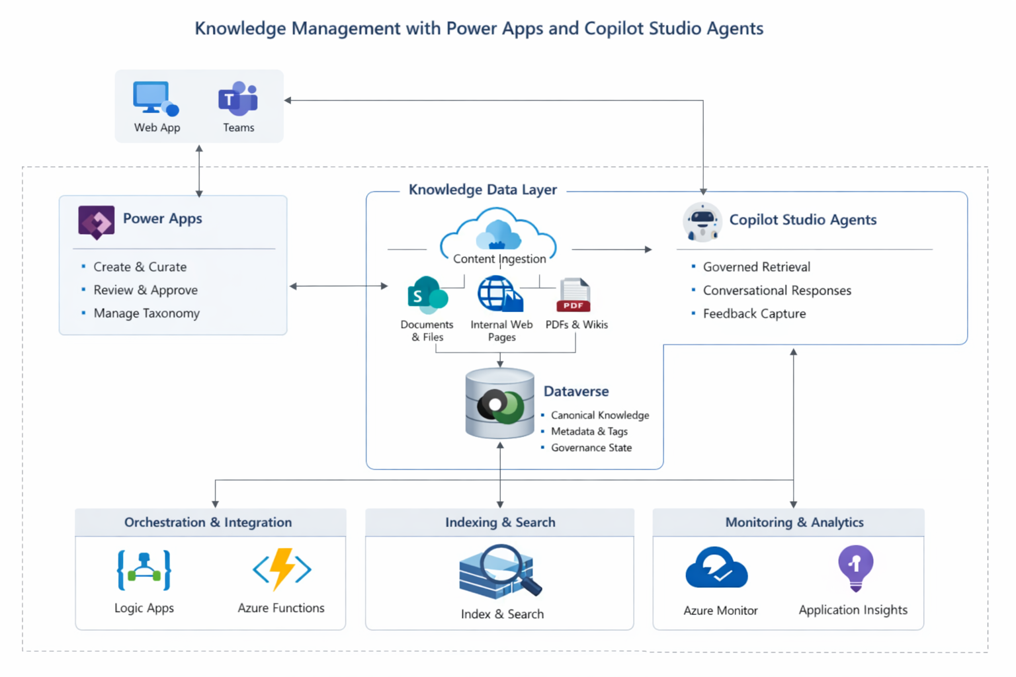
Dataflow
- Knowledge authors use a Power Apps knowledge management application to create, curate, and update knowledge content and metadata (category, product, business unit, region, validity, and ownership).
- Knowledge reviewers/approvers validate content for correctness and policy compliance, and the system transitions items through governance states (for example: Draft → Review → Approved → Published → Retired).
- Content ingestion collects knowledge from approved enterprise sources such as documents and files, internal web pages, and PDFs/wikis.
- Ingestion processes normalize and enrich content (format cleanup, metadata extraction, classification tagging), then associates the ingested content to a canonical knowledge record.
- Dataverse stores canonical knowledge metadata (taxonomy, tags, governance state), and references to the original content location.
- Indexing and search services build and maintain a searchable index to support efficient retrieval using metadata filters and governance constraints.
- Copilot Studio agents handle user queries, perform governed retrieval (permission-aware retrieval and approved-content-only filtering), and generate conversational responses grounded in retrieved knowledge.
- End users access the agent through channels such as a web experience or Microsoft Teams, receiving answers with consistent policy alignment and traceability to source knowledge.
- Feedback capture collects user signals (helpfulness, comments, missing content, incorrect answers) and stores them in Dataverse to drive knowledge improvement and lifecycle actions.
- Monitoring and analytics track ingestion health, indexing latency, retrieval performance, and agent usage/quality signals to support operations and continuous improvement.
This “ingestion → canonical store → indexed retrieval → agent response → feedback loop” is the core operating model for enterprise knowledge at scale.

Components
The following components appear in this architecture and explain why each is included:
- Power Apps (Knowledge Management application)
Provides authoring, curation, review/approval workflows, and taxonomy management for enterprise knowledge governance.
- Microsoft Dataverse (Canonical knowledge store)
Stores authoritative knowledge metadata, governance state, ownership, classification tags, and feedback signals to ensure consistency and auditability.
- Copilot Studio agents
Provide conversational access to enterprise knowledge with governed retrieval and feedback capture, enabling consistent responses across channels.
- Enterprise content sources (for example, documents, internal web pages, PDFs/wikis)
Represent the knowledge sources that must be consolidated and governed. These sources remain the system-of-record for raw content, while Dataverse maintains the canonical record and governance signals.
- Content ingestion capability
Collects, normalizes, and enriches content from multiple sources. Ingestion can be implemented using enterprise integration tools aligned to organizational standards.
- Indexing and search
Enables fast and relevant retrieval at scale. Retrieval should support metadata filters, freshness, and permission trimming to ensure users only receive content they are authorized to access.
- Orchestration & integration (Logic Apps / Azure Functions)
Executes ingestion pipelines, transformations, scheduled refresh, event-driven updates, notifications, and integration with additional systems where required.
- Monitoring & analytics (Azure Monitor / Application Insights)
Provides observability across ingestion jobs, indexing pipelines, agent runtime performance, and usage/quality metrics for operational excellence.

Alternatives
This section describes alternatives that organizations commonly evaluate for enterprise knowledge, and why they might be chosen depending on strategy and constraints.
- Data lake or analytics-first knowledge agent (for example, Databricks-based)
Useful when knowledge must be derived from large-scale data pipelines and analytics processing. This approach can be more complex for near-real-time publishing workflows and governance across multiple business units.
- Central AI platform approach (for example, Azure AI platform services)
Useful when an enterprise has a centralized AI platform strategy for multiple agent workloads and requires standardized controls across AI solutions. Ensure governance, permission trimming, and authoritative grounding are enforced consistently.
- Business-unit-specific knowledge tools
Can reduce organizational change initially, but typically increases long-term cost and fragmentation through duplicate tooling, inconsistent processes, and divergent standards across business units—often reintroducing the same problem the architecture is intended to solve.
A common decision point is whether the organization optimizes for central governance and reuse (recommended for scale) versus local autonomy (often higher long-term operational cost).

Scenario details
Organizations frequently face knowledge challenges such as:
- Knowledge scattered across business units and tools (documents, wikis, internal pages, PDFs).
- Lack of visibility into ownership, validity, freshness, and approval status.
- Duplicate or conflicting guidance across teams, leading to inconsistent answers.
- Higher support cost because users repeatedly ask the same questions and resolution depends on individual expertise.
- Difficulty governing “what is approved” and measuring knowledge effectiveness over time.
This scenario implements a governed knowledge platform that:
- Introduces a structured lifecycle (draft, review, publish, retire).
- Centralizes canonical knowledge metadata and classification in Dataverse.
- Enables conversational discovery through Copilot Studio agents with controlled retrieval.
- Captures feedback and usage analytics to continuously improve knowledge quality and reduce repeated support interactions.
Potential use cases
This reference architecture is applicable to many industries and internal functions, including:
- Healthcare: policies and procedures, operational guidance, member/provider service knowledge.
- Finance: servicing scripts, compliance guidance, regulated process knowledge.
- Manufacturing: troubleshooting guides, safety SOPs, maintenance playbooks.
- Telecommunications: support scripts, troubleshooting flows, retention playbooks.
- Government: citizen services knowledge, internal operations guidance.
- IT and shared services: helpdesk knowledge, onboarding, runbooks, standard operating procedures.

Considerations
These considerations help implement a solution that includes Dynamics 365. Learn more at Dynamics 365 guidance documentation.
Reliability
Reliability ensures your application can meet the commitments you make to your customers.
Knowledge systems require reliability across three operational motions: publishing, retrieval, and ingestion/index maintenance. A key principle is that ingestion failures should not prevent end users from receiving answers from the last approved knowledge set.
Reliability recommendations
- Decouple ingestion from end-user retrieval
Run ingestion and indexing asynchronously (scheduled or event-driven). Continue serving the last known good published index if ingestion fails.
- Use versioned publishing with rollback
Maintain explicit knowledge versions and published snapshots so critical categories can roll back quickly in case of incorrect guidance.
- Implement idempotent ingestion and change detection
Use stable source identifiers and content hashes to avoid duplicates and safely reprocess failed batches.
- Design for graceful degradation
If indexing services are degraded, provide a controlled fallback: curated “top articles,” FAQs, or guided navigation instead of returning ungrounded answers.
- Operational alerting for freshness and ingestion health
Alert on ingestion failures, indexing delays, and “freshness breaches” for critical categories (for example, policies exceeding a review window).
Reliability measures to track
- Ingestion success rate and time-to-recover (MTTR)
- Index freshness (time since last successful publish for high-priority categories)
- Retrieval latency (p50 / p95)
- Agent availability by channel and error rate
- User feedback trends indicating content gaps or declining answer quality

Security
Security provides assurances against deliberate attacks and the abuse of your valuable data and systems.
Knowledge platforms often contain sensitive internal guidance. Security should focus on preventing accidental exposure and ensuring retrieval respects permissions.
Security recommendations
- Least privilege and separation of duties
Define distinct roles: author, reviewer, publisher, and administrator. Restrict publishing to approved roles and require approval workflows for sensitive categories.
- Permission-aware retrieval (permission trimming)
Retrieval must only return knowledge items that the signed-in user is authorized to access. This is critical when a single agent serves multiple business units or restricted topics.
- Data classification and governance controls
Tag knowledge by confidentiality (public/internal/restricted). Enforce stricter approvals, visibility rules, and auditing for restricted categories.
- Align to Azure Security Baselines
Apply baseline guidance for services used in orchestration, storage, indexing, and monitoring to standardize secure configurations.

Cost optimization (Required)
Cost optimization is about looking at ways to reduce unnecessary expenses and improve operational efficiencies.
Knowledge systems can grow quickly in content volume and query usage. Cost is typically driven by storage, ingestion and indexing compute, monitoring retention, and agent runtime usage.
Primary cost drivers
- Content storage (documents and large files)
- Indexing/search footprint and query volumes
- Ingestion frequency and transformation complexity
- Monitoring ingestion and retention settings
- Agent usage volumes (queries, concurrency, channel adoption)
Cost optimization strategies
- Store large content in repositories, not in Dataverse
Keep large documents and binaries in SharePoint or the enterprise repository. Store canonical metadata, classification, governance, and pointers in Dataverse.
- Optimize ingestion frequency using change detection
Refresh high-change sources more often and stable sources less often. Avoid full re-indexing if only a small subset changed.
- Apply lifecycle controls to reduce index size
Retire, archive, or deprecate stale content so it does not remain in the active index indefinitely.
- Control telemetry and retention
Collect logs needed for operations and compliance, but set retention based on policy and operational need to avoid unnecessary ingestion costs.
- Start with high-value domains
Prioritize scenarios such as helpdesk deflection, SOP retrieval, and policy guidance before broadening to all knowledge domains.

Operational excellence
Operational excellence covers the operations processes that deploy an application and keep it running in production.
Operational excellence recommendations
- Implement ALM and environment segregation for Power Apps, Dataverse, and agent configuration (DEV/TEST/PROD).
- Establish runbooks for ingestion failures, indexing delays, and permission-trimming issues.
- Introduce review cadences (monthly/quarterly) by category and ownership to maintain freshness.
- Use controlled release rings for taxonomy changes, prompt updates, and agent routing changes.

Performance efficiency
Performance efficiency is the ability of your workload to scale to meet demand efficiently.
Performance recommendations
- Use metadata-rich indexing and smaller “knowledge chunks” to improve retrieval precision and reduce compute.
- Cache frequently accessed policies and standard SOPs (where supported by the indexing layer).
- Restrict retrieval scope by taxonomy, business unit, classification, and recency for relevance and speed.
- Measure and tune retrieval p95 latency and “no answer found” rate to detect relevance issues early.

Deploy this scenario
A recommended deployment approach:
- Define governance: taxonomy, classification levels, approval workflow, and role definitions (author/reviewer/publisher/admin).
- Build the Knowledge Management Power App: authoring, review/approve, publishing controls, and admin functions.
- Implement the Dataverse schema: canonical knowledge item, metadata/tags, governance state, feedback, and auditing.
- Configure ingestion: connect approved repositories, normalize content, enrich metadata, and schedule refresh based on change frequency.
- Implement indexing and retrieval: ensure permission trimming, metadata filters, and governance-state filtering (published-only).
- Configure Copilot Studio agents: connect to governed retrieval, define fallback behaviors, and enable feedback capture.
- Operationalize monitoring: dashboards and alerts for ingestion health, retrieval performance, channel availability, and freshness metrics.
- Roll out in phases: start with 1–2 knowledge domains, validate value and control, then expand to additional categories and business units.

Contributors
This article is maintained by Microsoft. It was originally written by the following contributors.
Principal authors:
- Rahul Dubey — Business Process Architecture Manager

