RowsetImportEngine
Design Spec

Contents
Overview 2
Related Documents 3
Terminology 3
Design Requirements 3
Design Details 4
Class Hierarchy 4
Class Definitions 5
Overview of Class Relationships 5
Bulk Insert 6
Reading Rowset Definitions 6
Exception Handling 6
Thread safety 7
Tokens 7
Document Revision History 8

Overview
PSS and customers both rely heavily on .SQL scripts to capture diagnostic data about performance and other types of SQL Server problems. RowsetImportEngine is intended to make it easy to import .SQL script output into a SQL database for simplified analysis. See RowsetImportFuncSpec.doc for a more complete description.

Related Documents
RowsetImportDesignSpec.doc | RowsetImportEngine design spec
RowsetImportFuncSpec.doc | RowsetImportEngine functional spec

Terminology
Rowset: The output of a single SELECT or similar command (e.g. DBCC) in a .SQL script
Rowset Header: The column names, the lines (“-----“) below the column names in a rowset, plus the single line preceding the column names
Rowset Identifier: A string that uniquely identifies a particular rowset. Must be part of the rowset header.
Rowset Definition File: Schema details for the rowsets that RowsetImportEngine can import are described in an XML file named TextRowsets.XML, referred to as the Rowset Definition File

Design Requirements

- Thread-safe: A single process must be able to create multiple TextRowsetImporters and import multiple files in parallel
- Bulk insert library must be reasonably isolated from other components to allow it to be replaced (anticipated change if/when a pure managed bulk load API exists).
- Though all input data is text, design must accommodate conversion of text to native SQL data types (int, bigint, varbinary, etc).
- Because script output captured in SQL engine failure situations may contain unexpected formatting (e.g. truncated rows, text error messages appearing where a datetime or other non-text column value is expected, etc), the design must be able to tolerate a small (& configurable) number of row insertion errors. These failures should be clearly logged and communicated to the user, but a failure to insert a single row should not abort the entire load.
- Must be possible for host to abort an in-progress load by calling a Cancel() method. Responding to this with full cancel and cleanup should not take more than 5 seconds.
- The default TextRowset class should be able to import any rowset that complies with the following rules:
  - Rowset has a column header that consists of column names on one line, column lines (“-------“) on the following line, and an optional rowset identifier on the line preceding the column names.
  - Each row is terminated by a CR/LF
  - The end of a rowset is indicated by an empty line
  - All columns are named
- It must be easy to extend the architecture to support odd rowsets that do not comply with one or more of these rules
- Must be easy to extend architecture to support new SQL data types as they are added in future releases (XML and varchar(max) column datatypes planned for Yukon, for example)

Design Details

Class Hierarchy
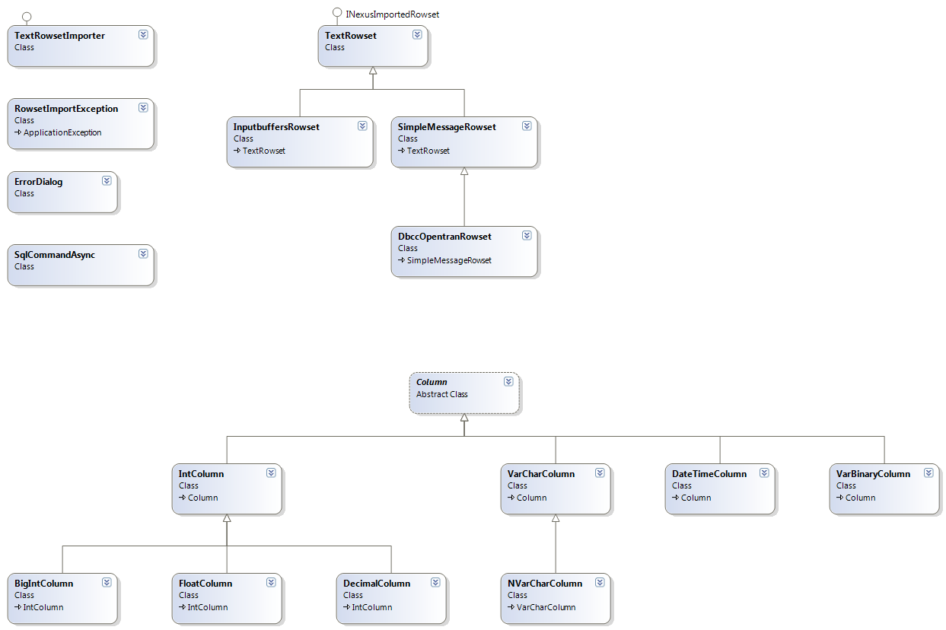

Class Definitions

public class TextRowsetImporter : INexusFileImporter
{
public void Initialize(string Filemask, string connString, string Server, bool UseWindowsAuth, string SQLLogin, string SQLPassword, string DatabaseName, ILogger Logger);
public bool DoImport();
public void Cancel();
}

public class TextRowset : NexusInterfaces.INexusImportedRowset
{
public System.Collections.ArrayList Columns;
public virtual string Name { get; set; }
public virtual bool IsEndOfRow(string RowText);
public virtual bool IsEndOfRowset(string RowText, string PrevLine);
public long RowsInserted { get; set; }
public virtual void DefineRowsetColumns (string HeaderLines, string ColumnNames);
public virtual void ParseRow(string RowText);
public virtual bool CheckForRowsetStart (string ColumnLines, string ColumnNames, string RowsetIdentifier);
}

public class InputbuffersRowset : TextRowset
{
public override bool IsEndOfRow(string RowText);
public override bool IsEndOfRowset (string RowText, string PrevLine);
public override bool CheckForRowsetStart (string ColumnLines, string ColumnNames, string RowsetIdentifier);
}

public class SimpleMessageRowset : TextRowset
{
public override bool IsEndOfRow(string RowText);
public override bool IsEndOfRowset (string RowText, string PrevLine);
public override void DefineRowsetColumns (string HeaderLines, string ColumnNames);
public override void ParseRow (string RowText);
public override bool CheckForRowsetStart (string ColumnLines, string ColumnNames, string RowsetIdentifier);
}

public abstract class Column
{
public string Name;
public int Length;
public int SqlColumnLength;
public abstract SqlDbType DataType { get; }
public virtual object Data { get; set; }
public virtual object ValidateData(object columndata);
public override string ToString();
public static implicit operator string (Column c);
public Column(string Name, int Length, int SqlColumnLength, bool RowsetLevel);
}

public class IntColumn : Column
{
public override SqlDbType DataType;
public override object Data { set; }
public override object ValidateData(object columndata);
}

public class FloatColumn : IntColumn
{
public override SqlDbType DataType;
public override object Data { set; }
public override object ValidateData(object columndata);
}

Overview of Class Relationships

The top-level class that the external host instantiates is TextRowsetImporter. TextRowsetImporter contains a KnownRowsets collection, which has one member TextRowset for each rowset that the engine recognizes and can import.

The KnownRowsets collection is populated from the Rowset Definition File (“TextRowsets.xml”) when TextRowsetImporter is initialized. When TextRowsetImporter encounters a set of lines in the input file that fits the general form of a rowset header, it calls CheckForRowsetStart() on each member of the KnownRowsets collection, giving each rowset an opportunity to “claim” the rowset. If a rowset recognizes the rowset, subsequent rows are passed to the rowset to parse and insert (TextRowset.ParseRow()) until the end of rowset is reached (TextRowset.IsEndOfRowset() returns true).

Each TextRowset in this collection has a Columns collection (ArrayList). Each member of the Columns collection describes the metadata for one column in that rowset. All column classes derive from abstract class Column, and include the logic that is needed to convert a text representation of the specified SQL datatype to a proper binary representation of the same value. For example, the FloatColumn.ValidateData() method contains logic to convert the string “1.2345E+3” into the numeric value 1234.5. Variable length types (e.g. VarCharColumn, VarBinaryColumn) also store the length of the column, which is typically auto-discovered from column headers in the input file but can be overridden in the Rowset Definition File.

Rowsets that violate one or more of the rules assumed by TextRowset are handled by inheriting from this class and overriding methods to implement the necessary custom parsing logic. For example, InputbufferRowset is a special kind of rowset that descends from TextRowset to handle DBCC INPUTBUFFER output, which violates TextRowset’s assumptions #2 and #3. To handle this usual rowset, InputbufferRowset uses a different end-of-row marker (“DBCC execution completed”), and also makes an assumption that the rowset consists of one and only one row (always true of DBCC INPUTBUFFER).

Bulk Insert
There is no managed bulk load interface for SQL Server. Non-bulk inserts were prototyped, but were not fast enough to meet the design goals for speed. To work around this limitation, RowsetImportEngine uses a C++ wrapper around the ODBC BCP API (a call-level interface). A BulkLoad class provides the managed interface to this library, and p/Invokes into the C++ library as necessary. The design of bulkload.dll is out of scope for this document.

(Update Nov 2006: There is a new SqlBulkLoad class in Whidbey that provides a way to do minimally-logged loads in managed code, but RowsetImportEngine was written before Whidbey. For the sake of simplicity, a future version of RowsetImportEngine should remove the p/Invoked custom BulkLoad library and replace with the new SqlBulkLoad class. This will require a non-trivial change; SqlBulkLoad usage is very different from the way the ODBC BCP API is used.)

Reading Rowset Definitions
TextRowsetImporter reads the Rowset Definition File once at construction. Reflection is used to match the rowset and column types specified in the XML file (e.g. “RowsetImportEngine.VarCharColumn”) to one of the known Column or TextRowset descendants. An invalid column or rowset type will cause a RowsetImportException to be thrown to the RowsetImportEngine host.

Exception Handling
Exception handlers instantiate an ErrorDialog and invoke Handle() on this object. The ErrorDialog ctor takes parameters specifying whether the error is ignorable. If it is ignorable, control returns to the catch block and processing resumes (typically with the next row in the input file). If the exception is not ignorable or if the user declines to attempt to continue, Handle() will rethrow a RowsetImportException w/original exception set to InnerException. ErrorDialog.Handle() will ensure that the same exception does not result in two error dialogs being raised to the user (tracked via a public member of RowsetImportException).

Thread safety
No static members are used, and no resources are shared across TextRowsetImporter instances. It is possible to import different files in parallel by instantiating a TextRowsetImporter instance for each input file. However, it is not a design goal to allow a single file to be imported using multiple threads; within a TextRowsetImport instance, all work is done on a single thread.

Tokens
Any column value can be used to set the value of a token, and “implied” columns can be added to any rowset that take on the current value of a token. For more information about use of tokens, see the functional spec doc. Tokens are stored in a private member of TextRowsetImporter. They are shared across rowsets in the same file, but not across TextRowsetImporter instances.

Document Revision History
- 7 May 2004 – Initial version (bartd)
- 18 Sept 2005 – Added information about new custom token handling feature (bartd)
- 12 Nov 2006 – Clean up, updated class diagram, other edits following SQL Nexus v2 integration (bartd)

