To import the solution ”Bookings” you need to add yourself as an administrator to the Contoso(default) environment  
  
Go to aka.ms/ppac  
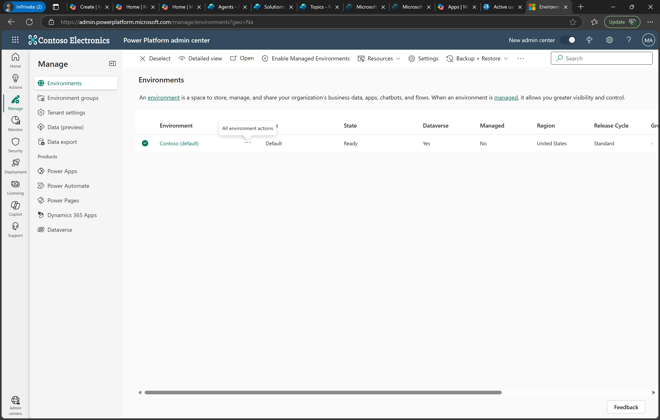

Click ellipsis [three dots] next to **Contoso(default)** and select membership

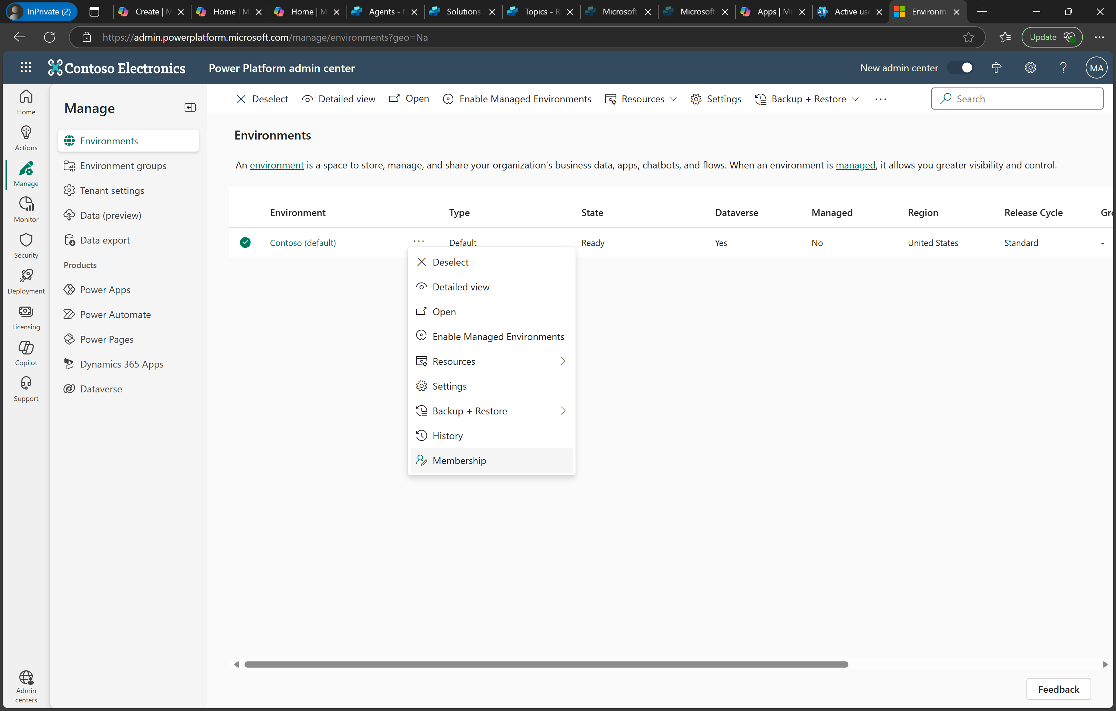

Click add me  
