Azure Governance-Management Groups
Introduction
Azure Governance is a collection of concepts and services that are designed to enable management of your various Azure resources at scale. These services provide the ability to organize and structure your subscriptions in a logical way, create and deploy re-usable and Azure native packages of resources, to define, audit and remediate your resources, and more.
Objectives
- Build a governance strategy from the scratch using Management Groups, Azure Policy, and Blueprints
- Group and organize your subscriptions in a logical hierarchy that support the deployment of other Governance services in a structured way
- Monitor and review all resources deployed through Resource Graph
Create an organization structure with Management Groups
Scenario
The very first step in implementing a governance strategy in Azure is to create a logical hierarchy in Management Groups
- Sign in to the Azure Portal using your Azure account
- Launch the Management Groups service in Azure portal by clicking All services, then searching for and selecting Management Groups.
- Click Add Management Group to create the following structure:
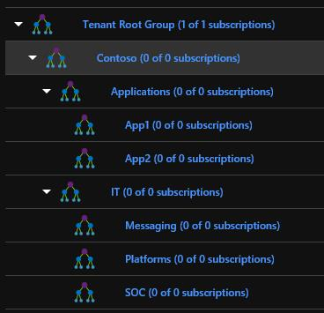
- After the management groups are created, you need to assign subscription to the management group.
Navigate to the Tenant Root Group, click the elipsis next to your subscription, select Move
Select Contoso and Save it.
Each management group can be assigned to a different subscription. However, for this lab we will have only 1 subscription assigned to the root management group.
