Exercise 3: Azure Blueprints
Scenario
Learning how to create and assign blueprints enables the definition of common patterns to develop reusable and rapidly deployable configurations based on Resource Manager templates, policy, security, and more. In this tutorial, you learn to use Azure Blueprints to do some of the common tasks related to creating, publishing, and assigning a blueprint within your organization, such as:
  - Create a new blueprint and add various supported artifacts
  - Make changes to an existing blueprint still in Draft
  - Mark a blueprint as ready to assign with Published
  - Assign a blueprint to an existing subscription
  - Check the status and progress of an assigned blueprint
  - Remove a blueprint that has been assigned to a subscription
Create a blueprint
The first step in defining a standard pattern for compliance is to compose a blueprint from the available resources. In this example, create a new blueprint named 'Contoso-IT' to configure role and policy assignments for the subscription, add a new resource group, and create a Resource Manager template and role assignment on the new resource group.
  - Click on All services and searching for and selecting Policy in the left pane. On the Policy page, click on Blueprints.
  - Select Blueprint Definitions from the page on the left and click the + Create Blueprint button at the top of the page.
  - Alternately, click on Create from the Getting started page to go straight to creating a blueprint.
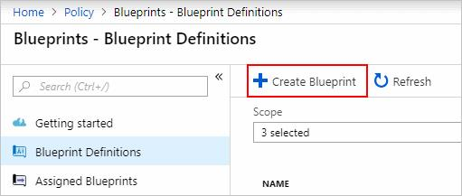
  - Name the Blueprint Contoso, but leave Blueprint Description blank for now. In the Definition Location box, click the ellipsis on the right, select the management group Contoso and click Select.
Blueprint definitions can only be saved to management groups.
  - Verify the information is correct (the Blueprint Name and Definition Location fields can't be changed later) and click Next : Artifacts at the bottom of the page or the Artifacts tab at the top of the page.
  - Add role assignment at subscription: Left-click on the + Add artifact… row under Subscription and the 'Add artifact' window opens on the right side of the browser. Select 'Role Assignment' for Artifact type. Under Role, select 'Contributor' and leave the Add User, App or Group field with the checkbox indicating a dynamic parameter. Click Add to add this artifact to the blueprint.
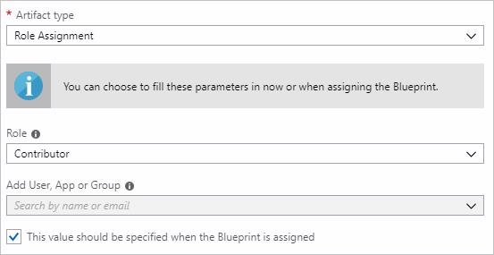
  - Add policy assignment at subscription: Left-click on the + Add artifact… row directly under the Subscription. Select 'Policy Assignment' for Artifact type. Change Type to 'Built-in' and in Search enter 'tag'. Click out of Search for the filtering to occur. Select 'Apply tag and its default value to resource groups' by clicking on it. Click Add to add this artifact to the blueprint.
  - Click on the row of policy assignment 'Apply tag and its default value to resource groups'. The window to provide parameters to the artifact as part of the blueprint definition opens and allows setting the parameters for all assignments (static parameters) based on this blueprint instead of during assignment (dynamic parameters). This example uses dynamic parameters during blueprint assignment, so leave the defaults and click Cancel.
  - Add resource group at subscription: Left-click on the + Add artifact… row under Subscription. Select 'Resource Group' for Artifact type. Leave the Resource Group Name and Location fields blank, but make sure that the checkbox is checked on each property to make them dynamic parameters. Click Add to add this artifact to the blueprint.
  - Add template under resource group: Left-click on the + Add artifact.. row directly under the ResourceGroup entry. Select 'Azure Resource Manager template' for Artifact type, set Artifact display name to 'StorageAccount', and leave Description blank.
  - On the Template tab in the editor box, paste the following Resource Manager template.
{
"$schema": "https://schema.management.azure.com/schemas/2015-01-01/deploymentTemplate.json#",
"contentVersion": "1.0.0.0",
"parameters": {
"storageAccountType": {
"type": "string",
"defaultValue": "Standard_LRS",
"allowedValues": [
"Standard_LRS",
"Standard_GRS",
"Standard_ZRS",
"Premium_LRS"
],
"metadata": {
"description": "Storage Account type"
}
}
},
"variables": {
"storageAccountName": "[concat(uniquestring(resourceGroup().id), 'standardsa')]"
},
"resources": [{
"type": "Microsoft.Storage/storageAccounts",
"name": "[variables('storageAccountName')]",
"apiVersion": "2016-01-01",
"location": "[resourceGroup().location]",
"sku": {
"name": "[parameters('storageAccountType')]"
},
"kind": "Storage",
"properties": {}
}],
"outputs": {
"storageAccountName": {
"type": "string",
"value": "[variables('storageAccountName')]"
}
}
}
  - After pasting the template, click on the Parameters tab and note that the template parameter storageAccountType and default value Standard_LRS was automatically detected and populated, but configured as a dynamic parameter.
  - Remove the check from the checkbox and note that the drop-down only contains values included in the Resource Manager template under allowedValues.
  - Check the box to set it back to a dynamic parameter. Click Add to add this artifact to the blueprint.
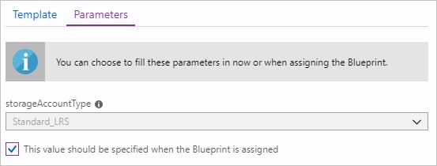
  - Your completed blueprint should look similar to the following. Notice that each artifact has 'x out of y parameters populated' under the Parameters column. The dynamic parameters are set during each assignment of the blueprint.
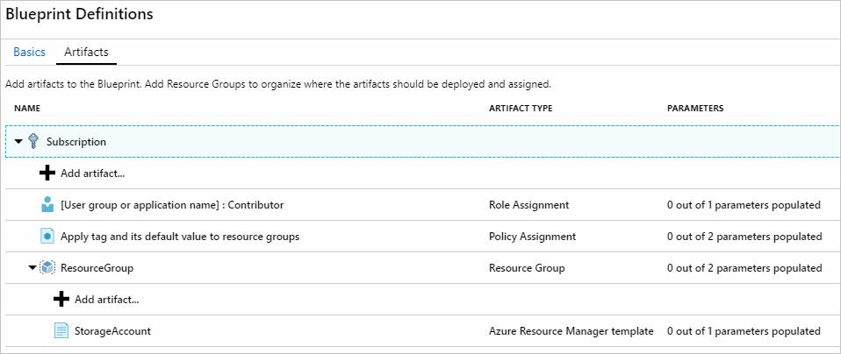
  - Now that all planned artifacts have been added, click Save Draft at the bottom of the page.
Edit a blueprint
In the previous Blueprint, a Description wasn't provided nor the role assignment added to the new resource group. Both can be fixed by following these steps:
  - Select Blueprint Definitions from the page on the left.
  - In the list of blueprints, right-click on the one you previously created and select Edit Blueprint.
  - In the Blueprint Description, provide some information about the blueprint and the artifacts that compose it. In this case, enter something like: "This blueprint sets tag policy and role assignment on the subscription, creates a ResourceGroup, and deploys a resource template and role assignment to that ResourceGroup."
  - Click Next : Artifacts at the bottom of the page or the Artifacts tab at the top of the page.
  - Add role assignment under resource group: Left-click on the + Add artifact… row directly under the ResourceGroup entry. Select 'Role Assignment' for Artifact type. Under Role, select 'Owner' and remove the check for the Add User, App or Group field and search for and select a user, app, or group to add. This artifact uses a static parameter set the same in every assignment of this blueprint. Click Add to add this artifact to the blueprint.
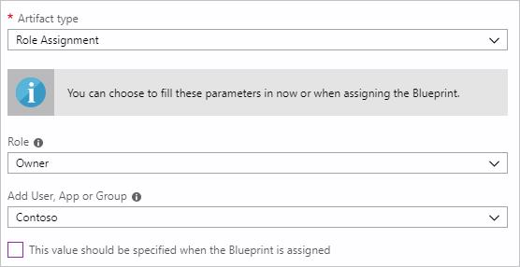
  - Your completed blueprint should look similar to the following. Notice that the newly added role assignment shows 1 out of 1 parameters populated meaning that it's a static parameter.
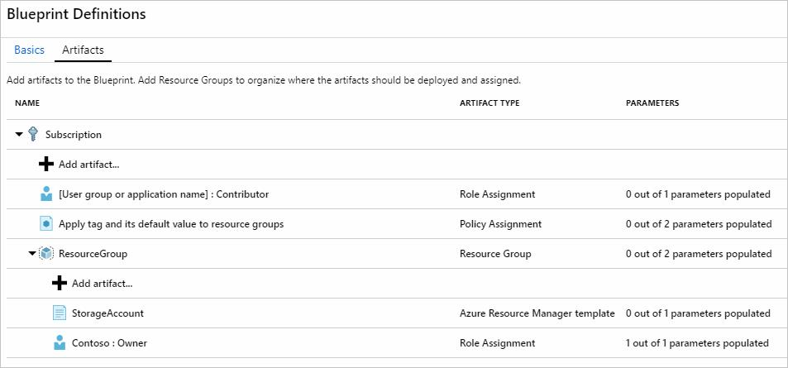
  - Click Save Draft now that it has been updated.
Publish a blueprint
Now that all the planned artifacts have been added to the blueprint, it's time to publish it. Publishing makes it available to be assigned to a subscription.
  - Select Blueprint Definitions from the page on the left.
  - In the list of blueprints, right-click on the one you previously created and select Publish Blueprint.
  - On the dialog that opens, provide a Version (letters, numbers, and hyphens with a max length of 20 characters) such as 'v1' and Change notes (optional) such as 'First publish'.
  - Click** Publish** at the bottom of the page.
Assign a blueprint
Once a blueprint has been published, it can be assigned to a subscription. Assign the blueprint you created to one of the subscriptions in your management group hierarchy.
  - Select Blueprint Definitions from the page on the left.
  - In the list of blueprints, right-click on the one you previously created (or left-click on the ellipsis) and select Assign Blueprint.
  - On the Assign Blueprint page, select the subscription(s) you want to deploy this blueprint to from the Subscription drop-down.
Note: An assignment is created for each subscription that is selected allowing changes to a single subscription assignment at a later time without forcing changes on the remainder of the selected subscriptions.
  - For Assigned Name, provide a unique name for this assignment.
  - In Location, select a region for the managed identity to be created in. Azure Blueprint uses this managed identity to deploy all artifacts in the assigned blueprint.
  - Leave the Blueprint definition version drop-down of Published versions on the 'v1' entry (default as the most recently Published version).
  - For Lock Assignment, leave the default of Don't Lock.
  - For the subscription level role assignment [User group or application name] : Contributor, search for and select a user, app, or group.
  - For the subscription level policy assignment, set the Tag Name to 'CostCenter' and the Tag Valueto 'ContosoIT'.
  - For the 'ResourceGroup', provide a Name of 'StorageAccount' and a Location of 'East US 2' from the drop-down.
  - On the Azure Resource Manager template 'StorageAccount', select 'Standard_GRS' for the storageAccountType parameter.
  - Read the information box at the bottom of the page and then click Assign.
Track deployment of a blueprint
When a blueprint has been assigned to one or more subscriptions, two things happen:
  - The blueprint is added to the Assigned Blueprints page per subscription assigned to
  - The process of deploying all the artifacts defined by the blueprint begins
Now that the blueprint has been assigned to a subscription, verify progress of the deployment.
  - Select Assigned Blueprints from the page on the left.
  - In the list of blueprints, right-click on the one you previously assigned and select View Assignment Details.
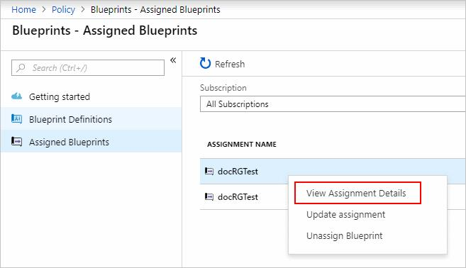
  - On the Deployment Details page, validate that all artifacts have been successfully deployed and that there have been no errors during the deployment. If errors occurred, see troubleshooting blueprintfor steps to determine what went wrong.
Unassign a blueprint
If no longer needed, remove a blueprint assignment from a subscription. The blueprint may have been replaced by a newer blueprint with updated patterns, policies, and designs. When a blueprint is removed, the artifacts assigned as part of that blueprint are left behind.
  - Select Assigned Blueprints from the page on the left.
  - In the list of blueprints, select the blueprint that is to be unassigned and then click the Unassign Blueprint button at the top of the page.
  - Read the confirmation message and then click OK.
Review Understand the life-cycle of an Azure Blueprint as it is an essential aspect of Blueprints.
PreviousNext: Exercise 4: Resource Graph

