Challenge 4: Cost Management

Scenario
Azure makes it easy to build and deploy cloud solutions. However, it's important that those solutions are optimized to minimize cost to an organization. Azure Cost Management gives you the tools to plan for, analyze and reduce wasted spend to maximize cloud investment.

Exercise 1: Azure Cost Management Overview
Click Steps | Screenshots
From the Cost Management overview  - Click on Cost Analysis (Focus on the main chart)  - Click on the Scope pill (top left) and select the Free Trial Subscription under App1  On the 1st pie chart  - Click virtual machines slice in the pie chart  - Click the Group By pill at the top and select MeterSubCategory | 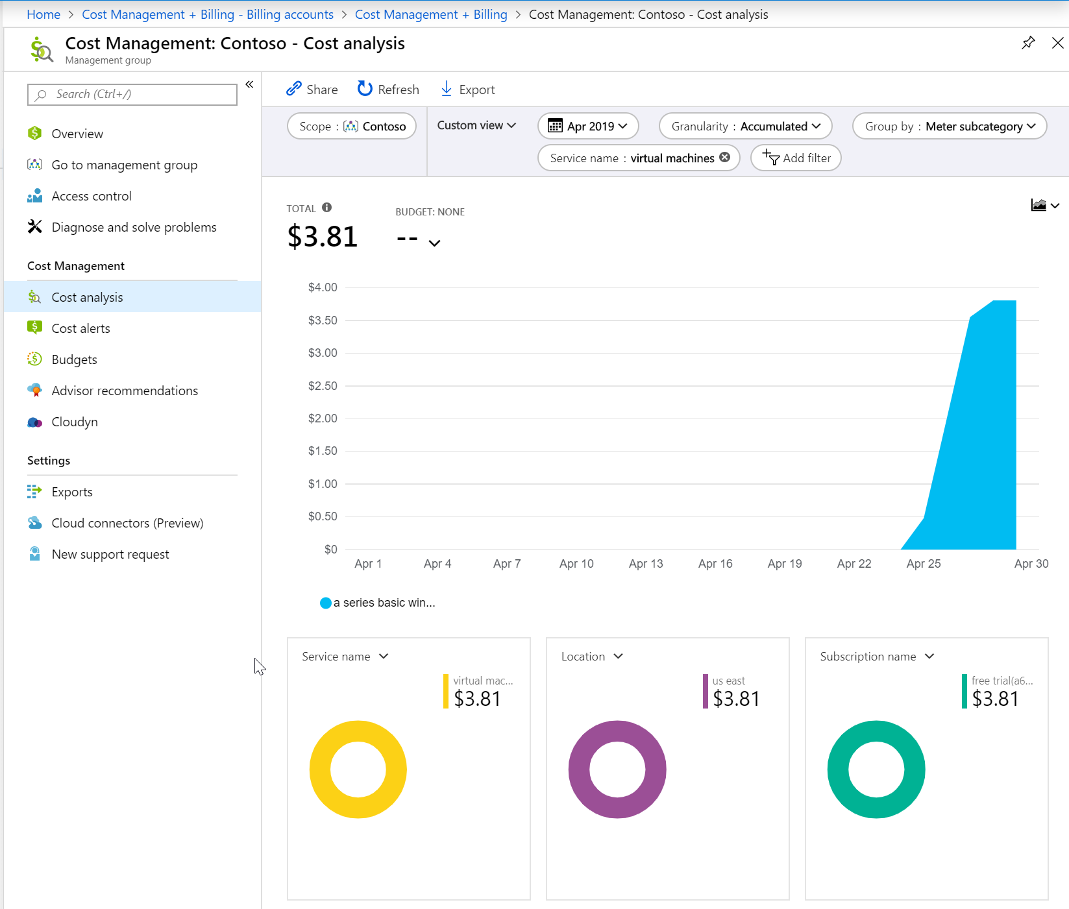
- Click Granularity pill and select Daily  - Click the Group By pill and select Resource Type  - Change the chart to a line graph | 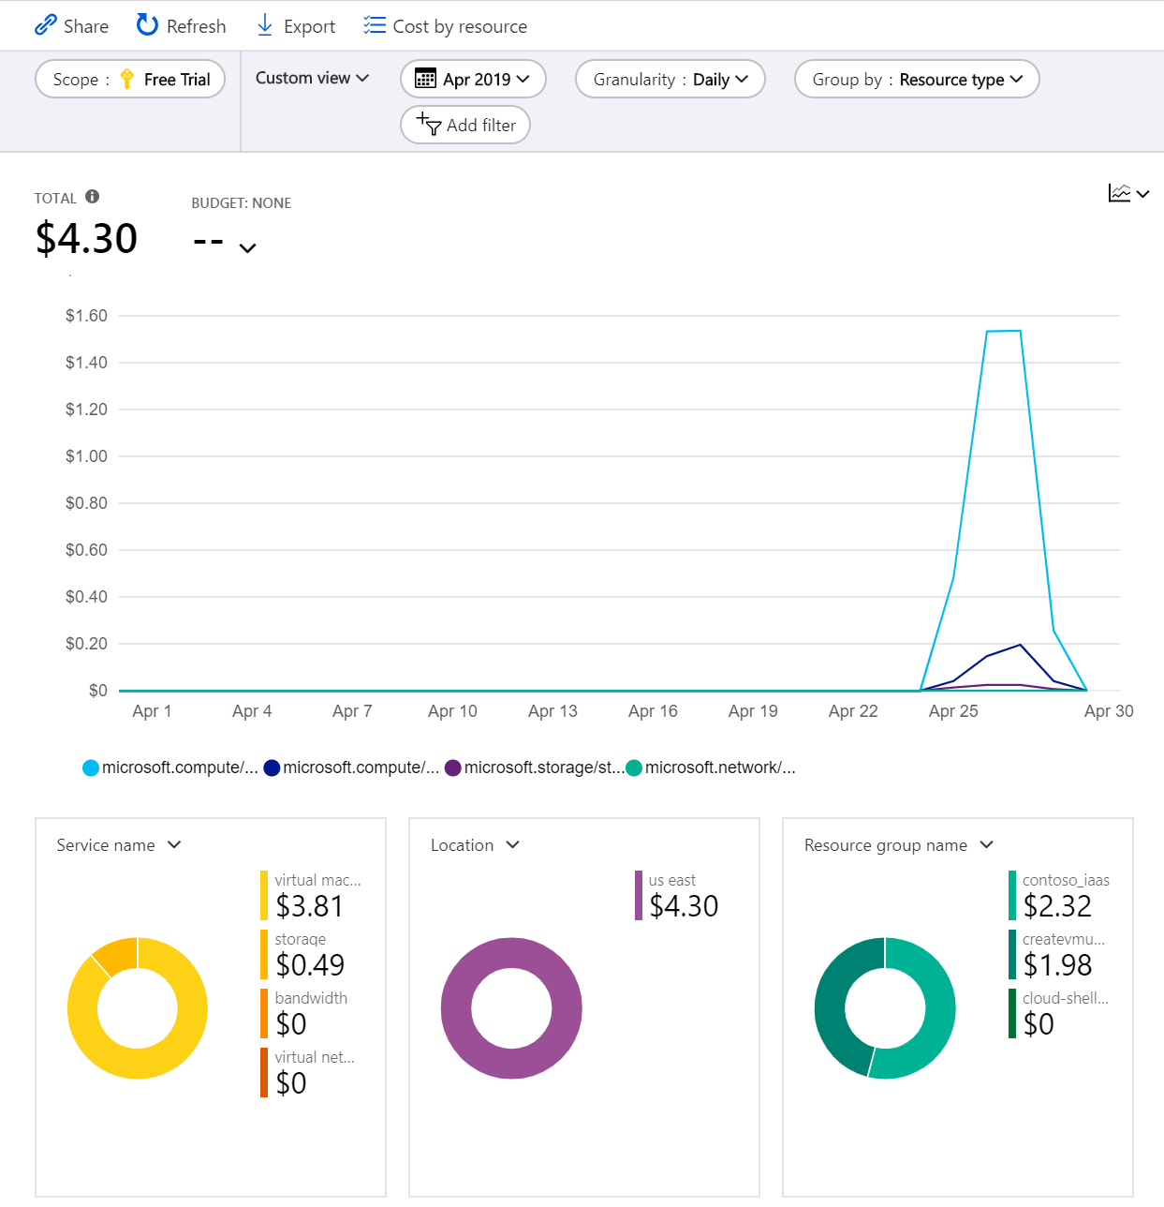
- Click on Cost Management + Billing from the Azure portal menu (on left hand side)  - Click on Cost Management from the menu items  - Click on Budgets  - Click on the Scope pill (top left) and click on Free Trial | 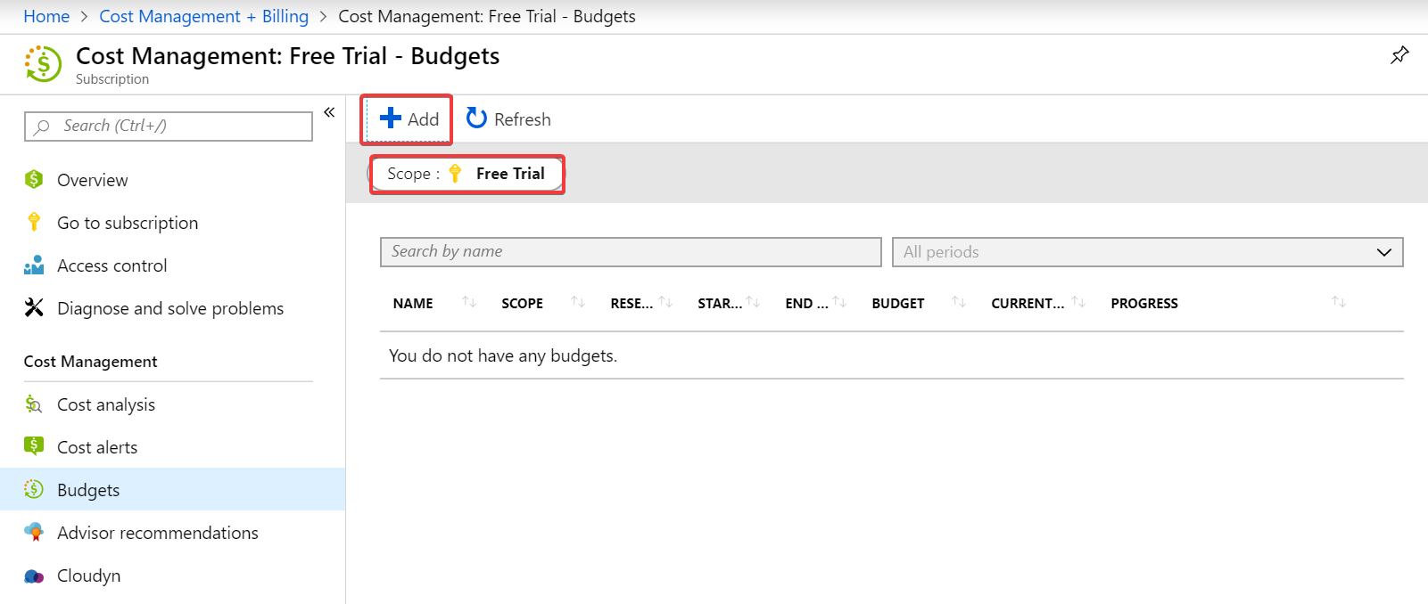
- On the Budgets menu, click Add  - For Name, call it MonthlyFreeTrialBudget  - Amount is 200  - Alerts, make the % of Budget 75 and send an email to one of your accounts to get alerted when you are getting close.  - Click Create | 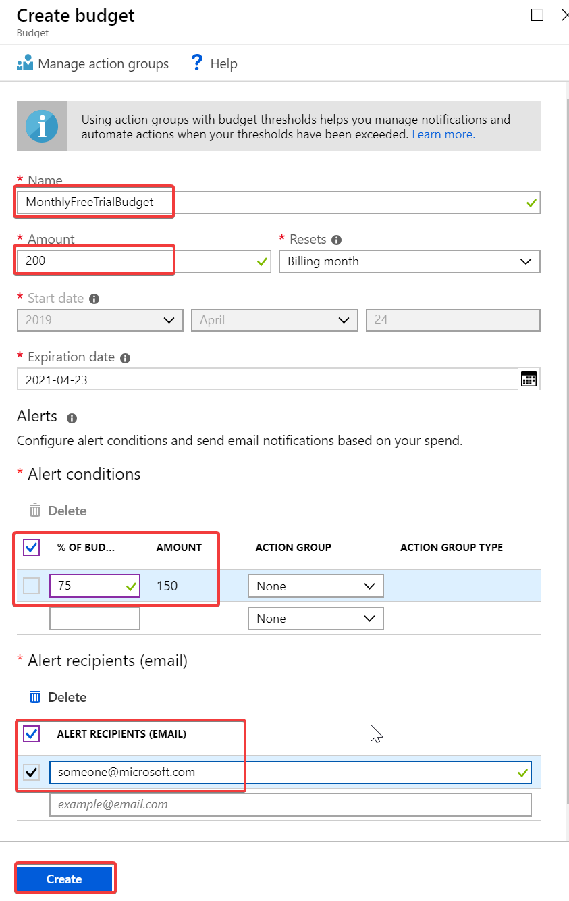
Back on the Budgets menu  - Click on the Scope pill and navigate back to and select the Free Trial subscription.  - Click on Budget from the left-hand menu  - Click on MonthlyFreeTrialBudget | 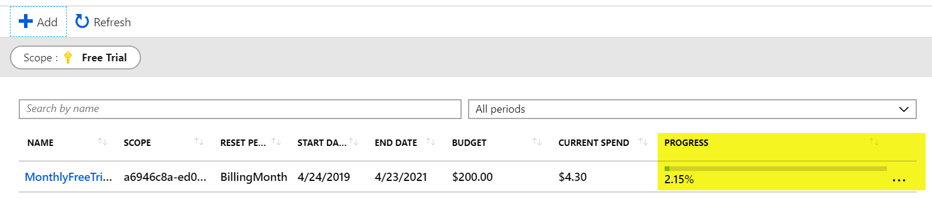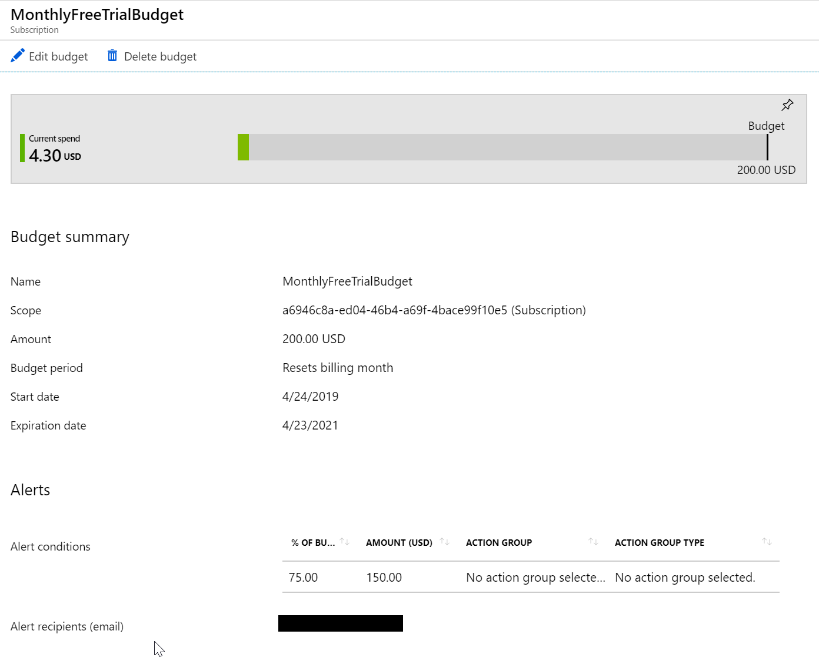
- Click on Cost Analysis from the menu items  - Click on the Scope pill and navigate back to and select the Free Trial  - In the date picker pill, select This quarter  - Select the Cost by service dropdown and select Cost by Resource | 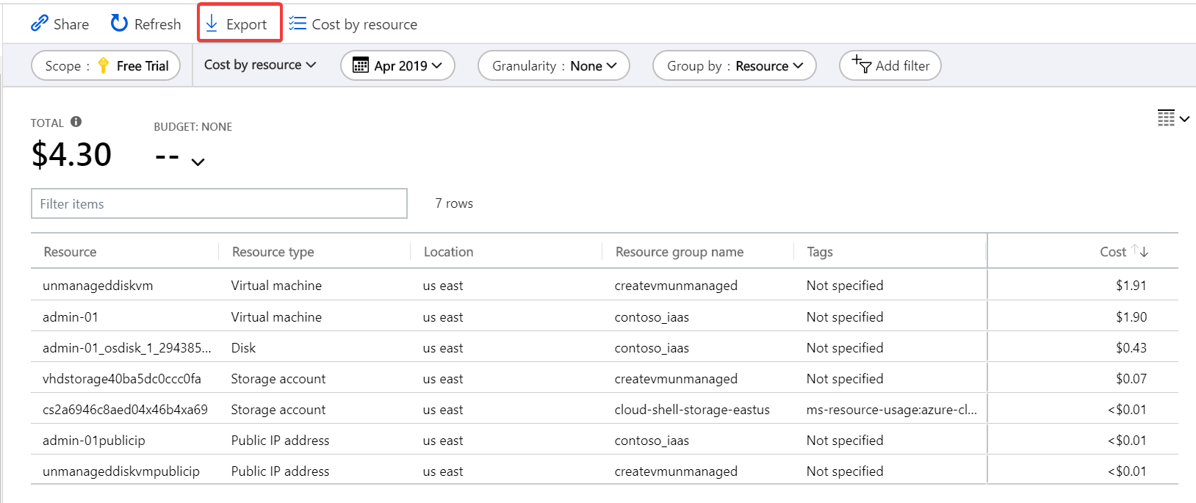
- Click on Export action button  - Select Download data to CSV | 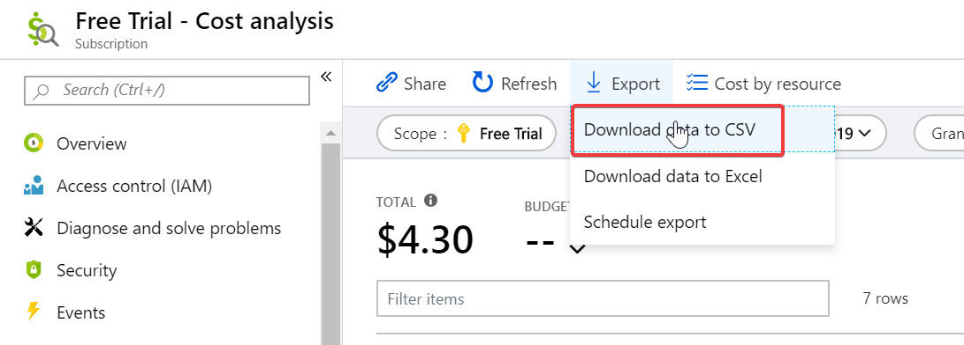

Additional Information & Links
- Azure Cost Management Documentation - https://docs.microsoft.com/en-us/azure/cost-management/
- Understand Cost Management data - https://docs.microsoft.com/en-us/azure/cost-management/understand-cost-mgt-data
- Azure Cost Management Best practices - https://docs.microsoft.com/en-us/azure/cost-management/cost-mgt-best-practices
- Azure Cost Management APIs - https://docs.microsoft.com/en-us/rest/api/cost-management/
- Azure Advisor cost savings recommendations - https://docs.microsoft.com/en-us/azure/advisor/advisor-cost-recommendations

