Azure Governance Workshop Setup Guide

Version 1.0

Contents
Getting Started 1
Tools for the Workshop 1
Create a new Azure AD Tenant 1
Create a new Azure Subscription 1
Create VMs used for Policy Challenge 1

Getting Started

Tools for the Workshop
- Install Visual Studio Code and Extensions (depending on your tool of choice)
  - Azure Resource Manager Tools - https://marketplace.visualstudio.com/items?itemName=msazurermtools.azurerm-vscode-tools
  - Azure Account and Sign-In (adds the Azure Cloud Shell for Bash) - https://marketplace.visualstudio.com/items?itemName=ms-vscode.azure-account
(Optional) Azure CLI Tools –
https://marketplace.visualstudio.com/items?itemName=ms-vscode.azurecli

Create a new Azure AD Tenant
- Create a new tenant and global admin account
  - From a web browser, navigate to https://account.azure.com/organization
  - Enter and complete the information. Then name supplied under Domain Name will subsequently become the name of your tenant e.g. contoso.onmicrosoft.com
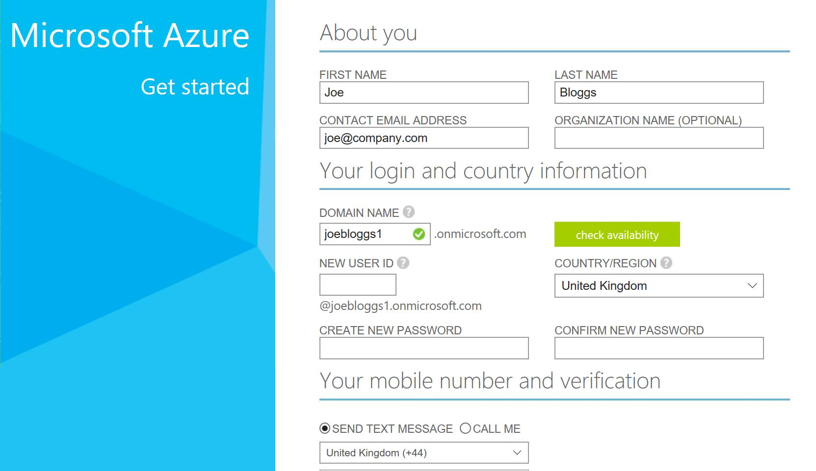
Keep a record of the user id and password as this is the Global Admin account, you’ll user later for the workshop

Create a new Azure Subscription
If you have created an Azure subscription for Free Trial before, you will not be able to create another subscription. Each person is only eligible for one Free Trial Account, all information would need to be different for the account to be eligible for a free Subscription.
Note: You will be required to use a credit card to create your Tenant and will get a free Azure Subscription
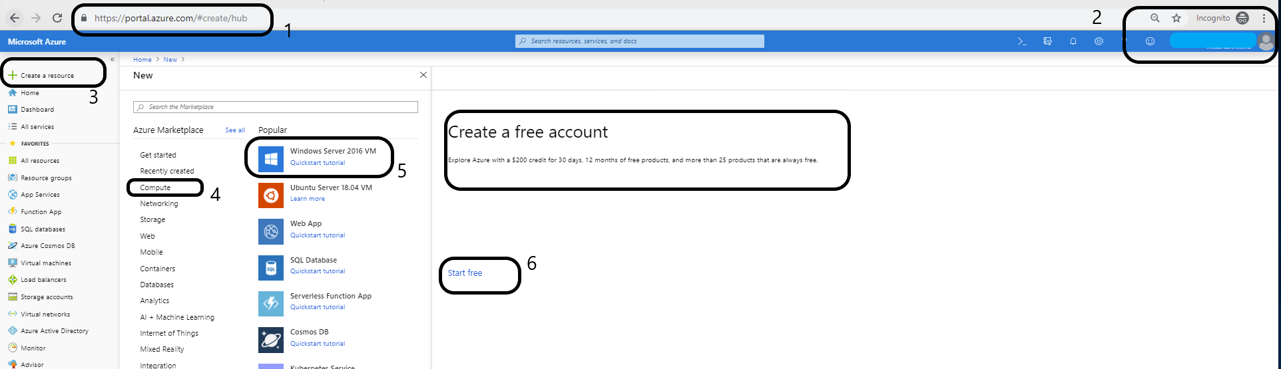
  - Open an In-Private browsing session and navigate to https://portal.azure.com (the In-Private session will ensure your corporate credentials are not used)
  - When prompted, enter the global admin account for your tenant created in Task 1. Within the Portal, you can view and manage Azure Active Directory
  - Click on Create a new resource. You can click to create any new Azure resource.
  - In the diagram about, we have shown to create a compute VM. Click on Compute
  - Click Windows Server or anything else in that list.
  - You will be prompted to create a new Azure Subscription. Click ‘Start Free’.
  - You will be prompted to enter your details and Credit Card information.
  - This new Azure Subscription will come with a $200 Azure Credits and it will not charge unless you upgrade to a PayAsYouGo subscription.
  - 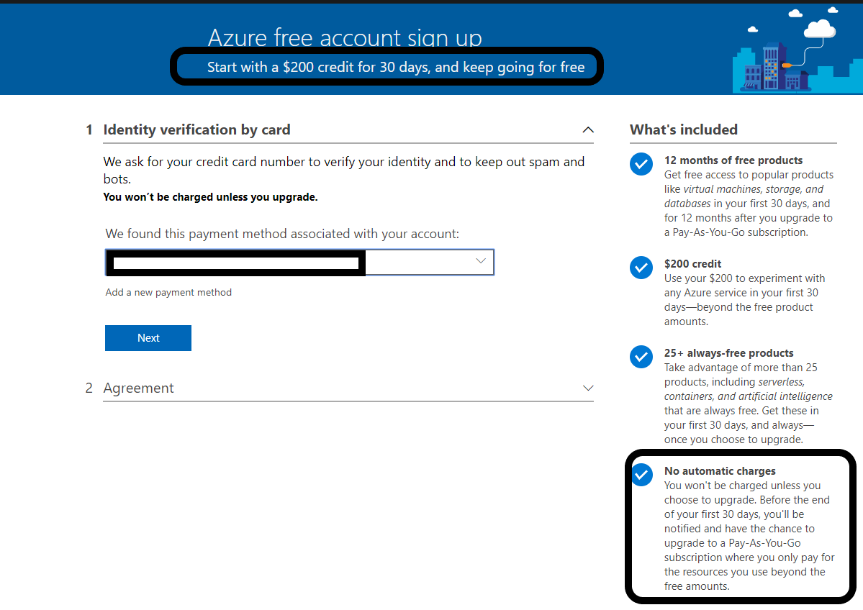

Create VMs used for Policy Challenge

Log into the Azure Portal using the new account you created and run the following Azure CLI commands from the Azure Bash Cloud Shell.
#Azure CLI commands to deploy the VMs used for the Azure Governance Policy Challenge
AdminPassword="MyP@ssW0rd!!!!" #Update password and make sure it follows the Azure password policy

#Create Virtual Machine with unmanaged disk
VmName="unmanageddiskVm"

#Create Resource Group for unmanaged disk VM
ResourceGroupName="CreateVmunmanaged"
az group create --name $ResourceGroupName --location eastus

az vm create \
--resource-group $ResourceGroupName \
--name $VmName \
--image win2016datacenter \
--admin-username azureuser \
--admin-password $AdminPassword \
--size Basic_A1 \
--use-unmanaged-disk \
--storage-sku Standard_LRS

#Create Virtual Machine with managed disk
VmName="ADMIN-01"

#Create Resource Group for managed disk VM
ResourceGroupName="Contoso_IaaS"
az group create --name $ResourceGroupName --location eastus

az vm create \
--resource-group $ResourceGroupName \
--name $VmName \
--image win2016datacenter \
--admin-username azureuser \
--admin-password $AdminPassword \
--size Basic_A1

