Challenge 04 –Create a Semantic Model in Analysis Services and Power BI Visualization.

Summary
In this challenge you will complete 3 tasks.

Tasks: -
Task-1. You will create an Analysis Services tabular project on top of Azure SQL DW using direct query mode.
Create relationship b/w tables using Visual Studio or SSDT.
Create a calculated column- Trip duration in the Analysis services project.
Deploy the final model to Azure Analysis Services Server.

Notes for Proctors: - Azure Analysis Services Solution file is available under assets challenge04
This screenshot shows how to select Direct Query mode: -
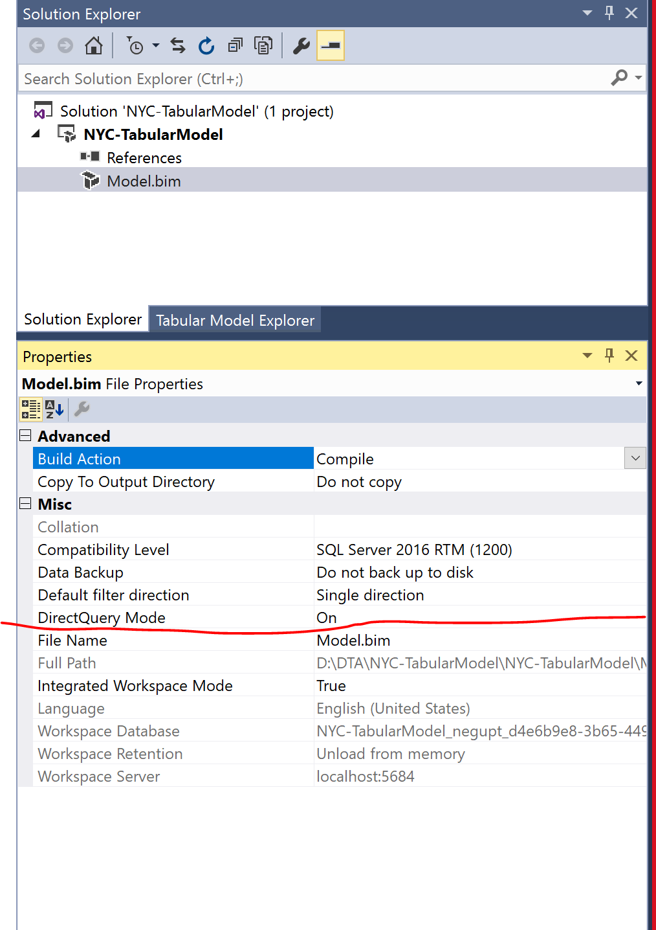
Task-2 Create following charts in Power BI desktop using Azure Analysis Services as a source and publish to Power BI online.
- Total Trips by Taxi Type - Yellow and Green
- Total Passengers by Year and Taxi type
- Count of trips over the timeframe of the trip
- Taxi passengers sometimes leave no tip. To maximize their drivers’ income, the taxi companies would like to see “zero tip” trips by taxi company, hour of day, and pickup/dropoff location. Your challenge is how to address this question with one or more simple-to-understand visualizations! Help the taxi companies help their drivers to make more money.
- NYC officials tell you that some of their staff are very non-technical and would prefer to speak questions of the data in plain language rather than use mouse and keyboard. For example, a senior executive would like to just ask “what was the total number of taxi trips in 2016 to 2018” and see a visualization. Can you provide this capability? They would also like to drill down at month level.

Notes for Proctors: - Pbix files are available under assets challenge04
Task-3 Connect Power BI with Databricks. Please create following reports
- Total Trips by Rate code description.
- Total Trips by Vendor
- Total Trips by payment type and Zone
- Total Trips by peak hour
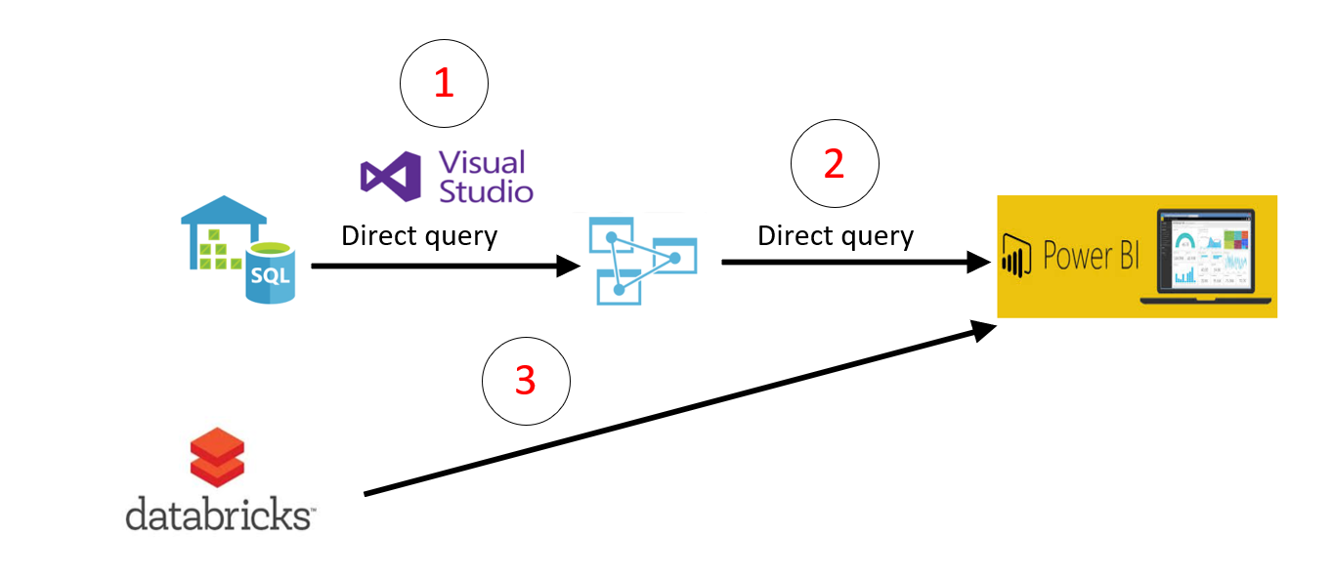

Notes for Proctors: -
Here are the steps on how to connect Power BI to Databricks
https://docs.azuredatabricks.net/user-guide/bi/power-bi.html

Prerequisites for all tasks: -
- Azure SQL DW should be up and running and you should have reference tables and aggregated table in SQL DW.
- Azure Analysis Services should be running.
- Visual Studio/SSDT with Business Intelligence Project Type
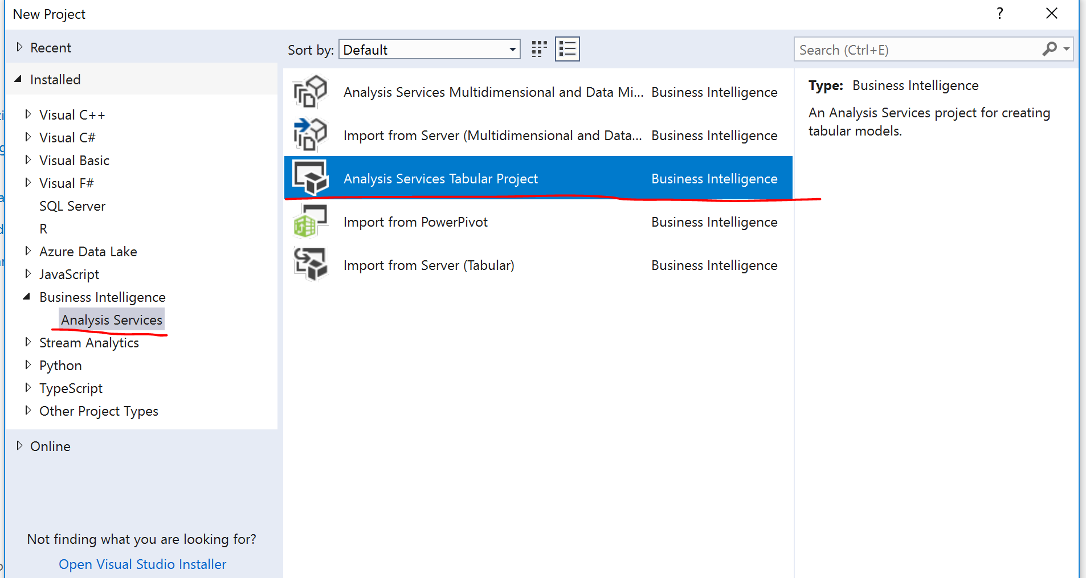
- This challenge is based on challenge 1, 2 and 3.
- Power BI Desktop
- Power BI Online (optional)
- Azure Databricks premium cluster with hive tables

Your tasks are complete when:
Task 1 - You see the deployed model under Azure Analysis Services. Browse this model and it should show calculate column Trip duration.
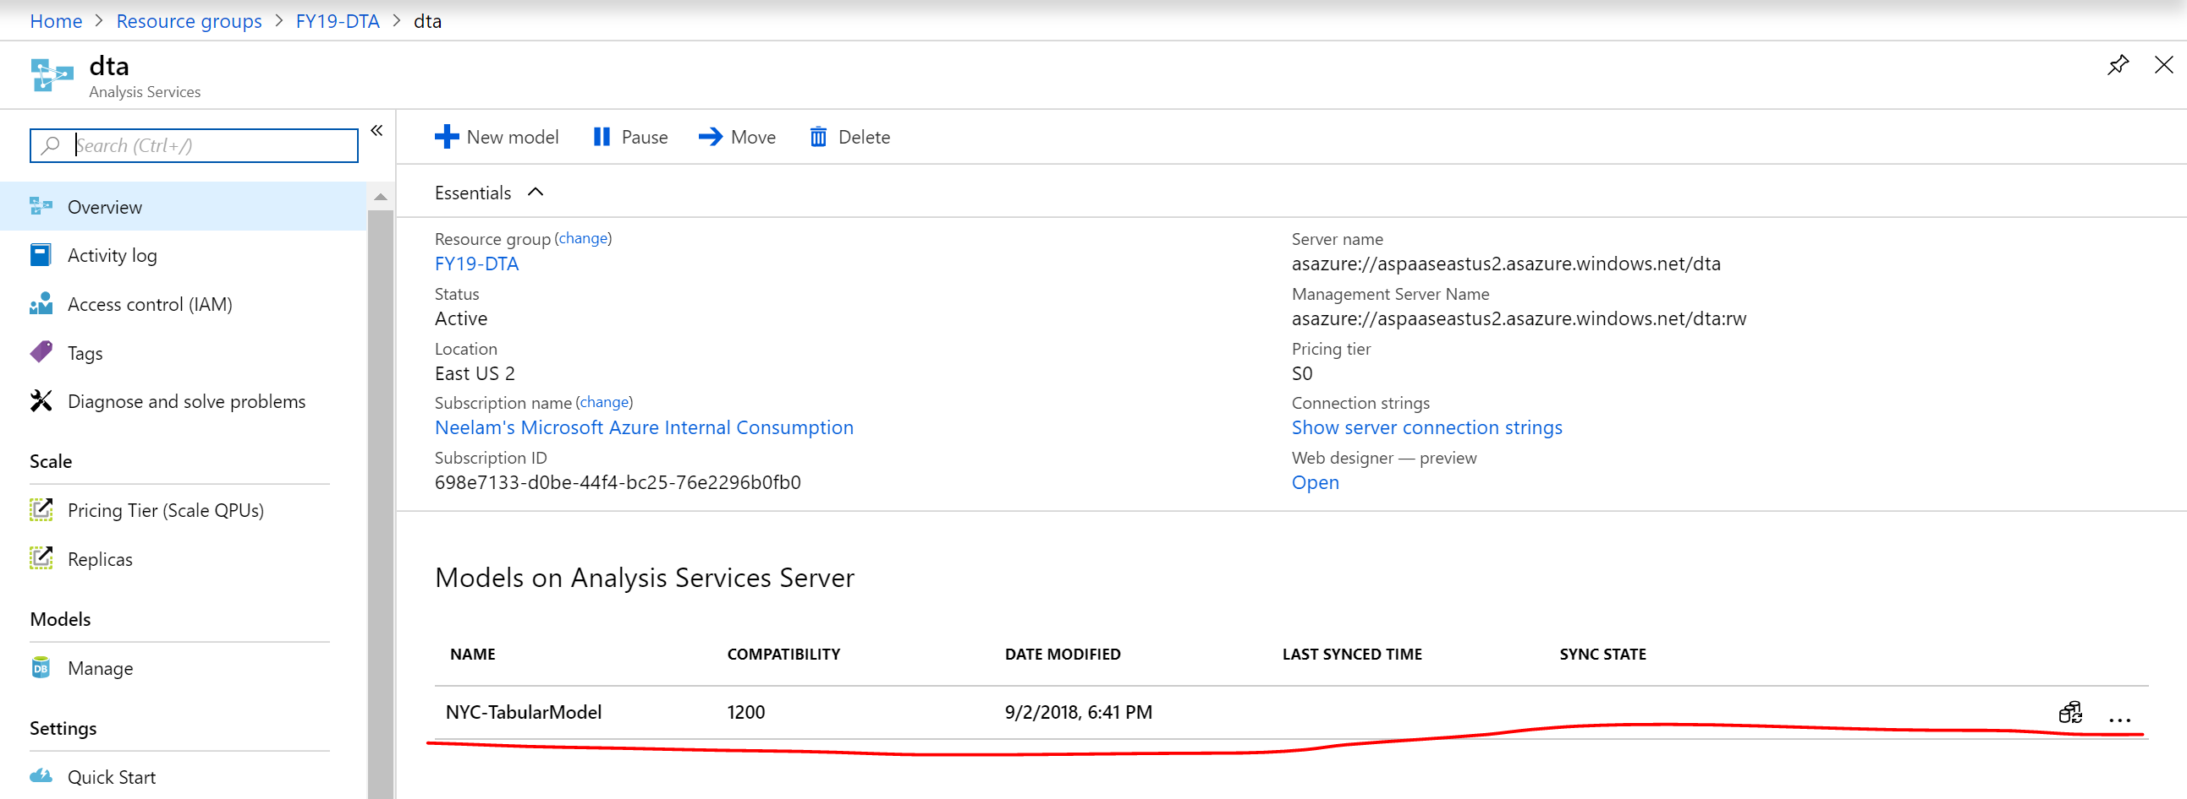
Task 2 - You should have all reports in Power BI desktop and publish Power BI online (optional)
Task 3 – You are successfully able to connect Power BI desktop with Databricks Cluster and have created task-3 reports

