Migrating to Aero Wizards

Wizards are key to simplifying the user experience. They allow taking a complex operation such as configuration of an application, and breaking it into a series of simple steps. At each point in the process, you can provide an explanation of what is needed, and display controls that allow the user to make selections and enter text.
Windows Vista will include a set of changes to the existing Win32-based Wizard ‘97 framework (PSH_WIZARD97) to allow for more interesting visual designs, more usable task pages, more effective use of text in wizards, and consistency with changes being made to explorer. The new framework will be used for new Wizards in Windows Vista. The new framework, which continues to be based on Win32, is referred to as the Aero Wizard Framework.
This exercise is for developers who want to migrate to Aero Wizard framework from Wizard ’97(legacy wizard). It also serves as an exercise for developing Aero Wizards. In this exercise, you will see all of the necessary changes that are needed to perform a successful migration from Wizard ‘97 to Aero Wizard. We’ll start with a Wizard ‘97 sample and show step-by-step conversion to Aero Wizard.

- Open the attached zip file and extract the files in it to a suitable directory
- Double click AeroWiz.sln file to open the project in Visual Studio
- Compile and run the project to see a sample Wizard ’97 that has 5 pages

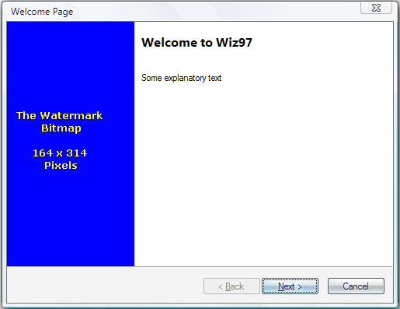
Figure 1 - Wiz97 Sample: Page 1

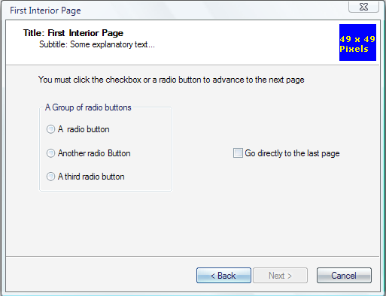

Figure 2 - Wiz97 Sample: Page 2

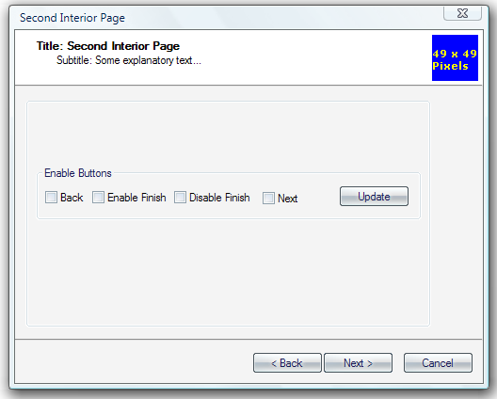
Figure 3 - Wiz97 Sample: Page 3
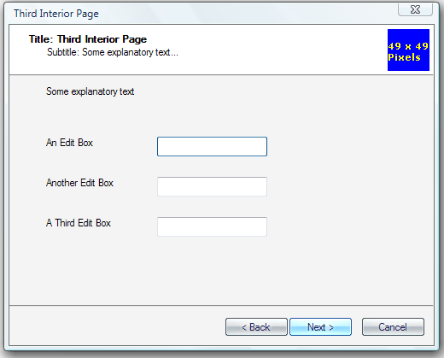
Figure 4 - Wiz97 Sample: Page 4
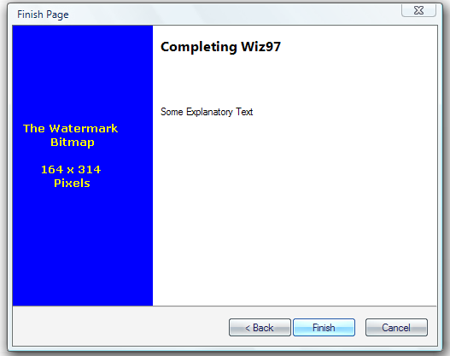
Figure 5: Wiz97 Sample: Page 5

Here’s the checklist of things to do for a successful migration to Aero Wizard.
- Use ComCtl32 v6
- Use correct Aero Wizard flags
- Set the Wizard title
- Set the Wizard Icon
- Remove the Welcome Page
- Remove the Finish Page
- Remove the Welcome & Finish Pages from Resources
- Clean up the Individual wizard pages

Task 1 – Use ComCtl32 v6
The Aero Wizard framework uses v6 version of comctl32.dll. To use comctl32 v6, include a manifest.

- Creating the manifest.
To make a manifest, we need to create a file which contains the following information. This file is already present in the AeroWizard folder as AeroWiz.exe.manifest. To learn more about manifest files & new visual styles refer to http://msdn.microsoft.com/library/default.asp?url=/library/en-us/dnwxp/html/xptheming.asp

<?xml version="1.0" encoding="UTF-8" standalone="yes"?>
<assembly xmlns="urn:schemas-microsoft-com:asm.v1" manifestVersion="1.0">
<assemblyIdentity type="win32" publicKeyToken="6595b64144ccf1df" name=SXS_ASSEMBLY_NAME version="5.1.0.0" processorArchitecture=SXS_PROCESSOR_ARCHITECTURE/>
<description>Aero Wizard Sample</description>
<dependency>
<dependentAssembly>
<assemblyIdentity
type="win32"
name="Microsoft.Windows.Common-Controls" version="6.0.0.0"
language="*"
processorArchitecture=SXS_PROCESSOR_ARCHITECTURE
publicKeyToken="6595b64144ccf1df"
/>
</dependentAssembly>
</dependency>
</assembly>

Task 2 – Use correct Aero Wizard flags
The next step in migration is to use the right set of flags.

- Open AeroWiz.cpp and find the snippet of code that uses PSH_WIZARD97. To use Aero Wizard, replace PSH_WIZARD97 flag with PSH_AEROWIZARD. If you have both PSH_WIZARD97 & PSH_AEROWIZARD flags, PSH_WIZARD97 flag is ignored and you’ll see Aero Wizard.

psh.dwSize = sizeof(psh);
psh.hInstance = hInstance;
psh.hwndParent = NULL;
psh.phpage = ahpsp;
psh.dwFlags = PSH_WIZARD97 | PSH_WATERMARK | PSH_HEADER;
psh.pszbmWatermark = MAKEINTRESOURCE(IDB_WATERMARK);
psh.pszbmHeader = MAKEINTRESOURCE(IDB_BANNER);
psh.nStartPage = 0;
psh.nPages = cPages;

Note: The code to be added is in blue and code to be removed is in red
psh.dwSize = sizeof(psh);
psh.hInstance = hInstance;
psh.hwndParent = NULL;
psh.phpage = ahpsp;
psh.dwFlags = PSH_AEROWIZARD | PSH_WATERMARK | PSH_HEADER;
psh.pszbmWatermark = MAKEINTRESOURCE(IDB_WATERMARK);
psh.pszbmHeader = MAKEINTRESOURCE(IDB_BANNER);
psh.nStartPage = 0;
psh.nPages = cPages;

- Aero Wizard doesn’t use a standard Header or Watermark Image. Remove the following from your code.
PSH_WATERMARK
PSH_HEADER
pszbmWatermark member
pszbmHeader member

psh.dwSize = sizeof(psh);
psh.hInstance = hInstance;
psh.hwndParent = NULL;
psh.phpage = ahpsp;
psh.dwFlags = PSH_AEROWIZARD|PSH_WATERMARK|PSH_HEADER;
psh.pszbmWatermark = MAKEINTRESOURCE(IDB_WATERMARK);
psh.pszbmHeader = MAKEINTRESOURCE(IDB_BANNER);
psh.nStartPage = 0;
psh.nPages = cPages;

Remove the references to header and watermark images in the resources file (AeroWiz.rc)
/////////////////////////////////////////////////////////////////////////////
//
// Bitmap
//

IDB_BANNER BITMAP "header.bmp"
IDB_WATERMARK BITMAP "watermrk.bmp"

Finally, remove the header & watermark from your resources.h file.
#define IDS_TITLE1 1
#define IDS_SUBTITLE1 2
#define IDS_TITLE2 3
#define IDS_SUBTITLE2 4
#define IDS_TITLE3 5
#define IDS_SUBTITLE3 6
#define IDB_BANNER 102
#define IDB_WATERMARK 103
#define IDD_INTRO 107
#define IDD_INTERIOR1 108
#define IDD_INTERIOR2 109

Compile & run the Wizard, you’ll see the Wizard in a new frame!

A Few Notes:
- The Watermark image doesn’t appear because Aero Wizard does not support it. We also removed the flags for it.

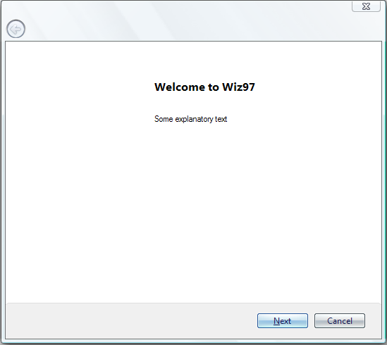
Figure 6 - Initial Aero Wizard Conversion

Task 3 – Set the Wizard title
Wizard97 uses CAPTION of the dialog as the title of the window. This enables users to have different titles for the wizard in each property sheet page (which is against the Aero design recommendations). Aero Wizard deprecated this functionality. Instead it uses pszCaption of PROPSHEETHEADER for the title of the wizard. Although you can set the header title of the individual wizard pages, the wizard title is same across all the pages.

- Open the AeroWiz.rc file and find the CAPTION line (this is optional, because Aero Wizard will ignore it anyway).

IDD_INTRO DIALOGEX 0, 0, 317, 193
STYLE DS_SETFONT | DS_FIXEDSYS | WS_CHILD | WS_DISABLED | WS_CAPTION
CAPTION "Welcome Page"
FONT 8, "MS Shell Dlg", 0, 0, 0x0

Remove the entire CAPTION line for each property page.

- When using Aero Wizard, you cannot set the title for each page by using PSP_USETITLE. You need to set pszCaption in the Propertysheet Header. So let’s add a string to the resource
While inside the AeroWiz.rc file, find the string table and add a new string for the Title.
STRINGTABLE
BEGIN
IDS_TITLE1 "Title: First Interior Page"
IDS_SUBTITLE1 "Subtitle: Some explanatory text..."
IDS_TITLE2 "Title: Second Interior Page"
IDS_SUBTITLE2 "Subtitle: Some explanatory text..."
IDS_TITLE3 "Title: Third Interior Page"
IDS_SUBTITLE3 "Subtitle: Some explanatory text..."
IDS_WIZTITLE "MSDN Sample Aero Wizard"
END

Add IDS_WIZTITLE to the resource.h file
#define IDS_TITLE1 1
#define IDS_SUBTITLE1 2
#define IDS_TITLE2 3
#define IDS_SUBTITLE2 4
#define IDS_TITLE3 5
#define IDS_SUBTITLE3 6
#define IDS_WIZTITLE 7

- In AeroWiz.cpp define pszCaption in the Propertysheet Header.
psh.dwSize = sizeof(psh);
psh.hInstance = hInstance;
psh.hwndParent = NULL;
psh.phpage = ahpsp;
psh.dwFlags = PSH_AEROWIZARD;
psh.pszCaption = MAKEINTRESOURCE(IDS_WIZTITLE);
psh.nStartPage = 0;
psh.nPages = cPages;

- Compile and run the wizard, and now the Wizard Title will appear!
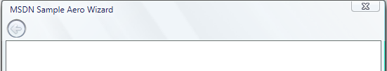
Figure 7 – Adding a Wizard Title

Task 4 – Set the Wizard Icon
Aero Wizard doesn’t let you define a Wizard Icon for each page; we can only set it for the entire wizard. This sample doesn’t use an Icon for the Wizard97, so let’s just add one. We have a sample icon file notepad.ico in the current directory which can be used.

- Open AeroWiz.rc and add the icon as a resource. Feel free to place it anywhere in the RC file. We will use notepad.ico as the icon for this wizard.
/////////////////////////////////////////////////////////////////////////////
//
// Icon
//

// Icon with lowest ID value placed first to ensure application icon
// remains consistent on all systems.
IDI_WIZICON ICON "notepad.ico"

- Add the Icon to the resources.h file.
// Used by AeroWiz.rc
//
#define IDS_TITLE1 1
#define IDS_SUBTITLE1 2
#define IDS_TITLE2 3
#define IDS_SUBTITLE2 4
#define IDS_TITLE3 5
#define IDS_SUBTITLE3 6
#define IDS_WIZTITLE 7
#define IDI_WIZICON 104
#define IDD_INTRO 107
#define IDD_INTERIOR1 108
#define IDD_INTERIOR2 109

- Finally, call the Icon resource in your PSH code by using PSH_USEICONID & pszIcon.

psh.dwSize = sizeof(psh);
psh.hInstance = hInstance;
psh.hwndParent = NULL;
psh.phpage = ahpsp;
psh.dwFlags = PSH_AEROWIZARD | PSH_USEICONID;
psh.pszCaption = MAKEINTRESOURCE(IDS_WIZTITLE);
psh.pszIcon = MAKEINTRESOURCE(IDI_WIZICON);
psh.nStartPage = 0;
psh.nPages = cPages;

- Compile & load the wizard, you should see the Wizard Icon!
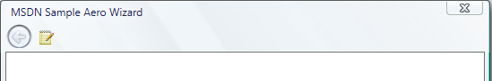
Figure 8 - Adding a Wizard Icon

Task 5 – Remove the Welcome Page
Although this is not a requirement, it is recommended that all Aero Wizards do not have a Welcome & Finish page. If you choose to keep your Welcome & Finish pages, keep in mind that Watermarks are no longer supported by Aero Wizard, so you’ll need to adjust the placement of text on these pages (e.g. left align the text).

- Please review the Welcome and Finish pages to make sure that you aren’t displaying any information that the user won’t find anywhere else in the wizard. If you are, please move it to another page.

- Let’s first remove the Welcome page from you Wizard. Open AeroWiz.cpp and find the opening page. Remove everything under the opening page except psp.dwsize, psp.hInstance, psp.lParam.
//
// Create the Wizard pages
//

// Opening page

psp.dwSize = sizeof(psp);
psp.dwFlags = PSP_DEFAULT | PSP_HIDEHEADER;
psp.hInstance = hInstance;
psp.lParam = (LPARAM) &wizdata; //The shared data structure
psp.pfnDlgProc = IntroDlgProc;
psp.pszTemplate = MAKEINTRESOURCE(IDD_INTRO);

ahpsp[cPages] = CreatePropertySheetPage(&psp);

if (ahpsp[cPages])
{
++cPages;

- psp.dwsize sets the size of the propertysheet.
- psp.hInstance & psp.lParam is shared information that needs to be set before the wizard is created.
- Move psp.hInstance & psp.lParam under the first interior page

//Opening page
psp.dwSize = sizeof(psp);

//First interior page

psp.dwFlags = PSP_DEFAULT|PSP_USEHEADERTITLE|PSP_USEHEADERSUBTITLE;
psp.hInstance = hInstance;
psp.lParam = (LPARAM) &wizdata; //The shared data structure
psp.pszHeaderTitle = MAKEINTRESOURCE(IDS_TITLE1);
psp.pszHeaderSubTitle = MAKEINTRESOURCE(IDS_SUBTITLE1);
psp.pszTemplate = MAKEINTRESOURCE(IDD_INTERIOR1);
psp.pfnDlgProc = IntPage1DlgProc;

- Remove the corresponding closing parenthesis of the removed ‘if’ statement.
}
}
}
}

if (fPagesCreated)
{
// Create the property sheet

- Remove the entire IntroDlgProc function and its forward definition from your .cpp file, since we don’t call it anymore.
- Compile & run the wizard

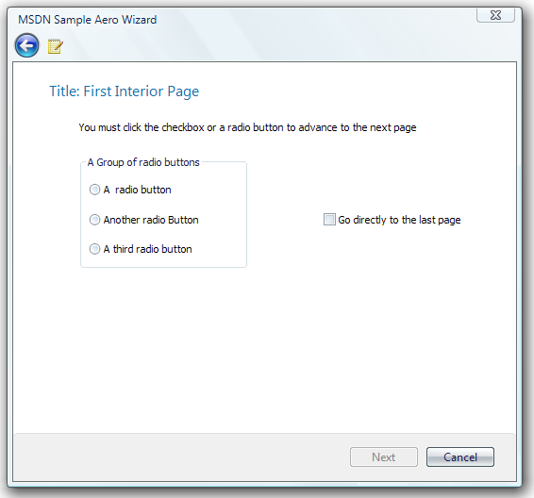
Figure 9 - Wizard starting on the first interior page

Task 6 – Remove the Finish Page
Now that we have the Welcome page removed, let’s move on to the Finish page.

- First, let’s remove the Finish Page code (highlighted in red).
if (ahpsp[cPages])
{
++cPages;

// Final page

psp.dwFlags = PSP_DEFAULT | PSP_HIDEHEADER;
psp.pszTemplate = MAKEINTRESOURCE(IDD_END);
psp.pfnDlgProc = EndDlgProc;

ahpsp[cPages] = CreatePropertySheetPage(&psp);
- Remove the corresponding closing parenthesis of the removed ‘if’ statement.
}
}
}

if (fPagesCreated)
{
// Create the property sheet

- Next, update the IntPage3DlgProc so we close the wizard gracefully & show the right buttons on the last page.
- Change the wizard buttons on the page to have PSWIZB_BACK & PSWIZB_FINISH.
BOOL CALLBACK IntPage3DlgProc (
HWND hwndDlg,
UINT uMsg,
WPARAM wParam,
LPARAM lParam
)
{
...
case PSN_SETACTIVE : //Enable the Next and Back buttons

PropSheet_SetWizButtons(GetParent(hwndDlg), PSWIZB_BACK | PSWIZB_NEXT | PSWIZB_FINISH);
break;

- Next, update the handling of Back button so that the wizard navigates to either previous page or the first page (based on checkbox state on the first page).
BOOL CALLBACK IntPage3DlgProc (
HWND hwndDlg,
UINT uMsg,
WPARAM wParam,
LPARAM lParam
)
{
...
case PSN_WIZBACK :
//If the checkbox was checked, jump back
//to the first interior page, not the second
if (pdata->fIsBoxChecked)
{
SetWindowLong(hwndDlg, DWL_MSGRESULT, IDD_INTERIOR1);
return TRUE;
}
break;

- Next, update the IntPage1DlgProc so when the user clicks “Go directly to the last page” we go to IDD_INTERIOR3 instead of the finish page which we just removed.
BOOL CALLBACK IntPage1DlgProc (
HWND hwndDlg,
UINT uMsg,
WPARAM wParam,
LPARAM lParam
)
{
...

case PSN_WIZNEXT:

// If the checkbox is checked, jump to the final page

if (pdata->fIsBoxChecked)
{
SetWindowLong(hwndDlg, DWL_MSGRESULT, IDD_INTERIOR3);
return TRUE;
}
break;

- Remove the entire EndDlgProc function and its forward definition from your .cpp file, as we no longer call it.
- Compile the wizard, and you’ll notice that we end on the third interior page (notice the “Finish” Button on the third page).
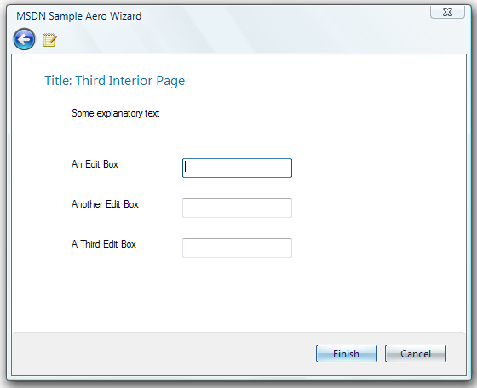
Figure 10 - Our new Finish Page

Task 7 – Remove the Welcome & Finish Pages from Resources
Now that we removed the code which calls the Welcome & Finish pages, we need to remove references to these pages in the resource file.

- First remove the dialog templates for these pages. Open the AeroWiz.rc file and find the dialog templates. Remove all references to IDD_INTRO & IDD_END (highlighted in red).
/////////////////////////////////////////////////////////////////////////////
//
// Dialog
//

IDD_INTRO DIALOGEX 0, 0, 317, 193
STYLE DS_SETFONT | DS_FIXEDSYS | WS_CHILD | WS_DISABLED | WS_CAPTION
FONT 8, "MS Shell Dlg", 0, 0, 0x0
BEGIN
LTEXT "Welcome to Wiz97",IDC_TITLE,115,9,189,31,NOT WS_GROUP
LTEXT "Some explanatory text",IDC_INTRO_TEXT,115,40,189,18
END

IDD_END DIALOG 0, 0, 317, 193
STYLE DS_SETFONT | DS_FIXEDSYS | WS_CHILD | WS_DISABLED | WS_CAPTION
FONT 8, "MS Shell Dlg"
BEGIN
LTEXT "Completing Wiz97",IDC_TITLE,115,8,195,37
LTEXT "Some Explanatory Text",IDC_STATIC,115,58,195,128
END

- Find the DESIGNINFO section in your AeroWiz.rc file and remove all references to IDD_INTRO & IDD_END (highlighted in red).
/////////////////////////////////////////////////////////////////////////////
//
// DESIGNINFO
//

#ifdef APSTUDIO_INVOKED
GUIDELINES DESIGNINFO
BEGIN
IDD_INTRO, DIALOG
BEGIN
LEFTMARGIN, 7
RIGHTMARGIN, 310
VERTGUIDE, 115
VERTGUIDE, 304
TOPMARGIN, 7
BOTTOMMARGIN, 186
HORZGUIDE, 8
HORZGUIDE, 40
END

IDD_END, DIALOG
BEGIN
LEFTMARGIN, 7
RIGHTMARGIN, 310
VERTGUIDE, 115
TOPMARGIN, 7
BOTTOMMARGIN, 186
END
END
#endif // APSTUDIO_INVOKED

- Finally, remove the IDD_INTRO & IDD_END references in your resources.h file.
#define IDS_TITLE1 1
#define IDS_SUBTITLE1 2
#define IDS_TITLE2 3
#define IDS_SUBTITLE2 4
#define IDS_TITLE3 5
#define IDS_SUBTITLE3 6
#define IDS_WIZTITLE 7
#define IDD_INTRO 107
#define IDD_INTERIOR1 108
#define IDD_INTERIOR2 109
#define IDD_END 110

Task 8 – Clean up the individual Wizard pages
Now that we have the wizard is good shape, it’s time to clean up the individual pages.

- First we need to remove any flags that are no longer supported by Aero Wizard.
- Open up AeroWiz.cpp and find the first interior, second & third interior pages. Remove the corresponding PSP flags that are no longer supported (highlighted in red).
- PSP_DEFAULT flag is no longer supported
- PSP_USERHEADERSUBTITLE flag is no longer supported

- Remove the pszHeaderSubTitle member from PSP structure for each page

// First interior page

psp.dwFlags = PSP_DEFAULT | PSP_USEHEADERTITLE | PSP_USEHEADERSUBTITLE;
psp.hInstance = hInstance;
psp.lParam = (LPARAM) &wizdata; //The shared data structure
psp.pszHeaderTitle = MAKEINTRESOURCE(IDS_TITLE1);
psp.pszHeaderSubTitle = MAKEINTRESOURCE(IDS_SUBTITLE1);
psp.pszTemplate = MAKEINTRESOURCE(IDD_INTERIOR1);
psp.pfnDlgProc = IntPage1DlgProc;

// Second interior page

psp.dwFlags = PSP_DEFAULT | PSP_USEHEADERTITLE | PSP_USEHEADERSUBTITLE;
psp.pszHeaderTitle = MAKEINTRESOURCE(IDS_TITLE2);
psp.pszHeaderSubTitle = MAKEINTRESOURCE(IDS_SUBTITLE2);
psp.pszTemplate = MAKEINTRESOURCE(IDD_INTERIOR2);
psp.pfnDlgProc = IntPage2DlgProc;

//Third interior page

psp.dwFlags = PSP_DEFAULT | PSP_USEHEADERTITLE | PSP_USEHEADERSUBTITLE;
psp.pszHeaderTitle = MAKEINTRESOURCE(IDS_TITLE3);
psp.pszHeaderSubTitle = MAKEINTRESOURCE(IDS_SUBTITLE3);
psp.pszTemplate = MAKEINTRESOURCE(IDD_INTERIOR3);
psp.pfnDlgProc = IntPage3DlgProc;

- Next, remove the resources to the Sub-Title strings in AeroWiz.rc
/////////////////////////////////////////////////////////////////////////////
//
// String Table
//

STRINGTABLE
BEGIN
IDS_TITLE1 "Title: First Interior Page"
IDS_SUBTITLE1 "Subtitle: Some explanatory text..."
IDS_TITLE2 "Title: Second Interior Page"
IDS_SUBTITLE2 "Subtitle: Some explanatory text..."
IDS_TITLE3 "Title: Third Interior Page"
IDS_SUBTITLE3 "Subtitle: Some explanatory text..."
IDS_WIZTITLE "MSDN Sample Aero Wizard"
END

- Because the Header Title is the only label for the wizard page, re-phrase the header title to be an instruction for the user (e.g. “Which files would you like to burn?”). Let’s update the strings.
/////////////////////////////////////////////////////////////////////////////
//
// String Table
//
STRINGTABLE
BEGIN
IDS_TITLE1 "Which Option do you want?"
IDS_TITLE2 "Click some buttons"
IDS_TITLE3 "Enter your order information"
IDS_WIZTITLE "MSDN Sample Aero Wizard"
END

- Finally, remove the Subtitle text from the resources.h file.
#define IDS_TITLE1 1
#define IDS_SUBTITLE1 2
#define IDS_TITLE2 3
#define IDS_SUBTITLE2 4
#define IDS_TITLE3 5
#define IDS_SUBTITLE3 6
#define IDS_WIZTITLE 7

- Now if we load the new wizard, we’ll see the new Main Instruction. There is one problem – the content is not aligned with the Main Instruction (see below).
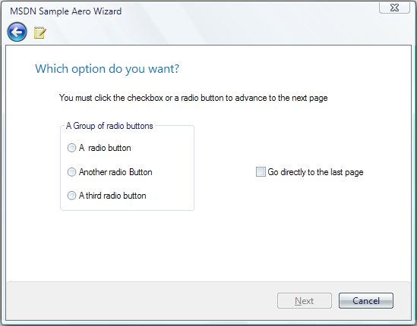
Figure 11 - Mis-aligned content

- To fix the alignment of your content, we provided a “fixed” margin so you can left align your task pages. Open your AeroWiz.rc file and locate the first coordinate for each on the page.
- For items that are supposed to be left aligned, we’ll set the margin to 0
- For the items in this Groupbox, we’ll add the difference between the left margin and where it originally was (e.g. The left most label was at 21 which became 0. So now any item placed past 21, we make the new value the difference between 21 and the larger value).

IDD_INTERIOR1 DIALOG DISCARDABLE 0, 0, 317, 143
STYLE WS_CHILD | WS_DISABLED | WS_CAPTION
FONT 8, "MS Shell Dlg"
BEGIN
LTEXT "You must click the checkbox or a radio button to advance to the next page",
IDC_STATIC,0,1,282,14
CONTROL "A radio button",IDC_RADIO1,"Button",BS_AUTORADIOBUTTON,
7,41,62,10
CONTROL "Another radio Button",IDC_RADIO2,"Button",
BS_AUTORADIOBUTTON,7,61,81,10
CONTROL "A third radio button",IDC_RADIO3,"Button",
BS_AUTORADIOBUTTON,7,80,75,10
GROUPBOX "A Group of radio buttons",IDC_GROUP1,0,24,119,74,
WS_GROUP
CONTROL "Go directly to the last page",IDC_CHECK1,"Button",
BS_AUTOCHECKBOX | WS_TABSTOP,194,61,100,10
END

IDD_INTERIOR3 DIALOG 0, 0, 317, 143
STYLE DS_SETFONT | WS_CHILD | WS_DISABLED | WS_CAPTION
FONT 8, "MS Shell Dlg"
BEGIN
LTEXT "Some explanatory text",IDC_STATIC,0,1,70,8
LTEXT "An Edit Box",IDC_STATIC,0,38,38,8
LTEXT "Another Edit Box",IDC_STATIC,0,67,54,8
LTEXT "A Third Edit Box",IDC_STATIC,0,96,52,8
EDITTEXT IDC_EDIT2,87,38,86,14,ES_AUTOHSCROLL
EDITTEXT IDC_EDIT3,87,67,86,14,ES_AUTOHSCROLL
EDITTEXT IDC_EDIT4,87,96,86,14,ES_AUTOHSCROLL
END

- Now when you run your wizard, all of your content will be left aligned!
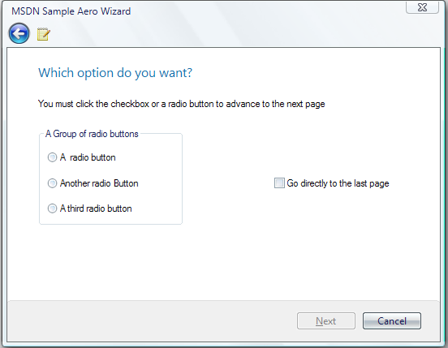
Figure 12 - Content left-aligned

That’s it; you’re done with the Aero Wizard Migration!

In a nutshell, you can easily change from Wizard97 to Aero-Wizard by just replacing PSH_WIZARD97 flag with PSH_AEROWIZARD. However, you’ll see the following issues if you don’t do the above mentioned steps:

- Your pages might not look great under the Aero Wizard (there will be an additional left and top margin)
- If you have a welcome and finish page, they wont look quite right under Aero
- Any wizard97 header subtitles will be lost
- Any watermark bitmaps will not be shown

