OmniProv1.0 - A Sample ATL OLEDB Provider for Custom Databases
by Prash Shirolkar
Reviewed by Daniel Kirby
Abstract
OmniProv1.0 is an example of an ATL OLEDB Provider that works with the Microsoft DataGrid Control 6.0(OLEDB) and the Microsoft ADO Data Control 6.0 (OLEDB) using server-side cursors and has the capability of supporting Non-Deferred Updates, Inserts and Deletes. Additionally, it implements a storage class, which interfaces with a custom database that comprises of a Schema and a Data file. Sample clients are also provided to test OmniProv1.0.
Note: Throughout the course of the remaining document I will refer to the Microsoft DataGrid Control 6.0 (OLEDB) as the ADO Data Grid and the Microsoft ADO Data Control 6.0 (OLEDB) as the ADO Data Control.

Introduction
The inability and inordinate struggles and frustrations of innumerable customers to create a custom provider that works with the ADO Data Grid and the ADO Data Control on its own steam without the scores of error messages popping out has been the motivation behind writing this provider - OmniProv1.0. Its endeavor is to demonstrate not only how to interface a custom ATL OLEDB Provider with ActiveX Controls like the ADO Data Grid using server-side cursors; but to also possess the capability to reliably perform inserts, updates and deletes maintaining consistency in a back-end custom database. Finally, it also offers an example for exposing data to consumers via text files that possess their own individual schematic data.
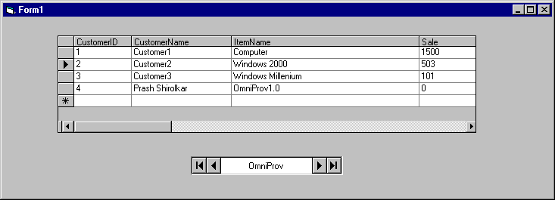
OMNIPROV1.0 Provider
Data.txt
-----------
-----------
Data.sxt
-----------
-----------
Data Info.
Schema Info.
Data
Events

FIGURE 1: Objective of OmniProv1.0
In essence OmniProv1.0 provides the following capabilities:
- Server-side cursor support,
- Non-Deferred updates, inserts and deletes, and
- Storage class that reads from a text file and it's associated schema file.
Note: OmniProv1.0 should be used with server-side cursors only, for client-side cursors, refer to Appendix B.
It also attempts to address the following:
- What do the ADO Data Grid and the ADO Data Control need from the provider?
- A working sample provider - Omniprov1.0 with source code and
- ADO Data Grid and straight ADO clients using Visual basic to test OmniProv1.0

What do the ADO Data Grid and the ADO Data Control need from the provider?
In addition to the default interfaces (refer to [3] in the References for more details) for the Data Source, Session, Command and Transaction; the ADO Data Grid and the ADO Data Control expect the following interfaces.

Interfaces
For proper functioning of the ADO Data Grid and the ADO Data Control the following interfaces need to be considered while creating the provider.
Component | Interfaces | Comments
Rowset | [mandatory] IAccessor* | For Accessor management.
 | [mandatory] IColumnsInfo* | Expose Info. on columns of a rowset.
 | [mandatory] IConvertType* | Info. on availability of type conversions.
 | [mandatory] IRowset* | Basic rowset interface.
 | [mandatory] IRowsetInfo* | Expose info. on a rowset.
 | [mandatory] IRowsetIdentity* | Testing for row identity.
 | [optional] IConnectionPointContainer*¹ | Provides a connection point for IRowsetNotify.
 | [optional] IChapteredRowset | Chapter management.
 | [optional] IRowsetChange* | Non-deferred update, insert and delete.
 | [optional] IRowsetLocate*¹ | Basic cursor support.
 | [optional] IRowsetScroll*¹ | Scrolling capability for server-side cursors.
 | [optional] IRowsetUpdate | For deferred updates.
 | [optional] IErrorRecords | Add and Retrieve records in OLEDB error object.
* Implemented in OmniProv1.0
¹ For the ADO Data Grid to work with server-side cursors IConnectionPointContainer, IRowsetScroll and IRowsetLocate have to be implemented.
TABLE 1: The Interfaces needed by the ADO Data Grid and the ADO Data Control from the Provider.
One point of caution is that the mandatory rowset interfaces should be exposed in the DBPROPSET_ROWSET as VARIANT_TRUE. In general, the ADO Data Control does not query (Query Interface) for mandatory Interfaces that have been initially set to VARIANT_FALSE.

Properties and ColumnInfo
There are some properties and column information flags that need to be dealt with cautiously. In addition to the specific interfaces being exposed in the DBPROPSET_ROWSET as VARIANT_TRUE, there are many properties that need to be exposed appropriately as well. For details on each of the properties refer to the OLEDB 2.0 / 2.5 Programmers Reference (see References [1]).
There are some properties that require special mention when their corresponding interfaces are exposed.
Note: The table is not a mapping between properties and interfaces. It is merely an exercise to address the importance of specific properties when certain interfaces are exposed. Additionally all the properties listed against the interfaces do not have to implemented. It depends on what the provider supports.

Interfaces | Properties
IRowsetChange | DBPROP_UPDATABILITY*, DBPROP_OWNINSERT*, DBPROP_OWNUPDATEDELETE *,  DBPROP_ REMOVEDELETED*
IRowsetScroll | DBPROP_CANFETCHBACKWARDS*, DBPROP_CANHOLDROWS*, DBPROP_CANSCROLLBACKWARDS*, DBPROP_SERVERCURSOR*, DBPROP_CLIENTCURSOR
IRowsetLocate | DBPROP_BOOKMARKS*, DBPROP_BOOKMARKSKIPPED*, DBPROP_BOOKMARKTYPE*, DBPROP_LITERALBOOKMARKS*, DBPROP_ORDEREDBOOKMARKS*
IRowsetIdentity | DBPROP_LITERALIDENTITY*, DBPROP_STRONGIDENTITY*
IConnectionPointContainer | DBPROP_NOTIFICATIONPHASES*,  DBPROP_NOTIFYCOLUMNSET*, DBPROP_NOTIFYROWDELETE*, DBPROP_NOTIFYROWFIRSTCHANGE, DBPROP_NOTIFYROWINSERT*, DBPROP_NOTIFYROWRESYNCH, DBPROP_NOTIFYROWSETRELEASE, DBPROP_NOTIFYROWSETFETCHPOSITIONCHANGE*,  DBPROP_NOTIFYROWUNDOCHANGE, DBPROP_NOTIFYROWUNDOINSERT, DBPROP_NOTIFYROWUPDATE*
*Exposed in OmniProv1.0
TABLE 2: Some Interfaces and Properties to consider

While setting the ATLCOLUMNINFO there are a couple of flags that need to be considered during implementation. Firstly, the DBCOLUMNFLAGS_ISBOOKMARK should set if the 0th column is a bookmark. Secondly, unless the DBCOLUMNFLAGS_WRITE flag is set for each column the ADO Data Grid does not allow data to be written even if the AllowUpdate property is set to True.

The Internals of Omniprov1.0
This section briefly addresses the modifications and additions to the various components of Omniprov1.0 namely, Data Source, Session, Schema Rowsets, Command, Rowset and the Storage classes.
Modifications to the Data Source class were confined to initializations and additions to the property set map involving the DBPROPSET_DATASOURCEINFO and the DBPROPSET_DBINIT only. For more details refer to the MSOmniProvDS.h header file in the sample.
The Session class is identical to the default session class generated by the ATL OLEDB Provider Wizard.
The few notable changes in the OmniProv1.0's Command class CMSOmniProvCommand lie in its property set map for DBPROPSET_ROWSET. For more details refer to the MSOmniProvRS.h header file.

Schema Rowset
The Schema rowset classes are limited to the three basic schemas - DBSCHEMA_TABLES, DBSCHEMA_COLUMNS and DBSCHEMA_PROVIDER_TYPES. The Tables schema class CMSOmniProvSessionTRSchemaRowset contains static data about the OmniTable. The Columns schema class describes the CMSOmniProvSessionColSchemaRowset describes static data about the four columns in the OmniTable. The Provider types describes the data types supported by OmniProv1.0 namely DBTYPE_STR and DBTYPE_I4. Hence, statically the Schema information depicted by the Schema Rowset classes of OmniProv1.0 is as follows:
Schema - OmniProv Schema
Catalog - OmniProv Catalog
Table - OmniProv
Number of Columns - 4
Column #1 - CustomerID, DBTYPE_STR, 10 (max length)
Column #2 - CustomerName, DBTYPE_STR, 40(max length)
Column #3 - ItemName, DBTYPE_STR, 40(max length)
Column #4 - Sale, DBTYPE_I4, 10(precision)

Rowset
OmniProv1.0's capability for server-side cursors and non-deferred updates, inserts and deletes lies in its Rowset class - CMSOmniProvRowset. It inherits from the following classes:
- CRowsetImpl,
- IRowsetScrollImpl,
- IRowsetChangeImpl,
- CProxyIRowsetNotify, and
- IConnectionPointContainerImpl.
Note: IRowsetScrollImpl is inherited by passing it as a parameter to the CRowsetImpl class. For details on inheriting IRowsetScroll or IRowsetLocate refer to [3] in the References.

Based on its inheritance the COM_MAP and CONNECTION_POINT_MAP for CMSOmniProvRowset can be defined as follows:

BEGIN_COM_MAP(CMSOmniProvRowset)
COM_INTERFACE_ENTRY(IRowsetLocate)
COM_INTERFACE_ENTRY(IRowsetScroll)
COM_INTERFACE_ENTRY(IRowsetChange)
COM_INTERFACE_ENTRY_IMPL(IConnectionPointContainer)
COM_INTERFACE_ENTRY_CHAIN(_OmniProvBaseClass)
END_COM_MAP()

FIGURE 2: The COM_MAP for CMSOmniProvRowset

BEGIN_CONNECTION_POINT_MAP(CMSOmniProvRowset)
CONNECTION_POINT_ENTRY(IID_IRowsetNotify)
END_CONNECTION_POINT_MAP()

FIGURE 3: The CONNECTION_POINT_MAP for CMSOmniProvRowset

CMSOmniProvRowset possesses the ability to create a rowset when ICommand::Execute or IOpenRowset::OpenRowset is issued, and retrieve data from the back-end database when the consumer asks for it.
The capability of creating a valid rowset is provided by the CMSOmniProvRowset::Execute method. This function entails the following tasks:
- Retrieve DBPROP_INIT_DATASOURCE property specifying where the schema and data files are located,
- Extract data from schema and data files,
- Assign unique Bookmarks for each row,
- Load the data into memory,
- Validate the SQL Query (Only a "SELECT * FROM <Table_Name>" query is supported.),
- Validate the name of the table with that passed from the schema file, and
- Build the column information structure.

The ability to retrieve data is provided by the CMSOmniProvRowset::GetData and the CMSOmniProvRowset::GetNextRows methods. Additionally, there are a host of helper functions that allow the CMSOmniProvRowset calls to meet its to objectives. For more details refer to MSOmniProvRS.cpp and MSOmniProvRS.h files.

Server-Side Cursor
The Server-side cursor capability is afforded to the Rowset via the IRowsetScrollImpl class. This class inherits from the IRowsetScroll. This provides basic scrollability. This involved implementing the following methods:

Method | Description
GetApproximatePosition | Gets the approximate position of a row corresponding to a specified bookmark.
GetRowsAtRatio | Fetches rows starting from a fractional position in the rowset
TABLE 3: IRowsetScroll methods implemented in IRowsetScrollImpl.

Implementing IRowsetScroll necessarily implies implementing IRowsetLocate. This interface provides the pre-requisite infrastructure for basic bookmark support. The IRowsetScrollImpl class implements the following IRowsetLocate methods:
Method | Description
Compare | Compares two bookmarks.
GetRowsAt | Fetches rows, starting with the row specified by an offset from a bookmark.
GetRowsByBookmark | Fetches the rows from that match the specified bookmark
Hash | Returns hash values for the specified bookmarks
TABLE 4: IRowsetLocate methods implemented in IRowsetScrollImpl.
For source code details on IRowsetScrollImpl refer to the IRowsetScroll.h header file.

Non-Deferred Update, Insert and Delete
The IRowsetChangeImpl class provides support for immediate updates, inserts and deletes. It essentially ensures that changes to the data get transmitted down to the Storage class before completion of any operation. This avoids the back-end from reaching an indeterminate state and providing inconsistent data. Additionally it ensures that notifications get triggered appropriately for a consumer processing events. It implements the following methods of the IRowsetChange interface:

Method | Description
SetData | Set Data in one or more columns in a row.
InsertRow | Creates and initializes a new row.
DeleteRows | Set data in one or more columns in a row.
TABLE 5: IRowsetChange methods implemented in IRowsetChangeImpl.
When inserting a new row, the ADO Data Grid inserts a 'blank' row i.e. a row containing no data or default data in its columns. OmniProv1.0 inserts default data into the columns of the newly inserted row according to the following pseudocode:

if Data type is DBTYPE_STR then
if Length of the column name of < Maximum length of the column then
column data = column name
else
column data = '?'
else if Data type is DBTYPE_I4 then
column data = 0

FIGURE 4: Pseudocode for inserting default values in the column
For source code details on IRowsetChangeImpl refer to the IRowsetChange.h header file.

The Storage Class
The Storage class implements the custom database. It comprises of a Schema and a data file. The Storage class initially reads the schema file pointed to by the Data Source property of the connection string. From the schema file OmniProv1.0 discerns what to expect from the data file. It provides support only for DBTYPE_I4 and DBTYPE_STR data types. The data file can be opened in exclusive or shared mode.
The schema file should have the 'sxt' extension and should be present in the same folder as the data file. The data file has a 'txt' extension. The schema file provides limited functionality, which is read in by a trivial parser. Essentially the schema contains table or column properties. The table properties include a table name and the number of columns it contains. Each column has a column name, data type, precision and size.

<Table_Properties> <Column_Properties>[1,...4]
<Table_Properties> ::= <Table_Name> <Number_of_Fields> <New_Line>
<Table_Name> ::= <Table_Alphabet>[1,....,20]
<Table_Alphabet> ::= [a,...,z] | [0,...9]
<Number_of_Fields> ::= [0,...,255]
<Table_Properties> ::= <Table_Name> <Number_of_Fields> <New_Line>
<Column_Properties> ::= <Column_Name> <Column_Type>
<Column_Precision> <Column_Size><New_Line>
<Column_Name> ::= <Column_Alphabet>[1,....,20]
<Column_Alphabet> ::= [a,...,z] | [0,...9]
<Column_Type> ::= DBTYPE_I4 | DBTYPE_STR
<Column_Presicion> ::= [1...255]
<Column_Size> ::= [1...255]
<New_Line> ::= '\n'

FIGURE 5: Grammar for parsing the schema file.

Based of the data extracted from the schema file the storage class assumes the data file to be a list of rows. Each row contains a fixed number of fields and each field contains data all in accordance to the information in the schema file. In case they do not then, an E_FAIL return code results. If the consumer is the ADO Data Grid, this results in a "Catastrophic Failure" automation error message. Refer to Appendix C on "Common Error messages".
<Rows>
<Rows> = <Row> [1,…,MAX_ROWS] - there is no theoretical limit on MAX_ROWS
<Row> = <Fields>[1,…<Number_of_Fields>**]
<Number_of_Fields> ::= [0,...,255]
<Fields> = [0,…n] | <String><New_Line> - where n ∈ N
<String>= <Character> [1,…,<Column_Size>**]
<Character>= [0,..9] | [a,…z]
<New_Line> ::= '\n'
** Defined in the Schema File

FIGURE 6: Grammar for parsing the Data file

Testing OmniProv1.0 using ADO
OmniProv1.0 can be tested with a variety of consumers ranging from the ADO Data Grid, to straight ADO, to straight OLEDB and the RowsetViewer tool which ships with Platform SDK or MDAC SDK. There are two consumers distributed with OmniProv1.0 which are:
- ADO Data Grid Consumer and
- Straight ADO Consumer
Additionally, I have elaborated on how to use the RowsetViewer tool to test the OmniProv1.0 in Appendix A.
Note: OmniProv1.0 (TheProvider.dll) must be registered before using it with any client.

ADO Data Grid Consumer
Firstly, setup the ADO Data Control as follows:
- Set the ConnectionString property to contain:
- Provider = TheProvider.MSOmniProv.1 and
- Set Data Source property in the connection string to the schema file e.g.:
Data Source = C:\Temp\data.sxt
- The CommandType property to adCmdText,
- The RecordSource property to specify a valid SQL Query with a valid table name e.g.
SELECT * FROM OmniTable
- The CursorLocation property to adUseServer, and
- The CursorType property to adOpenStatic and

Secondly, setup the ADO Data Grid:
- Set the AllowAddNew, AllowDelete and AllowUpdate properties to True, and
- The DataSource property to point to the ADO Data Control created above.

Straight ADO Consumer using Visual Basic
The ADO Client is broken down into the following steps:
- Specify a valid provider name and path to the data file e.g.
"Provider=TheProvider.MSOmniProv.1;Data Source=C:\Temp\data.sxt",
- Open the connection,
- Specify a valid SQL Query with a valid table name e.g.
SELECT * FROM OmniTable,
- Open the Recordset,
- Test for scrolling MoveFirst, MoveNext, MoveLast, MovePrevious, and
- Test for Immediate Update, Insert and Delete

Appendix A: Creating a RowsetViewer Consumer for testing
Creating the RowsetViewer consumer involves the following steps:
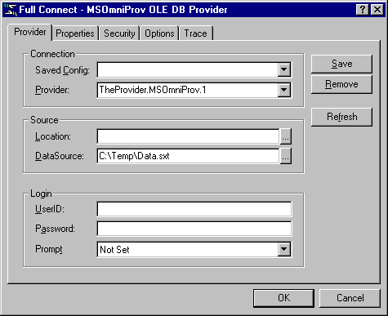
- Select the "Full Connect" Option in the "File" menu,
- Set up Full Connect parameters as shown in the figure and Press 'OK'
FIGURE 7: Setting connection parameters for the RowsetViewer consumer
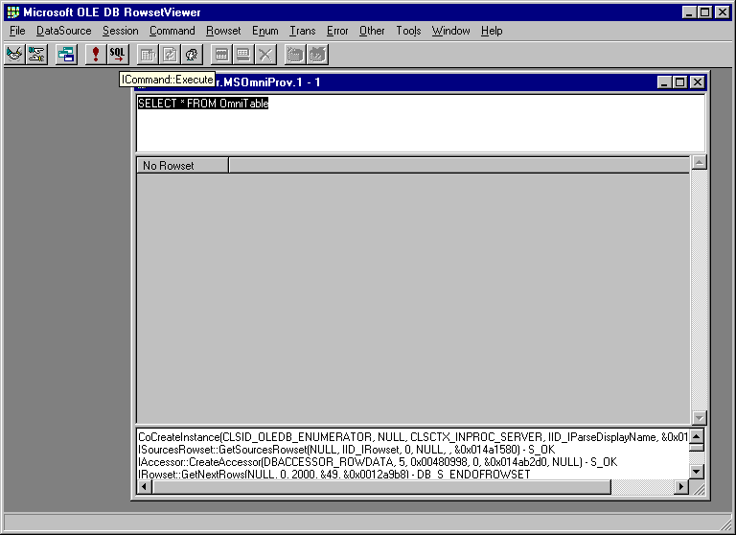
- Type the query and Press on the "SQL" button, that translates to an ICommand::Execute method call; as shown in the figure below:

FIGURE 8: Setting the SQL Query.

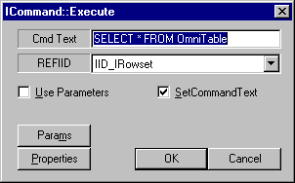
- Execute the query by pressing on the OK button.

FIGURE 9: Executing the SQL Query.

- This should return data into the Rowset window as shown in the figure below.
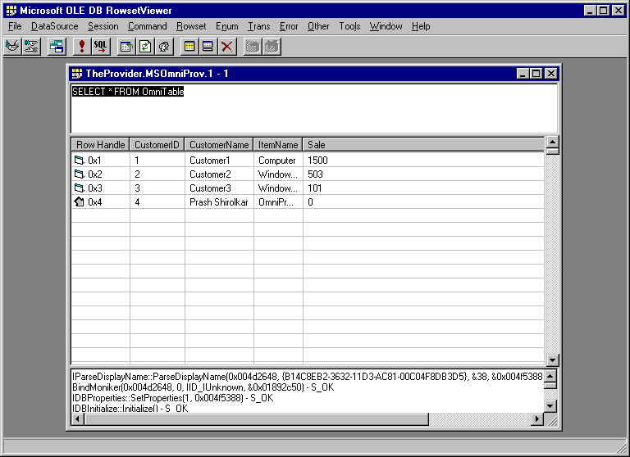
FIGURE 10: Executing the SQL Query.

Appendix B: Do's and Don'ts about OmniProv1.0
- Testing: This provider has been tested under Win9x and WinNT 4.0 only.
- SQL Support: It provides limited SQL Support restricted only to "Select * from <Table_Name>" queries. It is not advisable to use client-side cursors with the OmniProv.
- Schema: Schema information is provided for DBSCHEMA_TABLES, DBSCHEMA_COLUMNS and DBSCHEMA_PROVIDER_TYPES. This information is tailored to the data file being distributed with the OmniProv only. Any customizations will warrant changes to the Schema classes of the OmniProv.
- Scalability: OmniProv1.0 is not capable of scaling up to deal with multiple data files with multiple tables. This will have to be achieved programmatically by altering the schema and the source code.
- Support: There is no support for ISupportErrorInfo or ITransaction. Using OmniProv1.0 as a linked server in SQL server is not recommended.
- Multi-user Access: Only one user can make changes to the back-end at a time. Others can open the back-end database as read-only.
- Client-Side Cursor: OmniProv1.0 does not provide SQL_SUPPORT. It only recognizes a query of the type "SELECT * FROM <Table_Name>" where the Table_Name has to be defined within the schema file. Client-side cursors require SQL_SUPPORT. Hence, if OmniProv1.0 were used with client-side cursors it would not comprehend SQL statements passed to it. This could result in unpredictable results from OmniProv1.0.

Appendix C: Common Error Messages
While using the OmniProv.1 provider, following errors may be encountered:
- "Catastrophic Failure"
- "Unspecified Error"
Situation: During the startup of the program these errors could be encountered. These could be attributed to the following reasons:
Reason(s)
- Error in the connection string. Check to see if the Provider property is assigned to "TheProvider.MSOmniProv.1" and the Data Source property points to correct schema file. Additionally, make sure the data file is located in the same folder as the schema file.
- The schema file or data file contains no data or corrupted data.
- Some other process is using the schema or data file. For multi-user access, please refer to Appendix B.

REFERENCES (Editor: please create links when putting this paper out)
- OLEDB 2.0 Programmers Reference.
- Creating an OLE DB Template Provider
- Using the OLE DB Provider Templates
- Macros for OLE DB Provider Templates
- FAQ: Using the OLE DB Provider Templates
- PROVIDER: OLE DB Provider Templates Sample
- Mapping ADO Methods to OLE DB Interfaces
- Using the Visual C++ 6.0 OLE DB Provider Templates
- Enhancing the Simple Read-Only Provider

Note: All the references can be obtained from MSDN Books-on-line by searching at http:\\msdn.microsoft.com\

Keywords:
Microsoft Data Access Components 2.5; ATL OLEDB Provider; OmniProv; OmniProv1.0; ActiveX Controls; Microsoft DataGrid Control 6.0; ADO Data Grid; Microsoft ADO Data Control 6.0 (OLEDB); ADO Data Control; Grammar; Schema;

