Microsoft Corporation Technical Documentation License Agreement (Standard)
READ THIS! THIS IS A LEGAL AGREEMENT BETWEEN MICROSOFT CORPORATION ("MICROSOFT") AND THE RECIPIENT OF THESE MATERIALS, WHETHER AN INDIVIDUAL OR AN ENTITY ("YOU"). IF YOU HAVE ACCESSED THIS AGREEMENT IN THE PROCESS OF DOWNLOADING MATERIALS ("MATERIALS") FROM A MICROSOFT WEB SITE, BY CLICKING "I ACCEPT", DOWNLOADING, USING OR PROVIDING FEEDBACK ON THE MATERIALS, YOU AGREE TO THESE TERMS. IF THIS AGREEMENT IS ATTACHED TO MATERIALS, BY ACCESSING, USING OR PROVIDING FEEDBACK ON THE ATTACHED MATERIALS, YOU AGREE TO THESE TERMS.
1. For good and valuable consideration, the receipt and sufficiency of which are acknowledged, You and Microsoft agree as follows:
(a) If You are an authorized representative of the corporation or other entity designated below ("Company"), and such Company has executed a Microsoft Corporation Non-Disclosure Agreement that is not limited to a specific subject matter or event ("Microsoft NDA"), You represent that You have authority to act on behalf of Company and agree that the Confidential Information, as defined in the Microsoft NDA, is subject to the terms and conditions of the Microsoft NDA and that Company will treat the Confidential Information accordingly;
(b) If You are an individual, and have executed a Microsoft NDA, You agree that the Confidential Information, as defined in the Microsoft NDA, is subject to the terms and conditions of the Microsoft NDA and that You will treat the Confidential Information accordingly; or
(c)If a Microsoft NDA has not been executed, You (if You are an individual), or Company (if You are an authorized representative of Company), as applicable, agrees: (a) to refrain from disclosing or distributing the Confidential Information to any third party for five (5) years from the date of disclosure of the Confidential Information by Microsoft to Company/You; (b) to refrain from reproducing or summarizing the Confidential Information; and (c) to take reasonable security precautions, at least as great as the precautions it takes to protect its own confidential information, but no less than reasonable care, to keep confidential the Confidential Information. You/Company, however, may disclose Confidential Information in accordance with a judicial or other governmental order, provided You/Company either (i) gives Microsoft reasonable notice prior to such disclosure and to allow Microsoft a reasonable opportunity to seek a protective order or equivalent, or (ii) obtains written assurance from the applicable judicial or governmental entity that it will afford the Confidential Information the highest level of protection afforded under applicable law or regulation. Confidential Information shall not include any information, however designated, that: (i) is or subsequently becomes publicly available without Your/Company’s breach of any obligation owed to Microsoft; (ii) became known to You/Company prior to Microsoft’s disclosure of such information to You/Company pursuant to the terms of this Agreement; (iii) became known to You/Company from a source other than Microsoft other than by the breach of an obligation of confidentiality owed to Microsoft; or (iv) is independently developed by You/Company. For purposes of this paragraph, "Confidential Information" means nonpublic information that Microsoft designates as being confidential or which, under the circumstances surrounding disclosure ought to be treated as confidential by Recipient. "Confidential Information" includes, without limitation, information in tangible or intangible form relating to and/or including released or unreleased Microsoft software or hardware products, the marketing or promotion of any Microsoft product, Microsoft's business policies or practices, and information received from others that Microsoft is obligated to treat as confidential.
2. You may review these Materials only (a) as a reference to assist You in planning and designing Your product, service or technology ("Product") to interface with a Microsoft Product as described in these Materials; and (b) to provide feedback on these Materials to Microsoft. All other rights are retained by Microsoft; this agreement does not give You rights under any Microsoft patents. You may not (i) duplicate any part of these Materials, (ii) remove this agreement or any notices from these Materials, or (iii) give any part of these Materials, or assign or otherwise provide Your rights under this agreement, to anyone else.
3. These Materials may contain preliminary information or inaccuracies and may not correctly represent any associated Microsoft Product as commercially released. All Materials are provided entirely "AS IS." To the extent permitted by law, MICROSOFT MAKES NO WARRANTY OF ANY KIND, DISCLAIMS ALL EXPRESS, IMPLIED AND STATUTORY WARRANTIES, AND ASSUMES NO LIABILITY TO YOU FOR ANY DAMAGES OF ANY TYPE IN CONNECTION WITH THESE MATERIALS OR ANY INTELLECTUAL PROPERTY IN THEM.
4. If You are an entity and (a) merge into another entity or (b) a controlling ownership interest in You changes, Your right to use these Materials automatically terminates and You must destroy them.
5. You have no obligation to give Microsoft any suggestions, comments or other feedback ("Feedback") relating to these Materials. However, any Feedback you voluntarily provide may be used in Microsoft Products and related specifications or other documentation (collectively, "Microsoft Offerings") which in turn may be relied upon by other third parties to develop their own Products. Accordingly, if You do give Microsoft Feedback on any version of these Materials or the Microsoft Offerings to which they apply, You agree: (a) Microsoft may freely use, reproduce, license, distribute, and otherwise commercialize Your Feedback in any Microsoft Offering; (b) You also grant third parties, without charge, only those patent rights necessary to enable other Products to use or interface with any specific parts of a Microsoft Product that incorporate Your Feedback; and (c) You will not give Microsoft any Feedback (i) that You have reason to believe is subject to any patent, copyright or other intellectual property claim or right of any third party; or (ii) subject to license terms which seek to require any Microsoft Offering incorporating or derived from such Feedback, or other Microsoft intellectual property, to be licensed to or otherwise shared with any third party.
6. Microsoft has no obligation to maintain confidentiality of any Microsoft Offering, but otherwise the confidentiality of Your Feedback, including Your identity as the source of such Feedback, is governed by Your NDA.
7. This agreement is governed by the laws of the State of Washington. Any dispute involving it must be brought in the federal or state superior courts located in King County, Washington, and You waive any defenses allowing the dispute to be litigated elsewhere. If there is litigation, the losing party must pay the other party’s reasonable attorneys’ fees, costs and other expenses. If any part of this agreement is unenforceable, it will be considered modified to the extent necessary to make it enforceable, and the remainder shall continue in effect. This agreement is the entire agreement between You and Microsoft concerning these Materials; it may be changed only by a written document signed by both You and Microsoft.


Introduction to SDCA (SoundWire Device Class for Audio)
Spec Status: Draft Version 0.1

Contents
 1
1 SDCA VAD Overview 3
1.1 Architecture Diagram 3
1.2 Driver Descriptions 3
2 Generic SDCA Overview 4
2.1 Architecture Diagram 4
2.2 Driver Descriptions 4

Table of Figures

Figure 1 SDCA VAD Architecture 3
Figure 2 Generic SDCA Architecture 4

SDCA VAD Overview

Architecture Diagram

Figure 1 SDCA VAD Architecture

Driver Descriptions
- SDCA VDsp Driver
  - SdcaVDsp.sys
  - Root enumerated driver
  - This sample driver shows how to stream data to and from OS
  - On a real system, this driver will be replaced by “SDCA Streaming Driver”, generally provided by the SOC vendor
- SDCA VXu Driver
  - SdcaVXu.sys
  - Sits as a lower filter driver below SDCA VCodec Driver
  - This sample driver shows how to interact with ACX framework and the SDCA Class driver
  - On a real system, this driver will be replaced by “SDCA XU Driver”, generally provided by the SDCA Function Device vendor
- SDCA VCodec Driver
  - SdcaVCodec.sys
  - Root enumerated driver
  - This sample driver shows how to interact with ACX framework and the SDCA XU driver
  - On a real system, this driver will be replaced by “SDCA Class Driver”, provided by Microsoft.
The above-mentioned drivers are meant to demonstrate how to use ACX framework and various SDCA interfaces. They do not work on any real hardware.

Generic SDCA Overview

Architecture Diagram

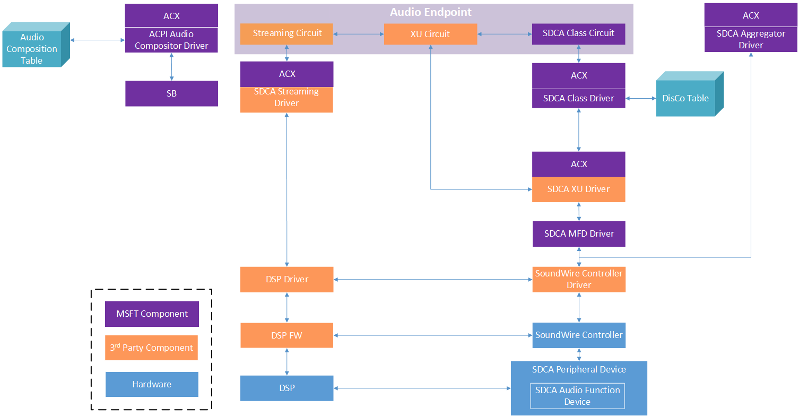

Figure 2 Generic SDCA Architecture
Above diagram shows a generic SDCA architecture on Windows. The architecture will vary slightly from one SOC vendor to another.

Driver Descriptions
SDCA Drivers
- SoundWire Controller Driver
  - Name varies
  - Provided by the SOC vendor
  - This driver exposes the IOCTL-based interface that allows the other drivers to interact with the SoundWire Controller and SDCA Peripheral Hardware
  - This driver creates a Device PDO for each SDCA Peripheral Device and SDCA Aggregator device
- SDCA Streaming Driver
  - Name varies
  - This driver is responsible for streaming data to and from the DSP on the system.
- SDCA MFD Driver
  - SdcaMfd.sys (“Multi-Function Device”)
  - Provided by Microsoft
  - This driver is loaded for each SDCA Peripheral Device
  - This driver creates Device PDOs for each SDCA Audio Function on the SDCA Peripheral Device
- SDCA XU Driver
  - Name varies
  - Provided by the SDCA Audio Function Hardware vendor
  - The SDCA XU driver sits as a lower filter driver below the SDCA Class driver
    - This ensures the SDCA XU driver is always loaded against the SDCA Peripheral Device before the SDCA Class driver is loaded
  - The SDCA XU driver allows the SDCA Function Device vendor to add additional behavior and logic to augment the SDCA Class driver
- SDCA Class Driver
  - SdcaClassV06.sys or SdcaClass.sys
    - SdcaClassV06 contains logic for SDCA Spec version 0.6 revision 4 hardware
  - Provided by Microsoft
  - This driver controls one SDCA Audio Function
  - This driver allows the SDCA Audio Function to be configured for basic streaming scenarios. More complicated scenarios that rely on vendor-specific logic require the SDCA XU driver to function correctly.
- SDCA Aggregator Driver
  - SdcaAggregator.sys
  - Provided by Microsoft
  - This driver is loaded as a child device of the SoundWire Controller device
  - This driver unifies two identical SDCA Audio Function devices into a single endpoint
- Audio Compositor Driver
  - AcpiAudioCompositor.sys
  - Provided by Microsoft
  - This driver consumes the Audio Composition table in the ACPI to determine how to connect the various audio devices (DSP, SDCA Audio Function) to create audio endpoints

