Software Requirements Document
For
Windows Azure ACS – Java Library for Authentication and Authorization.
Version 1.0
Prepared by Suresh Nallamilli
v-sunal@microsoft.com
Interoperability
March 06, 2012

Table of Contents
Table of Contents 2
Revision History 3
1. Introduction 4
1.1 Purpose/Scope 4
1.2 Summary of changes 4
1.3 Target audience 4
1.4 Assumptions and Dependencies 4
2. ACSAuthFilter Requirements 5
2.1 Requirements 5
2.2 Testing Tips 6

Revision History
Version | Date | Name | Comments
1.0 | 03/06/2012 | Suresh Nallamilli | Initial Draft

1. Introduction

This document outlines the Software requirements to develop a java library, here after referred as “ACSAuthFilter”, to communicate with Windows Azure ACS for authentication and authorization purpose.

Purpose/Scope
The purpose of this document is to outline the requirements for development of ACSAuthFilter,

This document covers only ACSAuthFilter requirements. Information about Windows Azure ACS and its configuration is outside the scope of this document.

Summary of changes
Java library wrapper development to implement website scenario of Windows Azure ACS.

Target audience
Development and Testing Teams.

Assumptions and Dependencies
- Cookies(at a minimum session cookies) will be enabled

- Need to have a properly configured ACS service.

- This filter has an external hard dependency on Apache’s commons-logging.jar

ACSAuthFilter Requirements
Following are the high level requirements of ACSAuthFilter

Requirements
- Need to develop a java library which automates website scenario of windows Azure ACS.

This web site scenario is shown below:

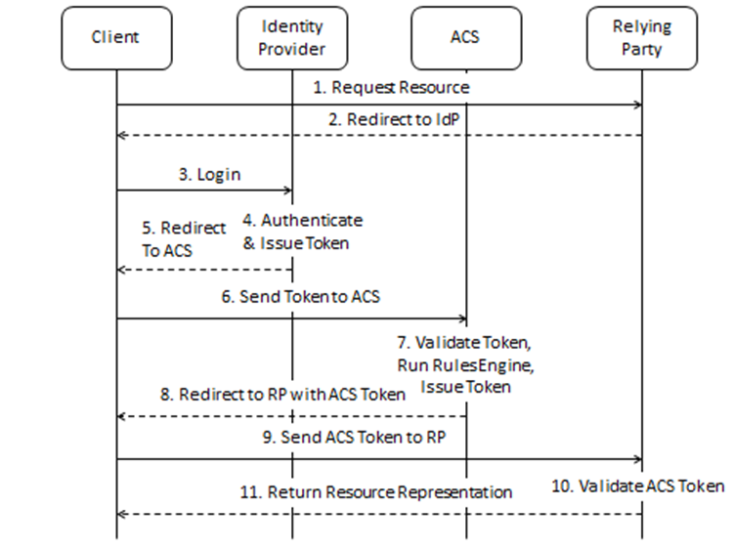

- For more details on web site scenario , please refer to documentation available at
http://acs.codeplex.com/documentation

- ACSAuthFilter need to intercept http request and see if the request is having valid credentials to access resources, if not it need to redirect to Windows Azure ACS endpoint.

Windows Azure ACS displays a login page with the identity providers that are configured and once successfully authenticated; ACS sends back SAML response to relying party.

- Java filter need to intercept response from ACS and parse SAML response to do following
- Validate signature of SAML response using CN (Common Name) provided in web.xml.
- Validate if the token is within the range of date validity.
- Extract claims and enable claims to be accessible over http request, so that developers of web applications can access the claims to add authorization logic in their web applications.
- Store required SAML information in session cookies, so that further subsequent request from the client need not go through login process again.

- ACSAuthFilter may need below configuration parameters in web.xml for it to communicate with Windows Azure ACS
- PassiveRequestorEndpoint, in other words this is ACS end point.
- RelyingPartRealm, this is the same value what will be provided in ACS portal at the time of configuring the ACS service.
- CertificatesPath
Please note that in case of CA signed certificates, this needs only Root and intermediate certificates only
- SigningCertificateSubject

Testing Tips
- Test the filter functionality in all the major browsers. Suggested versions are IE8,IE9,IE10(or whichever is latest) , Firefox , chrome and safari

- Test the filter in different java web / application servers. Suggested servers are tomcat 6 and 7, Jetty 7 and 8, Jboss 6 and 7, glassfish3, WebSphere application server community edition and WAS.

- Test the filter functionality by using both self-signed and CA signed certificates.

- Test the filter so that at a minimum it is supporting Windows Live, Yahoo and Google.

- Make sure that once the browser is closed all the filter related information is no longer accessible.

- Try with disabling cookies and also in private mode and see the behavior. The expected behavior over here is filter should not work provided if browser is not supporting session cookies also when cookies are disabled or in-private mode.

- Try to write a sample application and see if filter is working as expected after configuring the required configuration parameters.

- If possible see if there are any security related vulnerabilities.

