Windows Search Protocol Specification (MS-WSP)  “The overall goal is to validate the accuracy and usability of Technical Documents” | Version  4.0
Protocol Quality Assurance Report | Version  4.0

Test Suite Owner | Lav Gupta (v-lavg) | TD Location | \\nmtest\McppDocs\Monthly\2008_09_04_09_00\MCPP\Pdf
Current Phase | Final | TD Version and date | v20080904
Target Milestone | C7 | Designated Reviewer | Chi Song
Last Updated | 09/24/2008 | Protocol Team Contact | Satish Kaushik [satishka@microsoft.com]
Based on Template version 1.2
1 Document Review 3
1.1 Introduction 3
1.2 Protocol Properties 4
1.3 Results of Document Review 4
1.4 Recommended Test Approach 7
1.4.1 Manual Approach 7
1.4.2 Traditional Approach 7
1.4.3 Model Based Approach 8
1.4.4 Selected Approach 8
1.5 Adapter Method Suggested 8
1.6 Estimates 9
2 Test Suite Planning 9
2.1 Assumptions, Scope and Constraints 9
2.2 Test Suite Approach 10
2.3 Technical Feasibility of Message Generation/Adapter Approach 11
2.4 Dependencies/Considerations 11
2.5 Scenarios 11
2.6 Requirements coverage 13
2.7 TDIs filed 13
3 Test Suite Design 15
3.1 Model or Test Design Description 15
3.1.1 Test Design Description 15
3.1.2 Model description 15
3.2 Test Environment 20
3.2.1 Test Suite Environment 20
3.2.2 Test Execution Environment 20
3.3 Test Preparation 21
3.3.1 Test Suite Preparation 21
3.3.2 Test Execution Preparation 21
3.4 Test Cases 21
3.5 Adapter Design 23
3.5.1 WspAdapter 23
3.5.2 MessageBuilder: 26
3.5.3 Helper: 27
3.5.4 MessageValidator: 28
3.5.5 RequestSender: 29
3.5.6 Enums: 29
3.5.7 Sequence Diagram 30
3.6 Exceptions/Deviations 30
3.7 TDIs filed 31
4 Implementation and Execution 32
4.1 Overall Test Suite Summary 32
4.2 Test Report 33
4.3 TDIs Filed 33
4.4 Product Bugs Filed 35
4.5 Requirement Coverage Statistics 35
4.6 Sustaining Engineering 36
5 Housekeeping 37
5.1 Checklist 37
5.2 Related Links 37
5.3 Issues 37
5.4 Cuts 37
5.5 Change History 37

Document Review

Introduction
Windows Search Protocol (MS-WSP) allows a client to query and administer catalogs hosted by a Windows Search Service running on a remote server. A catalog represents a set of documents indexed by Windows Search Service. Windows Search Service maintains catalogs by extracting useful information after analyzing the documents. Extracted information is organized to efficiently return response to queries sent by the client. Client-Server communication occurs by exchanging Request and Response messages.

Remote Querying:
Remote query is a multi-step task that involves a client to send following messages in tandem:
- Establish connection with the server.
- Send query parameter.
- Specify expected result of the query.
- Obtain the result sets.
- Check the status of the query (optional).
- Release the query once the result sets are obtained.
- Release the connection with the server.
The following diagram depicts a typical message sequence for a simple query from a client to remote server:

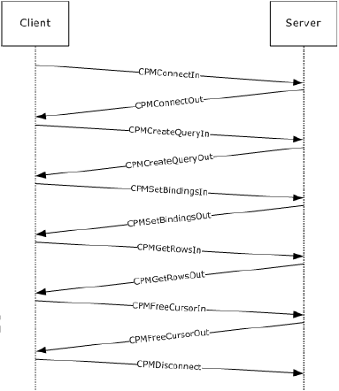

Remote Administration:

The Windows Search Protocol enables the following Windows Search service catalog management tasks from a client:

- Query the current state of catalog on the server.
- Update the state of a catalog.
- Launch the indexing process for a particular set of files.
- Initiate optimization of an index to improve query performance.
No state is maintained on the client for any administration call. The administrative calls can be made in any order.
The following diagram depicts a typical message sequence for administrative tasks from a client to remote server:

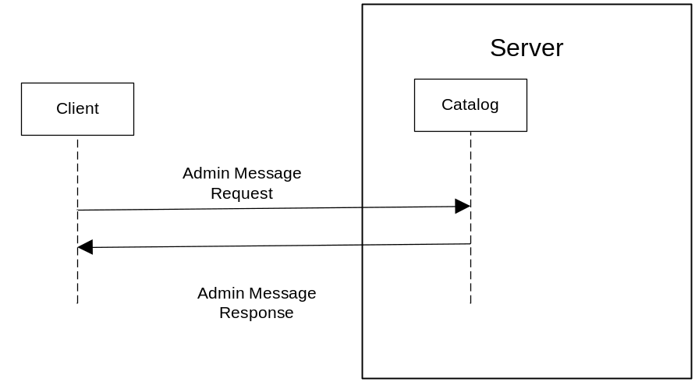

Protocol Properties
Windows Search Protocol is a Block protocol. It uses the underlying SMB named pipe protocol (\pipe\MSFTEWDS) to retrieve the identity of the caller that made the connection. It is designed for querying and managing catalogs (a collection of documents that can be queried) on remote server from a client. Messages are exchanged between client and server synchronously.
There are no additional protocol security considerations other than the one used by underlying SMB Named Pipe. The Named Pipe sets the SECURITY_IDENTIFICATION as the Impersonation Level in the request to open the named pipe. None of the protocol messages are encrypted.

Results of Document Review
Forty nine TDIs were filed and nine editorial suggestions were submitted.
Technical document has missing information that could affect implementation of test suite, for which, appropriate TDIs were filed. However, the overall protocol behavior, scope and usage are described clearly for it to be considered adequate for testing.

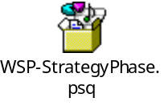

TDI summary report as on 24th Sep 2008

TDI# | Priority | Severity | Status | Resolution | Description
8349 | 2 | 3 | Closed | Fixed | [MS-WSP] : Description is not available for CPMSetBindingsOut Message Structure in document
8354 | 3 | 3 | Closed | Fixed | [MS-WSP]:Clarification on description between two constant values
8456 | 3 | 3 | Closed | Fixed | [MS-WSP]: Description is not available for Serialized value in SERIALIZEDPROPERTYVALUE Structure in document
8457 | 3 | 3 | Closed | Fixed | [MS-WSP] : Field _dummy is missing in the Protocol example
8458 | 3 | 3 | Closed | Fixed | [MS-WSP] : Insufficient information in Abstract Data Model.
12763 | 2 | 2 | Closed | Fixed | [MS-WSP]:Section 1: Template Violation
12765 | 2 | 2 | Closed | Fixed | [MS-WSP]: Section 4.1 :Incorrect protocol server.
13473 | 2 | 2 | Closed | Fixed | [MS-WSP]:Section 2.2.2 : Incorrect reference
13573 | 3 | 3 | Closed | Fixed | [MS-WSP]: Section 4.1 : Incorrect Message given in step 14
13574 | 3 | 3 | Closed | Fixed | [MS-WSP]: Section 4.1 : Incorrect Message given in step 9
13576 | 3 | 3 | Closed | Fixed | [MS-WSP]: Section 3.1.5 : Field name Incorrect
13865 | 1 | 2 | Closed | Fixed | [MS-WSP]: Section 2.2.3.4 Insufficient Information
13944 | 2 | 2 | Closed | Fixed | [MS-WSP]:Certificate Requirements not specified
14181 | 2 | 2 | Closed | Fixed | [MS-WSP]: Ambiguous/ Redundant Information given to validate the _ulChecksum field
14185 | 2 | 2 | Closed | Fixed | [MS-WSP]:Section 2.2.1.11 Invalid use of Normative SHOULD
14218 | 2 | 2 | Closed | Fixed | [MS-WSP]:Section 2.2.1.24 : Incorrect field name
14219 | 2 | 2 | Closed | Fixed | [MS-WSP]:Section 2.2.1.32.1 : Unclear\Incorrect information
14221 | 2 | 2 | Closed | Fixed | [MS-WSP]:Section 2.2.3.6: Incorrect Field
14231 | 2 | 2 | Closed | Fixed | [MS-WSP]:No Windows behavior for the optional/ambiguous requirements
14296 | 2 | 2 | Closed | Fixed | [MS-WSP]:Section 3.1.5.1.2: Condradicting information given for the response of server to CPMUpdateDocumentsIn message.
14360 | 2 | 2 | Closed | Fixed | [MS-WSP]: Section 3.1.5.2.3 : _QStatus field not defined
14422 | 2 | 2 | Closed | Fixed | [MS-WSP]: Undefined field VT_BLOB_OBJECT
14472 | 2 | 2 | Closed | Fixed | [MS-WSP]: Section 6. <7> : Windows XP and Windows Server 2003 are given in the table indicating possible client systems.
14855 | 2 | 2 | Closed | Fixed | [MS-WSP]: Section 2.2.1.23 : Incorrect usage of MAY
14863 | 2 | 2 | Closed | Fixed | [MS-WSP]: Section 2.2.1.1.1.2: Incorrect field size given for vVectorData
14864 | 2 | 2 | Closed | Fixed | [MS-WSP]: Section 2.2.3.4: Incorrect reference given
14865 | 2 | 3 | Closed | Fixed | [MS-WSP]: Section 1.3.2 : Step missing in the steps given for sending a search query .
14866 | 2 | 2 | Closed | By Design | [MS-WSP]: Section 2.2.1.1/ 2.2.1.1.1.2 : Invalid element type in structure
14867 | 2 | 2 | Closed | Fixed | [MS-WSP]: Section 2.2.3.4: The field "cExPropSet" not defined.
15112 | 2 | 2 | Closed | Fixed | [MS-WSP]: Section 2.2.1.4 Unreferenced structure CKey in the TD
15114 | 1 | 2 | Closed | Fixed | [MS-WSP]: Section 1.3: Incomplete information in the TD.
15310 | 1 | 2 | Closed | Fixed | [MS-WSP]: Section 2.2.1.17: Undefined fields RestrictionWithFlag and CRestrictionWithFlag.
15369 | 2 | 2 | Closed | Fixed | [MS-WSP]: Section 2.2.5: Reference missing
15412 | 2 | 2 | Closed | Fixed | [MS-WSP]: Incomplete information.
15500 | 2 | 2 | Closed | Fixed | [MS-WSP]:Section 3.1.5 :Fig-5 : Incorrect pre-requisite message for CPMGetRowsIn Message
15682 | 1 | 2 | Closed | Fixed | [MS-WSP]:Section 3.1.5 :Fig-5 :Messages mentioned in the fig doesn't exists in the TD description.
15686 | 2 | 2 | Closed | Fixed | [MS-WSP]:Section 3.1.5 :Fig-5 :Messages missing in the fig.
15688 | 2 | 2 | Closed | Fixed | [MS-WSP]:Section 3.1.5 :Fig-5 : Description for CPMFetchValueIn is not in sync with fig.
15918 | 2 | 2 | Closed | Fixed | [MS-WSP]:Section 3.1.5.2.10 : Wrong response for CPMGetApproximatePositionIn Request.
16031 | 2 | 2 | Closed | Fixed | [MS-WSP]:Section 2.2.3.9 :Two fields with same name.
16128 | 2 | 2 | Closed | Fixed | [MS-WSP]: Section [ 2.2.1.40 ]: Incorrect description
16131 | 1 | 2 | Closed | Fixed | [MS-WSP]: Section [ 2.2.1.31 ] Missing information
16132 | 2 | 2 | Closed | Fixed | [MS-WSP]: Section[2.2.3.4] Lack of clarity
16133 | 2 | 2 | Closed | Fixed | [MS-WSP]: Section[2.2.1.32] Lack of clarity
16309 | 2 | 2 | Closed | Fixed | [MS-WSP]: Section [2.2.3.18] : Incorrect field description for CPMFetchValueOut message.
16895 | 1 | 2 | Closed | By Design | [MS-WSP]: Section 2.2.1.17: Padding field observed in CRestiction structure which is not defined in TD
16910 | 2 | 2 | Closed | Fixed | [MS-WSP] : Section 2.2.1.32.1 , A structure is assigned to a value which is not defined
16916 | 2 | 2 | Closed | Fixed | [MS-WSP]:Section 2.2.1.32 Missing Information
17325 | 2 | 2 | Closed | Fixed | [MS-WSP]: Section 2.2.3.4, Incorrect values for iClientVersion field

Recommended Test Approach
MS-WSP operations involve simple request/response communication pattern. Server Requirements are specific to the syntax and structure of the messages and not on how they are exchanged between client and server.
- PAC cannot be used because the message structures include dynamic padding.
- Messages and nested structures would be hard coded as specified in the Technical Document.
Following approaches were evaluated for validation of MS-WSP Technical document.

Manual Approach

Generation of traffic can be done using a Search Utility tool or Management Consoles (e.g. Windows Search). Message sequences can be validated using network sniffer tool such as Network Monitor. Sequence of messages can be validated using Network Monitor. However, it is difficult and consumes more time to validate message payload manually considering the complexity of the messages.

Traditional Approach

Traditional testing can be performed by following any one of the below mentioned approaches:

- Traditional test with Synthetic Packet generation:
Traffic can be generated by synthesizing protocol messages and sending over protocol transport (Named Pipe). Message sequence and payload can be validated by reading the Named Pipe for server responses. However, considering the complexity of protocol messages, synthetic message generation will take significant amount of time and effort.

- Traditional test using existing tools:
Network traffic can be generated using existing tools. Netmon API can be used to validate the message sequences and message payload. All logical sequences may not be achieved as there will not be control over message sequencing and changing Protocol Data Units (PDUs).

Model Based Approach

The protocol client maintains no state for self. The Windows Search Service has "not initialized", "running", and "shutting down" states.

There are a few messages sequencing rules that dictate the order in which operations need to be performed. Although, most of the requirements to be validated are specific to the syntactical consistency of the message payload flowing over wire, modeling provides a systematic approach to deal with the server states and the ease to implement the sequences specified in the protocol document. Message structures are framed synthetically and sent over the Named Pipe (protocol transport).

Selected Approach

“Model with Synthetic Message generation” is selected over other two approaches because of following reasons:

- Manual validation requires more effort and is inefficient as structures in the messages are very complex.
- Though most of the messages have a common prerequisite message, the protocol does not pose any restrictions on the order in which the messages flow on the wire.

Most of the server requirements fall under payload validations which includes validating the syntactical consistency of the messages and testing the fields of the messages adhering to the boundary conditions and typical values defined by the protocol.

Adapter Method Suggested
A managed adapter will be written to abstract the details of traffic generation from the test suite. The adapter will expose simple methods which test suite can invoke with required parameters. This adapter will be responsible for synthetically framing client messages and send them to server over SMB Named Pipe (\pipe\MSFTEWDS). Server writes back the response to the same pipe. Syntactic validation of response messages from server will be done in adapter.

Estimates
Test Suite Deliverables and Estimates:

Doc Page | Protocol Name | Package | EstMethod | Doc Revw | Req Spec | Prot Model | Adapt | Auto Exec | Final Revw | Total Est
MsWSPDocumentV1 | [MS-WSP]: Windows Search Protocol Specification | ModelAndTest | Manual | 65 | 70 | 91 | 101 | 41 | 20 | 388
Test Cluster (e.g. C6 = PTSClusterSix) |  |  |  | C6 | C7 | C7 | C7 | C7 | C7

Test effort estimations for protocol:

Last Modified: 9/25/2008

Deliverable | Estimated (days) | Actual | Remaining | Slip | % Complete
Document Review | 65 | 181 | 0 | -116 | 100
Requirement Specification | 70 | 184 | 0 | -114 | 100
Protocol Modeling | 75 | 82 | 0 | -7 | 100
Adaptering | 101 | 151 | 0 | -50 | 100
Auto Test Execution | 24 | 19 | 0 | 5 | 0
Final Review | 20 | 0 | 20 | 0 | 0

Note:

The document was suspended for a while as it went through a major revision. Before the document was suspended, 84 and 47 person days of efforts were spent on Document Review and Requirement Specification respectively.

Test Suite Planning

Assumptions, Scope and Constraints
Assumptions

- The test suite assumes that the name of the server and a catalog name are known to the client.
- The test suite assumes that the client and server have a security association that is usable with named pipes.

In Scope

- Validation of the server responses for search queries invoked by the client.
- The Windows Search Services Protocol is designed for querying and managing catalogs on a remote server from a client in the following versions in 32 and 64 bit Windows.
- Windows Server 2008
- Windows Vista
- Windows Server 2003 and Windows XP (Act as a server or a client if Windows Search Version 4 is installed).
- Windows Server 2003 and Windows XP (Act only as a client if Windows Search Version 3 is installed).

Out of Scope

- The validation of the protocol client requirements is not in the scope of the test suite.

Constraints

- The test suite uses single connection and is not considering any race condition.

Test Suite Approach
Protocol server is the system under test (SUT). Spec Explorer is used to generate the model for the protocol. Spec Explorer generated test cases will be used for testing the MS-WSP Technical Document. Protocol request messages are defined as method calls and their respective responses are defined as event callback.

- Each request initiated from the client and response from the server is represented as an action in model.
- Synchronous modeling pattern is used.
- Appropriate abstraction mechanism has been followed for representation in model. Enumerators and abstract identifiers are used.

Architectural Diagram depicting the Test Suite approach:

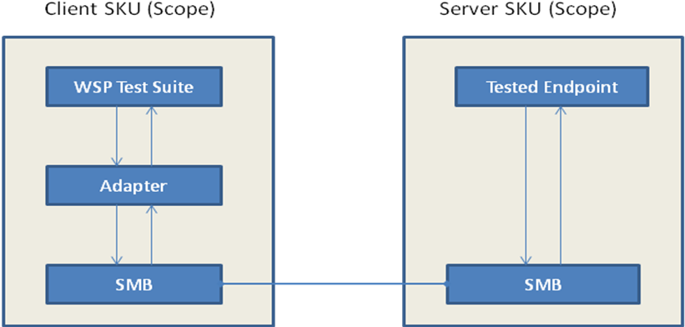

MS-WSP.chm embedded below describes the interface planned, covering all the data structures and methods used by the Test Suite.

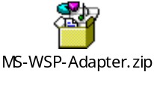
Model Abstraction Level:

- There is a one-to-one correspondence between the protocol messages and the actions in the test suite.
- The actions corresponding to the request messages are calls. The actions corresponding to the response from the server are events.
- There are no actions other than one specific to protocol messages. Model does not use any action to initialize the SUT or to obtain information from the server.
- All input variations would be handled as a part of Model. The variables for which there are variations or the ones that are causing change in state are abstracted and taken as parameters in model actions (request actions).
- The response Messages and Structures will be validated in the adapter.
- The model targets the behavior for correctness of the protocol and not the completeness.

Technical Feasibility of Message Generation/Adapter Approach

WSP messages will be generated using synthetic packet approach. The request messages will be framed and sent to the server using the named pipe over SMB.

A managed adapter is written to abstract the details of traffic generation from the test suite. WSP adapter exposes simple methods, which test suite can invoke with required parameters. This adapter is responsible for synthetically framing client messages and sending them to server over SMB Named Pipe (\pipe\MSFTEWDS). Server writes back the response to the same pipe. Syntactic validation of response messages from server will be done in adapter.
All the message sequence related validation and error code validation will be done in the protocol model.

Dependencies/Considerations

- MS-WSP uses SMB as a transport protocol.
- All the messages are transported using a named pipe \pipe\MSFTEWDS.

Scenarios
MS-WSP Protocol will be tested with following scenarios (including negative scenarios) based on Request and Response messages:

QueryForResultSets:
This scenario validates the server responses for the query result sets:
The client sends the request CPMConnectIn to the server hosting WSS, server acknowledges the request with a CPMConnectOut response.
The client then sends the CPMCreateQueryIn request specifying the query scope and the restrictions. The server responds with CPMCreateQueryOut message.
The client then sends a CPMSetBindingsIn request, the server responds with the header of CPMSetbindingsIn message.
The client then sends a CPMGetRowsIn message to the server, the server responds with CPMGetRowsout message containing the rows to be returned.
The client then sends the CPMFetchValueIn request, the server responds with CPMFetchValueOut message.
The client then sends the CPMFreeCursorIn message to free all the cursors held by the server, the server releases all the cursors and responds with CPMFreeCursorOut message.
The client then sends CPMDisconnect message to release the connection.

QueryForDifferentQueryStatus:
This scenario validates the server responses for the different query status requests sent by the client:
The client sends the request CPMConnectIn to the server hosting WSS, server acknowledges the request with a CPMConnectOut response.
The client then sends the CPMCreateQueryIn request specifying the query scope and the restrictions. The server responds with CPMCreateQueryOut message.
The client then sends a CPMQueryStatusIn request, the server responds with the CPMQueryStatusOut message.
The client then sends a CPMQueryStatusExIn request, the server responds with the CPMQueryStatusExOut message.
The client then sends the CPMRatioFinishedIn request, the server responds with CPMRatioFinishedOut message.
The client then sends the CPMGetNotify request, the server responds with CPMSendNotifyOut message.
The client then sends the CPMFreeCursorIn request, the server responds with
CPMFreeCursorOut message.
The client then sends CPMDisconnect message to release the connection.

QueryAdminMessages:
This scenario validates the server responses when the client sends the request to perform any catalog management task on the server:
The client sends the request CPMConnectIn to the server hosting WSS, server acknowledges the request with a CPMConnectOut response.
The client sends the request CPMCiStateInOut to the server hosting WSS, server acknowledges the request with the CPMCiStateInOut response.
The client sends the request CPMForceMergeIn to the server hosting WSS, server acknowledges the request with the header of CPMForceMergeOut message as response.
The client then sends CPMDisconnect message to release the connection.

ConnectOut_StatusInvalidParameter:
This is a negative scenario leading to error state in which client’s request for connecting to the server fails. This scenario validates the error code returned by the server when already connected client sends ConnectIn request.

Admin_StatusInvalidParameter :
This is a negative scenario leading to error state in which client requests to perform operation that can be done as part of WSS Catalog Management fails. This scenario validates the error code returned by the server when a non-connected client sends a request to perform any management task on the server.

QueryOut_ClientNotConnectedCase:
This is a negative scenario leading to error state in which the Query request sent by the client fails. This scenario validates the error code returned by the server when a non-connected client sends CreateQueryIn request to create query.

QueryOut_CreatingExistingQueryCase:
This is a negative scenario leading to error state in which the request sent by the client to create existing query fails. This scenario validates the error code returned by the server when the client sends the request to create an already existing query.

QueryNotAssociatedCase:
This is a negative scenario leading to error state in which the different query status requests sent by the client fails. This scenario validates the error code returned by the server when the client sends different query status requests for any non-existing query.

GetRowsOut_E_FailError:
This is a negative scenario leading to error state in which the GetRowsIn request sent by the client fails. This scenario validates the error code returned by the server when client sends GetRowsIn request with invalid binding information for the query.

SetbindingsError:
This is a negative scenario leading to error state in which the SetBindingsIn request sent by the client fails. This scenario validates the error code returned by the server when the SetBindingsIn request is sent with invalid binding information for the query.

FetchValue_StatusInvalidParameterError:
This is a negative scenario leading to error state in which the FetchValueIn request sent by the client fails. This scenario validates the error code returned by the server when FetchValueIn request is sent for the non-existing query.

Requirements coverage
Requirement statistics are as follows:

Total Requirements (A) | Server Normative Requirements (B) | Non-Testable Server Normative Requirements (C) | Testable Server - Normative Requirements (D = B - C) | Unverified Server Normative  Requirements (E) | Verifiable Server/Both- Normative Requirements  (F = D - E)
944 | 461 | 146 | 300 | 75 | 225

Percentage Coverage = (Covered / (Testable & Non-client & Normative)) *100
= ((300-75)/300)*100 = 75%

Total Derived Requirements | Server Derived Requirements | Server verifiable Derived Requirements | Unverified  Derived Requirements (server Derived) | Non-Testable Derived Requirements(server Derived) | Verifiable Derived Requirements
79 | 61 | 56 | 2 | 5 | 54

Derived Requirements Percentage Coverage = [Covered / (Testable & Non-client)] *100

= ((56-2)/56)*100=96.42% ~ 96%

Note: Fifty Four requirements related to below mentioned messages are considered as Non-
Testable, as these messages are not implemented on Windows:
- CPMStopAsynchIn
- CPMUpdateDocumentsIn
- CPMGetApproximatePositionIn/Out
- CPMRestartPositionIn
- CPMCompareBmkIn/Out

TDIs filed
Ten TDIs and Two TDQs were submitted.
Technical document had missing information that could affect implementation of test suite, for which, appropriate TDIs were filed.

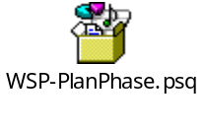

TDI summary report as on 24th September 2008.

TDI # | Priority | Severity | Status (Open, Resolved, Closed) | Resolution | Description
17998 | 2 | 2 | Closed | Fixed | [MS-WSP]: Sections 2.2.3.13 & 2.2.3.14 Contradictory statements
18000 | 1 | 2 | Resolved | Fixed | [MS-WSP]:Section 3.1.5.2.6 Clarity needed on seek description field in CPMGetRowsIn and CPMGetRowsOut messages
18114 | 2 | 2 | Closed | Fixed | [MS-WSP]:Clarity needed on SeekDescription field
18115 | 2 | 2 | Closed | Fixed | [MS-WSP]: Section 3.2.4.2.4 Incorrect reference
18275 | 2 | 2 | Closed | Fixed | [MS-WSP]: Query Regarding unknown error E_NOINTERFACE
18325 | 2 | 2 | Closed | Fixed | [MS-WSP]: Section 3.2.4.1.3 : Mentioned message is incorrect in the given context.
18329 | 2 | 2 | Closed | Fixed | [MS-WSP]: Section 3.1.5, Fig-5 : Incorrect message name is mentioned in the figure.
18402 | 2 | 2 | Closed | Fixed | [MS-WSP]: Query Regarding unknown error E_NOTIMPL in StopAsynchIn message
18403 | 1 | 2 | Closed | Fixed | [MS-WSP]: Section 3.1.5.2.6 Needed clarity on the size of property values in CPMGetRowsIn request
18404 | 2 | 2 | Closed | Fixed | [MS-WSP]: Normative information found in Section 4

Test Suite Design

Model or Test Design Description
This section describes MS-WSP protocol test suite implementation.

Test Design Description

The high level design of the test suite is given below:

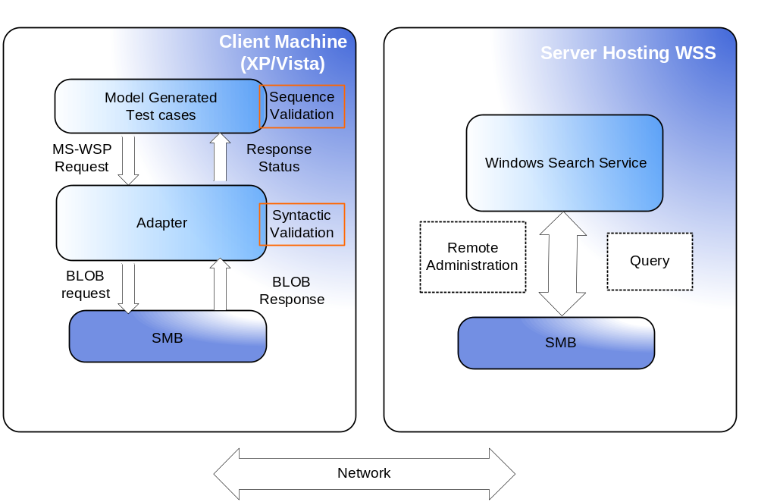

Test Suite runs from a client machine to validate the test cases specific to each scenario. These test cases are generated by a Model program that emulates the behavior of MS-WSP Protocol.

Model description

The Model comprises of the following files:

Model.cs: A static class “Model” describes the various pre-conditions and the corresponding updates for the actions in MS-WSP. The behavior of methods in MS-WSP protocol corresponding to the specified interfaces is modeled.

Config.cord: Contains the action vocabulary and the scenarios under test.

The following shows the data abstracted from TD in model:

WspErrorCode Enum:

WspErrorCode enum specifies defined error codes for WSP Protocol

public enum WspErrorCode : uint
{
/// <summary>
/// Specifies Successful response
/// </summary>
SUCCESS = 0x00000000,
/// <summary>
/// Specifies Invalid Parameter
/// </summary>
STATUS_INVALID_PARAMETER = 0xC000000D,
/// <summary>
/// Specifies No Catalog associated
/// </summary>
CI_E_NO_CATALOG = 0x8004181D,
/// <summary>
/// Specifies No Query Associated
/// </summary>
QUERY_S_NO_QUERY = 0x8004160C,
/// <summary>
/// Unknown Errors
/// </summary>
ERROR_OTHER = 0xFFFFFFFF,
/// <summary>
/// Generic Access Denied Error
/// </summary>
STATUS_ACCESS_DENIED = 0xC0000022,
/// <summary>
/// Failure
/// </summary>
E_FAIL = 0x80004005,
/// <summary>
/// Invalid Binding Info
/// </summary>
DB_E_BADBINDINFO = 0x80040E08
}

WspMessage Enum:

WspMessage Enum specifies all input and pre-requisite messages for the protocol model.

public enum WspMessage
{
None = 0,
CPMConnectIn = 1,
CPMCiStateInOut = 2,
CPMUpdateDocumentsIn = 3,
CPMForceMergeIn = 4,
CPMCreateQueryIn = 5,
CPMGetQueryStatusIn = 6,
CPMGetQueryStatusExIn = 7,
CPMSetBindingsIn = 8,
CPMGetRowsIn = 9,
CPMRatioFinishedIn = 10,
CPMFetchValueIn = 11,
CPMGetNotify = 12,
CPMGetApproximatePositionIn = 13,
CPMCompareBmkIn = 14,
CPMRestartPositionIn = 15,
CPMStopAsyncIn = 16,
CPMFreeCursorIn = 17,
CPMDisconnect = 18,
ErrorState = 19,
CPMConnectOut = 20
}

protocolState :

‘protocolState’ variable maintains the last message that has been exchanged between the protocol client and server.

/// <summary>
/// 'protocolState' variable is defined to update the protocol state after
/// the successful request sent to the server.
/// 'protocolState' holds the present state of the message flow.
/// </summary>
static WspMessage protocolState = WspMessage.None;

pendingRequest:

‘pendingRequest’ variable specifies whether a response message is anticipated from the server.
/// <summary>
/// 'pendingRequest' is a bool variable defined to updated the pending
/// request information.
/// It is updated after each action is performed.
/// 'pendingRequest' indicates whether there is any pending request for
/// server or not.
/// </summary>
static bool pendingRequest = false;

adminPrivilege:

‘adminPrivilege’ variable specifies whether a connected client has administrative privilege to perform remote catalog management tasks.

/// <summary>
/// 'adminPrivilege' is a bool variable to indicate whether the
/// client have/does not have admin priviledges.For the admin messages,
/// server will resond successfully only if this variable is set to 'true'.
/// </summary>
static bool adminPrivilege = false;

IsValidBindingInfo:

‘IsValidBindingInfo’ variable specifies whether a client has successfully bound a query.

/// <summary>
/// IsValidBindingInfo is the bool variable to indicate whether the client
/// have/does not have valid current set of bindings.
/// </summary>
static bool isValidBindingInfo = false;

rowsReceived:

‘rowsReceived’ variable specifies whether a client has received a successful CPMGetRowsOut message.

/// <summary>
/// 'rowsReceived' is a bool variable that indicates whether there are more /// rows to be fetched or not. Server will respond successfully for
/// CPMFetchValueIn request, only if this variable is set to 'true'.
/// </summary>
static bool rowsReceived = false;

isConnected:

‘isconnected’ variable specifies whether a client has received a successful CPMConnectOut message.

/// <summary>
/// isConnected is a bool variable to indicate whether the client is
/// successfully connected or not.
/// </summary>
static bool isConnected = false;

isQueryAssociated:

‘isQueryAssociated’ variable specifies whether a client has received a successful CPMCreatequeryOut message.

/// <summary>
/// isQueryAssociated is a bool variable to indicate whether the query has
/// successfully associated with the client or not.
/// </summary>
static bool isQueryAssociated = false;

isHandleAssociated:

‘isHandleAssociated’ variable specifies whether a client has received a cursor handle successfullly in CPMCreateQueryOut message.

/// <summary>
/// isHandleAssociated is a bool variable to indicate whether the handle is
/// associated with the client or not.
/// </summary>
static bool isHandleAssociated = false;

Representation of Actions in Model:
Synchronous modeling pattern is followed for modeling MS-WSP protocol. There is a one-to-one correspondence between the protocol messages and the actions in the test suite. The actions corresponding to the request messages are calls. The actions corresponding to the response from the server are events.

Multiple rule methods are used to model a single action (to separate different behaviors according to the errorCode return by the server).
Following actions are used in Model:
CPMConnectInRequest() is to sent a request to establish a connection with the server and start WSP query processing or WSP catalog administration. This is the first request, occurs once throughout the scenario/test suite for each client.
[Action("CPMConnectInRequest()")]
static void CPMConnectInRequest()

CPMCiStateInOut() requests the information about the state of the Windows Search Service.
It is one of the admin messages.

[Action("CPMCiStateInOut(isAdminClient)")]
static void CPMCiStateInOut(bool isAdminClient)

CPMForceMergeIn()request is send to improve query performance. It is an admin message for which client needs to have admin priviledges.

[Action("CPMForceMergeIn(isAdminClient)")]
static void CPMForceMergeIn(bool isAdminClient)

CPMCreateQueryIn() emulates WSP CPMCreateQueryIn message and associates a query with the client if successful.

[Action("CPMCreateQueryIn()")]
static void CPMCreateQueryIn()

CPMGetQueryStatusIn() requests the status of the query.

[Action("CPMGetQueryStatusIn(isCursorValid)")]
static void CPMGetQueryStatusIn(bool isCursorValid)

CPMGetQueryStatusExIn() requests for the status of the query and the additional information from the server.

[Action("CPMGetQueryStatusExIn(isCursorValid)")]
static void CPMGetQueryStatusExIn(bool isCursorValid)

CPMRatioFinishedIn() requests for the completion percentage of the query.

[Action("CPMRatioFinishedIn(isCursorValid)")]
static void CPMRatioFinishedIn(bool isCursorValid)

CPMSetBindingsIn() requests the bindings of columns to a rowset.

[Action("CPMSetBindingsIn(isValidBindingInfo,isCursorValid)")]
Static void CPMSetBindingsIn(bool isValidBindingInfo,bool isCursorValid)

CPMGetRowsIn() message requests rows from a query.

[Action("CPMGetRowsIn(isCursorValid)")]
static void CPMGetRowsIn(bool isCursorValid)

CPMFetchValueIn() requests for the property value that was too large to return in a rowset.

[Action("CPMFetchValueIn(isCursorValid)")]
static void CPMFetchValueIn(bool isCursorValid)

CPMGetNotifyIn() requests that the client wants to be notified of rowset changes.

[Action("CPMGetNotify(isCursorValid)")]
static void CPMGetNotify(bool isCursorValid)

CPMFreeCursorIn() requests to release a cursor.

[Action("CPMFreeCursorIn(isCursorValid)")]
static void CPMFreeCursorIn(bool isCursorValid)

CPMDisconnect() request is sent to end the connection with the server.

[Action("CPMDisconnect()")]
static void Disconnect()

Test Environment

Test Suite Environment

Following are the Hardware and Software requirements:

Hardware:
- A machine acting as a protocol client.
- A machine acting as a protocol server.

Software:
- Licensee Operating System.
- Licensee implementation of WSP protocol.

Test Execution Environment

Test Environment Requirements
Hardware | - Machine Acting as Protocol Server,  - Machine Acting as Protocol Client,
Software | OS | Windows Vista Ultimate SP1  Windows XP Professional SP3  Windows Server 2003 Enterprise R2 Windows Server 2008 Enterprise RTM
Software | Client | Windows Vista Ultimate SP1 (64 bit)  Windows XP Professional SP3 (32 bit)
Software | Server | Windows Server 2003 Enterprise R2 (32 bit)  Windows Server 2008 Enterprise RTM (64 bit)

Test Preparation

Test Suite Preparation

The test suite environment is a WORKGROUP environment.

Components of Setup:

- Server system: A system which receive request and send responses. Search Service must be running on the server.

- Client system: A system which sends request and receives response messages from server system. Client must have administrative privileges to perform catalog management tasks.

Test Execution Preparation

Setup environment:

Server – Windows Server 2003 SP2 Enterprise R2
Windows Server 2008 Enterprise RTM

Client – Windows XP Professional SP3
Windows Vista Ultimate SP1

Configuration of Server:

- Install Windows Server 2003 Enterprise R2 or Windows Server 2008 Enterprise RTM on 32bit system.
- Install Windows Search Services.

Configuration of Client:

Install Windows XP Professional SP3 (32 bit) or Windows Vista Ultimate SP1 (64 bit) Operating System.

Test Cases
Test-cases are generated with the scenarios explained in Section 2.5. For every scenario there are test cases generated by the model using link coverage.

Scenario | Test Case ID | Description
QueryForResultSets | TestCaseQueryForResultSets | Validates the response for the request sent by the client to connect to the server, query a catalog for result sets, release the cursor and finally free the connection from the server.
QueryForDifferentQueryStatus | TestCaseQueryForDifferentQueryStatus | Validates the response for different query status requests sent by the client to the server.
QueryAdminMessages | TestCaseQueryAdminMessages | Validates the response for catalog management requests sent by the client to the server.
ConnectOut_StatusInvalidParameter | TestCaseConnectOut_StatusInvalidParameter | Validates the error code returned by the server when already connected client sends ConnectIn request.
Admin_StatusInvalidParameter | TestCaseAdmin_StatusInvalidParameter | Validates the error code returned by the server when a non-connected client sends a request to perform any management task on the server.
QueryOut_ClientNotConnectedCase | TestCaseForQueryOut_ClientNotConnectedCase | Validates the error code returned by the server when a non-connected client sends CreateQueryIn request to create query.
QueryOut_CreatingExistingQueryCase | TestCaseForQueryOut_CreatingExistingQueryCase | Validates the error code returned by the server when the client sends the request to create an already existing query.
QueryNotAssociatedCase | TestCaseForQueryNotAssociatedCase | Validates the error code returned by the server when the client sends different query status requests for any non-existing query.
GetRowsOut_E_FailError | TestCaseGetRowsOut_E_FailError | Validates the error code returned by the server when client sends GetRowsIn request with invalid binding information for the query.
SetbindingsError | TestCaseSetbindingsError | Validates the error code returned by the server when the SetBindingsIn request is sent with invalid binding information for the query.
FetchValue_StatusInvalidParameterError | TestCaseFetchValue_StatusInvalidParameterError | Validates the error code returned by the server when FetchValueIn request is sent for the non-existing query.

Adapter Design

WspAdapter
WspAdapter is the only adapter for this test suite. This class implements IWspAdater interface. The responsibility of this class is to communicate with the server to administer a remote catalog or to execute a remote query. Also, validates the syntax of the responses obtained from the server.

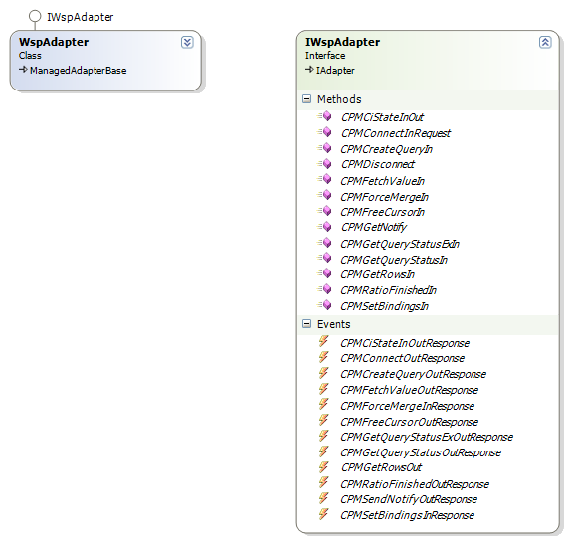

The following table describes the action of the WspAdapter class:

S. No. | Exposed Methods | Event Callback | Description
1 | CPMCiStateInOut() | CPMCiStateInOutResponse | Constructs and sends CPMCiStateInOut request message to the server corresponding to the specific client machine, which is passed as parameter to this method by the caller.  Obtains a response from the server.  Validates the syntax of the response message received from the server and fires the event CPMCiStateInOutResponse with the result status.
2 | CPMConnectIn() | CPMConnectOutResponse | Constructs and sends CPMConnectIn request to the server corresponding to the specific client machine name, client version, catalog name, user name and admin privilege which are passed as parameter to this method by the caller.  Obtains a response from the server.  Validates the syntax of the response messages received from the server and fires the event CPMConnectOutResponse with the status.
3 | CPMCreateQueryIn() | CPMCreateQueryOutResponse | Constructs and sends CPMCreateQueryIn request to the server corresponding to the specific client machine, query scope and query path which are passed as parameter to this method by the caller.  Obtains a response from the server.  Validates the syntax of the response message received from the server and fires the event CPMCreateQueryOutResponse with the result status.
4 | CPMDisconnect() | None | Constructs and sends CPMDisconnect request to the server corresponding to the specific client machine
5 | CPMFetchValueIn() | CPMFetchValueOutResponse | Constructs and sends CPMFetchValueIn request to the server corresponding to the specific client machine, which is passed as parameter to this method by the caller.  Obtains response from the server.  Validates the syntax of the response message received from the server and fires the event CPMFetchValueOutResponse with the result status.
6 | CPMForceMergeIn() | CPMForceMergeOutResponse | Constructs and sends CPMForceMergeIn request to the server corresponding to the specific client machine, which is passed as parameter to this method by the caller.  Obtains response from the server.  Validates the syntax of the response message received from the server and fires the event CPMForceMergeOutResponse with the result status.
7 | CPMFreeCursorIn() | PMFreeCursorOutResponse | Constructs and sends CPMFreeCursorIn request to the server to release a cursor associated with a query. Client machine, which is passed as parameter to this method by the caller.  Obtains response from the server.  Validates the syntax of the response message received from the server and fires the event CPMFreeCursorOutResponse with the result status.
8 | CPMGetNotify() | CPMSendNotifyOutResponse | Constructs and sends CPMGetNotify request to the server to get notified for the row set changes. Client machine is passed as parameter to this method by the caller.  Obtains response from the server.  Validates the syntax of the status of the row set from the response message received from the server and fires the event CPMSendNotifyOutResponse with the result status.
9 | CPMGetQueryStatusExIn() | CPMGetQueryStatusExOutResponse | Constructs and sends CPMGetQueryStatusExIn request to the server to get the status of a query and other additional information related to the catalog. Client machine is passed as parameter to this method by the caller.  Obtains response from the server.  Validates the syntax of the response message received from the server and fires the event CPMGetQueryStatusExOutResponse with the result status.
10 | CPMGetQueryStatusIn() | CPMGetQueryStatusOutResponse | Constructs and sends CPMGetQueryStatusIn request to the server to get the status of a query. Client machine is passed as parameter to this method by the caller.  Obtains response from the server.  Validates the syntax of the response message received from the server and fires the event CPMGetQueryStatusExOutResponse with the result status.
11 | CPMGetRowsIn() | CPMGetRowsOutResponse | Constructs and sends CPMGetNotify request to the server to obtain the result of a query. Client machine is passed as parameter to this method by the caller.  Obtains response from the server.  Validates the syntax of the query result received from the server and fires the event CPMGetRowsOutResponse with the result status.
12 | CPMRatioFinishedIn() | CPMRatioFinishedOutResponse | Constructs and sends CPMGetNotify request to the server to obtain query status in terms of ratio completed. Client machine is passed as parameter to this method by the caller.  Obtains response from the server.  Validates the syntax of the query status received from the server and fires the event CPMRatioFinishedOutResponse with the result status.
13 | CPMSetBindingsIn() | CPMSetBindingsInResponse | Constructs and sends CPMSetBindingsIn request to bind a query with a catalog. Client machine is passed as parameter to this method by the caller.  Obtains response from the server.  Validates the response received from the server and fires the event CPMSetBindingsInResponse with the result status.

WspAdapter uses the following classes:

MessageBuilder:
MessageBuilder class is responsible for framing client messages. Adapter builds all client messages using this class and sends them over to server. Obtained response from the server is then validated.

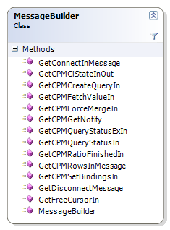

S. No. | Exposed Method | Description
1 | GetConnectInMessage() | Builds GetConnectInMessage request message.
2 | GetCPMCiStateInOut() | Builds GetCPMCiStateInOut request message.
3 | GetCPMCreateQueryIn() | Builds GetCPMCreateQueryIn request message.
4 | GetCPMFetchValueIn() | Builds GetCPMFetchValueIn request message.
5 | GetCPMForceMergeIn() | Builds GetCPMForceMergeIn request message.
6 | GetCPMQueryStatusExIn() | Builds GetCPMQueryStatusExIn request message.
7 | GetCPMQueryStatusIn() | Builds GetCPMQueryStatusIn request message.
8 | GetCPMRatioFinishedIn() | Builds GetCPMRatioFinishedIn request message.
9 | GetCPMRowsInMessage() | Builds GetCPMRowsInMessage request message.
10 | GetCPMSetBindingsIn() | Builds GetCPMSetBindingsIn request message.
11 | GetDisconnectMessage() | Builds GetDisconnectMessage request message.
12 | GetFreeCursorIn() | Builds GetFreeCursorIn request message.
13 | GetCPMGetNotify() | Builds GetCPMGetNotify request message.

Helper:
Helper class is used across Adapter while building client request messages and also while validating response messages from the server.

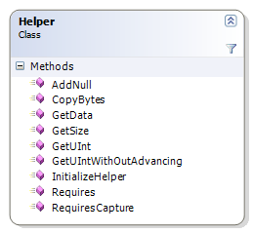

S. No. | Exposed Method | Description
1 | GetUInt() | Reads 4 bytes unsigned integer from a BLOB.
2 | CopyBytes() | Copies a given number of bytes to a BLOB.
3 | AddNull() | Appends null to a string.
4 | GetUIntWithOutAdvancing() | Reads 4 bytes unsigned integer from a BLOB without advancing the cursor
5 | GetSize() | Gets the size of a Base Storage Variant type.
6 | InitializeHelper() | Static Initializer for the Helper class.
7 | Requires() | Assert a condition in Model.
8 | RequiresCapture() | Assert a condition and captures a requirement.
 | GetData() | Reads a variable data of given length.

MessageValidator:
This is used by adapter to validate the response messages obtained from the server.
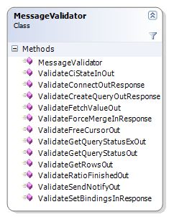
S. No. | Exposed Method | Description
1 | ValidateCiStateInOut() | Validates CPMCiStateInOut response message obtained from Server.
2 | ValidateConnectOutResponse() | Validates CPMConnectOut response message obtained from Server.
3 | ValidateCreateQueryOutResponse() | Validates CreateQueryOut response message obtained from Server.
4 | ValidateFetchValueOut() | Validates FetchValueOut response message obtained from Server.
5 | ValidateForceMergeInResponse() | Validates ForceMergeIn response message obtained from Server.
6 | ValidateFreeCursorOut() | Validates FreeCursorOut response message obtained from Server.
7 | ValidateGetQuerySatusExOut() | Validates GetQuerySatusExOut response message obtained from Server.
8 | ValidateGetQueryStatusOut() | Validates GetQueryStatusOut response message obtained from Server.
9 | ValidateGetRowsOut() | Validates GetRowsOut response message obtained from Server.
10 | ValidateRatioFinishedOut() | Validates RatioFinishedOut response message obtained from Server.
11 | ValidateSendNotifyOut() | Validates SendNotifyOut response message obtained from Server.
12 | ValidateSetBindingsInResponse() | Validates SetBindingsIn response message obtained from Server.
13 | MessageValidator() | Public constructor of MessageValidator class.

RequestSender:
This is responsible for opening and exchange messages with the Server via protocol Named Pipe.
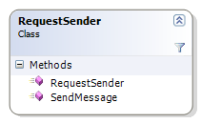

S. No. | Exposed Method | Description
1 | SendMessage () | Sends message over the pipe to the Server.
2 | RequestSender() | Constructor which takes the NamedPipe path as parameter.

Enums:
Other than these classes, there are various enums and data classes which help in defining the Model as well as implementation of the Adapter.
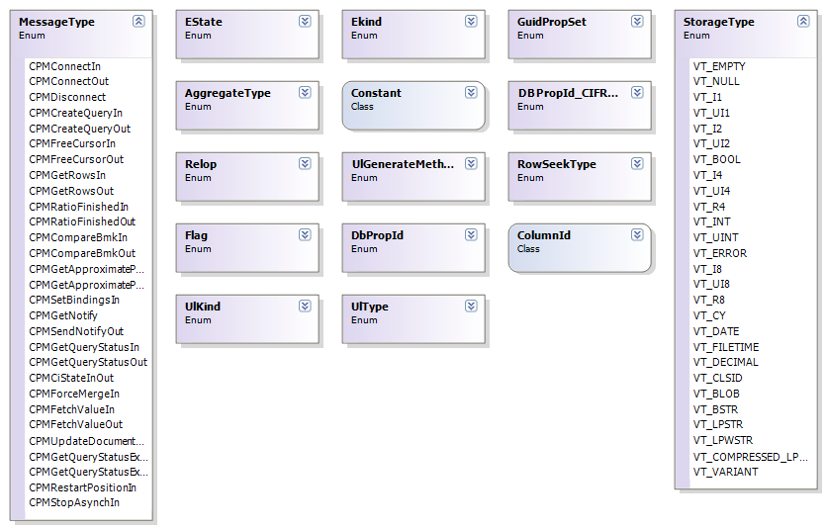

Sequence Diagram

The following sequence diagram depicts the flow of each test execution starting from the WspTestSuite.

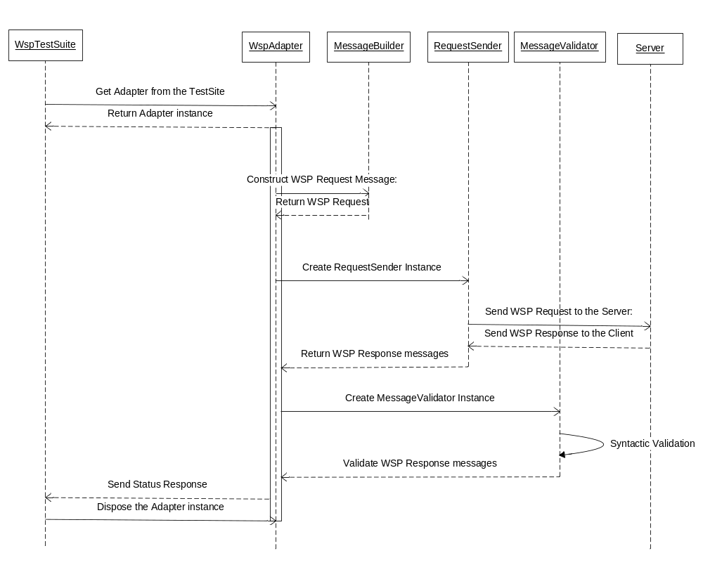
MS-WSP-Adapter.chm embedded below describes the adapter design.

Exceptions/Deviations
None.

TDIs filed
Nine TDIs were submitted .

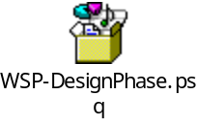

TDI # | Priority | Severity | Status (Open, Resolved, Closed) | Resolution | Description
17870 | 1 | 2 | Closed | Fixed | [MS-WSP]: Section 2.2.3.6 Incorrect Padding field.
18816 | 2 | 2 | Closed | Fixed | [MS-WSP]: Section 2.2.3.2, 3.1.5.1.2 Unsupported Message CPMUpdateDocumentsIn
18901 | 2 | 2 | Open | - | [MS-WSP]: Status value as E_NOTIMPL for messages CPMGetApproximatePositionIn, CPMCompareBmkIn and CPMRestartPositionIn.
18902 | 2 | 2 | Open | - | [MS-WSP]: Section 2.2.3.4, Clarity needed on MachineName and UserName fields in CPMConnectIn message.
19272 | 1 | 2 | Open | - | [MS-WSP]: Section 6:<11>Duplicate windows behavior.
19275 | 2 | 2 | Open | - | [MS-WSP]: Section 2.2.1.42, 2.2.3.5: Incorrect usage of the Normative terms.
19482 | 1 | 2 | Open | - | [MS-WSP]: Section 2.2.3.20: Outranged field value in CPMSendNotifyOut Message
19554 | 1 | 2 | Open | - | [MS-WSP]: section 2.2.3.26 , 3.1.5.2.13 Unsupported Message CPMStopAsynchIn
19612 | 1 | 2 | Open | - | [MS-WSP]: section 2.2.4 Invalid Statement regarding return value

Implementation and Execution

Overall Test Suite Summary

Every test case corresponds to a particular test scenario. The test methods internally call WSPAdapter which generates the protocol specific messages. Methods in the MessageValidator class validate the results returned by the server. The syntax related validations of response messages are done inside the test methods i.e. validation of the results and boundary conditions. Following is the summary of test result.

- Seventy Six TDIs were logged in the process of test suite development.
- Some tests involving server behavior could not be simulated.
- Most of the Server verifiable requirements have passed.
- 225 requirements out of 300 normative testable requirements are validated on XP SP3 - Win2K3 Enterprise R2 (32 bit client – 32 bit server) and Vista Ultimate SP1- Win2K8 Enterprise RTM ( 32bit client – 64 bit server) test combinations.
- Requirements that could not be validated have been marked as unverified with appropriate description.
- The resolution of the TDIs has helped in enhancing the quality of the technical document.
- For the failing requirements, appropriate TDIs have been filed which are still active. The failing requirements will be validated after the corresponding TDIs get resolved.

The test cases and OS Combination for the test suite is given below:

OS Combination | Type | No. of Test Cases Executed | No. of Test Cases Passed | No. of Test Cases Failed | No. of Test Cases Not Tested
XP SP3 - Win2K3 Enterprise R2 ( 32bit client – 32 bit server) | Automated | 3x15 | 45 | 0 | 0
 | Manual | 0 | 0 | 0 | 0
Vista Ultimate SP1- Win2K8 Enterprise RTM ( 32bit client – 64 bit server) | Automated | 3x15 | 45 | 0 | 0
 | Manual | 0 | 0 | 0 | 0

Each Test was run three times on each OS Combination with different test configuration to validate requirements that are based on the configuration data.

Test Report
Refer to MS-WSP-TestResult.html for the test report generated by reporting tool.

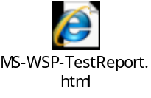

TDIs Filed

8 TDIs were submitted during this phase.

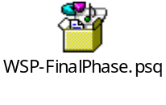

TDI # | Priority | Severity | Status (Open, Resolved, Closed) | Resolution | Description
19902 | 1 | 2 | Active | - | [MS-WSP]: Section 3.1.5.2.3: Wrong server behavior mentioned
19903 | 1 | 2 | Active | - | [MS-WSP]: Server behavior is not in sync with the behavior mentioned in TD.
19905 | 1 | 2 | Active | - | [MS-WSP]: Section 2.2.3.1: Outranged value for eState field of CPMCiStateInOut message
19907 | 1 | 2 | Active | - | [MS-WSP]: Section 3.1.5.2.1 Clarityneeded on the term Catalog in CPMConnectIn message
19909 | 1 | 2 | Active | - | [MS-WSP]: Section 3.1.5.1.3: Wrong error code
19912 | 1 | 2 | Active | - | [MS-WSP]: Section 3.1.5.2.6: Inconsistent server response
19919 | 1 | 2 | Active | - | [MS-WSP]: 3.1.5.2.8, Undefined error for Invalid Binding Info
19921 | 1 | 2 | Active | - | [MS-WSP]: Section 2.2.4 :Normative MUST is present in informative statements.

Overall TDI Summary:
TDI Priority | Total Number Active | Total Number Resolved | Total Number Closed
0 | 0 | 0 | 0
1 | 10 | 2 | 9
2 | 1 | 0 | 47
3 | 0 | 0 | 7
Total | 11 | 2 | 63

Phase discovered | Total Number Active | Total Number Resolved | Total Number Closed
Strategy | 0 | 0 | 49
Plan | 0 | 1 | 9
Design | 3 | 1 | 5
Final | 8 | 0 | 0
Total | 11 | 2 | 63

Pie Chart showing the percentage of TDIs with each of the severity types

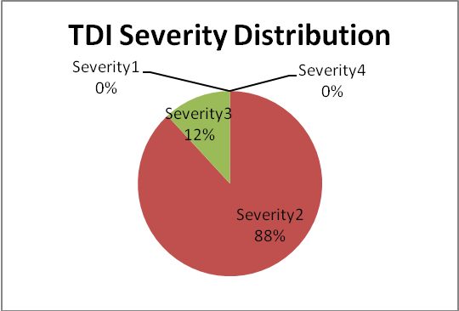

Pie Chart showing the percentage of TDIs generated by phase

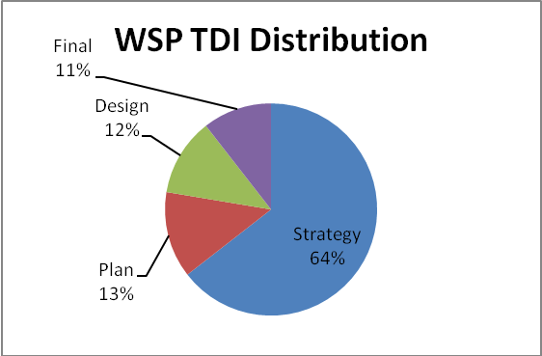

Pie Chart showing the percentage of active versus closed TDIs.

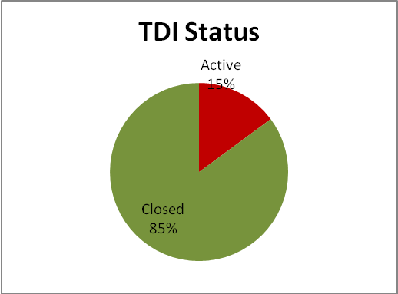

Product Bugs Filed
None.

Requirement Coverage Statistics
The MS-WSP-RequirementSpec.xlsm document contains the requirements for the protocol.
Statistics for the requirement coverage are given below:

Requirement Type | Count/Percent
Total Requirements Captured | 944
Requirements deleted as per the latest TD | 15
Total Requirements | 929
Total Server normative testable requirements | 299
Total Normative non-client and testable requirements covered | 228 (76.25%)
Normative, non-client and un-verified requirements  - Requirements unverified because scenario to get these values could not be generated.  - Requirements unverified due to non Windows behavior  - Requirements unverified due to active TDI | 71 (23.75%)
21 (7.1%)
28 (9.35%)
22 (7.3%)

Sustaining Engineering
Following MS-WSP TDIs are in Active state:

Bug Id | Description | Impact
19482 | [MS-WSP]: Section 2.2.3.20: Outranged field value in CPMSendNotifyOut Message | Blocked requirement  MS-WSP_R755.
19554 | [MS-WSP]: section 2.2.3.26 , 3.1.5.2.13 Unsupported Message CPMStopAsynchIn | Not impacting requirement coverage. MS-WSP_R785, MS-WSP_R786, MS-SP_R787, MS-WSP_R788, MS-SP_R789, MS-WSP_R790 are considered as Non-Testable.
19902 | [MS-WSP]: Section 3.1.5.2.3: Wrong server behavior mentioned | Blocked requirement  MS-WSP_R675
19903 | [MS-WSP]: Server behavior is not in sync with the behavior mentioned in TD. | Blocked requirements  MS-WSP_R683, MS-WSP_R696,  MS-WSP_R706, MS-WSP_R745,  MS-WSP_R794
19905 | [MS-WSP]: Section 2.2.3.1: Outranged value for eState field of CPMCiStateInOut message | Blocked requirement  MS-WSP_R380
19907 | [MS-WSP]: Section 3.1.5.2.1 Clarity needed on the term Catalog in CPMConnectIn message | Blocked requirements  MS-WSP_R650, MS-WSP_R652
19909 | [MS-WSP]: Section 3.1.5.1.3: Wrong error code | Blocked requirement  MS-WSP_R654
19912 | [MS-WSP]: Section 3.1.5.2.6: Inconsistent server response | Blocked requirement  MS-WSP_R708
19919 | [MS-WSP]: 3.1.5.2.8, Undefined error for Invalid Binding Info | Not impacting requirement coverage.
18000 | [MS-WSP]:Section 3.1.5.2.6 Clarity needed on seek description field in CPMGetRowsIn and CPMGetRowsOut messages | Blocked requirements  MS-WSP_R301, MS-WSP_R302,  MS-WSP_R307, MS-WSP_R533,  MS-WSP_R720
19921 | [MS-WSP]: Section 2.2.4 : Normative MUST is present in informative statements. | Blocked requirements  MS-WSP_R535, MS-WSP_R596

Inputs for Sustained Engineering:
- If the above TDIs are resolved, code changes need to be made to the Test Suite.
- Document Version 5.0 (v20080904) has been taken as baseline version for developing the test code.

Housekeeping

Checklist
None

Related Links

The following are the artifacts that have been delivered:

- MS-WSP-TestEnvironmentDeploymentGuide.docx
- MS-WSP-RequirementSpec.xlsm
- MS-WSP-TestResult.html
- Logs and Captures

Issues
None.

Cuts
None.

Change History
Version | Date | Changes Made | Author
1.0 | 7/16/2008 | Updated Section1 for MS strategy review | v-lavg
1.1 | 7/28/2008 | Strategy Comments incorporated | v-lavg
2.0 | 8/26/2008 | Updated Section 2 for MS plan review | v-abdand
3.0 | 9/10/2008 | Incorporated MS plan review comments and updated section 3 for MS Design Review | v-shgoel
3.1 | 9/17/2008 | Incorporated MS design review comments. | v-shgoel
4.0 | 9/24/2008 | Updated Section 4-5 for Final MS Review | v-shgoel

