Advanced Spatial Sound Sample

*This sample is compatible with the Microsoft Game Development Kit (June 2020)*

# Description

This sample demonstrates how use ISpatialAudioClient to playback both static and dynamic positional audio using Windows Sonic technologies. The static bed plays on startup and dynamic sounds that follow random paths can be added and removed

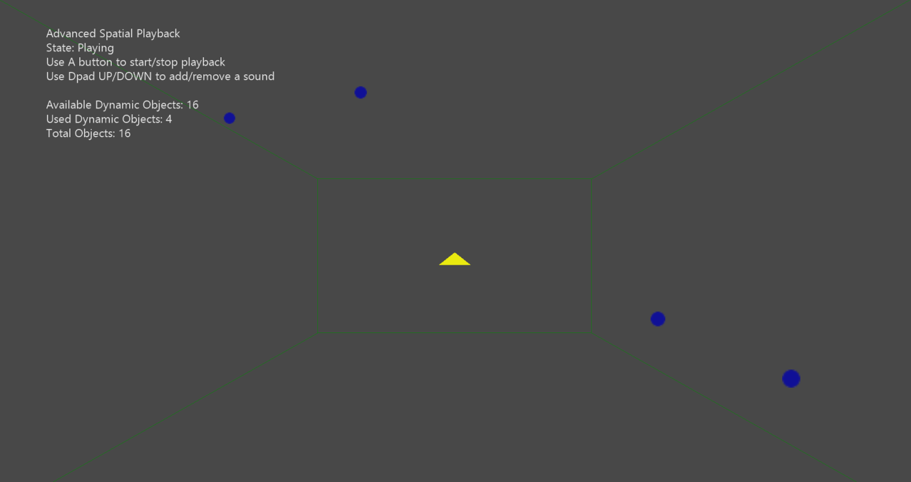

# Building the sample

If using an Xbox One devkit, set the active solution platform to Gaming.Xbox.XboxOne.x64.

If using Project Scarlett, set the active solution platform to Gaming.Xbox.Scarlett.x64.

*For more information, see* Running samples*, in the GDK documentation.*

# Using the sample

|  |  |
| --- | --- |
| Action | Controller |
| Start/Stop Playback | A button |
| Add a dynamic sound | DPad Up |
| Remove a dynamic sound | DPad Down |
| Exit | View button |

# Implementation notes

This sample demonstrates how to use ISpatialAudioClient to play static and dynamic positional sound using spatial technologies. Once ISpatialAudioClient has been initialized and started, it uses the callback to request buffer frames.

# Update history

Initial release March 2019