Simple WASAPI Play Sound Sample

*This sample is compatible with the Microsoft Game Development Kit (June 2020)*

# Description

This sample demonstrates how to play setup and play a simple sound (sine tone) to a WASAPI render endpoint on Xbox One.

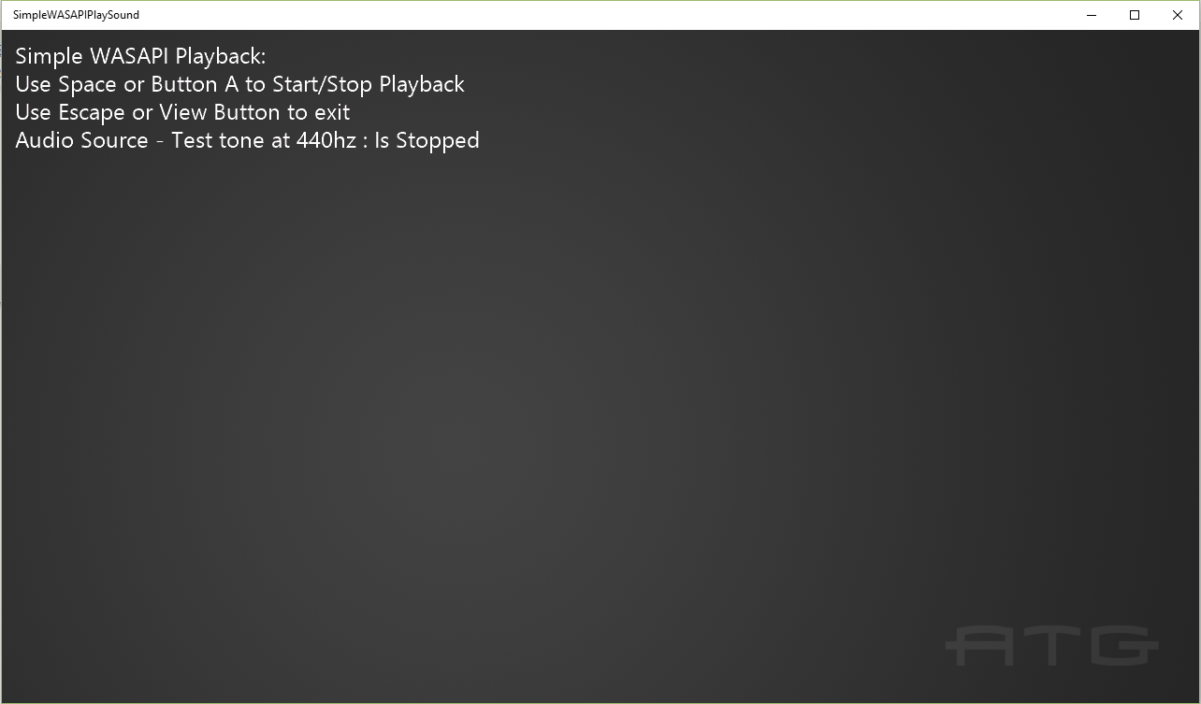

# Building the sample

If using an Xbox One devkit, set the active solution platform to Gaming.Xbox.XboxOne.x64.

If using Project Scarlett, set the active solution platform to Gaming.Xbox.Scarlett.x64.

*For more information, see* Running samples*, in the GDK documentation.*

# Using the sample

Use Spacebar on keyboard or Button A on gamepad to start and stop the playback. Use Escape on keyboard or View Button to exit the app.

# Implementation notes

For more information on WASAPI see [MSDN](https://msdn.microsoft.com/en-us/library/windows/desktop/dd371455.aspx).

# Privacy statement

When compiling and running a sample, the file name of the sample executable will be sent to Microsoft to help track sample usage. To opt-out of this data collection, you can remove the block of code in Main.cpp labeled “Sample Usage Telemetry”.

For more information about Microsoft’s privacy policies in general, see the [Microsoft Privacy Statement](https://privacy.microsoft.com/en-us/privacystatement/).