

Dynamic LOD Sample

*This sample is compatible with the Microsoft Game Development Kit (June 2020) and Windows 10 (Version 2004) May 2020 Update*

# Description

This sample demonstrates how to leverage amplification shaders to do per-instance frustum culling and mesh level-of-detail (LOD) selection entirely on the GPU for an arbitrary number of instances. Using the mesh shader pipeline this technique fits neatly into a single amplification & mesh shader pipeline state object.

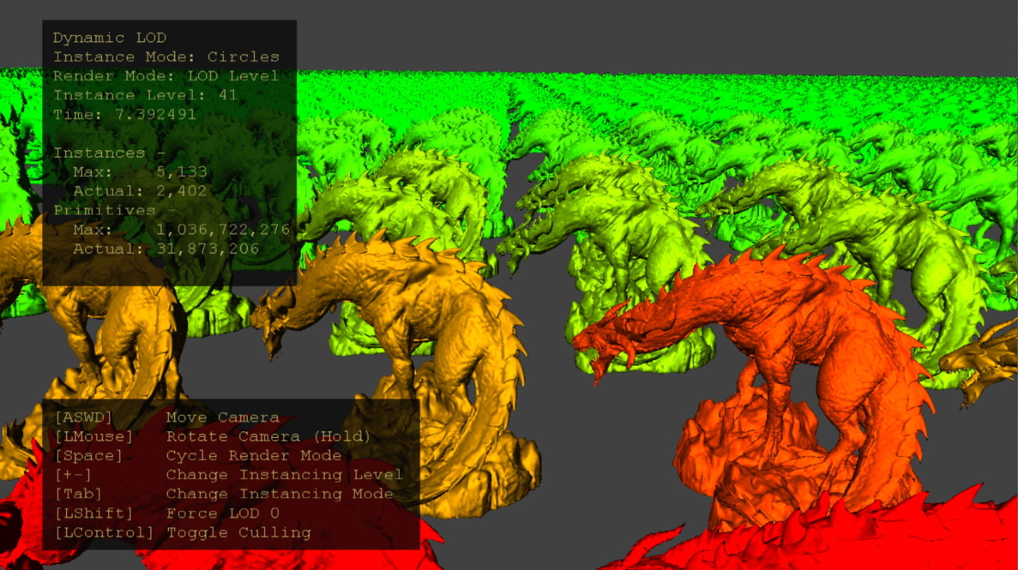

# Building the sample

If using Project Scarlett, set the active solution platform to Gaming.Xbox.Scarlett.x64.

If using PC with appropriate hardware and Windows 10 release, set the active solution platform to Gaming.Deskop.x64.

This sample does not support Xbox One.

*For more information, see* Running samples*, in the GDK documentation.*

# Using the sample

Use standard controls to drive the camera around. Tinker with visualization modes and the method in which instances are extrapolated. Observe the effect instance frustum culling and LOD selection has on the GPU by disabling culling or forcing LOD choice to level 0 (most detailed).

# Controls

|  |  |  |
| --- | --- | --- |
| Action | Gamepad | Keyboard |
| Move Camera | Left Thumbstick | WASD or Arrow Keys |
| Rotate Camera | Right Thumbstick | Hold LMB + Mouse |
| Reset camera | Right Thumbstick (Push) | - |
| Change Instancing Mode | A | Tab |
| Change Render Mode | X | Spacebar |
| Change Instancing Level | Right Shoulder & Trigger | +/- |
| Toggle Force LOD 0 | Y | Left Shift |
| Toggle Culling | B | Left Control |
| Exit | View Button | Escape |

# Implementation notes

The amplification shader stage precedes the mesh shader stage in the mesh shader pipeline. It’s a compute-like shader stage whose purpose is to determine the outstanding geometric workload, populate a payload buffer of data, and launch the requisite number of mesh shader threadgroups to process geometry.

CPU-side code generates instances by user input and uploads the instance buffer to a GPU resource. An array of mesh LODs populate a descriptor table for shader code to dynamically index into by LOD index. The amplification shader (AS) is configured to have a group size of one shader wave – this avoids the necessity of wave synchronization and memory barriers. The CPU dispatches enough AS waves to schedule one instance per thread.

Each thread of the AS threadgroup processes a single instance - culling against the view frustum and doing an LOD calculation. LOD instance counts are taken and reorganized using wave intrinsics to generate payload data for the dispatched mesh shaders (figure 2, left). This consists of a few different per-LOD instance counts, offsets, and instance index lists. The total number of meshlets to render determines the number of mesh shader threadgroups to dispatch using the DispatchMesh amplification shader intrinsic function.

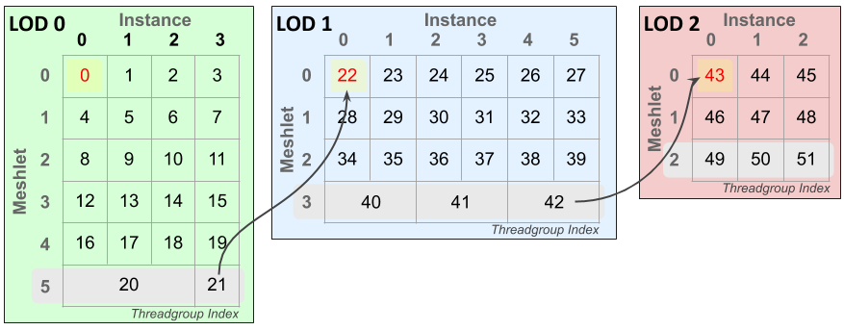

Figure 1: Example indexing layout of mesh shader threadgroups across instances and meshlets. In this scenario four instances are LOD 0, six instances LOD 1, and three instances LOD 2 requiring 52 mesh shader threadgroups. The last meshlet of each LOD (highlighted gray) may pack multiple instances into a single mesh shader threadgroup – its vertex & primitive count allowing. The yellow highlighted cells are the first threadgroup for each LOD, the red value is the global offset of each LOD level – this must be subtracted off the threadgroup index to determine the threadgroup’s LOD index. Arrows are to show continuation of threadgroup IDs across LOD boundaries.

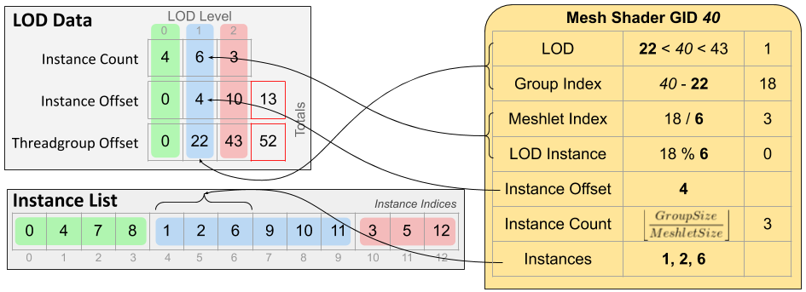

Figure 2: The payload data (left) passed from each Amplification Shader threadgroup to its dispatched Mesh Shader threadgroups (example threadgroup on right.) Using the threadgroup’s index the shader can compute the LOD, meshlet index, and instance index for which it should process. Group size is the number of threads in a threadgroup, and meshlet size is the max of a meshlet’s vertex and primitive count.

The mesh shader is a simple meshlet rendering shader, but with code to compute its LOD, meshlet, and instance indices using the payload data. Meshlet and vertex data is read by indexing into SRV arrays by LOD index. Multiple instances may be processed in a single threadgroup if it’s the last meshlet of an LOD level to maximum threadgroup utilization.

# Known Issues

Disabling optimizations (-Od) causes InstancedLodMS.hlsl to be broken on PC. This is due to a bug in the shader compiler (dxc.exe) in the version that ships with the Windows SDK (10.0.19041.) This issue has since been fixed in the latest release available on [GitHub](https://github.com/microsoft/DirectXShaderCompiler).

# Update history

4/20/2020 – Sample creation.

4/28/2020 - Updated to use the D3DX12 helpers for mesh shader pipeline creation

9/2/2021 – Added note about being broken on PC when disabling optimizations using Windows SDK dxc

# Privacy Statement

When compiling and running a sample, the file name of the sample executable will be sent to Microsoft to help track sample usage. To opt-out of this data collection, you can remove the block of code in Main.cpp labeled “Sample Usage Telemetry”.

For more information about Microsoft’s privacy policies in general, see the [Microsoft Privacy Statement](https://privacy.microsoft.com/en-us/privacystatement/).