Simple MSAA

*This sample is compatible with the Microsoft Game Development Kit (June 2020)*

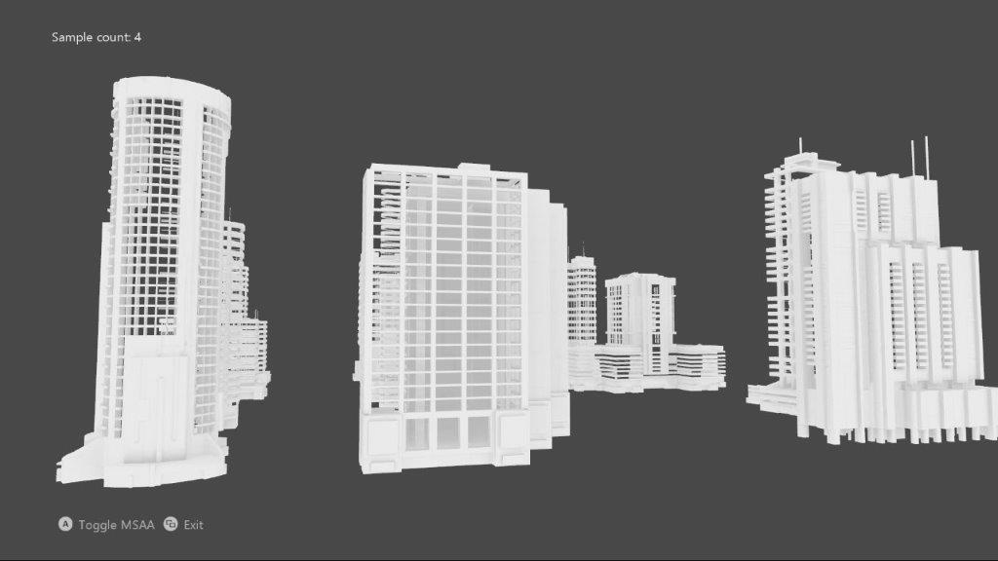

# Description

This sample implements an MSAA render target & depth/stencil buffer for a 3D scene using DirectX 12.

# Building the sample

If using an Xbox One devkit, set the active solution platform to Gaming.Xbox.XboxOne.x64.

If using an Xbox Series X|S devkit, set the active solution platform to Gaming.Xbox.Scarlett.x64.

*For more information, see* Running samples*, in the GDK documentation.*

# Using the sample

|  |  |
| --- | --- |
| Action | Gamepad |
| Toggle MSAA vs. single-sample | A button |
| Exit | View Button |

# Implementation notes

The UI is drawn without MSAA, and makes use of an explicit resolve rather than relying on an implicit resolve of an MSAA swapchain.

# Privacy Statement

When compiling and running a sample, the file name of the sample executable will be sent to Microsoft to help track sample usage. To opt-out of this data collection, you can remove the block of code in Main.cpp labeled “Sample Usage Telemetry”.

For more information about Microsoft’s privacy policies in general, see the [Microsoft Privacy Statement](https://privacy.microsoft.com/en-us/privacystatement/).