

Windows PC Fundamentals Sample

*This sample is compatible with the Microsoft Game Development Kit (March 2022)*

# Description

This sample demonstrates signing into Xbox Live and making a license check to ensure that the game is owned by the currently signed in user. It also performs an update check to ensure the app is up-to-date compared with the published version in the store.

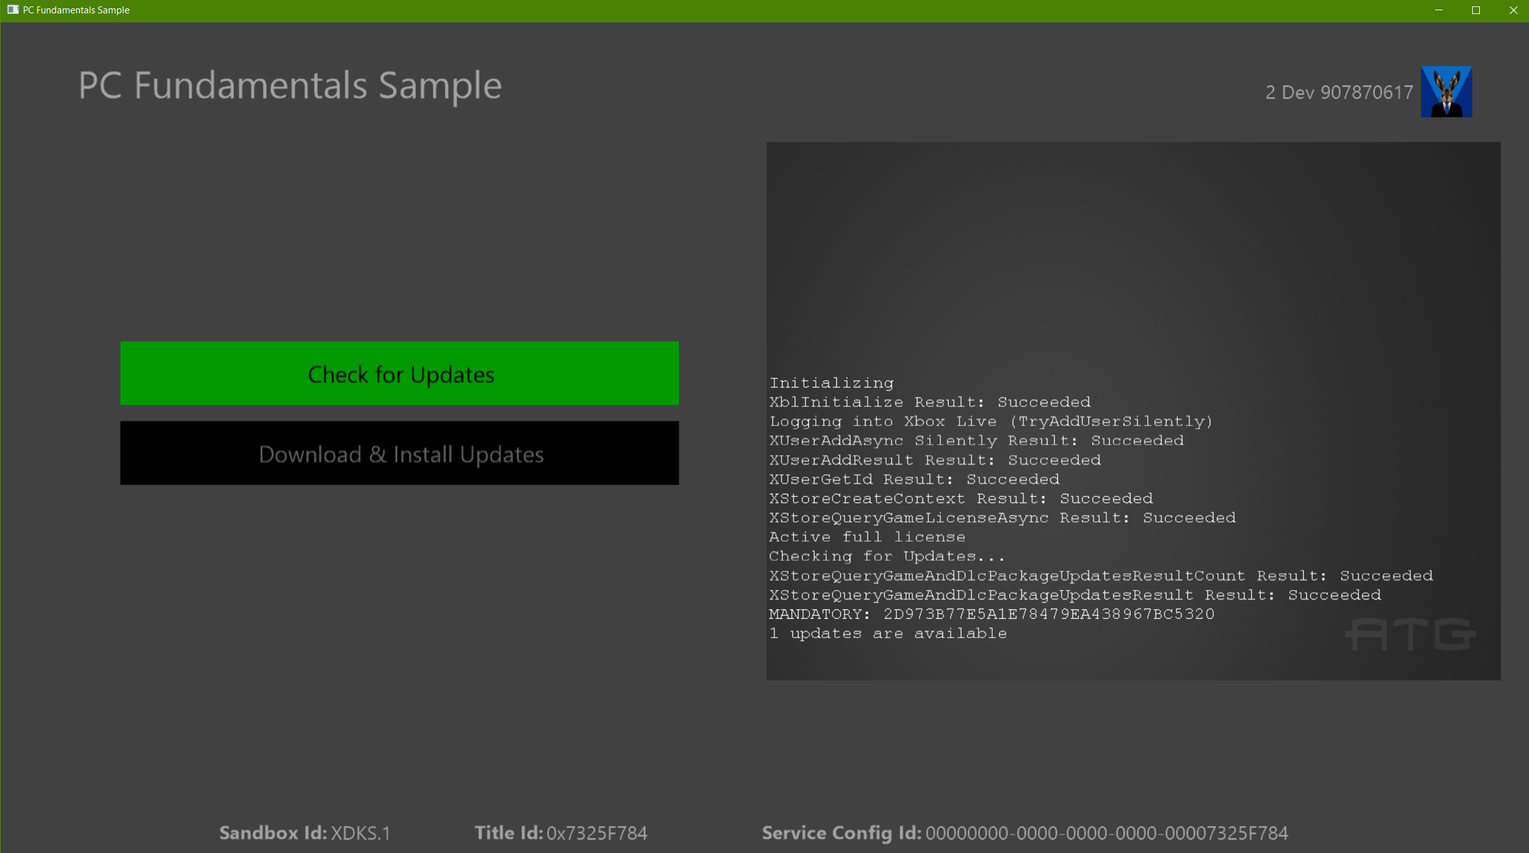

# Pre-requisites

* Microsoft GDK (March 2022) 10.0.22000.3160
* Visual Studio 2019 or later
* Xbox Test Account signed in first to Xbox app and then Store app in Sandbox XDKS.1

Get a license for the sample in the store with the test account (run  
ms-windows-store://pdp/?productid=9NRL15W975GM or msxbox://game/?productId=9NRL15W975GM)

# Building the sample

The sample is configured for building with VS2017. This sample is intended for Windows PC only, so only platform “Gaming.Desktop.x64” is available.

# Running the sample

A key characteristic of using the XStore API’s is that they require a valid license in order to function. This is verified with a call to the licensing service at launch. Without this available, the APIs will typically return 0x803f6107 indicating that a valid license was not found.

To obtain a valid license for your test account, run this command to reach the Store page for the sample’s product directly:

Run box (Win+R):

ms-windows-store://pdp/?productid=9NRL15W975GM

or

msxbox://game/?productId=9NRL15W975GM

Note that you must be in the XDKS.1 sandbox and then sign-in to the Xbox app* with your test account before also signing into the Windows Store with the same test account.

The sample as installed from the store will be properly licensed and function properly but may represent an older version of the sample. To have the sample built in Visual Studio work, some additional setup is required. With the November 2019 GDK and older, running the sample through F5 will not properly register your debug version and link to the appropriate license information. Furthermore, a loose deployed build will also not execute the update download and install scenarios properly.

## Launching sample

To enable a loose, locally built version you will need to run the add-appxpackage command in the steps below. This uses the included MicrosoftGameConfig.mgc to register the built sample with the same name and identity as the package downloaded from the store which the license is tied to.

To set up your locally built version of the sample to run do the following:

1. [Switch your sandbox to XDKS.1](https://docs.microsoft.com/en-us/gaming/xbox-live/xbox-live-sandboxes)
2. Log into the Xbox app* with your test account (any test account should work in this sandbox)
3. Log into the Windows Store app with the same test account
4. Build the sample
5. Run just using **F5**

* For the Xbox app, this can either be the Xbox Console Companion app or the new Xbox App which presents a storefront and has Game Pass information. For the latter, once you switch to a new account that does not match the one in the Store app, it will prompt you to reconcile.

## Testing updates

The loose deployed build (as opposed to packaged) will only be able to check for update availability (i.e. XStoreQueryGameAndDlcPackageUpdatesAsync) if the content ID matches that of the published package obtained from the store (1062A2A1-C314-4DDC-94A2-424693687D97). This can be verified in this registry entry:

HKEY_CURRENT_USER\Software\Microsoft\Windows\CurrentVersion\Store\ContentId\41336MicrosoftATG.ATGSimpleLiveSample_dspnxghe87tn0

This should be set properly if the sample app was fully installed in the store; otherwise you may need to set it manually if the first app installation instance was with the loose build.

To actually test the download and applying of the update, **packaged** builds must be used:

1. Create v1 package using *createmsixvc.cmd*
2. *wdapp install <v1 msixvc>*
3. Edit MicrosoftGameConfig.mgc to increment version
4. Deploy app in Visual Studio to ensure changes is copied to Gaming.Desktop.x64/Debug
5. Create v2 package with new version using *createmsixvc.cmd*
6. *wdapp update <v2 msixvc> /m*

At this point v2 is staged as an available mandatory update. Now when v1 is launched (installed in step 2), will detect an available update and the Download & Install button will be displayed. Clicking on this button will terminate the app and simulate updating the game.

Once update is complete, launching the title will result in v2 being run. You can verify the version that is installed by running in powershell:

get-appxpackage 41336MicrosoftATG.ATGSimpleLiveSample

This is the only update flow that is testable. Due to signing differences, it will not be able to detect any published store package as an update even though it has a higher version. Store packages will only update to higher version store packages.

# Implementation notes

Note that if multiple users are signed in, the StoreContext will be assigned to the latest account in the user changed callback, which may or may not match the account that is displayed in the sample. Store operations really do not work well in multi-user scenarios, so assigning the StoreContext to the account that presses A is typically appropriate. Signing in using the Xbox (beta) app will be the best way to detect and ensure account consistency.

# Privacy statement

When compiling and running a sample, the file name of the sample executable will be sent to Microsoft to help track sample usage. To opt-out of this data collection, you can remove the block of code in Main.cpp labeled “Sample Usage Telemetry”.

For more information about Microsoft’s privacy policies in general, see the [Microsoft Privacy Statement](https://privacy.microsoft.com/en-us/privacystatement/).

# Update history

**Initial Release:** April 2019

**Updated:** January 2020

**Updated:** June 2022