

Leaderboards Sample

*This sample is compatible with the Microsoft Game Development Kit with Xbox Extensions (June 2020)*

# Description

The leaderboards sample demonstrates the usage of Xbox Live Leaderboards with Events-Based stats (previously referred to as Stats 2013).

# Building the sample

* If using an Xbox One devkit, set the active solution platform to Gaming.Xbox.XboxOne.x64.
* If using an Xbox Series X|S devkit, set the active solution platform to Gaming.Xbox.Scarlett.x64.
* If build and run for desktop, set the active solution platform to Gaming.Desktop.x64.

*For more information, see* Running samples*, in the GDK documentation.*

# Running the sample

* You will need an Xbox Live test account signed in to send player stats and view *Social Leaderboards*
* Xbox One devkit: set the console’s sandbox to XDKS.1

*NOTE: You will need more than one test account, friended with each other both having sent stats from the sample to see more than one user listed in Social Leaderboards queries*

# Sample Setup in Partner Center

*Leaderboards* make use of Player Stats combined with Player Stat Rules to rank players. To make a Leaderboard, you must first define the Player Stats, Stat Rules and Leaderboard in Partner Center. This section documents how the Leaderboards Sample was configured in Partner Center.

1. Create a Player Stat
2. Create one or more Stat Rules which aggregate that stat
3. Create a leaderboard that ranks players based on a stat rule

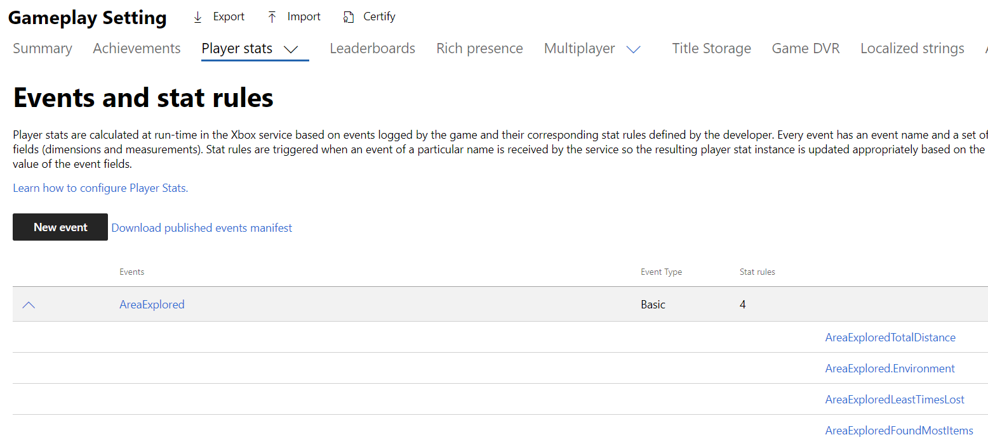

*NOTE: These images reflect the layout of Partner Center at the time this sample was written.*

## Creating An Event

When creating a new event, consider what other fields might be relevant to the user at the time the event is fired. While you can only aggregate on a single field, you can request additional columns to be returned in a leaderboard query. More on this when we create a Stat Rule.

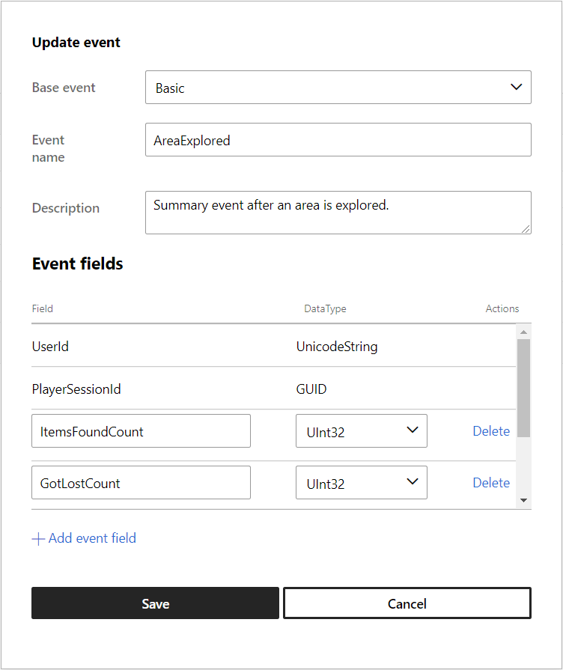

4 fields were added to this event: *ItemsFoundCount (UInt32)*, *GotLostCount (UInt32)*, *Environment (Unicode String)* and *DistanceTraveled (UInt32)*

## Creating A Stat Rule

Stat rules indicate which field will be aggregated and how. Adding fields to the stat metadata allows you to designate additional fields as includable when querying with the stat value. In this case, we are interested in what the Environment and Distance Traveled values were at the time they collected the most items.

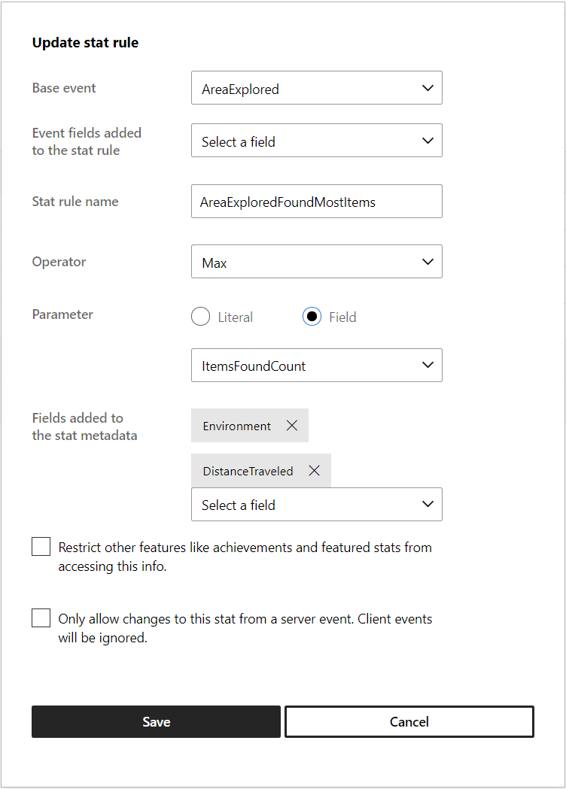

*NOTE: When SUM aggregation is used, the metadata fields will be set to the values of the last event received*

If you wish to create a leaderboard that aggregates on a specific value of a field (such as a level, area, weapon, etc.), then that field should be included in the “Event fields added to the stat rule” section. See *MostTraveledMaze* below.

## Creating Leaderboards

The leaderboard for *MostItemsFound* is defined using the following parameters.

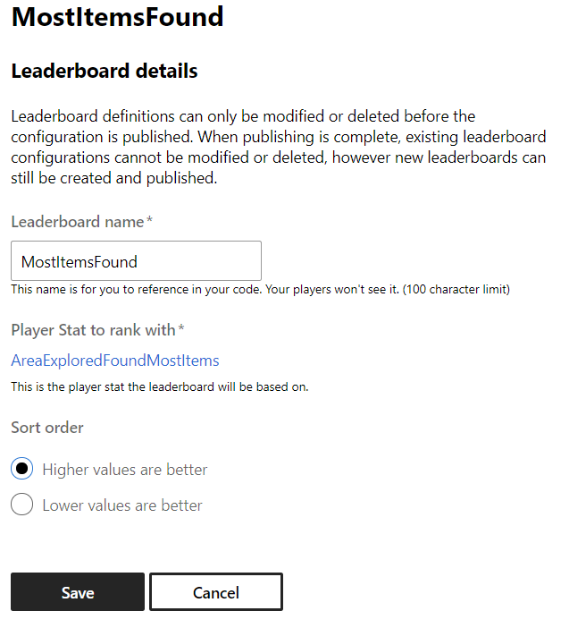

|  |  |
| --- | --- |
|  |  |

# Implementation notes

* While the implementation allows for both Global and Social leaderboards to be queried, the only real difference between them is setting an enum value passed into the query and including a XUID to indicate who’s friends should be included in the result list.
* The sample also demonstrates querying of stat values directly.

*NOTE: Leaderboards.cpp contains code relevant to producing and querying stats and leaderboards*

# Known issues

Some global leaderboard rankings listed in the “Times Lost” category were set while still tweaking the gameplay simulation and aren’t achievable without modifying the code. I left this as a reminder to developers when designing their stats – they can’t be changed without resetting the stat/leaderboard, which would cause players to lose their progress.

# Privacy statement

When compiling and running a sample, the file name of the sample executable will be sent to Microsoft to help track sample usage. To opt-out of this data collection, you can remove the block of code in Main.cpp labeled “Sample Usage Telemetry”.

For more information about Microsoft’s privacy policies in general, see the [Microsoft Privacy Statement](https://privacy.microsoft.com/en-us/privacystatement/).

# Update history

**Update:** March 2022

**Initial Release:** October 2019