

Custom Event Provider Sample

*This sample is compatible with the Microsoft Game Development Kit (June 2020)*

# Description This sample demonstrates how to use custom ETW event providers on Xbox One. Building the sample

If using an Xbox One devkit, set the active solution platform to Gaming.Xbox.XboxOne.x64.

If using an Xbox Series X|S devkit, set the active solution platform to Gaming.Xbox.Scarlett.x64.

*For more information, see* Running samples*, in the GDK documentation.*

# Using the sample

The sample uses the following controls:

|  |  |
| --- | --- |
| Action | Gamepad |
| Exit the sample. | Left Trigger + Right Trigger + Right Shoulder |

Implementation notes  
This sample follows the same structure as a conventional Windows ETW provider, however since a title running in the Exclusive partition cannot add its event providers to the registry some additional steps are required on the host PC to resolve generated event data correctly.

To generate events, you first need to create an event manifest file (in this sample, this can be found in **etwprovider.man**).

The event manifest file can be created by hand – it’s XML based – or it can be built using **ecmangen.exe,** a GUI-based tool that ships as part of the Windows SDK. The Manifest Generator tool can usually be found in the following location: c:\Program Files (x86)\Windows Kits\10\bin\{sdk version}\x64\ecmangen.exe

Once you have an event manifest, it is compiled into a resource file (**etwproviderGenerated.rc**) and header (**etwproviderGenerated.h**) using the Visual Studio message compiler (mc.exe). Both resource file and header are included in the title project.

To generate the header, resource, and binary files, mc.exe is called with the following parameters:

mc.exe -um *inputmanifestfile.man*

The.BIN files generated by this step are automatically brought in by the generated .RC file, and compiled into your executable or DLL.

During title initialization, the event provider is registered via a call to **EventRegisterCEP_Main**, and then subsequently unregistered via a call to **EventUnregisterCEP_Main** during shutdown processing. “Mark” events are emitted via calls to **EventWriteMark** which takes a single Unicode string as a parameter.

The sample can be built, deployed and activated as for any other sample. Once it is running, use xperf to capture events (tracelog lacks the ability to merge ETL provider events, and xbperf lacks the capability to specify custom event providers). Since the title’s event provider hasn’t been added to the registry it has to be identified via GUID, not by name (note that the GUID must match the provider GUID specified in the event manifest):

C:\temp>xbrun /x/title /O xperf -start -on PROC_THREAD+LOADER+DPC+INTERRUPT+CSWITCH+PROFILE -stackwalk PROFILE+CSWITCH -f d:\kernel.etl

Once the required data has been captured, the session can be stopped in the usual way:

C:\temp> xbrun /x/title /O xperf -start "user" -on A4A76336-4BA7-4CD9-85C3-B9C236D3041C -f d:\user.etl

Merge the ETL file on the devkit to resolve the system event providers. This will *not* resolve our custom event provider:

C:\temp> xbrun /x/title /O xperf -stop -stop "user" -d d:\merged.etl

Now the merged file can be copied back to the host PC:

C:\temp\> xbcp xd:\merged.etl .

This file can be loaded into WPA, and the custom events will appear in the “Generic Events” graph within the “System Activity” group. However at this point the events will only be identified by GUID, and information like the Task Name and Opcode Name will not be visible. More importantly, the custom data we provided for each event (the Unicode string) will not be displayed either.

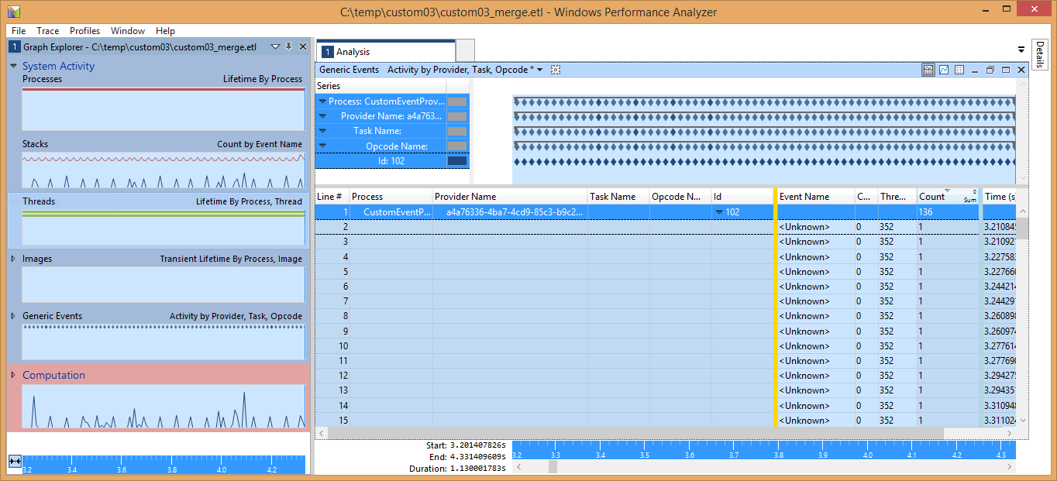

In order to display the full information for each custom event, we make use of a trick – *we register the event provider on the host PC, rather than the devkit, and resolve the events there.*

First, edit the provider node of the event manifest (evtprovider.man) and make sure that the **resourceFileName** and **messageFileName** attributes point at the location on your development PC where the Xbox One executable is built:

<provider name="CEP-Main" guid="{A4A76336-4BA7-4CD9-85C3-B9C236D3041C}"   
symbol="CEP_MAIN"   
resourceFileName="S:\samples\gx_dev\Samples\System\CustomEventProvider\Gaming.Xbox.x64\Debug\CustomEventProvider.exe"   
messageFileName="S:\samples\gx_dev\Samples\System\CustomEventProvider\Gaming.Xbox.x64\Debug\CustomEventProvider.exe">

Next, register the event provider on your host PC by running the wevtutil.exe tool from an elevated command prompt:

D:\dev\CustomEventProvider>wevtutil im etwprovider.man

If you check in the registry on your host PC, you should see the provider listed under HKLM\SOFTWARE\Microsoft\Windows\CurrentVersion\WINEVT\Publishers

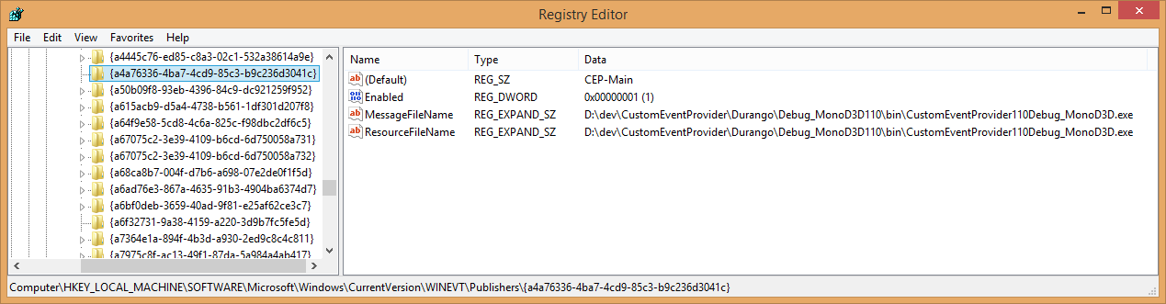

Finally, resolve the ETL file on your host PC using xperf:

C:\temp\custom03>xperf -merge merged.etl final.etl

If the host merged ETL file (**final.etl**) is loaded into WPA you should now see the events correctly resolved:

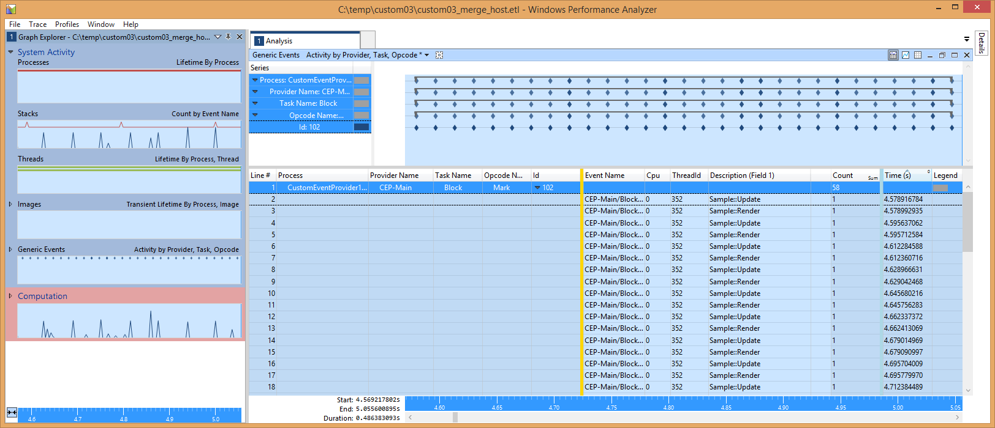

Note how the Description (Field 1) column now contains the strings that were logged with the events. We can also see the Task and Opcode names.

When you have finished your performance analysis session, you can remove the provider from your host PC:

D:\dev\CustomEventProvider>wevtutil um etwprovider.man

The BlockCulled event is similar to the Mark event, save in the respect that it has a single UInt32 payload rather than a string payload. Unfortunately, at present it is not possible to graph a numeric field of a custom event within WPA.

**Regions of Interest**

Since October 2013, WPA has supported the concept of [Regions of Interest](http://msdn.microsoft.com/en-us/library/windows/hardware/dn450838.aspx): the capability to denote and label temporal ranges within a capture. The **EtwScopedEvent** class and **ETWScopedEvent()** macro demonstrate how, with the appropriate payload, Regions of Interest (ROI) can be used to provide bracketing functionality analogous to **PIXBeginEvent()** and **PIXEndEvent()**.

To show ROI you will first need to load the region definition file. From the Trace menu choose Trace Properties and then load the regions.xml definition that ships with the sample.

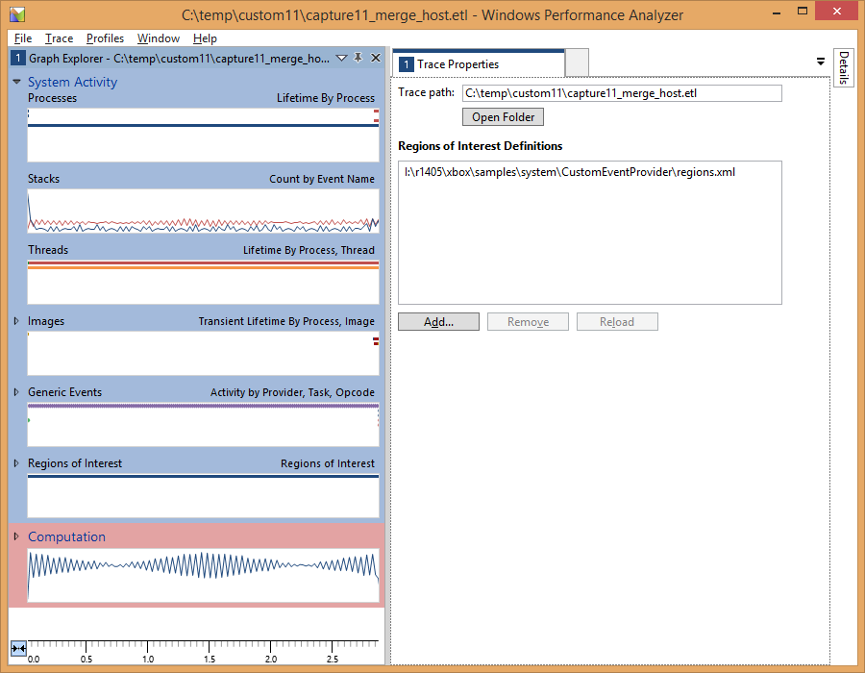

You should now see the Regions of Interest graph available under the Generic Events graph. Drag the ROI graph over to the analysis area to expand it; the default view preset (on the toolbar) should be “Regions of Interest”. Add the Region column to the table (so that each region gets a unique color), and expand the Root node; you should see a display similar to this:

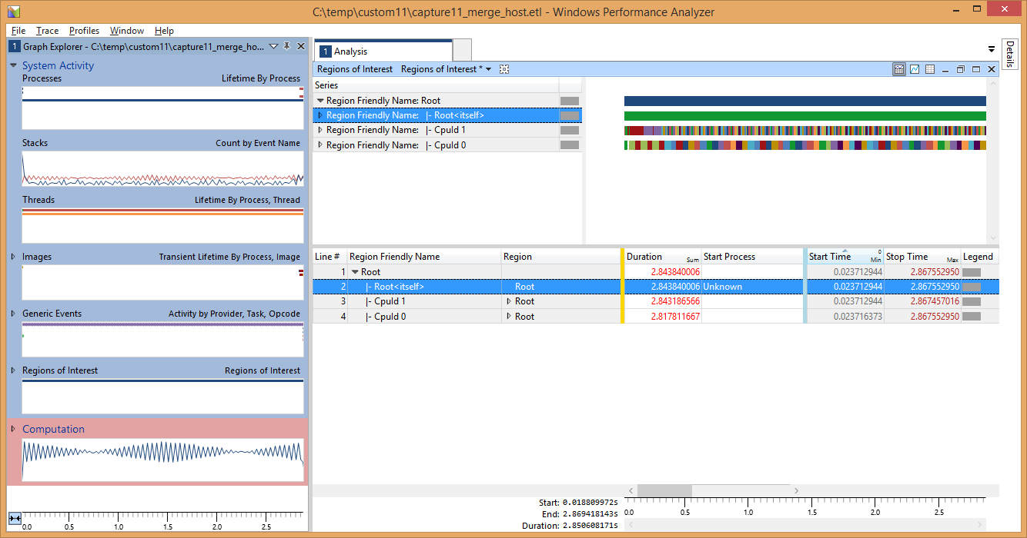

Expanding the Region nodes of the table will give you information on the individual brackets:

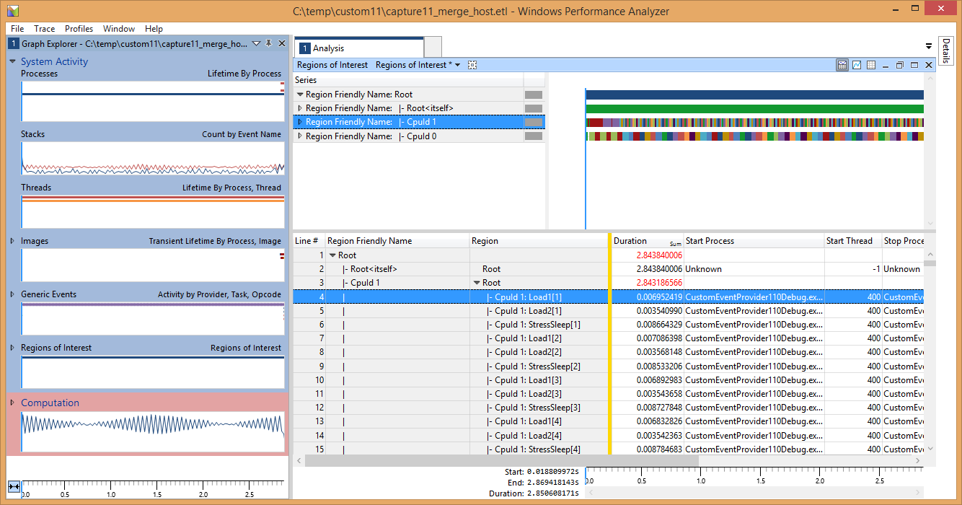

As you can see, the labels that were provided in the calls to **ETWScopedEvent()** are visible here (the number is the instance of a particular label).

Expanding the graph will show each region’s timeline separately:

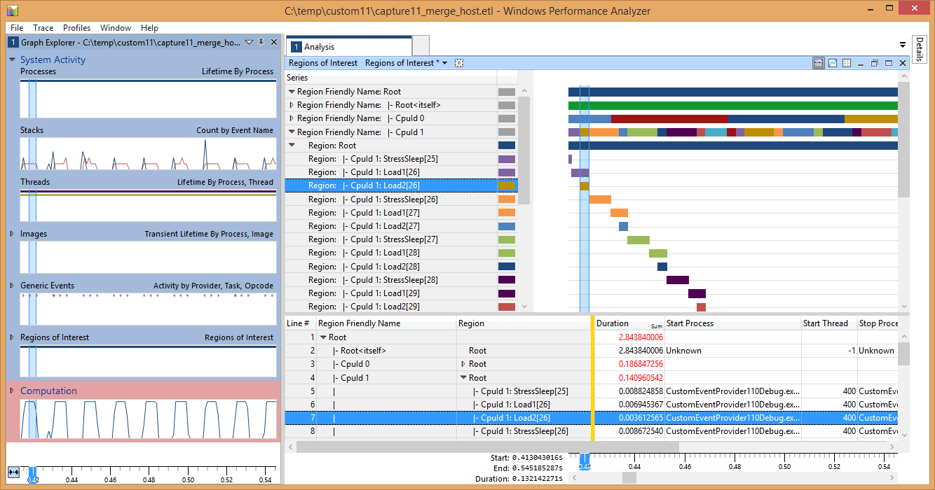

Better still, you can now correlate regions with data from a sampling capture, if you had this enabled:

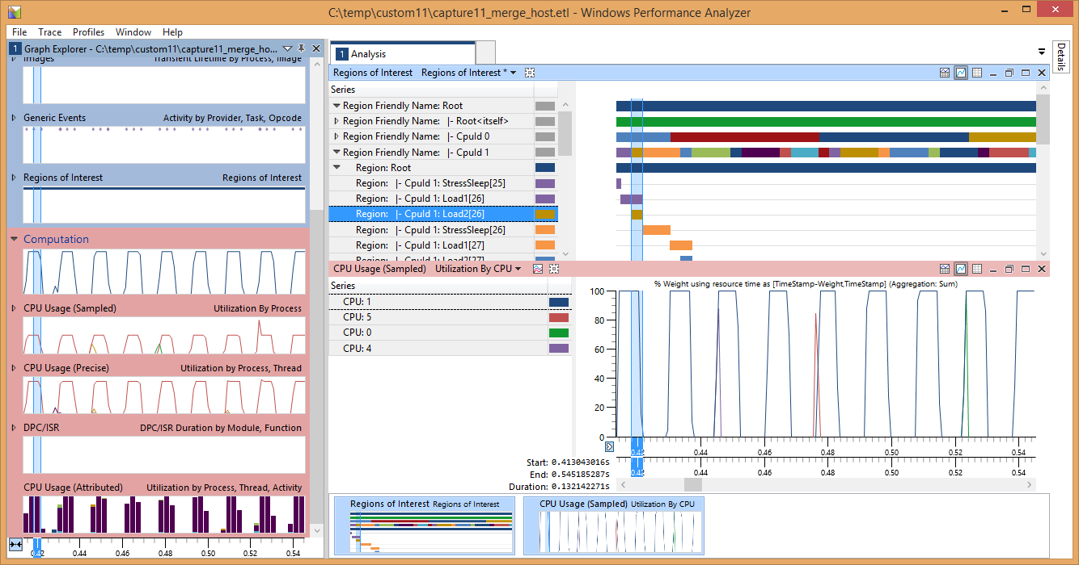

# Known Issues

Since we resolve the event provider GUID on the host PC, it is essential that no ETW providers with that ID have already been registered. If you create a new event manifest from the one in the sample, regenerate the GUIDs using **ecmangen** when the manifest is being edited, or use guidgen.exe (provided with Visual Studio) to generate new GUIDs.

When the ETL file is resolved on the host PC you may see some additional event providers appear in the Generic Events view; these can be ignored.

# Other Resources

## Creating an Event Manifest

* [Using Windows Event Log](https://docs.microsoft.com/en-us/windows/desktop/WES/using-windows-event-log)
* [Writing an Instrumentation Manifest](https://docs.microsoft.com/en-us/windows/desktop/WES/writing-an-instrumentation-manifest)
* [Compiling an Instrumentation Manifest](https://docs.microsoft.com/en-us/windows/desktop/WES/compiling-an-instrumentation-manifest)
* [Message Compiler (mc.exe)](https://docs.microsoft.com/en-us/windows/desktop/WES/message-compiler--mc-exe-)

## Windows Performance Analyzer

* [Windows Performance Analyzer](https://docs.microsoft.com/en-us/windows-hardware/test/wpt/windows-performance-analyzer)
* [Regions of Interest](https://docs.microsoft.com/en-us/windows-hardware/test/wpt/regions-of-interest)
* [Creating a Regions of Interest file](https://docs.microsoft.com/en-us/windows-hardware/test/wpt/creating-a-regions-of-interest-file)

# Privacy statement

When compiling and running a sample, the file name of the sample executable will be sent to Microsoft to help track sample usage. To opt-out of this data collection, you can remove the block of code in Main.cpp labeled “Sample Usage Telemetry”.

For more information about Microsoft’s privacy policies in general, see the [Microsoft Privacy Statement](https://privacy.microsoft.com/en-us/privacystatement/).