

FrontPanelGame Sample

*This sample is compatible with the Microsoft Game Development Kit (June 2020)*

# Description

FrontPanelGame is the classic “snake game” implemented completely on the Xbox One X Devkit and Xbox Series X|S Devkit Front Panels. The sample is mainly provided for fun but nonetheless does demonstrate some important aspects of the front panel control:

* The front panel is completely programmable from title code
* The buttons and DPAD APIs are analogous to the familiar Gamepad APIs
* The sample showcases some utility code that you can use in your own front panel project
  + Text rendering using RasterFont (see also: the FrontPanelText sample)
  + FrontPanelInput provides a reusable input class much like DirectXTK::GamePad
  + FrontPanelDisplay provides a simple class for managing the front panel buffer
  + Code for drawing basic shapes such as lines and rectangles

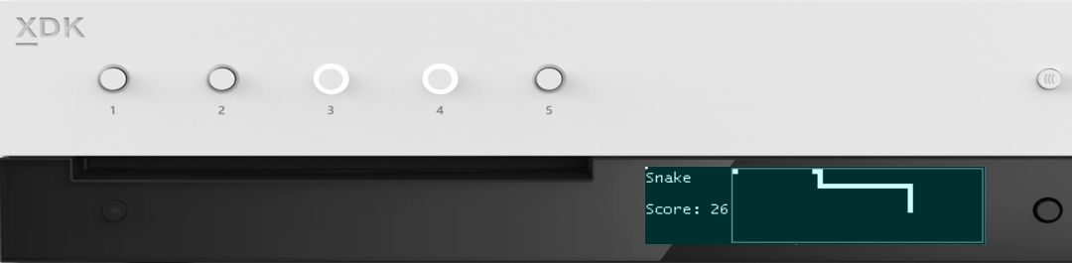

Press to start

256 x 64 x 4bpp OLED display

DPAD + Select

* Move the snake
* Take a screenshot

# Building the sample

If using an Xbox One devkit, set the active solution platform to Gaming.Xbox.XboxOne.x64.

If using an Xbox Series X|S devkit, set the active solution platform to Gaming.Xbox.Scarlett.x64.

*For more information, see* Running samples*, in the GDK documentation.*

# Using the sample

|  |  |
| --- | --- |
| Action | Front Panel |
| Start a new game | Button 1 |
| Move the snake | DPAD (Left, Right, Up, Down) |
| Take a screenshot | DPAD Select |
| Toggle between game mode and system mode | Press and hold DPAD Select |

# Update history

April 2019, first release of the sample.

November 2019, support for the Xbox Series X|S Devkit.

# Privacy Statement

When compiling and running a sample, the file name of the sample executable will be sent to Microsoft to help track sample usage. To opt-out of this data collection, you can remove the block of code in Main.cpp labeled “Sample Usage Telemetry”.

For more information about Microsoft’s privacy policies in general, see the [Microsoft Privacy Statement](https://privacy.microsoft.com/en-us/privacystatement/).