

Gamepad Sample

*This sample is compatible with the Microsoft Game Development Kit (June 2020)*

# Description

This sample demonstrates how to read inputs from a gamepad on the Xbox One

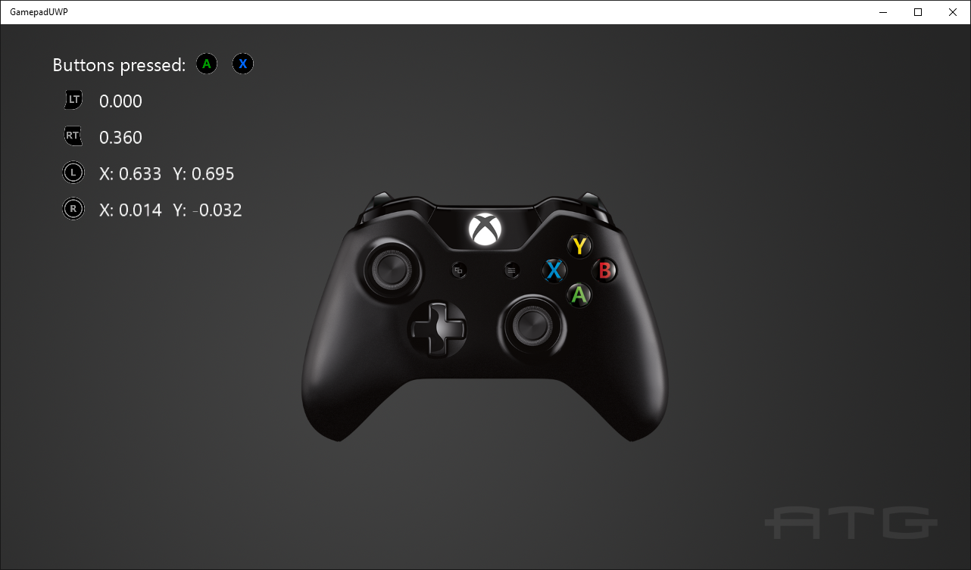

# Building the sample

If using an Xbox One devkit, set the active solution platform to Gaming.Xbox.XboxOne.x64.

If using Xbox Series X|S, set the active solution platform to Gaming.Xbox.Scarlett.x64.

For PC, you can set the active solution platform to Gaming.Desktop.x64. **This requires the June 2022 GDK or later**.

*For more information, see* Running samples*, in the GDK documentation.*

# Using the sample

Press buttons to see them displayed and move the thumbsticks and triggers to see their readings.

# Implementation notes

This sample demonstrates how to use the new GameInput API to read input from a gamepad, including thumbsticks and triggers.

# Version History

* October 2018: Initial GDK release
* February 2020: Updated for changes to GameInput API.
* June 2022: Added support for GameInput on PC (June 2022 GDK or later)

# Privacy statement

When compiling and running a sample, the file name of the sample executable will be sent to Microsoft to help track sample usage. To opt-out of this data collection, you can remove the block of code in Main.cpp labeled “Sample Usage Telemetry”.

For more information about Microsoft’s privacy policies in general, see the [Microsoft Privacy Statement](https://privacy.microsoft.com/en-us/privacystatement/).