

Gamepad Vibration Sample

*This sample is compatible with the Microsoft Game Development Kit (June 2020)*

# Description

This sample demonstrates how to use vibration with a gamepad on an Xbox One.

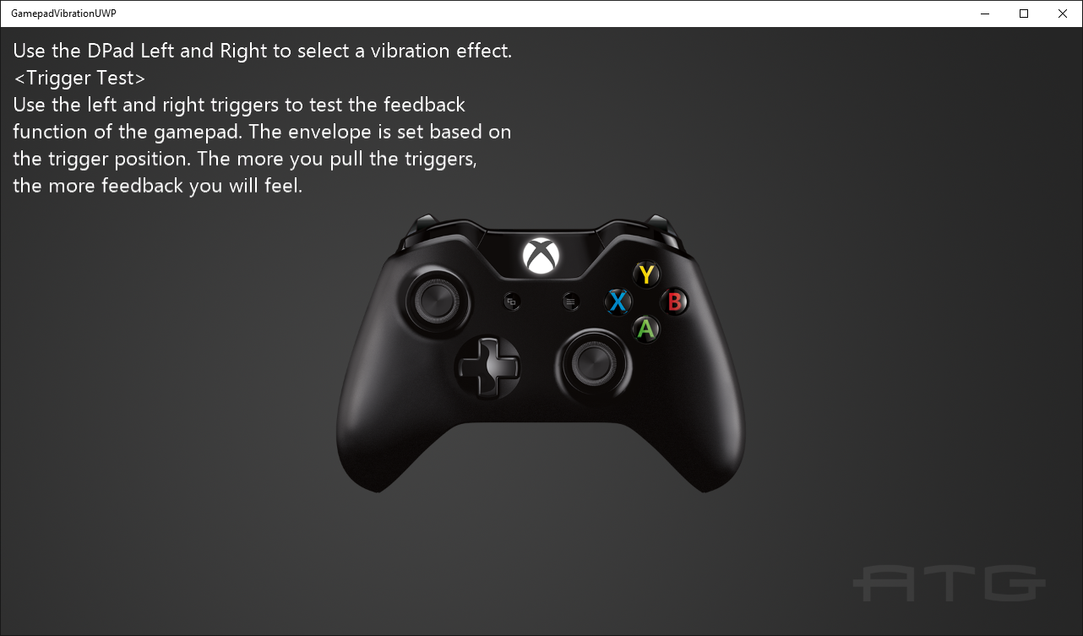

# Building the sample

If using an Xbox One devkit, set the active solution platform to Gaming.Xbox.XboxOne.x64.

If using Xbox Series X|S, set the active solution platform to Gaming.Xbox.Scarlett.x64.

For PC, you can set the active solution platform to Gaming.Desktop.x64. **This requires the June 2022 GDK or later**.

*For more information, see* Running samples*, in the GDK documentation.*

# Using the sample

Use left and right on the DPad to cycle between different vibration examples. Use the triggers in most of these examples to increase the amount of vibration.

Please note that there are some 3rd party controllers which do not have trigger rumble motors, so effects using those motors on these controllers will not cause vibration.

# Implementation notes

This sample demonstrates how to use the GameInput API to set vibration levels on an Xbox One gamepad.

# Update history

* Initial release April 2019
* Updated in June 2019 for minor breaking change to **SetRumbleState**.
* February 2020: Updated for changes to GameInput API.
* June 2022: Added support for GameInput on PC (June 2022 GDK or later)

# Privacy statement

When compiling and running a sample, the file name of the sample executable will be sent to Microsoft to help track sample usage. To opt-out of this data collection, you can remove the block of code in Main.cpp labeled “Sample Usage Telemetry”.

For more information about Microsoft’s privacy policies in general, see the [Microsoft Privacy Statement](https://privacy.microsoft.com/en-us/privacystatement/).