Microsoft Virtual Worlds Group

Microsoft Comic Chat
Content Development

DRAFT 2: 11/8/2026

Overview
Developing content for Comic Chat is a five-step process:
- Create the designs for a background or character.
- Scan the artwork, creating bitmap files.
- Use the original bitmap images to create transparency and aura masks.
- Create an .AVF file, which is a textual description of how the pieces of art come together to construct the character.
- Compile the .AVF file and place it in the Comicart\Avatars directory.

The design process allows for two character formats, giving you control over how the personality of your character is expressed. Separate bitmap images enable your character to make standard gestures, as well as express a wide range of emotions. Once the data for a character is compiled, Comic Chat reads the compiled character information at run-time to determine how the character moves and expresses itself.

You can design a Comic Chat character to be either unary or binary. Bitmap images for a unary character portray the entire body, in various poses. Bitmap images for binary characters combine separate head poses and body gestures, allowing a broad range of expression with a moderate amount of original artwork.

What you’ll need:
- a bitmap image for the background (optional)
- a 40x40 thumbnail sketch of your character
- foreground images of your character in several poses
- an aura mask for each foreground image
- a transparency mask for each foreground image
- a text file (.AVF file) that describes how the bitmap images for your character combine to form gestures

The sections which follow present guidelines for designing a Comic Chat character, and instructions for creating the .AVF text file.

Terms Used In This Document
unary character
A character whose original artwork portrays both head and body in a single bitmap for each gesture.
binary character
A character whose original artwork portrays head gestures in separate bitmap files from body gestures.
emotion wheel
The Comic Chat tool enabling the user to select a character's expression. The center of the emotion wheel represents a neutral posture. Positions on the outer edge of the wheel represent more extreme expressions of the selected emotion. Emotions and gestures are arranged around the outer edge of the circle.
icon
The term icon as used in this document refers to a 40x40 bit image that is used in the icon view of the Member List pane. It portrays a thumbnail sketch of the character, usually the head.

Designing a Character for Comic Chat
Artwork for a Microsoft Comic Chat environment consists of single-frame bitmap files: one for the background, and a collection of bitmap files for each character. How many bitmap files you need to create depends on the range of expressions you want the personality to express, and whether you choose to make the character unary or binary.

Bitmap files can be any size or shape, but when designing a character, keep in mind that up to five characters can appear in one frame. The system automatically scales artwork to fit inside a frame. Make sure the visual complexity of the background does not overpower the character design.

What files you need to create
For each Comic Chat character you create, you need at least the following files:
- One bitmap file showing the character itself. If your character is binary, you need two bitmaps, one for the head and one for the body of your character.
- A black-and-white transparency mask, to prevent the background from bleeding through your image. Binary characters need one transparency mask for each head and one for each body bitmap.
- A black-and-white aura mask, to provide some white space around your character’s figure. Binary characters need one aura mask for each head and one for each body bitmap.
- a 40x40 thumbnail sketch of your character, for the Icon view of the Member List pane.
- A textual description of your character and the files necessary to display it (.avf format).

All of these files are described in the sections which follow. With only one bitmap image, your character does not change from frame to frame during a chat session. To give life to your character, you need additional bitmaps that show your character expressing itself. Emotions and gestures are described in Section 2.3, “Define the personality's gestures and emotions.”

Choose a unary or binary character
Unary characters are easier to create than binary characters. Jordan is an example of a unary character. Each expression and intensity is contained in one frame of one bitmap file. Each bitmap file shows the whole person, as shown in the following example:

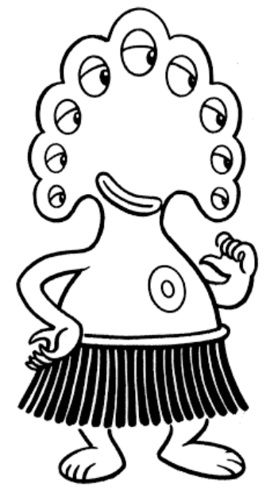
Figure 1: Jordan, a unary character
The binary character format can generate a large number of expressions from a minimum of artwork. Ten head designs and ten body designs can combine to make 100 possible gestures. You have control over how much random access is available to the program. Choosing a binary character also allows you to combine gestures such as pointing or waving with emotions such as laughter or sadness. The following example shows two bitmaps, one showing the head of a binary character, the second showing its torso:

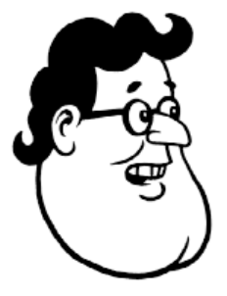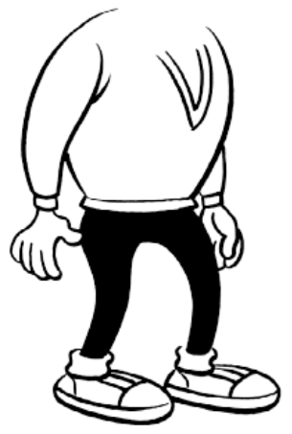
Figure 2: TongueTyed, a binary character

Define the personality's gestures and emotions
Before creating the artwork for a character, you need to define its personality. Keep in mind that end users select these images to represent themselves.

Your character expresses its personality through the following emotion keywords on the Comic Chat emotion wheel:
- Laugh
- Happy
- Coy
- Bored
- Scared
- Sad
- Angry
- Shout

In addition, you need to design the following gestures:
- at least three neutral poses (the system cycles randomly through these)
- a wave
- your character pointing to him or herself
- your character pointing to someone else

If you do not provide artwork for an emotion, Microsoft Comic Chat randomly selects from the available gestures. Create several neutral poses so the character does not remain static from frame to frame.

You also need a 40x40 bitmap file that contains a thumbnail sketch of your character. This image is used for the Icon view option for the Member List pane.

Planning Your Character's Poses
Microsoft Comic Chat automatically adjusts character position depending on how many characters are in one frame, and sometimes might flip an image from left to right. Because of this, the image needs to be bilaterally symmetric.

The system tries to make the characters look toward one another. For consistency, your characters should face either forward, or to their left (your right as you face the screen). A three-quarter turn generally appears more natural than a full profile.

Since most frames show only the head and shoulders of a character, it is best to avoid unusual or eccentric poses.

The system automatically scales images to fit the frame of the background. You can add white space above a character’s head or below its feet in your original artwork, but extra white space is trimmed and discarded.

Special Considerations for Binary Characters
Plan an overlap design for binary characters. Sometimes a simple change in registration can produce a new expression. You describe the relative alignment of head and torso using specially calculated coordinates that are placed in the .avf file. For information on calculating x- and y-coordinates for binary characters, see the section “Construction of the AVF file.”

The head and torso of binary characters have the same scale (DPI), but can be different resolutions.

In most cases, the system draws the torso first, then places the head. You can also design characters whose head needs to be placed before the torso (for example, if your character wears a high collar that covers the chin). Keywords in the .avf file specify whether head or torso needs to be drawn first. For information on what these keywords are, see the section “Header keywords and values.”

Intensity Levels for Emotions and Gestures
When end users select an emotion from the emotion wheel, they choose an emotional intensity as well. You can create unresponsive characters by providing only a small range of intensity, or excitable characters by providing many levels of expression per emotion or gesture. Comic Chat reads intensity in tenths of a point on a scale from 0.0 to 1.0, where 0.0 is neutral and 1.0 is extreme. Because of the small size of the emotion wheel, it may be difficult for a user to select from more than four or five intensity levels. To keep your character interesting, provide from two to four images for each emotion or gesture.

Reserve the 0.0 intensity for neutral poses.

Using Color
On most systems, images appear in black-and-white even when the original bitmaps are in color. If a user's video card has a high color depth (more than 16 bit), it bypasses the lookup table and uses direct color.

Creating the Image Files
Use any program that creates bitmap (.bmp) files. The program scales the artwork to fit into the frames. Bitmap files can be Run-Length Encoded (RLE) for compression, or uncompressed (non-RLE).

Caution: Not all paint programs create the same RLE output. RLE files created by some programs cannot be read by Comic Chat. If you plan to use RLE files for compression, test your program’s output to make sure it is recognized by Comic Chat. To avoid problems, use non-RLE files, or use Paint Shop Pro to convert a bitmap file to RLE format.

Selecting the size and format of your original bitmap is a tradeoff between resolution and download time. For best results, and to reduce download time and disk space for the end user, set the height from 220 to 440 pixels, with a width appropriate for your character.

Use a 1, 4, or 8-bit .bmp file for the foreground images, using 4-bit for gray scale. A 4-bit .bmp file, compressed, is more than twice the size of a 1-bit .bmp file. If your goal is a small compressed file (for example, 50k), you may need to use 1-bit black and white bitmaps. Conversion programs such as Debabelizer can change files from 4-bit to 1-bit format.

Transparency masks and aura masks need to be 1-bit black-and-white bitmap files. More information for creating transparency and aura masks is in the following section.

Use a standard naming convention to organize your bitmap files. The sample .AVF file at the end of this document uses the following naming convention:

- The first two characters are an abbreviation of the character's name.
- An underscore follows the abbreviation.
- A sequence number follows the underscore. Each sequence number maps to an emotion.
- An m or a follows the sequence number for transparency masks (m) and auras (a).
For example, one set of bitmap files for Jordan are named:
jn_1.bmp foreground
jn_1a.bmp aura
jn_1m.bmp transparency mask

Transparencies and auras
For each character/gesture combination you create, you also need a bitmap file for the transparency mask and for the aura.

The transparency mask is a one-bit black and white bitmap file that is black in the areas where you want the character to be visible, and white where it should be transparent. Transparency masks prevent the background from showing through the character, and prevent head-body-aura interference in binary characters. The upper left pixel defines the transparency color.

The aura is a one-bit black and white mask file that creates a band of white space around the character's image. To construct an aura mask, begin with the transparency mask and add a black band around the outline, about four to ten pixels wide. Any white space becomes transparent in the final image.

TIP: If you are using Adobe Photoshop, you can use the Edit Stroke toolbar to create the aura.

You can use the aura file to achieve interesting effects, such as a wider aura around the character’s head when it is angry, or a halo around the head of a very happy character.

The following images show a character, its transparency mask and aura mask. Note that the aura mask is identical to the transparency, and slightly larger.

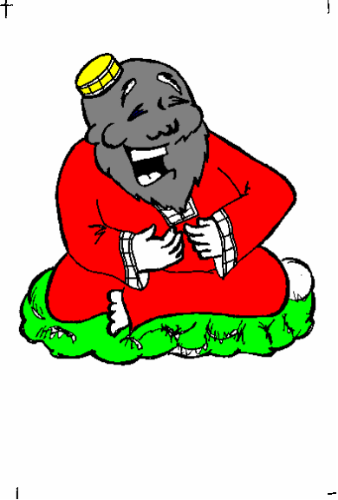
Figure 3: Foreground image and transparency mask for unary character

Figure 4: aura mask for unary character (4 to 10 pixels wider than transparency mask)

Designing a Background for Comic Chat
You can substitute your own background instead of the one provided with Microsoft Comic Chat. The background is a simple bitmap file. You can create your own, or use any of the bitmaps provided by Microsoft Windows™ as a background. The system automatically scales the image to the appropriate size.

Place the background bitmap file in the Comicart\Backdrop folder of your Comic Chat directory. Select the background in Microsoft Comic Chat by clicking the Backgrounds tab of the View Options menu.

Getting the Images into Comic Chat
Once you have created the images for a character, the next step is to create an ASCII text file (.avf file) that describes how the pieces of art come together to construct your character. Use any text editor or word processor that creates text files. Give the .avf file the same name as the character; for example, the one for Jordan is named Jordan.avf. To see sample .avf files, see the end of this section.

The program AvatarFiler.exe compiles the .avf file into a format that Comic Chat can use. When you start this program, it opens a blank window. Use the File Open command to open your .avf file, then click File Save As to save it as a compiled .avb file. Give the file the same name as your character. For example, the files for Maynard are called Maynard.avf and Maynard.avb.

When AvatarFiler has created the .avb file, place it in the Comicart\Avatars folder of your Comic Chat directory. If you have created a new background bitmap, move the .bmp file for the background into the Comicart\Background folder of your Comic Chat directory.

Construction of the AVF file
You need to create one .avf file for each character you have created. Comments can appear anywhere in the .avf file. The pound sign (#) as the first character on the line indicates a comment. You can use either spaces or tabs interchangeably as data separators.

Each .avf file has the following structure:
- The first line begins with the string "#AvFile" followed by two numbers:
• 1 for binary characters, or 2 for unary characters
• version number information (currently, the version is 1)
For example, the first line of the .avf file for Jordan would read:
#AvFile 2 1
- Header information consisting of keywords and values, summarizing general information about the character and artist.
- For a unary character, a section beginning with “BeginBodies” and ending with “EndBodies” (no quotation marks). This section describes the foreground file, transparency file, and aura file for each gesture for this character.
For a binary character, two sections: one delimited by “BeginFaces” and “EndFaces,” and a second delimited by “BeginTorsos” and “EndTorsos” (no punctuation and no quotation marks). These sections describe the foreground, transparency mask, and aura mask for each head and torso for this character.
- Each .avf file ends with the keyword “End.”

The following sections provide details for each section of the .avf file. For a sample .avf file, see the end of this document.

Header keywords and values

The following keywords can appear in the header portion of a character's .avf file:

Name
Enter the name of the character. Microsoft Comic Chat sessions show the character’s name exactly as you type it, including capitalization.
Style
Enter a numeric value representing the background environment the character best fits in. At present, this value is 1.
Flags
For binary characters only. Enter one or more of the following keywords, separated by spaces, that describe how to draw the character:
TORSOFIRST indicates the torso is drawn first
HEADMASK indicates a mask file is provided for the head
HEADFIRST indicates the head is drawn first
TORSOMASK indicates a transparency mask is provided for the torso
Desc
Enter a brief description of the character.
Artist
Enter the name of the artist.
Icon
Enter the name of the bitmap file that contains the icon for this character.

Emotion wheel keywords
Descriptive information is organized by emotion or gesture. This section immediately follows the header keywords. Information printed for each emotion and gesture is different, depending on whether your character is unary or binary. The keywords for emotions are gestures are:
EM_POINTOTHER
EM_POINTSELF
EM_NEUTRAL
EM_WAVE
EM_COY
EM_ANGRY
EM_BORED
EM_LAUGH
EM_HAPPY
EM_SCARED
EM_SHOUT
EM_SAD

The only required gesture is EM_NEUTRAL, with an intensity of 0.0. All other gestures and emotions are optional.

Describing unary characters in the .avf file
Each emotion or gesture has three lines of text: one for the foreground (six columns), one for the aura (two columns), and one for the transparency (two columns). Each line begins with one of the following keywords: FOREGROUND, AURA, or DITTO.

Column layout for unary character
Column 1  Keyword | Column 2 | Column 3 | Column 4 | Column 5 | Column 6
FOREGROUND | name of .bmp file | keyword for emotion or gesture | intensity value (in tenths) | center of head X-coordinate | center of head Y-coordinate
AURA | name of .bmp file | (blank) | (blank) | (blank) | (blank)
TRANSPARENCY | name of .bmp file | (blank) | (blank) | (blank) | (blank)
DITTO | (blank) | keyword for emotion or gesture | intensity value (in tenths) | (blank) | (blank)

The intensity value is a decimal value, ranging in tenths from 0.0 to 1.0. Use 0.0 only for the EM_NEUTRAL, EM_POINTOTHER, EM_POINTSELF, and EM_WAVE keywords.

For example:

FOREGROUND jn_2.bmp EM_POINTSELF 0.0 133 131
AURA jn_2a.bmp

DITTO EM_COY 0.8

You can use any number of spaces or tabs to separate the columns, but for readability, it is better to align the columns vertically, as shown in the examples.

You can use the keyword DITTO to use the same bitmap file for two gestures. In the previous example, the same image is used for EM_POINTSELF and EM_COY.

Describing binary characters in the .avf file
The .avf file for a binary character has two main sections following the header:
- A section describing the character's head
  - begins with the keyword “BeginFaces”
  - three lines of text for each emotion/intensity level: one describing the foreground (ten columns), one naming the transparency bitmap (two columns), one naming the aura bitmap (two columns)
  - ends with the keyword “EndFaces”
- A section describing the character's body
  - begins with the keyword “BeginTorsos”
  - three lines of text for each emotion/intensity level: one describing the foreground (six columns), one naming the transparency bitmap (two columns), one naming the aura bitmap (two columns)
  - ends with the keyword “EndTorsos”

The ten columns describing the foreground for the head contains the following information:

Column layout for binary characters (head section)
Col. 1  keyword | Col. 2 | Col. 3 | Col. 4 | Col. 5 | Col. 6 | Col 7 | Col 8 | Col 9 | Col 10
FOREGROUND | name of .bmp file | emotion or gesture keyword | intensity value (in tenths) | DOT X | DOT Y | Delta X | Delta Y | Center of head X-coordinate | Center of head y-coordinate
AURA | name of .bmp file | (blank) | (blank) | (blank) | (blank) | (blank) | (blank) | (blank) | (blank)
TRANSPARENCY | name of .bmp file | (blank) | (blank) | (blank) | (blank) | (blank) | (blank) | (blank) | (blank)
DITTO | (blank) | emotion or gesture keyword | intensity value (in tenths) | (blank) | (blank) | (blank) | (blank) | (blank) | (blank)

The intensity is expressed as a decimal value, ranging in tenths from 0.0 to 1.0. Use 0.0 for the EM_NEUTRAL, EM_POINTOTHER, EM_POINTSELF, and EM_WAVE keywords.

DOT X and DOT Y are the x- and y-coordinates for the point where the head aligns with the body.

DELTA X and DELTA Y are calculated values. For an explanation of how to calculate these values, see “Calculating Head and Torso Coordinates for Binary Characters.”

Column layout for binary character (torso section)
Column 1  keyword | Column 2 | Column 3 | Column 4 | Column 5 | Column 6
FOREGROUND | Name of .bmp  file | keyword for emotion or gesture | decimal value for intensity | TRUE X  (calculated) | TRUE Y  (calculated)
AURA | Name of .bmp  file | (blank) | (blank) | (blank) | (blank)
TRANSPARENCY | Name of .bmp  file | (blank) | (blank) | (blank) | (blank)
DITTO | (blank) | keyword for emotion or gesture | decimal value for intensity | (blank) | (blank)

The intensity is expressed as a decimal value, ranging in tenths from 0.0 to 1.0. Use 0.0 for the EM_NEUTRAL, EM_POINTOTHER, EM_POINTSELF, and EM_WAVE keywords.

For an explanation of how to calculate values for head and torso coordinates, see the following section, “Calculating Head and Torso Coordinates for Binary Characters.”

You can use any number of spaces or tabs to separate the columns, but for readability, it is better to align the columns vertically, as shown in the examples.

You can use the keyword DITTO to use the same bitmap file for two gestures.

A sample .avf file for TongueTyed, a binary character, is shown at the end of this document.

Calculating Head and Torso Coordinates for Binary Characters
This section describes how to normalize the head and body bitmaps against each other and arrive at the relative coordinates recorded in the .avf file.

For each head and body image, select a point where the head aligns with the torso. The X and Y coordinates for this point are labeled NEW X and NEW Y.

Align each head and torso image into a single image. Find the actual points where the head and torso line up with one another. The X and Y coordinates for this point are called DOT X and DOT Y. Use the DOT X and DOT Y values of the first head as the BASE X and BASE Y values for the torso. Use the DOT X and DOT Y values of the first torso as the BASE X and BASE Y values for the head.

Use either a spreadsheet or a calculator to calculate the following values:
DELTA X(unit) = DOT X(unit) minus BASE X
DELTA Y(unit) = DOT Y(unit) minus BASE Y

In this formula, unit refers to either the head or torso unit. Each head and each torso has a delta x and delta y value calculated for it. Base X and Base Y remain constant for all torsos and heads. See the sample spreadsheet for an example.

Find the center of the head and record the X and Y coordinates in a value called FACE X and FACE Y.

True X and True Y for the torso are calculated according to the following formula:

True X = NEW X minus DELTA X minus (FACE X for the corresponding head)

Example
The following example shows part of the spreadsheet for TongueTyed, a binary character.

Base X Base Y
Head Frame 228 323 (Body1 = Neutral)

Dot X Dot Y Delta X Delta Y Face X Face Y
Head1 240 337 12 14 104 171 87 109
Head2 235 328 7 5 96 171 90 118
Head3 228 332 0 9 107 170 96 119
Head4 238 335 10 12 110 164 90 116
Head5 220 312 -8 -11 107 158 110 112
Head6 230 329 2 6 112 167 90 109
Head7 229 343 1 20 96 175 82 114
Head8 224 331 -4 8 97 168 88 116
Head9 232 339 4 16 84 175 68 115
Head10 232 334 4 11 83 170 67 113
Head11 227 333 -1 10 104 173 87 111

Base X Base Y
Body Frame 240 337 (Head 1)

Dot X Dot Y Delta X Delta Y New X New Y True X True Y
Body1 228 323 -12 -14 123 20 123 20
Body2 224 325 -16 -12 87 27 91 25
Body3 219 332 -21 -5 128 64 137 55
Body4 218 336 -22 -1 134 41 144 28
Body5 223 335 -17 -2 117 61 122 49
Body6 222 341 -18 4 198 38 204 20
Body7 229 334 -11 -3 103 34 102 23
Body8 239 327 -1 -10 160 43 149 39
Body9 220 322 -20 -15 133 29 141 30
Body10 219 318 -21 -19 110 33 119 38
Body11 229 327 -11 -10 147 38 146 34

Compare these figures with the values in the sample .avf file for TongueTyed, shown in the following section.


Dot X, Dot Y coordinates for head
Figure 5: Dot X, Dot Y coordinates for head of binary character
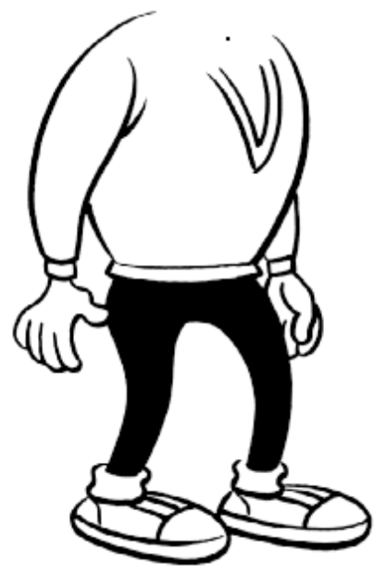
Dot X, Dot Y coordinates for torso
Figure 6: Dot X and Dot Y coordinates for torso of binary character
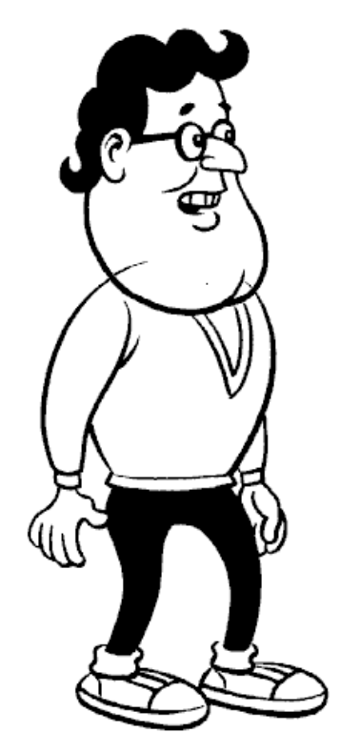
True X, True Y point of alignment
Figure 7: Head and torso of aligned binary character

Sample .avf files
The following example shows the .avf file for Jordan, a unary character.

#AvFile 2 1
Name Jordan
Style 1
Flags TORSOFIRST HEADMASK
Desc This is Jordan
Artist Jim Woodring
Icon jn_icon.bmp

BeginBodies

FOREGROUND jn_1.bmp EM_POINTOTHER 0.0 133 131
AURA jn_1a.bmp

FOREGROUND jn_2.bmp EM_POINTSELF 0.0 133 131
AURA jn_2a.bmp

DITTO EM_COY 0.8

FOREGROUND jn_3.bmp EM_ANGRY 1.0 133 131
AURA jn_3a.bmp

FOREGROUND jn_4.bmp EM_BORED 0.8 133 131
AURA jn_4a.bmp

FOREGROUND jn_5.bmp EM_LAUGH 1.0 133 131
AURA jn_5a.bmp

FOREGROUND jn_6.bmp EM_WAVE 0.0 133 131
AURA jn_6a.bmp

FOREGROUND jn_7.bmp EM_NEUTRAL 0.0 133 131
AURA jn_7a.bmp

DITTO EM_HAPPY 0.4

FOREGROUND jn_9.bmp EM_NEUTRAL 0.0 133 131
AURA jn_9a.bmp

# Not very scared, but better than random neutrals
DITTO EM_SCARED 0.2

FOREGROUND jn_11.bmp EM_NEUTRAL 0.0 133 131
AURA jn_11a.bmp

FOREGROUND jn_12.bmp EM_SHOUT 1.0 133 131
AURA jn_12a.bmp

DITTO EM_SAD 1.0

EndBodies

END

The following example shows an .avf file for a binary character.

#AvFile 1 1
Name TongueTyed
Style 1
Flags TORSOFIRST HEADMASK
Desc This is TongueTyed
Artist Jim Woodring

BeginFaces

FOREGROUND tt_h1.bmp EM_NEUTRAL 0.0 104 171 12 14 87 109
TRANSPARENCY tt_h1m.bmp
AURA tt_h1a.bmp

FOREGROUND tt_h2.bmp EM_HAPPY 0.2 96 171 7 5 90 118
TRANSPARENCY tt_h2m.bmp
AURA tt_h2a.bmp

# Also Neutral
DITTO EM_NEUTRAL 0.0

# Also Coy
DITTO EM_COY 0.5

FOREGROUND tt_h3.bmp EM_LAUGH 0.8 107 170 0 9 96 119
TRANSPARENCY tt_h3m.bmp
AURA tt_h3a.bmp

FOREGROUND tt_h4.bmp EM_ANGRY 0.4 110 164 10 12 90 116
TRANSPARENCY tt_h4m.bmp
AURA tt_h4a.bmp

# Above can also be neutral?

#FOREGROUND tt_h5.bmp DOUBLE 0.0 107 158 -8 -11 110 112
#TRANSPARENCY tt_h5m.bmp
#AURA tt_h5a.bmp

FOREGROUND tt_h6.bmp EM_SAD 0.8 112 167 2 6 90 109
TRANSPARENCY tt_h6m.bmp
AURA tt_h6a.bmp

FOREGROUND tt_h7.bmp EM_ANGRY 0.8 96 175 1 20 82 114
TRANSPARENCY tt_h7m.bmp
AURA tt_h7a.bmp

# Also a poor excuse for shout...
DITTO EM_SHOUT 0.8

FOREGROUND tt_h8.bmp EM_ANGRY 0.6 97 168 -4 8 88 116
TRANSPARENCY tt_h8m.bmp
AURA tt_h8a.bmp

# Front shot
FOREGROUND tt_h9.bmp EM_NEUTRAL 0.0 84 175 4 16 68 115
TRANSPARENCY tt_h9m.bmp
AURA tt_h9a.bmp

# Front shot
FOREGROUND tt_h10.bmp EM_HAPPY 0.7 83 170 4 11 67 113
TRANSPARENCY tt_h10m.bmp
AURA tt_h10a.bmp

FOREGROUND tt_h11.bmp EM_HAPPY 0.8 104 173 -1 10 87 111
TRANSPARENCY tt_h11m.bmp
AURA tt_h11a.bmp

EndFaces

BeginTorsos

FOREGROUND tt_b1.bmp EM_NEUTRAL 0.0 123 20
#TRANSPARENCY tt_b1m.bmp
AURA tt_b1a.bmp

# Also minor angry
DITTO EM_ANGRY 0.4

FOREGROUND tt_b2.bmp EM_NEUTRAL 0.0 91 25
#TRANSPARENCY tt_b2m.bmp
AURA tt_b2a.bmp

# Also minor angry
DITTO EM_ANGRY 0.2

FOREGROUND tt_b3.bmp EM_WAVE 0.0 137 55
#TRANSPARENCY tt_b3m.bmp
AURA tt_b3a.bmp

FOREGROUND tt_b4.bmp EM_POINTSELF 0.0 144 28
#TRANSPARENCY tt_b4m.bmp
AURA tt_b4a.bmp

#FOREGROUND tt_b5.bmp EM_DOUBLEPOINT 0.0 122 49
#TRANSPARENCY tt_b5m.bmp
#AURA tt_b5a.bmp

FOREGROUND tt_b6.bmp EM_SHRUG 0.0 204 20
#TRANSPARENCY tt_b6m.bmp
AURA tt_b6a.bmp

FOREGROUND tt_b7.bmp EM_POINTOTHER 0.0 102 23
#TRANSPARENCY tt_b7m.bmp
AURA tt_b7a.bmp

FOREGROUND tt_b8.bmp EM_ANGRY 0.8 149 39
#TRANSPARENCY tt_b8m.bmp
AURA tt_b8a.bmp

FOREGROUND tt_b9.bmp EM_NEUTRAL 0.0 141 30
#TRANSPARENCY tt_b9m.bmp
AURA tt_b9a.bmp

# Also moderate anger
DITTO EM_ANGRY 0.6

FOREGROUND tt_b10.bmp EM_NEUTRAL 0.0 119 38
#TRANSPARENCY tt_b10m.bmp
AURA tt_b10a.bmp

# Also moderate coy
DITTO EM_COY 0.5

EndTorsos

Icon tt_icon.bmp
END

