Customers Are Using Copilot Chat. Can You Convert That into Governed Value?
  - Pitch Maker Agent (BETA) — transform Partner Center signals into an executive-ready business case in minutes

Executive Summary
Customers are already using free Copilot Chat at scale, but adoption is often ungoverned and disconnected from the Microsoft 365 workloads where measurable productivity and risk controls live.
The Pitch Maker Agent (BETA) helps partners convert Partner Center Copilot growth opportunity signals into customer-ready narratives—reducing pitch preparation from days to minutes and improving consistency across stakeholders (replace with your measured baseline).

What it enables (partner outcomes)
- Turn raw usage signals into an executive business case with clear opportunity, risk, and next steps.
- Standardize value conversations across IT and business buyers while keeping customer context specific.
- Accelerate conversion from exploration to governed deployment by anchoring on Microsoft 365 workloads.

Why it’s different
- Evidence-led: uses Partner Center Copilot growth opportunities (ASPX) signals rather than generic prompts.
- Buyer-ready: outputs a structured narrative (not a feature list) designed for executive alignment and action.

Inputs required
- Partner Center Copilot growth opportunities export (all columns) for the target customer.

The Opportunity: From AI Exploration to Enterprise Direction
The move from free Copilot Chat to Microsoft 365 Copilot is a timing advantage: customers have intent and familiarity, but need a governed path that ties AI to real work in Teams, Outlook, Excel, and beyond.
- Advisory gap: translate usage metrics into business insight executives can fund.
- Governance gap: balance opportunity with security, compliance, and lifecycle controls.
- Workflow gap: connect AI usage to measurable outcomes inside Microsoft 365 workloads.

How the Agent Works (BETA)
The Agent follows a simple, repeatable flow to generate an executive-ready pitch narrative from Partner Center Copilot growth opportunity signals.

In three steps
- Upload the Partner Center Copilot growth opportunities export (all columns).
- Run the Agent to translate usage signals into a customer-specific executive narrative.
- Use the generated business case, recommendations, and next steps in the customer conversation.

What the Output Enables
- Translate Partner Center signals into a fundable business case, faster.
- Improve executive alignment by presenting opportunity, risk, and plan in one narrative.
- Increase repeatability across accounts with a consistent structure and messaging.
The figure below illustrates how the Agent turns usage signals into a concise, executive-ready pitch narrative and action plan.
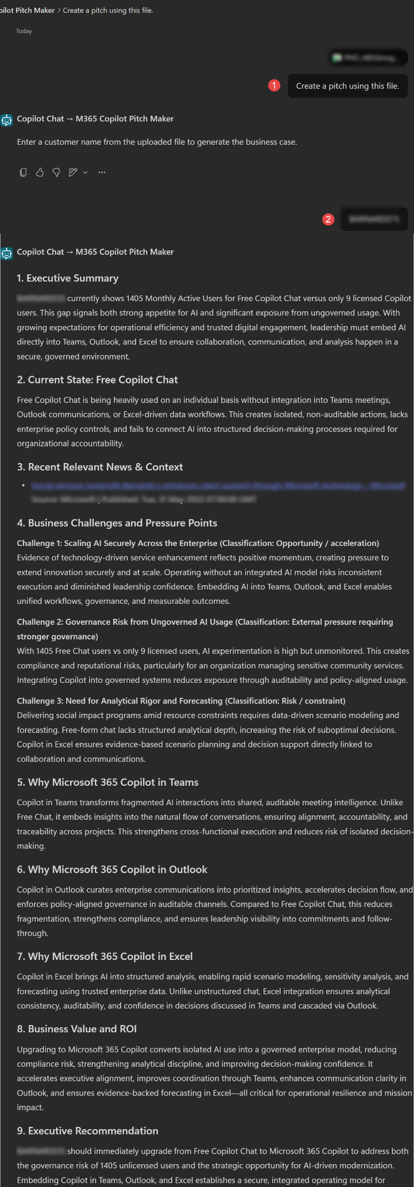
Figure 1. From Copilot Chat signals to an executive pitch narrative and next-step plan.
For customers, the conversation shifts from features to outcomes—clear productivity impact, role-based change, and risk-aware governance.

Deployment and Execution
The Agent is delivered as a solution package and deployed through Copilot Studio with a straightforward publish-and-run flow.
- Prepare Partner Center ASPX export (all columns) and validate sensitivity labels.
- Import the solution package into Copilot Studio.
- Verify dependencies, publish the Agent, and enable access in Microsoft 365 Copilot and Teams.
- Run the guided pitch flow by uploading customer data and capturing the narrative output.
The run guide provides step-by-step visuals for data preparation, import, publication, and how to use the output in customer conversations.

Why This Matters for Partner Practices
The Pitch Maker Agent (BETA) supports a repeatable value motion: identify opportunity, align stakeholders, and move customers from experimentation to governed Microsoft 365 Copilot adoption.
- Higher conversion: clearer executive rationale anchored in evidence and outcomes.
- Lower effort: less time drafting, more time on discovery and delivery.
- Better governance: built-in prompts to address risk, readiness, and controls early.

Call to Action

This week: 15-minute start
- Locate the solution package and run guide in the Agent folder.
- Deploy the Agent in Copilot Studio and publish to Microsoft 365 Copilot/Teams.
- Export Partner Center Copilot growth opportunities data and validate sensitivity labels.
- Upload the dataset and generate a customer-specific executive pitch narrative.

Resources
Helpful links to learn more and access supporting materials:
- Copilot growth opportunities data in Partner Center: https://learn.microsoft.com/partner-center/insights/growth-opportunities-data/copilot
- GitHub Repository: https://github.com/microsoft/m365-copilot-automated-readiness-assessment
- Automated Readiness Assessment Overview: https://github.com/microsoft/m365-copilot-automated-readiness-assessment/blob/main/README.md
- Run Guide: https://github.com/microsoft/m365-copilot-automated-readiness-assessment/blob/main/RUN.md

