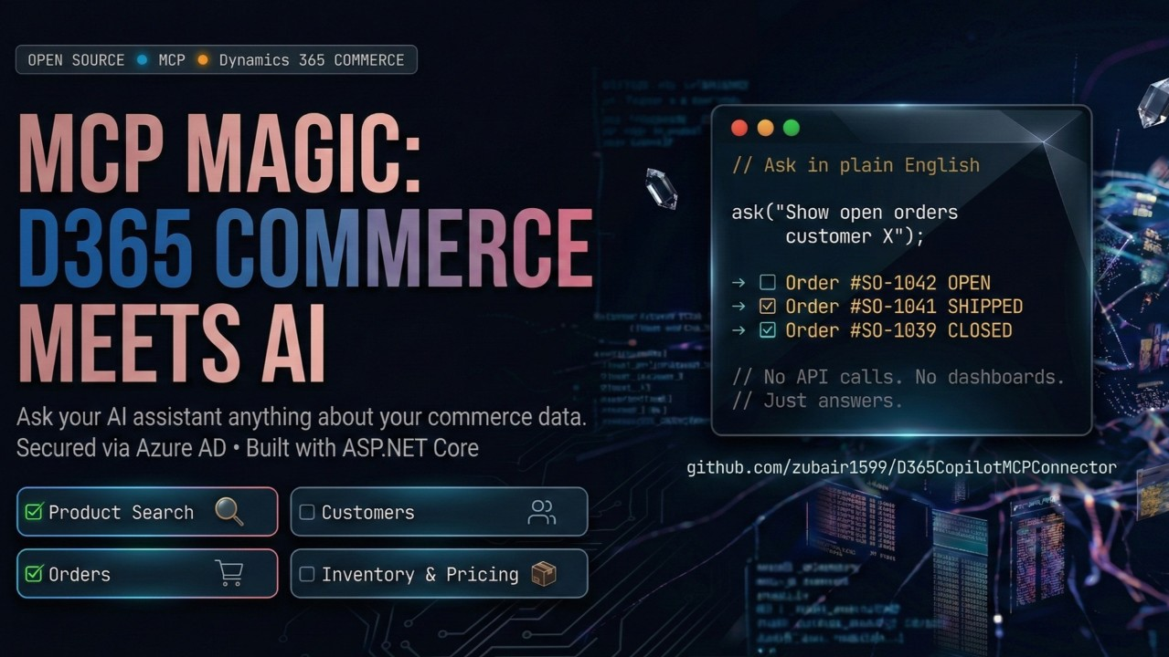
MCP Magic: Turning a Commerce API into a Copilot Commerce Agent

In real world, where D365 Commerce is implemented, the business managers spending way too much time navigating 10 different screens just to find a simple answer.
What if an AI assistant could just talk to your commerce platform? Not pull up docs or give generic answers, but genuinely dig into live data, the way a colleague would. So this weekend, instead of waiting, I built it. The result is D365 Commerce Copilot MCP Connector.

For a business user, no more API calls. No more screen hopping. Just ask:

→ "Search for running shoes under $100"

→ "What's the stock level for SKU-ABC123?"

→ "Show me all open orders for this customer"

→ "How many open shifts we have per store.

→ "What discounts are active on Electronics?" And it just works.

Built with ASP.NET Core, clean architecture, and Azure AD OAuth2, it provides some sample of product search, order management, customer data, and inventory & pricing out of the box all using D365 Commerce CSU Apis. Also you can publish as a connector in your own tenant and Entra details can be provided during addition. The solution can act as foundation for your extensions.

Below diagram can help you understand the overall flow and how each component can talking to each other.

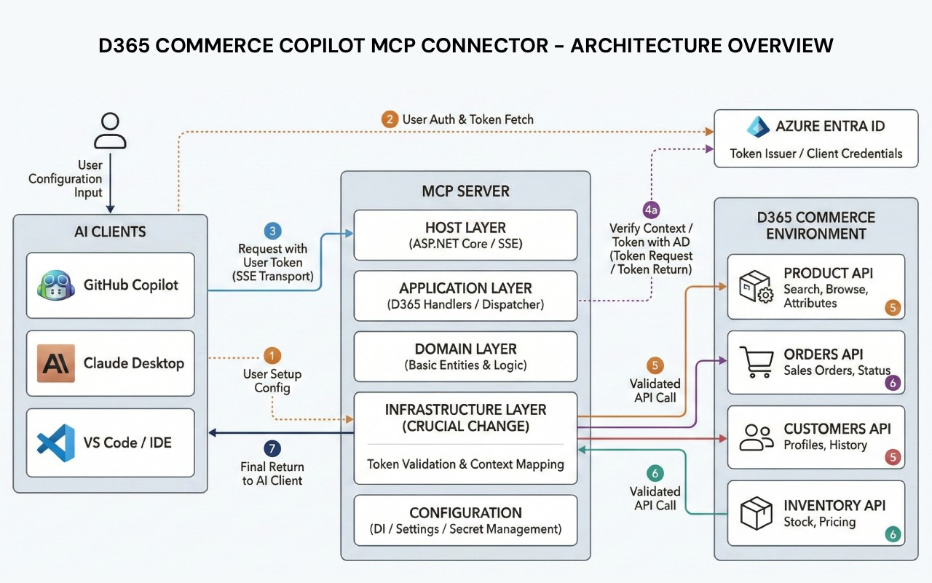

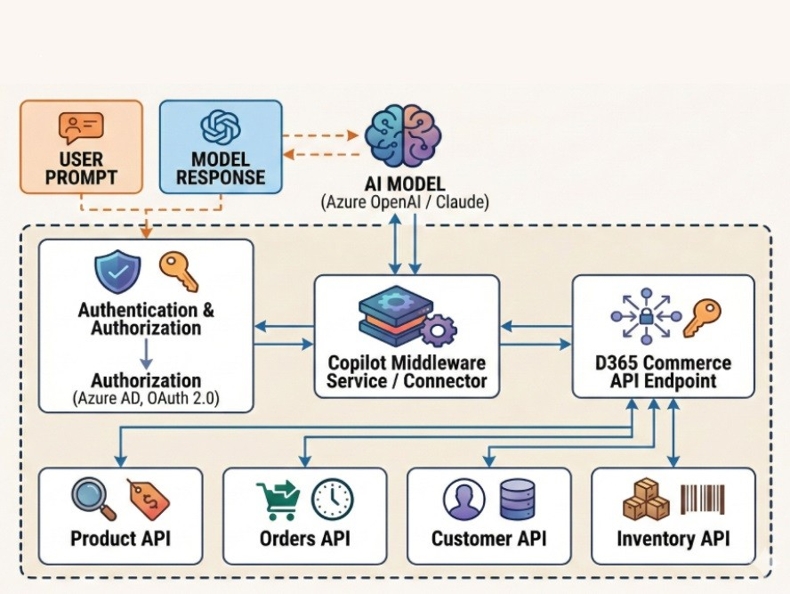

This is the tooling I wish had existed when I first started building on D365 Commerce. MCP is opening up a fundamentally different way to connect AI to enterprise system. And this is my small contribution to that future.

Repo is open source — would love your feedback, stars, and contributions! https://github.com/zubair1599/D365CopilotMCPConnector #MCP #Dynamics365 #DotNET #OpenSource #AITools #GitHubCopilot #Claude #EnterpriseAI #CSharp #AzureAD

