Enterprise call center architecture on Dynamics 365 Customer Service
This article describes a generalized architecture pattern for implementing an enterprise-scale call center solution using Dynamics 365 Customer Service. The architecture enables omni-channel engagement, centralized case management, secure external access, and scalable enterprise integrations while aligning with reliability, security, and cost optimization principles commonly required in regulated industries.
This solution represents a generalized architecture pattern that can be applied across multiple industries and scenarios. Scenario-specific solution ideas can extend this core architecture to address industry or organization-specific requirements.

Architecture
This architecture positions Dynamics 365 Customer Service as the system of engagement for customer interactions and service operations. Omnichannel for Customer Service provides a unified agent experience across digital and assisted support channels. Azure integration services introduce a decoupled integration layer that improves scalability, resiliency, and long-term maintainability. External users interact with the system through secure portals, reducing call volumes and improving service transparency.

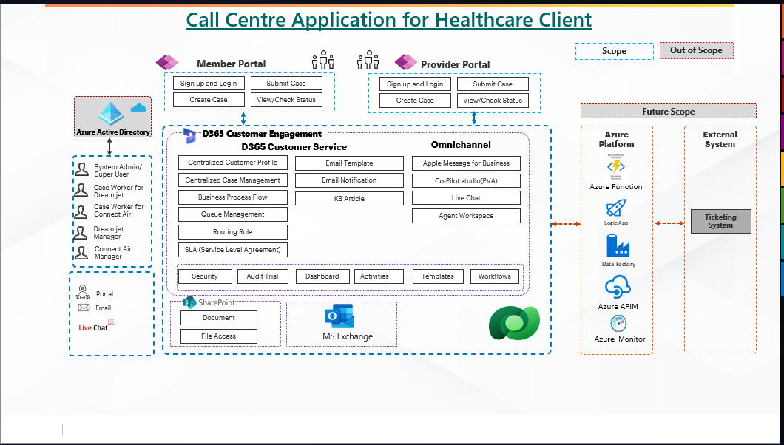

Dataflow
- External users (members or providers) authenticate and access the appropriate portal using enterprise identity controls.
- Users create service requests or review existing case status through the portal, which writes data to Microsoft Dataverse.
- Customer data and case records are maintained centrally in Dynamics 365 Customer Service.
- Service agents and supervisors access cases, interaction history, activities, and timelines through the agent workspace.
- Omnichannel routes incoming digital interactions (chat, voice, email) to appropriate queues based on routing rules, skills, priority, and availability.
- Business process flows, SLAs, and workflows govern case progression, escalation, and resolution.
- Collaboration occurs through integrated productivity services such as email and document management.
- Knowledge articles provide standardized guidance to improve first-contact resolution.
- Integration with external systems is handled asynchronously via Azure services, isolating core operations from downstream failures.
- Monitoring, logging, and telemetry are captured to support operational visibility and incident management.

Components
- Dynamics 365 Customer Service
Provides case management, queues, routing rules, service level agreements, dashboards, audit logs, and activity tracking.
- Omnichannel for Customer Service
Enables consistent engagement across digital channels with a single agent workspace and intelligent routing.
- Microsoft Dataverse
Acts as the centralized data platform for customer profiles, cases, activities, and configuration data with role-based security.
- External-facing portals
Enable self-service case creation and status tracking for members and providers while reducing inbound call volume.
- Microsoft Entra ID (Azure Active Directory)
Provides centralized identity and access management aligned to enterprise authentication standards.
- SharePoint
Stores service-related documents with access control and content governance.
- Azure API Management
Secures, publishes, and governs APIs used for integration with external systems.
- Azure Logic Apps
Orchestrates business workflows and long-running integration processes.
- Azure Functions
Supports event-driven processing and lightweight transformation logic.
- Azure Monitor
Provides end-to-end observability, diagnostics, alerting, and operational insights.

Alternatives
Depending on organizational standards and scale requirements, alternative approaches may be considered:
- Event-driven messaging architectures for higher decoupling and guaranteed delivery.
- Certified third-party telephony platforms where existing voice infrastructure must be retained.
- Alternative identity providers for external users if advanced customer identity and access management is required.
Scenario-specific architectures can build on this generalized pattern to address specialized needs while maintaining architectural consistency.

Scenario details
Enterprise call centers often manage large volumes of interactions across multiple channels while operating under strict service level, security, and compliance requirements. In regulated industries, additional controls are required to ensure auditability, data protection, and least-privilege access.
This architecture addresses common enterprise challenges such as:
- Disjointed customer and interaction data across support channels
- Manual or inconsistent case routing and prioritization
- Limited visibility into end-to-end service operations
- Tight coupling between core platforms and external systems
- Difficulty scaling or extending the solution over time
The architecture demonstrates how to consolidate customer service capabilities into a single platform, provide a unified agent experience, and introduce structured integration patterns that support long-term growth.

Potential use cases
This architecture is suitable for multiple industries and scenarios, including:
- Healthcare: member services, provider support, eligibility inquiries
- Financial services: customer care, claims handling, regulated servicing
- Government: citizen services and public-sector contact centers
- Telecommunications and utilities: service requests, fault reporting, customer retention

Considerations
These considerations help implement a solution that includes Dynamics 365. Learn more at https://learn.microsoft.com/dynamics365/guidance/.

Reliability
Reliability ensures the solution can meet service commitments under expected load and during failure conditions.
Key reliability considerations include:
- Designing integrations as asynchronous workflows to prevent downstream system issues from impacting agent productivity.
- Implementing retry logic, error handling, and idempotency in integration services.
- Monitoring queue depth, routing latency, channel availability, and integration failure rates.
- Maintaining operational runbooks for common incident scenarios, such as channel disruptions or external system outages.
The architecture minimizes single points of failure by decoupling core case processing from enterprise integrations and operational dependencies.

Security
Security protects customer data and service operations from unauthorized access and misuse.
Key security practices include:
- Enforcing role-based access control across Dynamics 365 and Dataverse.
- Restricting portal users to scoped records using table permissions and access rules.
- Securing integrations using API Management, managed identities, and network controls.
- Aligning Azure workloads to Azure Security Baseline recommendations.
- Maintaining audit trails for configuration changes, user actions, and data access.

Cost optimization
Cost optimization focuses on controlling platform consumption while maintaining required service levels.
Primary cost drivers include Dataverse storage and API consumption, Omnichannel capacity, integration executions, and monitoring telemetry.
Cost optimization strategies include:
- Offloading document storage to SharePoint to reduce Dataverse storage usage.
- Using asynchronous integration patterns to avoid costly synchronous processing.
- Scaling Omnichannel capacity based on actual concurrency and business demand.
- Applying retention policies to monitoring data and logs.
- Phasing channel enablement to avoid overprovisioning.
Azure pricing tools should be used to model expected workloads and evaluate cost impacts as usage scales.

Operational excellence
Operational excellence ensures the solution can be deployed, monitored, and supported consistently.
Recommended practices include:
- Using managed solutions and automated pipelines for application lifecycle management.
- Maintaining separate environments for development, testing, and production.
- Implementing centralized dashboards and alerts across Dynamics 365 and Azure services.
- Adopting phased releases for configuration or routing changes to reduce operational risk.

Performance efficiency
Performance efficiency enables the solution to scale effectively as interaction volumes grow.
Performance considerations include:
- Avoiding heavy synchronous logic on user-facing operations.
- Periodically reviewing and tuning routing rules and queues.
- Optimizing portal queries and restricting unnecessary data exposure.
- Applying throttling and protection policies through API Management to safeguard backend services.

Deploy this scenario
A typical deployment approach includes:
- Establishing environments and ALM pipelines.
- Configuring core data models, security roles, queues, and SLAs.
- Enabling Omnichannel channels incrementally.
- Deploying portals with secure authentication and scoped permissions.
- Implementing the Azure integration layer with monitoring and alerting.
- Validating reliability, performance, and operational readiness before full production rollout.

Contributors
This article is maintained by Microsoft. It was originally written by the following contributors.
Principal authors:
- Rahul Dubey
Business Process Architecture Manager

