D365 Reference Architecture for Wholesalers Distributors Importers
Applies to: Dynamics 365 Finance, Dynamics 365 Supply Chain Management, Dynamics 365 Commerce, Power Automate, Power Apps, Power Pages, Dataverse, Azure Synapse, Azure Key Vault, Azure SQL Database, Azure Active Directory…

Introduction
These target audience for this architecture may be Wholesalers, imports, New Product launch companies operating with main market geographies and sourcing from offshore vendors for products on OEM, ODM or Contract Manufacturing basis. The company in addition to B2B Sales model, can use D365 to enter Marketplaces like Amazon or Direct to Consumer Websites managed by providers like Shopify.

Reference Architecture
The following diagram illustrates the architecture for the solution. This diagram is made in Visio (*.vsdx).
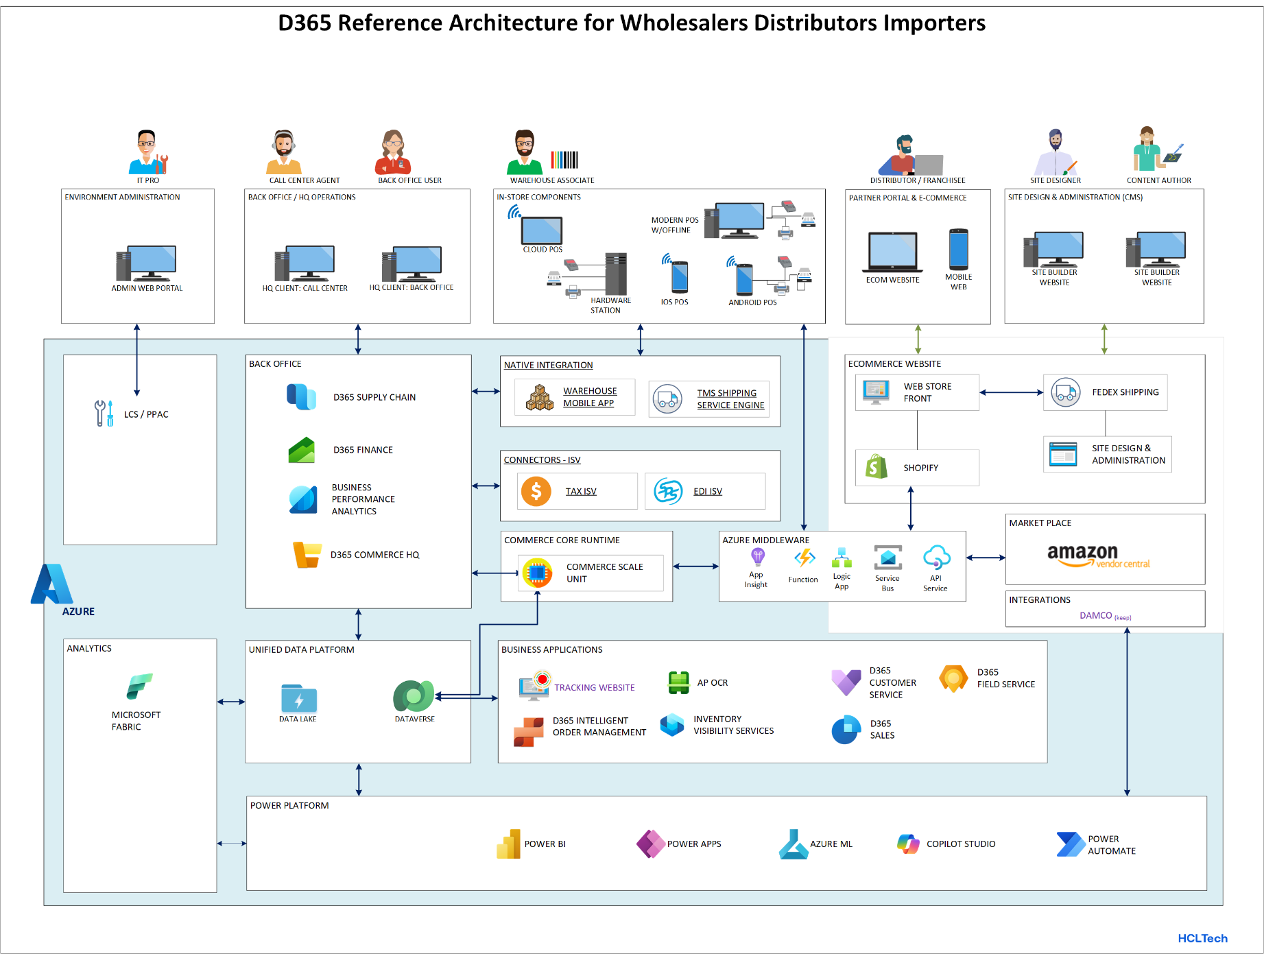

Workflow
Export From D365
Merchandizing data (Products, Pricing, Promotions) are NOT exported to ecommerce and marketplace platforms from D365 in this reference Architecture as this only covers early adapters and bringing down TCO for end client. In initial phase we are suggesting manual configuration of Product, inventory and Price for testing response.
Import To D365
Sales Order can be connected exported from Legacy ERP to D365 follow the following sequence
- The sales orders created in Shopify are posted to service bus topic. For Amazon a pull request does the same created in Azure.
- The listener azure function transform the incoming json to D365 native payload.
- Azure function further post the json to CSU to create a customer order in D365.
- On confirmation, Azure function using a webhook to notify the sender app about creation status.

Components
The following components are used in the reference architecture.
- D365 F&O is the future ERP client is implementing.
- CSU is used as headless commerce and provide end points for commerce communication
- DMF is used for data migrations and integrations to move data in and out from D365 mostly for migration or supporting bulk upload to other platforms.
- Azure Logic Apps in coordination with other components are used for integrations.
- Azure Service Bus is used to decouple direct dependencies between sender and listener.
- Azure Functions are used to do complex transformations.
- Azure Key Vaults are used to store the sensitive information for all native or third-party applications.
- App Insights are used to log all Api communications, error or exceptions. It is also enabled in D365 to post D365 Exceptions.
- Inventory Visibility is used enabled to provide near to real-time inventory on hand and soft reservation feature.
- Synapse Link is used to sync F&O tables to Data Lake which are further used for reporting. Alternatively Fabric is also being used for evaluation to shift to Synapse or keep Fabric.
- Tracking Website (Power pages + Power BI) is created for internal Sales people and external partner network users to get status updates;
- D365 Custom Services are built to integrate custom data contracts with Azure.
- D365 Business Events are used to notify DMF jobs completion, sales order status updates etc.

Scenario Detail
This Architecture is designed to support businesses migrating from legacy systems like MAS500, SAGE, AS400 etc. into D365 with a clean cut-off. Some key solution highlights are;
- EDI remains as a key integration / adapter component for B2B business model
- B2C model shifts to CSU based API communication mechanism.
- For B2B Sales Pool and Sales Order Origin helps out in reporting with combination of Financial Dimension driven from Product & Customer
- For B2C Focus shifts to Channel specific financial dimension in addition to Customer & Product
- Shipping Integration is used from back office for B2B and for B2C ecommerce shipping API is leveraged.
- IOM is used for orchestration and fulfillment logic switching between B2B & B2C.
- Dedicated and some virtual but basic warehouses are configured for support inventory isolation and support Dropship (Direct Delivery) use case.

Potential Use Case
Applicable to.
- Importers who operate in USA and specialize in foreign products being imported on a resale agreement.
- Wholesalers / Distributors who may buy from local vendors or do consignment orders for selling to other businesses.
- Importer Business model who are taking on Distributor or Franchiser Model at a slow adoption pace

Considerations
These considerations help implement a solution that includes Dynamics 365. Learn more at Dynamics 365 guidance documentation.

Cost optimization
Cost optimization is about looking at ways to reduce unnecessary expenses and improve operational efficiencies. For more information, see Overview of the cost optimization pillar.
Since legacy system was limited and had allot custom work done to fit growth needs. D365 seem to be the right fit to promise scalability, but any exception needed to be rationalized.

Implementing [name of solution]
NA

Procedure: [Name of procedure]
- NA

Next step
- Solution Blue Print Review with access to a configured Demo sandbox to Client with Fit User Stories configured for confirming design.

Related patterns
- NA

Related resources
- Related Resources has been provided in Git hub

Tags
Industries: Wholesale Trade (50-51), Finance
Stakeholders: Accounts payable, Accounts receivable, Administrative, Audit, Customer services, Finance, Human Resources, IT, Marketing, Merchandising, Operations, Project Management, Purchasing, Retail store operations, Sales, Service operations, Transportation, Warehouse
Products: Dynamics 365 Commerce, Dynamics 365 Customer Service, Dynamics 365 Finance, Dynamics 365 Sales, Dynamics 365 Supply Chain Management, Power Automate, Power Apps, Power Pages, Dataverse, Azure Logic Apps, Azure Functions, Azure Data Lake, Azure Synapse, Azure Key Vault, Azure SQL Database, Azure Active Directory…

Contributors
This article is maintained by Microsoft. It was originally written by the following contributors.
Principal author: Faiq Wyne - Solution Architect
Other contributors:
NA

