

Fundraising and Engagement

for Dynamics 365 Sales, a Microsoft solution built with MISSION CRM

Deployment Guide

**Published**: October 8, 2020

**Release Version**: v1.0

Contents

Overview 2

Getting Started 3

Intended Audience 3

Prerequisites 3

Configuring Your Application Registration in Dynamics 5

Setting up Azure Components to Support Multiple Dynamics Environments 6

Azure Components Created 7

Deploying Fundraising and Engagement for Dynamics 365 Sales Enterprise 8

Prerequisites Installed During Solution Deployment 8

Acquire directly from within Dynamics 8

Acquire directly from AppSource Directly 10

Provisioning the ARM Template 12

Completing the ARM Template 12

Adding the Azure SQL User Accounts 16

Deploying the Azure Components 18

Clone the Solution 18

Build the Solution 20

Deploy to Azure 21

Populate the Azure SQL Schema **Error! Bookmark not defined.**

Troubleshooting 35

When a Failure Occurs 35

Updating Visual Studio 2019 Community Edition (or Higher) 35

Modifying the Template 35

Naming and Unique Name Concepts 35

Learn More About Azure and Extending Dynamics 365 36

# Overview

Fundraising and Engagement built for Dynamics 365 Sales, a Microsoft solution built with MISSION CRM, requires an accompanying single tenant Azure environment to access features such as recurring donation processing, Bank ACH batching, and automated financial summaries. Although this functionality resides in the Fundraising and Engagement Dynamics 365 solution, the solution relies on an Azure environment to process, generate, and calculate data on an ongoing basis.

To set up an Azure environment for a Fundraising and Engagement instance, an Azure ARM template has been pre-configured to allow implementors to provision the required environment with as little intervention as possible.

This guide walks an implementor through the process of deploying the Azure ARM template and ensuring it is correctly configured. The process assumes tthat the user deploying the Azure ARM template thoroughly understands the prerequisites listed on page 4 prior to completing this process.

See the latest version of the [ARM template](https://aka.ms/FEARMTEMPLATE) and [ARM template documentation](https://aka.ms/FEARMDEPLOYMENTGUIDE).

# Getting Started

This guide is intended to help implementors navigate the initial setup of a new Azure environment that is supporting a new instance of Dynamics 365 Customer Engagement which has already installed and configured the Fundraising and Engagement managed solution. Take a moment to review the requirements prior to moving ahead. The process requires that the user take note of the results of the creation of the Azure environment as they are needed to complete the setup process.

## Intended Audience

This guide assumes the user implementing the Fundraising and Engagement Azure environment has a solid understanding of Azure, Web Applications, and has completed AZ-900 or comparable accreditation at a minimum.

## Prerequisites

The following prerequisites are required to deploy the template and create the Azure components.

|  |
| --- |
| Note: The ARM template is not capable of rolling back components. This means if the ARM template fails as a result of the following prerequisites not being met, the user implementing the template must manually remove the created components before reattempting the deployment. |

### Azure Role

The template has been designed to run as a user that has the ‘Owner’ role assignment on the target subscription. During the creation process, several steps assign access privileges and associate roles to application user accounts. Without the ‘Owner’ role, the ability to manage this process automatically via the template cannot occur.

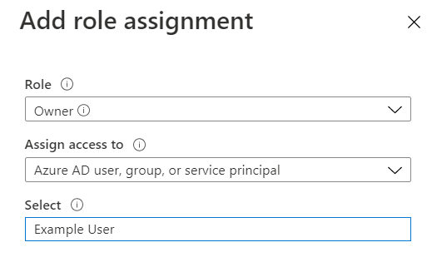

### Azure Active Directory Application Registration

The Azure Active Directory Application user must be set up and configured to have the Dynamics 365 Customer Engagement rights within the tenant. Once the Application user is set up, record the secret and client application identifier.

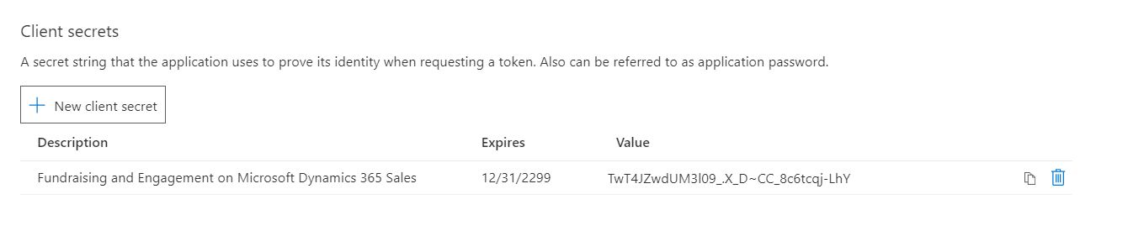

|  |
| --- |
| Note: The application client secret, once generated, cannot be retrieved after it has been configured. Be sure to record the value as it is needed in the completion of the template. The value must match or the Azure environment will not work as expected. |

The Application (client) ID will also be required. Record the value to complete the ARM template process.



### Dynamics 365 Customer Engagement Instance Information

The Azure components require the creation and update of Dynamics records and therefore require the Dynamics Customer Engagement API URL.

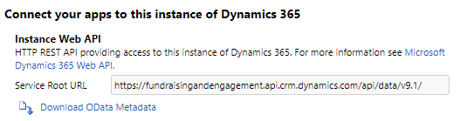

The value required will be in the format of <https://instancenameasdisplayed.api.crmx.dynamics.com>.

### Existing Azure Subscription

It is expected that the subscription used in the deployment is the same subscription for which the user has the ‘Owner’ role assignment.

### Azure and Dynamics Tenant

The Azure environment you are creating the components in must be within the same Office 365 Azure Active Directory controlled tenant. Due to the Azure environment relying on server to server authentication by means of the application record in Azure Active Directory, the user must be visible to your Fundraising and Engagement for Dynamics 365 Sales solution instance.

### Retrieve Your Azure Directory Tenant ID

The Azure Active Directory Tenant Identifier is required during the setup of the Azure components. For the server-to-server authentication to work as expected, both the application identifier and the tenant identifier are required. The tenant identifier in Azure can be found by navigating to ‘Azure Active Directory’ and viewing the ‘Tenant ID’ from the overview pane.

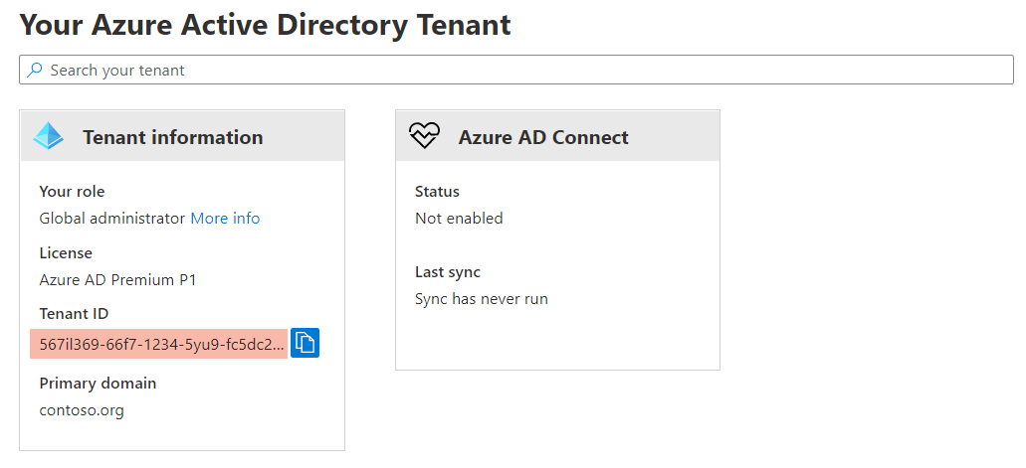

### Configure SQL Server Management Studio (SSMS)

It is required to access the Azure SQL database that is created post completion of the ARM template deployment. Get the latest version of [SQL Server Management Studio (SSMS)](https://docs.microsoft.com/en-us/sql/ssms).

At the time of authoring this document, SQL Server Management Studio is the only SQL scripting tool that can add and provision SQL users as required by the deployment.

## Configuring Your Application Registration in Dynamics

To ensure your application registration works as expected, add the application registration into Dynamics 365. Dynamics 365 treats application registrations differently than that of regular provisioned users. To gain access, the view must first change from the standard ‘All Users’ to ‘Application Users:

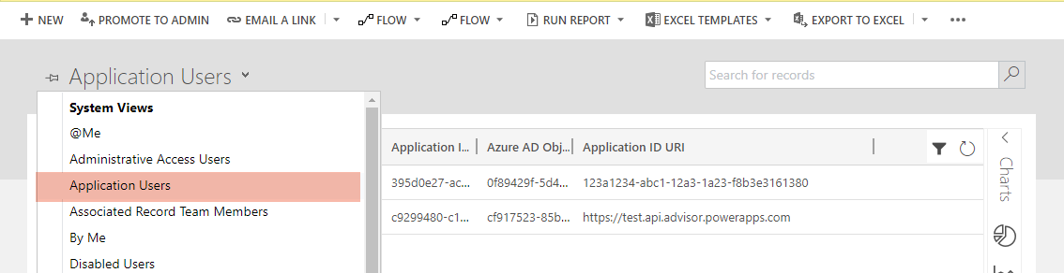

From here you can ‘add’ the application registration by entering the ‘Application (client) ID’. Although the user name, full name, and email address are required, the application does not validate those fields so a user can enter any identifying information they please.

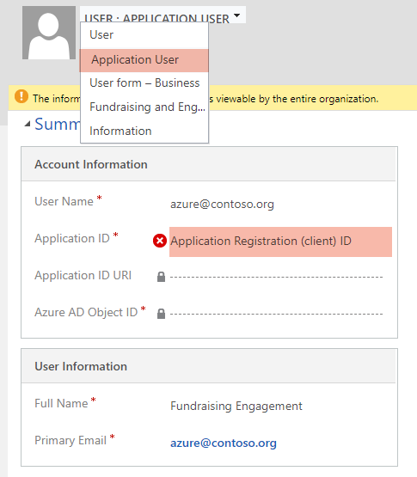

For additional details on configuring your ‘Application Users’ please review documentation on [setting up non interactive users as application users in Dynamics 365](https://docs.microsoft.com/en-us/power-platform/admin/create-users-assign-online-security-roles#create-an-application-user).

When an ‘Application User’ interacts with Dynamics 365, the application applies the same privilege and access logic as it does to an interactive user. This means an administrator must grant the application user the correct privileges for the records that will be created or updated. In Fundraising and Engagement, the following records are both created and/or updated:

* Transaction
* Payment Schedule
* Payment Method
* Response Record.

For more details on administering privileges in Dynamics 365, view [Security Roles and Privileges](https://docs.microsoft.com/en-us/power-platform/admin/security-roles-privileges).

## Setting up Azure Components to Support Multiple Dynamics Environments

The deployment template creates a single resource per instance of Dynamics 365. An administrator preparing an implementation spanning several Dynamics 365 Instances may wish to share a single resource group. In this case, the template may act as the starting process for the deployment and administrators can expand this by manually adding additional resources.

Note that this template and this guide cover a typical deployment for a single instance of Dynamics 365.

## Azure Components Created

The following Azure components are created during the deployment of the ARM template:

|  |  |  |
| --- | --- | --- |
| Component | Type | Purpose |
| API | App Service | The API used to send data from Dynamics 365 Customer Engagement to Azure. |
| Background Services | App Service | The Function processes to manage rollup queries and calculations, this primarily writes values back to Dynamics 365 Customer Engagement. |
| Bank Run | App Service | The application which generates and delivers the import file for the specified bank using the specified value. |
| Recurring Donation Engine | App Service | A process that manages the recurring gift process and generates the results in the form of Transactions that are written back to Dynamics 365 Customer Engagement. |
| App Service Plan | App Service Plan | The service plan created during the creation of the Azure environment. This plan can be edited after creation. |
| API Insights | Application Insights | The corresponding Application Insights instance that corresponds to the created API. |
| Background Services Insights | Application Insights | The corresponding Application Insights instance that corresponds to the created Background Services. |
| Bank Run Insights | Application Insights | The corresponding Application Insights instance which corresponds to the created Bank Run. |
| Recurring Donation Engine Insights | Application Insights | The corresponding Application Insights instance which corresponds to the created Recurring Donation Engine. |
| Vault | Key Vault | The secure storage that brokers sensitive information such as SQL passwords between Azure Applications. |
| Azure SQL Database | SQL Database | The Azure SQL Database which stores data passed to it from Dynamics. |
| Azure SQL Server | SQL Server | The Azure SQL server that is created by default in order to facilitate the Azure SQL Database. |
| Logging Storage | Storage Account | The storage account which holds the logging information from the recurring donation engine. |

# Deploying Fundraising and Engagement for Dynamics 365 Sales Enterprise

The intended deployment methodology is through AppSource. As the AppSource deployment is automated, it is important to note the prerequisite managed solutions which are installed or upgraded during the AppSource deployment.

## Prerequisites Installed During Solution Deployment

1. As part of the required prerequisites, the Nonprofit Core managed solution is deployed. Fundraising and Engagement is set up to work with the latest version of the Nonprofit Core data schema in the Common Data Model (CDM) for Nonprofits. The Nonprofit Core can be installed directly from the Fundraising and Engagement AppSource listing. If you are acquiring the solution as source code from GitHub you will need to install the Nonprofit Core managed solution from the GitHub link noted below before deploying Fundraising and Engagement.

|  |
| --- |
| **Note**: To inspect the latest version of the Common Data Model (CDM) for Nonprofits and how it may impact those organizations who have already deployed the CDM, please review the latest release on [GitHub](https://github.com/microsoft/Industry-Accelerator-Nonprofit/releases). |

## Acquire Fundraising and Engagement from within Dynamics

1. Login into your Dynamics 365 instance. From the application welcome screen select ‘Advanced Settings’, ‘Customization’ and then ‘AppSource’:

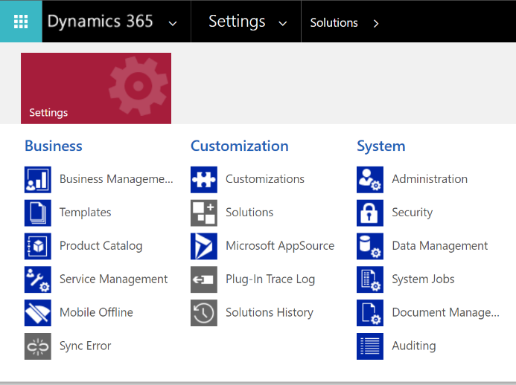

1. Using the navigation, find ‘Fundraising and Engagement’ and then select ‘Get it Now.’

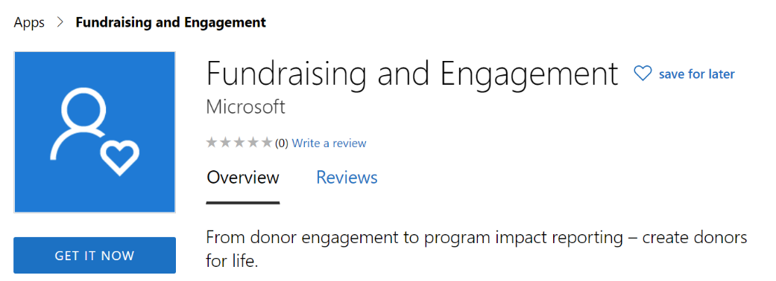

1. Follow the prompted guide to complete the process ensuring that the user completing the AppSource process has at least ‘System Administrator’ role assigned.

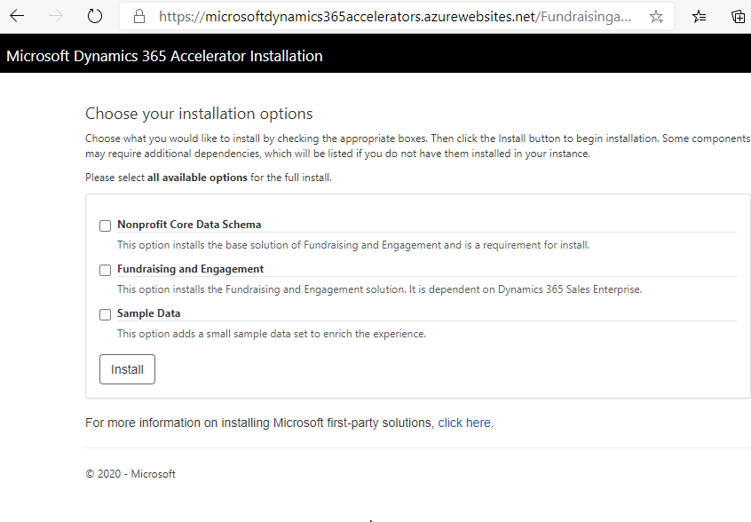

The Nonprofit Core Data Schema is required for Fundraising and Engagement. The Sample Data is optional and will provide a small set of sample data as well as default Configuration Record for users to use to get a good sense of how the solution works in their own environment. The Sample Data cannot be downloaded on its own. It must be deployed at the same time as the Fundraising and Engagement solution.

1. The Fundraising and Engagement application will appear once installed. With the application visible this indicates a successful deployment.

## Acquire from AppSource

1. From the AppSource catalogue, navigate to Fundraising and Engagement by first going to the [AppSource](https://appsource.microsoft.com/) home page. Then search for ‘Fundraising and Engagement.’ Once located select ‘GET IT NOW’.



1. Follow the prompted guide to complete the process ensuring that the user completing the AppSource process has at least ‘System Administrator’ role assigned.
2. You will be prompted to login to your tenant. From there select the Dynamics 365 instance you want to deploy Fundraising and Engagement.

Follow the remaining prompted steps, such as the privacy policy and terms and conditions, both of which must be accepted for the solution to be installed.



The Nonprofit Core Data Schema is required for Fundraising and Engagement. The Sample Data is optional and will provide a small set of sample data as well as default Configuration Record for users to get a good sense of how the solution works in their own environment. The Sample Data cannot be downloaded on its own. It must be deployed at the same time as the Fundraising and Engagement solution.

1. The Fundraising and Engagement application will appear once installed, with the application visible this indicates a successful deployment.

Once Fundraising and Engagement is successfully deployed, the user needs to set up the Configuration Record for the Dynamics components to work properly. Step by step instructions on how to configure the Configuration Record can be found in the [User Guide](https://aka.ms/feuserguide).

# Provisioning the ARM Template

## Completing the ARM Template

1. Login into your Azure Portal as the user with ‘Owner’ privileges for the subscription. The guide assumes you have accessed your Azure environment via <https://portal.azure.com>.
2. Create a new resource.

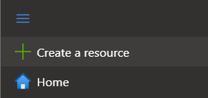

1. In the search box, enter ‘Template’ and select ‘Template deployment (deploy using custom templates).’

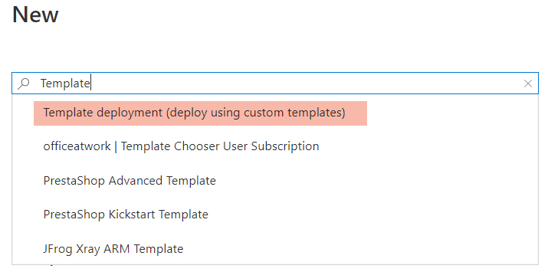

1. Select, ‘Create.’

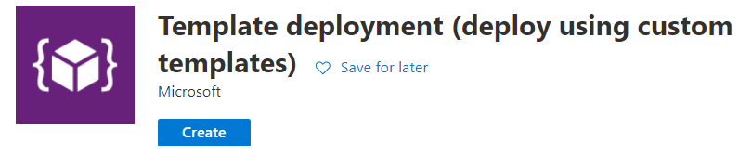

1. Select ‘Build your own template.’

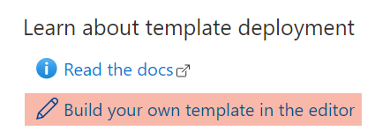

1. Select ‘Load file’ from within the ‘Edit template’ section and select the ARM Template.

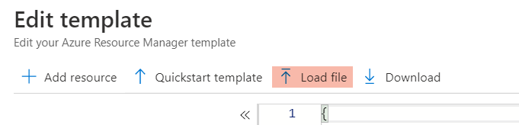

1. Select ‘Save’ to progress to the user inputs.
2. The template will require all inputs to be completed before the deployment. The specific inputs are:
   1. Basics section

|  |  |  |
| --- | --- | --- |
| **Setting** | **Description** | **Example** |
| *Subscription* | Select from an existing subscription, although multiple subscriptions may be visible, only those that the user deploying the template as the ‘Owner’ role set on can be used. | *Pay-As-You-Go* |
| *Resource Group* | Enter the resource group to be used, enter a descriptive name as all the Azure components will be assigned to this resource group and identifying those resources that are needed for Fundraising and Engagement will be beneficial to a demonstrator. | *FundraisingandEngagement* |
| *Location* | The resource locations for these components, all resources are assigned to specific geographic locations based on the group. Locations can be moved post deployment. | *(US) Central US* |

* 1. Settings section

|  |  |  |
| --- | --- | --- |
| **Setting** | **Description** | **Example** |
| *Client Name* | The short name for the client; this value acts as the suffix applied to the components created during this process forming a unique name for each application. | *Contoso* |
| *Env* | Select from Dev, QA, UAT, Test and Prod. Select the option that best suits the purpose of this deployment, this acts as a prefix to the naming of the created applications. | *prod* |
| *Sql Server Admin Login* | The SQL Server Administrator account that will be used when creating the Azure SQL Server. It will be important to record these details securely as they are required to complete additional configuration. | *sql-admin* |
| *Sql Server Admin Login Password* | The SQL Server Administrator password that will be used when creating the Azure SQL Server. It will be important to record these details securely as they are required to complete additional configuration. | *An example password* |
| *Database Password* | The SQL Database user password that will be stored as a secret in the secure key vault | *An example password* |
| *CrmApplication ID* | This is the ‘Application (Client)’ ID captured during the prerequisites | *39b994e7-6430-4969-9…* |
| *Crm Application Key* | The application secret key obtained from the ‘Application’ registration in Azure Active Directory. Captured during your prerequisite checklist. | *W+GLdvquGb&f3PU4z6…* |
| *Crm Organization URL* | The Dynamics 365 for Sales Enterprise API URL | *https://fundraisingandengagement.api.crm.dynamics.com* |
| *Crm Tenant Id* | The Azure Active Directory identifier | *488d3e41-7005-4a64-8…* |

1. Using the above example inputs, the template will look like this:

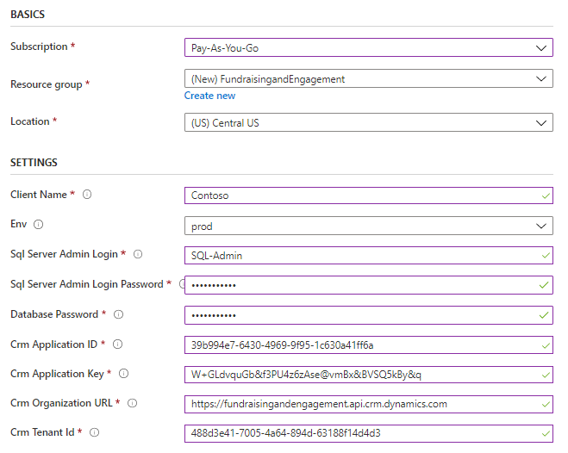

1. To start the process, select ‘I agree to the terms and conditions stated above.’

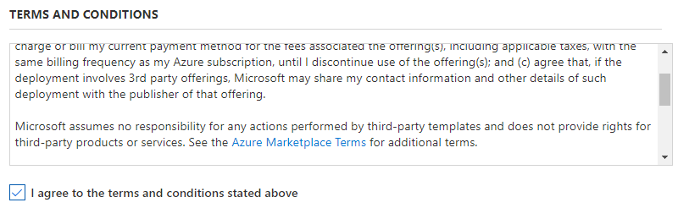

1. Proceed to create.
2. Review the completed process. Any errors presented during the deployment of the template will result in an administrator needing to delete the components, correct the input error, and re-run the template.
3. The process will create the following components:

|  |  |
| --- | --- |
| Azure Component | Example Name (Using the Above Example) |
| Service Plan | Contoso-AppServicePlan |
| SQL Server | Contoso-sqlserver-prod |
| SQL Database | Contoso-db-prod |
| SQL Database Username | Contoso_prod_user |
| Secure Key Vault | Contoso-vault-prod |
| Azure Storage Account | Contosostorageprod |
| Azure Function | Contoso-BackgroundServices-prod |
| Azure Web Application (API) | Contoso-ApiApp-prod |
| Azure Web Job (Recurring Donation Engine) | Contoso-RecurringDonationApp-prod |

1. The deployment will alert the user to the success of the deployment. A successful deployment presents the following:

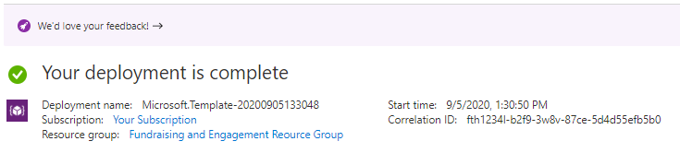

## Adding the Azure SQL User Accounts

Once the template has successfully completed the creation of all Azure components, the pre-created SQL user account needs to be set up within the Azure SQL Database.

|  |
| --- |
| Note: SQL Server Management Studio is required as these steps must be performed against the ‘master’ database of the SQL Azure Server. You can download the latest version of [SQL Server Management studio](https://docs.microsoft.com/en-us/sql/ssms/download-sql-server-management-studio-ssms?view=sql-server-ver15). To enable access from SQL Server Management Studio to the SQL Azure Server, follow these steps on how to set firewall rules using the [Azure portal](https://docs.microsoft.com/en-us/azure/azure-sql/database/firewall-configure#use-the-azure-portal-to-manage-server-level-ip-firewall-rules). |

The SQL username will have been created using a pre-defined naming convention of ‘Client_Name’ and ‘Environment’ and ‘User.’ Using the examples listed in this document, the SQL user account will be:

*Contoso_prod_user*

From within a Query against the ‘Master’ database on the SQL Server, configure the Azure SQL user using the following example script:

CREATE LOGIN SQL_Login_Name (e.g. Contoso_prod_user)

WITH PASSWORD = 'Password as entered during ARM Template configuration'

GO

|  |
| --- |
| Note: You must first create the user against the SQL Server. Ensure that the SQL Query is being run against the master database. |

With the SQL user setup within the SQL Server, the SQL user must now be provisioned to access the SQL Database. Use the following example script to complete this required process:

CREATE USER SQL_Login_Name e.g. Contoso_prod_user

FOR LOGIN SQL_Login_Name e.g. Contoso_prod_user

WITH DEFAULT_SCHEMA=dbo

GO

EXEC sp_addrolemember N'db_owner', N'SQL_Login_Name e.g. Contoso_prod_user'

GO

# Deploying the Azure Components

These steps assume the Azure environment is now ready to be populated by the applications that power the Fundraising and Engagement solution. Each component created must be in place before completing the steps outlined in this section.

The following prerequisites are required to deploy the template and create the Azure components:

* Visual Studio 2019 Community Edition or Higher
* Access to the latest [GitHub repository for Fundraising and Engagement](https://github.com/microsoft/fundraising-and-engagement)
* The latest updates to [Visual Studio 2019 Community Edition](https://visualstudio.microsoft.com/vs/community/) or higher.

|  |
| --- |
| Note: This guide assumes the user populating the Azure environment has a basic understanding of Visual Studio. Visual Studio 2019 Community Edition or higher is the only supported version. Download the latest version of [Visual Studio 2019](https://visualstudio.microsoft.com/downloads/), a free development tool. |

## Clone the Solution

The goal is to clone the latest GitHub repository to your local Visual Studio instance. This guide covers only the initial clone.

|  |
| --- |
| Note: If you have already deployed the Fundraising and Engagement Azure components using this guide, connect to [GitHub](https://github.com/microsoft/Industry-Accelerator-Nonprofit) to retrieve the latest solution. Always use the most up to date version of the solution when deploying to Azure. |

1. Retrieve the latest GitHub repository URL by locating the most recent repository and selecting ‘<> Code.’

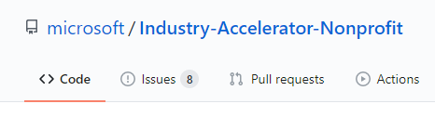

Copy the URL that now displays in the browser window.

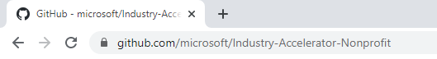

1. Open Visual Studio and select ‘Clone or check out code.’

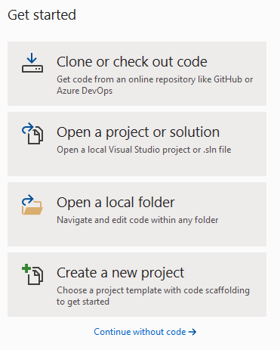

1. Enter the previously copied GitHub URL. You now have an option to change the local path.

|  |
| --- |
| Note: If you have already deployed the Fundraising and Engagement Azure components using this guide, to avoid a conflict, you may want to change the local path to indicate the most recent cloned release form GitHub. |

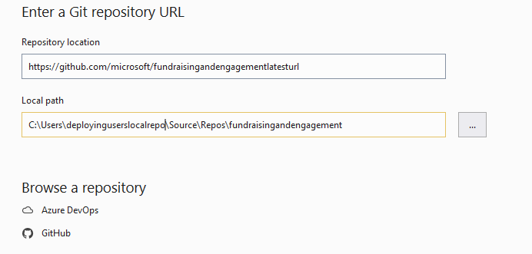

1. The solution will indicate it is cloning successfully by presenting the progress bar.

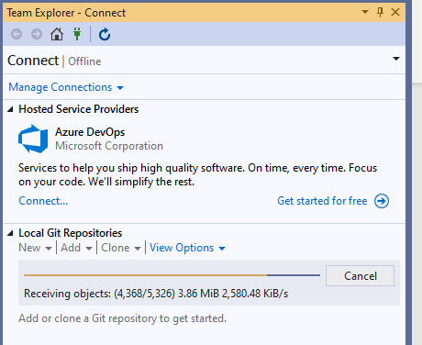

1. Change the view to default to the ‘Team Explorer’ tab.
2. Open the services solution by double clicking on the ‘FundraisingandEngagementServices.sln.’
3. Navigate back to the solution by selecting the ‘Solution Explorer’ tab.

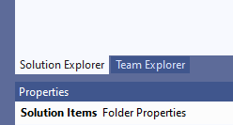

## Build the Solution

The solution requires building locally prior to deploying to Azure. The process of building the solution to deploy does not require that the user run it locally. As a result, the default base installation of Visual Studio 2019 Community Edition has the required prerequisites to complete this task.

To build the solution, right click on the solution and select ‘Build Solution.’

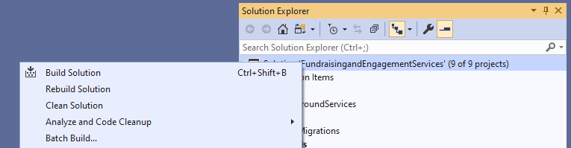

There are nine build steps. The user can confirm that the build was successful by verifying the output:

Sample screenshot of step #9 showing successful verification

## Deploy to Azure

Deploying the solution to the previously created Azure components requires that the user deploying the solution has access to those that were previously created. This guide assumes the user creating the Azure components is using the same access credentials as the user that then deploys the Fundraising and Engagement solution.

Visual Studio 2019 Community Edition supports multiple profiles. Ensure the profile in use matches the target for the deployment:

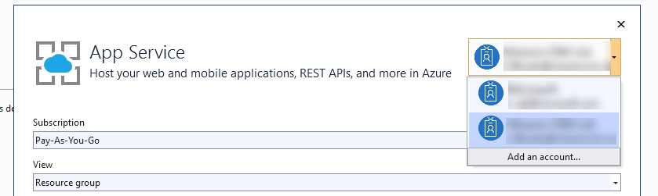

There are three components that require deploying to Azure: the API, RecurringDonations, and the BackgroundServices. Follow these steps to deploy each Azure application.

### API

1. Right click on the API Visual Studio folder and select ‘Publish.’

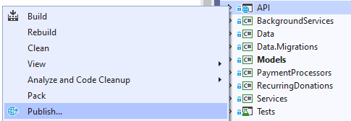

Select ‘Start.’

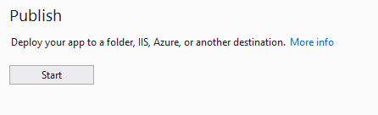

1. Select ‘App Service’ (this is the default) and ensure that ‘Select Existing’ is checked:

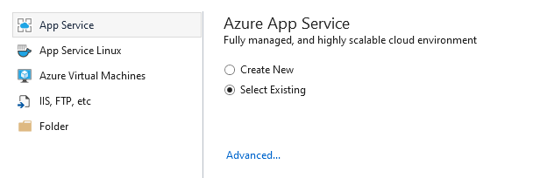

1. Select ‘Create’ and ensure the profile in use is the profile that has ‘contributor’ rights to the Azure deployment. Select the subscriptions, change the view to ‘Resource Group,’ then locate the ‘API’ created during the Azure deployment steps:

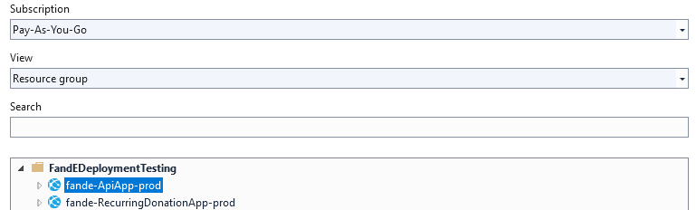

1. Select ‘OK’ then ‘Publish.’

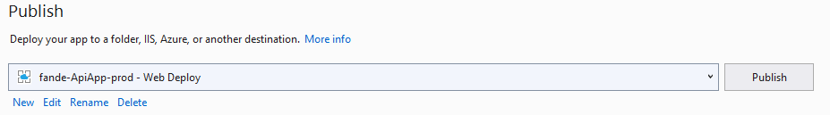

1. Verify the success by ensuring the ‘Output’ section displays the successful deployment:

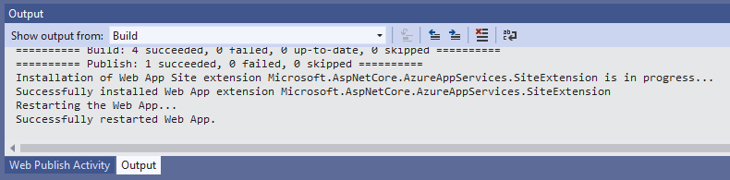

### Recurring Donation

1. Right click on the ‘RecurringDonations’ Visual Studio folder and select ‘Publish.’

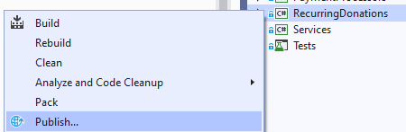

1. Select ‘Azure WebJobs’ then ‘Select Existing.’

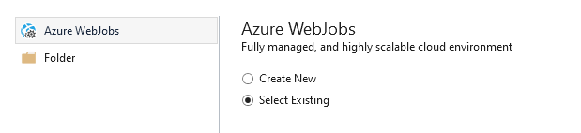

1. Select ‘Create Profile’ and ensure the profile in use is the profile that has ‘contributor’ rights to the Azure deployment. Select the subscriptions, change the view to ‘Resource Group,’ then locate the ‘Recurring Donation App’ created during the Azure deployment steps:

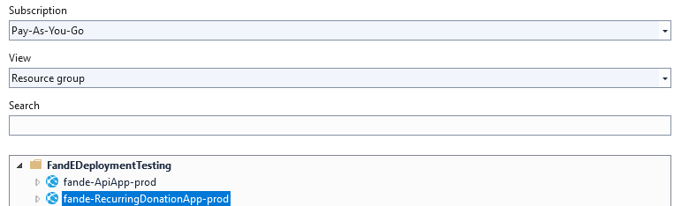

1. Select ‘OK’ then ‘Publish.’

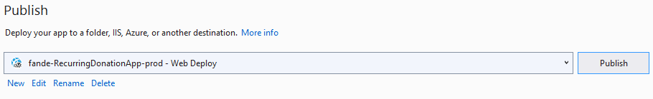

1. Verify success by ensuring the ‘Output’ section displays the successful deployment:



### Background Services

1. Right click on the ‘BackgroundServices’ folder in Visual Studio folder and select ‘Publish.’

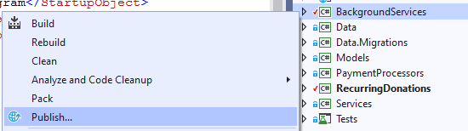

1. Select ‘Folder’ then ‘Next.’

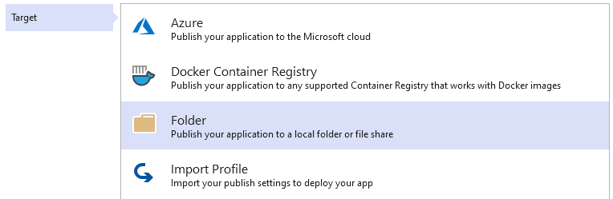

1. Select a local folder repository that you have permission to write to e.g. C:\Users\Username\Documents\Deployment Folder.

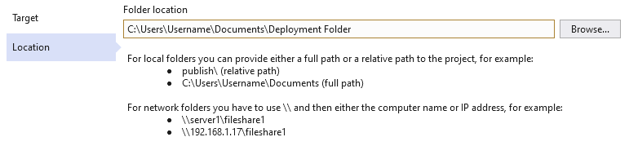

1. Select ‘Publish.’

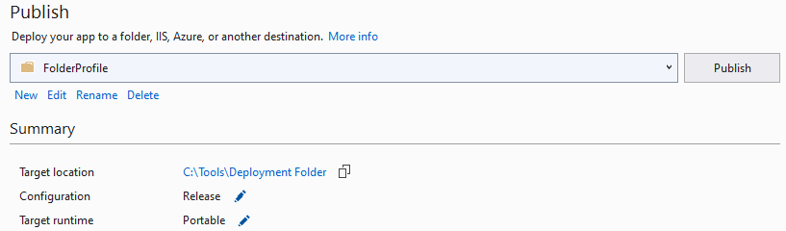

1. Confirm the build was successful.

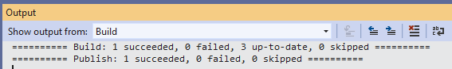

1. Navigate to the deployment folder, select all folders in the deployment path, and add them to a zip file.

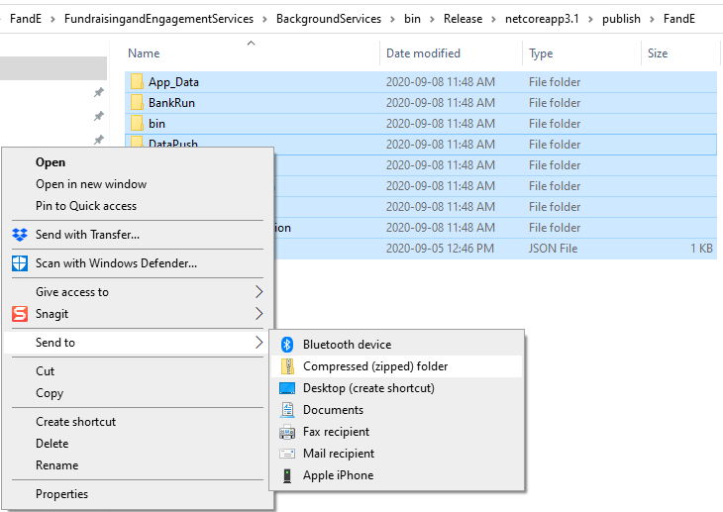

1. Navigate to the originally created function app within Azure, select ‘Advanced Tools,’ then select ‘Go.’

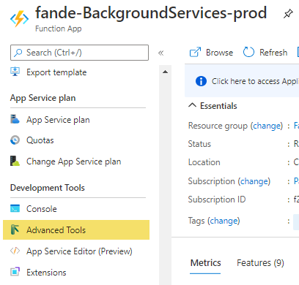

1. From the explorer tools, select ‘Tools’ then ‘Zip Push Deploy.’

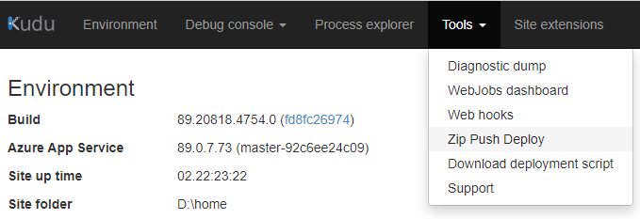

1. Drag and drop the zip file directly to the open browser window.

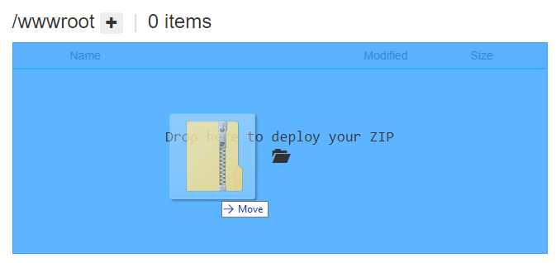

1. The process will complete and display a successful deployment message.

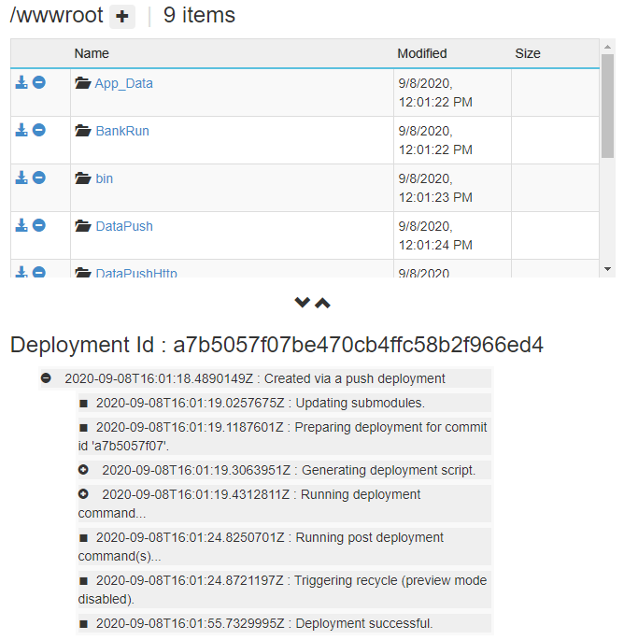

1. Your deployment is complete. All three Azure components are now deployed.

## Populate the Azure SQL Schema (Using C# Migrations)

To populate the newly created database using the C# migrations from within Visual Studio, follow these steps.

|  |
| --- |
| Note: This assumes you have access to the details of the created azure components and have successfully opened the solution in Visual Studio. |

* + - 1. **Set the API as the Startup Project:**

From within the project navigation, highlight the “API” project and right click, then select ‘Make Start Up Project’

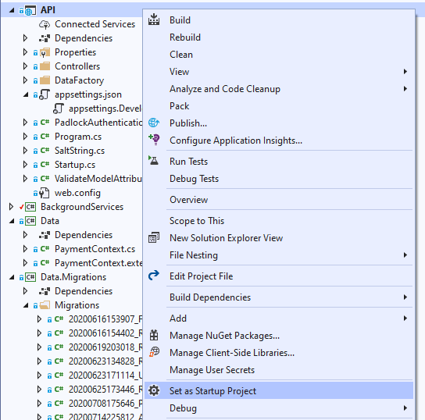

* + - 1. **Update the appsettings.Development.json File:**

Locate the appsettings.Development.json file in the API project. Double click on this file to review its contents

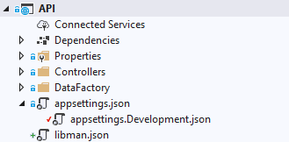

* + - 1. **Set the PaymentContect data source:**

With the appsettings.Development.json open, update the connection string with the details captured during the Azure setup.

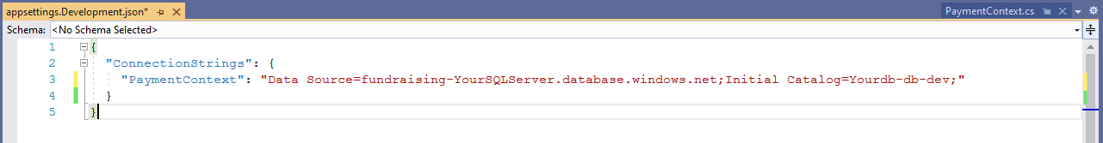

The PaymentContext value should consist of the SQL Server with the intial catalogu beeing the name of the database created during the process. In the above example this would be:

* Data Source: Contoso-sqlserver-prod
* Initial Catalogue: Contoso-db-prod
  + - 1. **Create the secrets.json**

To create or manage the private secrets need to send the password information to build the SQL tables, right click on the “API” project and then select “Manage User Secrets”. Note that if no user secrets have been stored prior, this may read ‘Add User Secrets’.

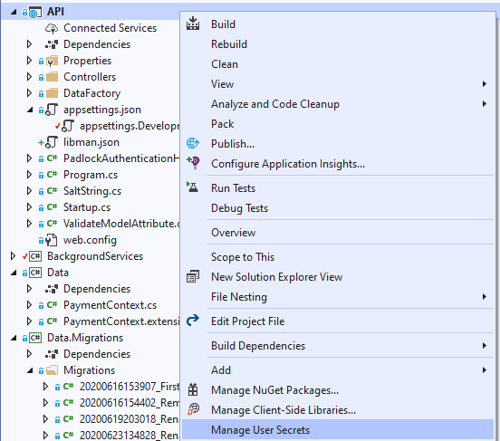

With the user secrets open, assuming no existing user secrets already exist, copy and paste ht following into it:

{

"ConnectionSecrets": {

"PaymentContextPassword": "YourSQLPassword",

"PaymentContextUserID": "YourSQLDatabase_dev_user"

}}

The result should look as so:

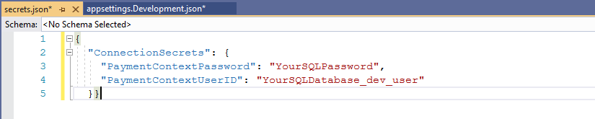

The two values required that are specific to each environment will be:

1. "PaymentContextPassword": The SQL user password recorded during the setup of the Azure components
2. "PaymentContextUserID": The SQL username recorded during the setup of the Azure components
   * + 1. **Navigate to Package Manager Console:**

With the connections now updated, the SQL tables can eb created using the C# migrations within the solution. Navigate to ‘View’, then ‘Other Windows’ and then select ‘Package Manger’

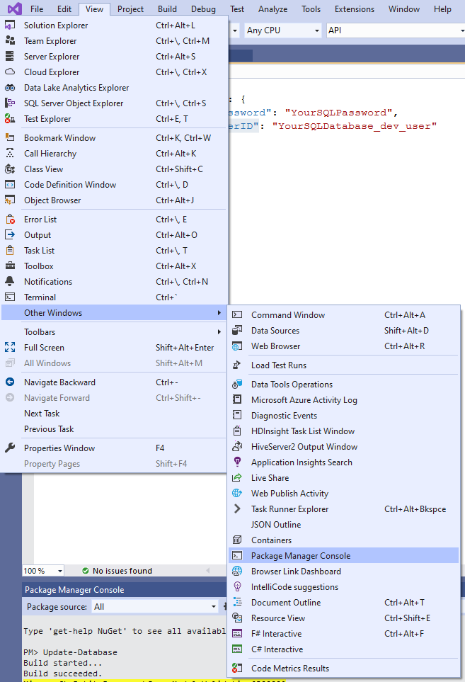

* + - 1. **Run Migrations:**

Within package manager, type in ‘Update-Database’ as shown in the following screen shot:

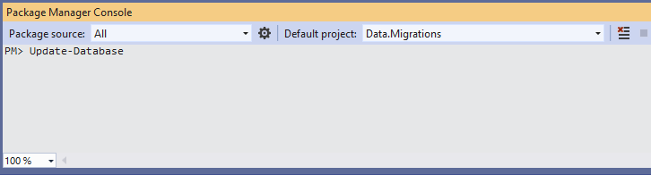

Hit Enter, and then confirm that the last message presented form the Package Manager reads ‘Done’. This indicates a successful deployment of the tables and schema changes.

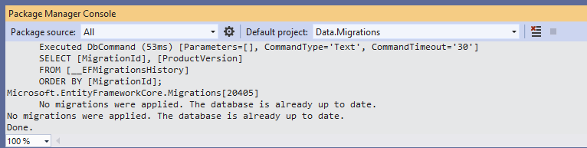

# Post Deployment Tasks (Dynamics 365)

Prior to leveraging Fundraising and Engagement key steps are required post setup of the environment within Dynamics 365. At least one configuration record populated with the Azure information and is required and all users need a configuration record to be assigned to their user record prior to use.

## Configuration Record Prerequisites

The configuration record requires five specific azure dependent configuration settings being in place prior to use, these have been listed here along with how to retrieve the value from Azure. Note that the labels of the following options match the label of the configuration record in Fundraising and Engagement.

* + - 1. **Azure Web API URL:**



1. Locate the azure Web App that is hosting your API components
2. From the General tab, locate the URL
3. Paste the URL into the ‘Azure Web API URL’ field and append /api/ to it – the full URL must look as so: <https://fundraising-yourexample-dev.azurewebsites.net/api/>
   * + 1. **API Padlock Token:**

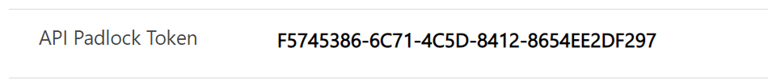

1. Update the ‘API Padlock Token’ with this value – F5745386-6C71-4C5D-8412-8654EE2DF297

Currently the padlock is set to this value by default.

* + - 1. **Background Services Web Job URL:**



1. Locate the Azure Background Functions application
2. Under Overview, view the URL
3. Locate and view the function ‘DataPushHttp’
4. Paste the URL into the ‘Background Services Web Job URL’ field as is – the full URL must look as so: <https://fundraising-yourbackgroundservices-dev.azurewebsites.net>
   * + 1. **Bank Run Security Key:**



1. Locate the Azure Background Functions application
2. Under Functions, select Functions
3. Navigate to and select the ‘BankRun’ function
4. Once the function opens in the new window, select ‘Overview’
5. Select ‘Get Function Url’
6. In the URL, copy the entire value after the ‘?code=’
7. Update the ‘Bank Run Security Key’ value with that of the copied URL value, the result should look as so: *a5RSdPgNdTKyUMEZe2BCHsdkcmonm4t8ngfnwmc2o5Pu99g78ks7RzuiHnmODbECfPSQ==*
   * + 1. **Yearly Giving Security Key:**



1. Locate the Azure Background Functions application
2. Under Functions, select Functions
3. Navigate to and select the ‘YearlyGivingFromEntity’ function
4. Once the function opens in the new window, select ‘Overview’
5. Select ‘Get Function Url’
6. In the URL, copy the entire value after the ‘?code=’
7. Update the ‘Yearly Giving Security Key’ value with that of the copied URL value, the result should look as so: *a5RSdPgNdTKyUMEZe2BCHsdkcmonm4t8ngfnwmc2o5Pu99g78ks7RzuiHnmODbECfPSQ==*
   * + 1. **Event Receipting Security Key:**



1. Locate the Azure Background Functions application
2. Under Functions, select Functions
3. Navigate to and select the ‘EventReceipting’ function
4. Once the function opens in the new window, select ‘Overview’
5. Select ‘Get Function Url’
6. In the URL, copy the entire value after the ‘?code=’
7. Update the ‘Event Receipting Security Key’ value with that of the copied URL value, the result should look as so: *a5RSdPgNdTKyUMEZe2BCHsdkcmonm4t8ngfnwmc2o5Pu99g78ks7RzuiHnmODbECfPSQ==*

## Assigning Configuration Settings to Dynamics 365 Users

All users that need to interact with the Fundraising and Engagement business logic must have a configuration record assigned. Users are limited to a single configuration record assigned at any one time. To associate a configuration record to a user in Dynamics, log in to Dynamics 365 as a user that has the System Administrator role and complete the following steps:

1. Navigate to ‘Advanced Settings’
2. Navigate to System and then select ‘Security’

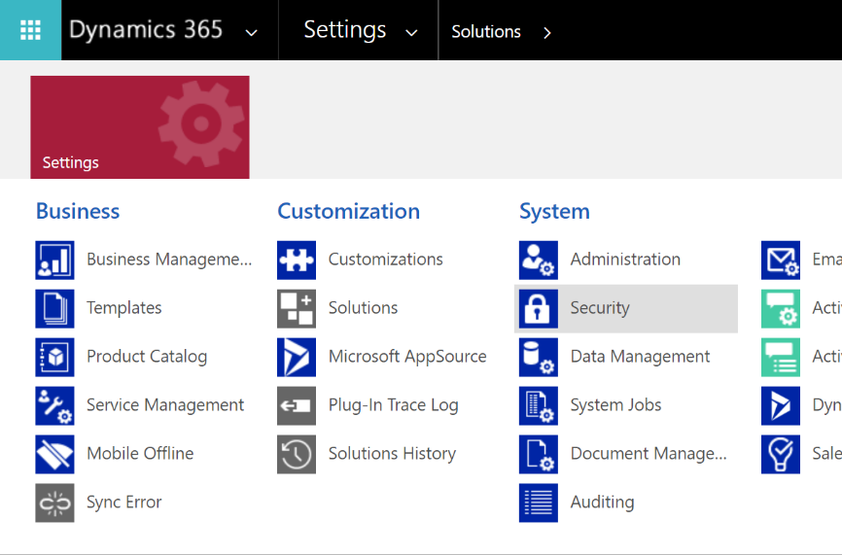

1. Select Users

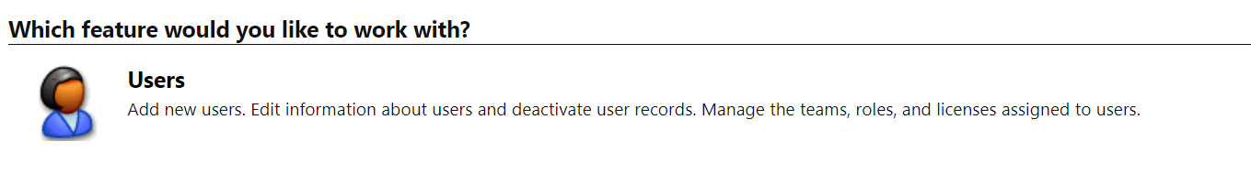

1. Retrieve and open the user record you want to assign the configuration record to
2. Use the lookup to locate the correct configuration record and then hit save and close

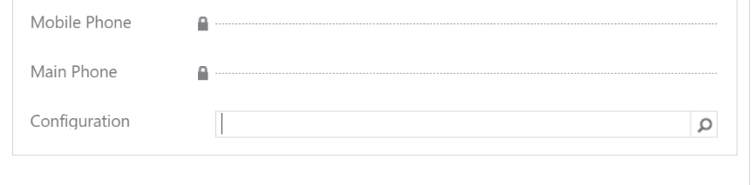

# Troubleshooting

## When a Failure Occurs

Note that the ARM template is not capable of rolling back components. This means if the ARM template fails as a result of the prerequisites not being met, the user implementing the template must manually remove the created components prior to reattempting the deployment.

## Updating Visual Studio 2019 Community Edition (or Higher)

Ensure your installation has the latest updates. This guide relies on the integrated publishing processes from Visual Studio to Azure components. As a result, they may need to be frequently updated for Azure components to be deployed. To update Visual Studio, select ‘Help’ then ‘Check for updates.’ Follow prompts to update the installation if required.

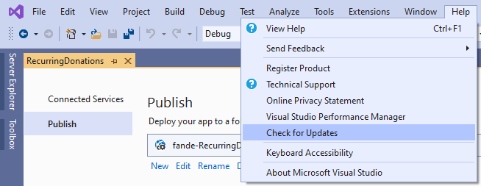

## Modifying the Template

The ARM template has been configured and tested to deploy a single Azure environment per Dynamics 365 instance. For implementors wishing to change the deployment process or alter how the template delivers the application and configuration, they do so at their own risk. Support currently covers a single deployment per Dynamics 365 instance architecture.

## Naming and Unique Name Concepts

A failure during deployment of the template can occur due to the naming conventions used during the template setup. Resource names are externally addressable and must be unique. The template has been configured to generate unique names for the created applications but in the unlikely event that a names space for a component within the template is already in use, the deployment will fail. If this occurs, the implementor must modify the organization name to create a unique naming convention.

Please see details on best practices for [Azure naming conventions](https://docs.microsoft.com/en-us/azure/cloud-adoption-framework/ready/azure-best-practices/naming-and-tagging).

# Learn More About Azure and Extending Dynamics 365

This document assumes users provisioning Fundraising and Engagement Azure environments have a solid understanding of both the Azure components that will be created and configured as well as the Dynamics 365 environment which will utilize this functionality.

The following courses and certification paths are recommended prior to utilizing this guide:

|  |  |  |  |
| --- | --- | --- | --- |
|  | **Educate** | **Accredit** | **Discussion** |
| Azure Fundamentals | [Learning](https://docs.microsoft.com/en-us/learn/paths/azure-fundamentals/) Path | [Exam](https://docs.microsoft.com/en-us/learn/certifications/exams/ai-900) | [Community](https://powerusers.microsoft.com/t5/PowerApps-Community/ct-p/PowerApps1) |
| Dynamics 365 Fundamentals | [Learning](https://docs.microsoft.com/en-us/learn/paths/dynamics-365-fundamentals/) Path | [Exam](https://docs.microsoft.com/en-us/learn/certifications/exams/mb-900) | [Community](https://powerusers.microsoft.com/t5/Microsoft-Flow-Community/ct-p/FlowCommunity) |