To enable more complex functionality such as generating and emailing an html report, additional tools are needed. Many tools are provided in the tools directory to automate common functionality, and which can serve as examples for making additional specialized tools.

mcfreport.xslt
This XSL file generates a readable report from the structured xml log which includes all the tests and groups that were run and what their result was. To support investigations into test case failures, the report also has controls to expand the output of each test case with messages, trace statements, comments, and exceptions for each test case if they were enabled using /dbglvl (see “Command Line Parameters” in MCF.doc). These controls require javascript which may be disabled by security, but if it is then there will be a control at the top that allows you to temporarily enable it for the report.
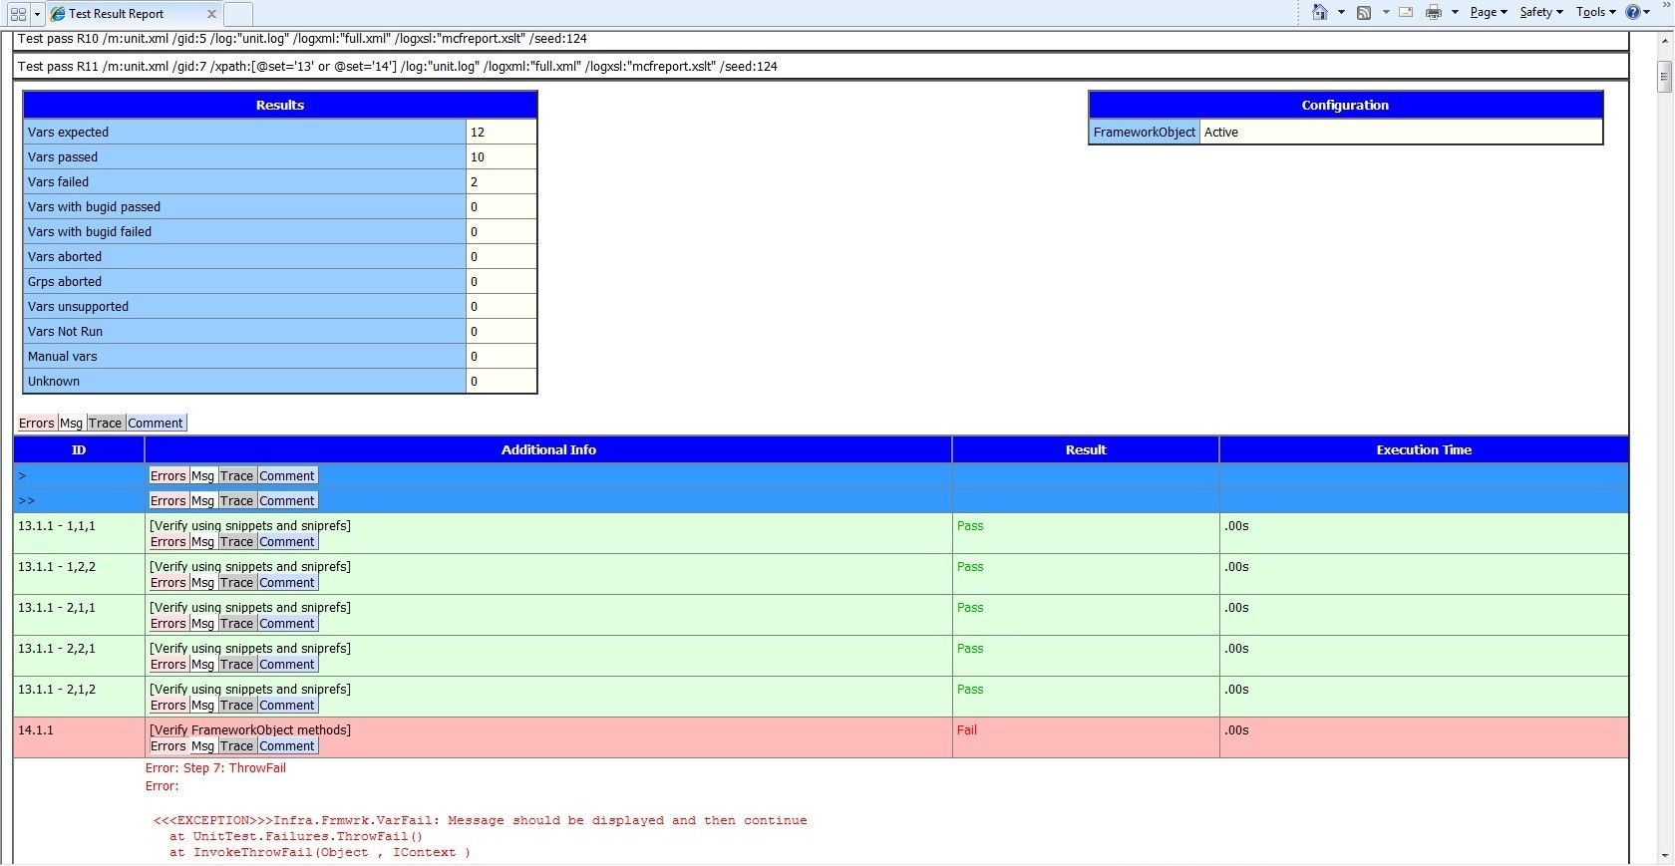
This report can be used by opening an XML file that references mcfreport.xslt in IE while mcfreport.xslt is in the same directory or the XmlTransform tool can be used to generate a new HTML file. MCF will automatically make the report reference the xslt when run with the /logxsl switch, or alternately the MCF XML log includes a comment to help manually link it. See ‘XSL Formatting’ in MCF.doc for details on referencing the XSLT file.

MineTestRuns.ps1
A PowerShell script which reads multiple xml reports and generates a condensed report of which tests pass/fail, execution times, etc. The resulting data can be imported into Excel to analyze test stability and execution speed:
Import the generated data into Excel
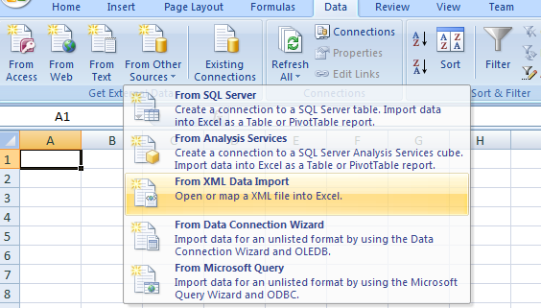
Create a PivotChart from the imported data
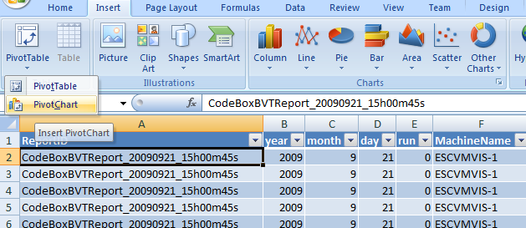
Drag items into the PivotChart tables to construct a report. Some examples:
Execution time for each set
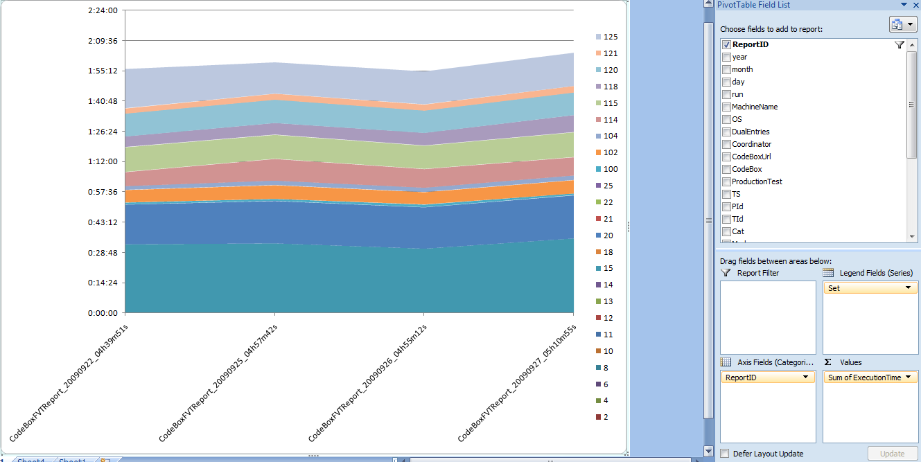
Percent passing/failing for each test case
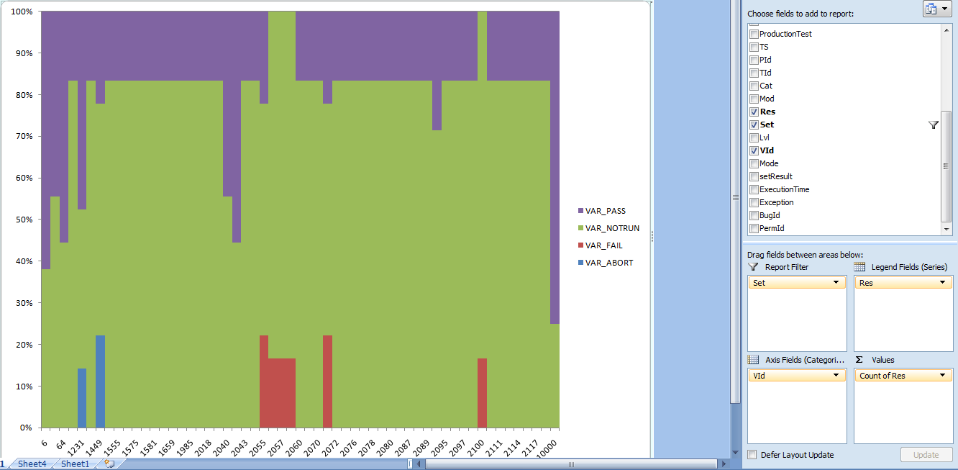

MCFTestLib
MCFTestLib is a managed test automation library which contains methods for UI operations (Internet Explorer, Win32, WPF, Silverlight, etc.) as well as access filesystems and databases, and is optimized for use with MCF. The BaseTest class can be used directly by MCF var nodes, or it can be extended to create an MCF test class specific to a particular product.
For more details, see the wiki page: http://codebox/mcf/Wiki/Home/MCFTestLib+User+Guide.

MCF2WTT
MCF2WTT Log converts MCF log files to a WTT log format. It is suited for automated or standalone execution. The tool consumes MCF style logs and uses WTT Logger API calls to generate a WTT log consistent with WTT format viewable within WTT studio or for post processing.
For more information and usage guidelines see the ReadMe.txt file included in the MCF2WTT folder.

VSToMCFLogConversion
VSToMCFLogConversion converts a VS2008 test result file into an MCF 3.1 text log file. This allows tools that are designed to parse the MCF log (e.g. the LogReader class) to consume results from Visual Studio unittests.
This is implemented as a vb script which can be executed as Wscript transformVStoMCF.vbs Source.trx

mcf.bat
mcf.bat is an example test automation script designed to be modified and adapted to a specific situation. By default it will generate structured xml output and connect it to an XSL file, timestamp the xml log, and generate an html report. It also shows how to send the report in an email, but the steps are commented out.
mcf.bat does not take command line parameters, but instead uses variables defined at the top of the file.

compact.xslt
This XSL file is designed to be used with XmlTransform to remove scripting and invisible elements from an HTML document in preparation for emailing. These elements aren’t supported by sendmail but would still be present resulting in a large email. Currently this is used to reduce the filesize of the generated report for SendMail.

TimestampFile.bat
This utility takes an existing file and will generate a copy with the current date and time in the filename, and a second copy with “latest” in the filename.
There is an example here for reading the components of a filename (path, name, extension).

XmlTransform.exe
This utility will transform an xml file using an XSL file. Currently this is used to generate the html report and to compact the report for emailing.

SendMail.exe
This utility will send an html file to an email address. Currently this is used to send the html report to members of the team.

Monitor
Monitor provides a way to watch a text file, causing any new lines in the file to be printed to the console (similar to tail -f), while providing some font coloring based on MCF messages. This is mainly useful for monitoring the progress of MCF while it is running on a separate machine. When monitor stops, it will also output the number of passes and failures that it saw while running.
To remotely monitor MCF, call Monitor.exe <network path to the MCF text log output>.
To stop monitoring a file, use ctrl-c.

Escape
The Escape tool will provide a string that is properly escaped for different parsing systems. There are several parsers used by MCF which either need to be escaped, or avoided (see “Escaping” in MCF.doc for more details):
- XML parsing: Data is usually stored in the varmap, so it must be escaped for XML parsing. This can be avoided by using CDATA or comments.
- MCF’s subrecord parsing: When using the shortened function call syntax, data must be escaped for MCF parsing. This can be avoided by using the longer function call syntax.
- Regular expressions: For testing, it is often useful to verify data using regular expressions. If a function uses regular expressions and a direct match is needed, then the data must also be escaped for regex parsing. This can be avoided by having a sister method that verifies without using regular expressions.
- Command line: When passing records from the command line, the values need to be escaped for command line parsing. This can be avoided by storing the parameters in the varmap instead.
For more information, launch escape.hta and see the provided documentation.

