Campus Recycling Program Analysis (2023-2024)
Scope: Two-year campus waste review covering landfill, recycling, compost, diversion rate, and recycling contamination trends.
IMPORTANT: All datasets, charts, and findings in this paper are clearly labeled simulated educational data created for training and demonstration before recording.
Prepared for Student AI Learning Series Episode 05.

Executive Summary
Landfill tonnage decreased by 122.5 tons year-over-year despite a modest increase in total measured material volume. These patterns suggest that targeted sorting education and bin placement improvements can produce practical gains.
The simulated data indicates measurable progress between 2023 and 2024. Diversion rate rose from 49.2% to 56.9%, while average contamination in recycling streams dropped from 17.4% to 14.2%.

Data Snapshot (Simulated)
Year | Landfill (tons) | Recycling (tons) | Compost (tons) | Total (tons) | Diversion Rate
2023 | 930.0 | 602.7 | 296.6 | 1829.3 | 49.2%
2024 | 807.5 | 703.5 | 361.7 | 1872.7 | 56.9%

Findings
3. Contamination decline: Average recycling contamination decreased from 17.4% to 14.2%, indicating better sorting behavior.
2. Landfill reduction: Landfill volume dropped by 122.5 tons year-over-year while recycling and compost rose.
1. Diversion improvement: Diversion rate increased by 7.7 percentage points from 2023 to 2024.
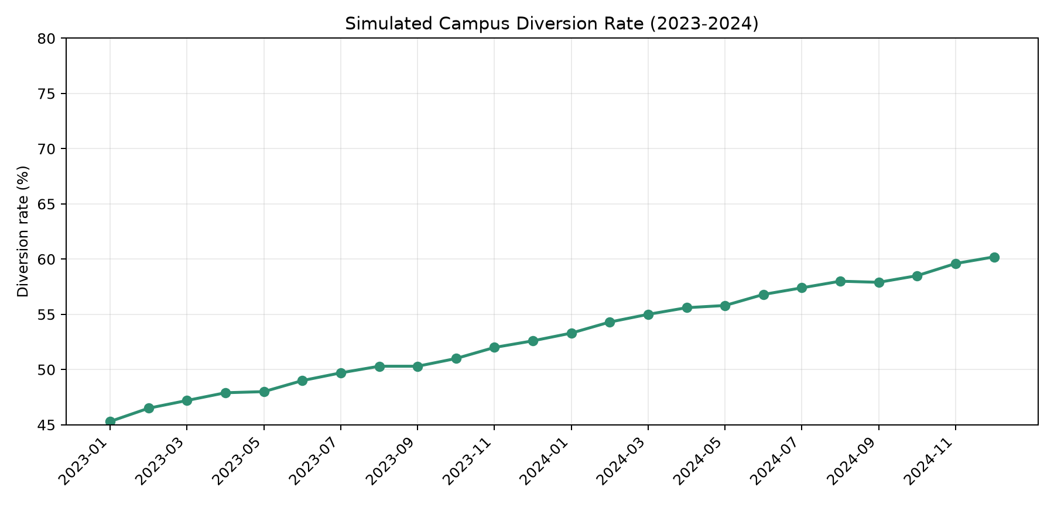
Figure 1. Simulated monthly diversion rate trend (2023-2024).
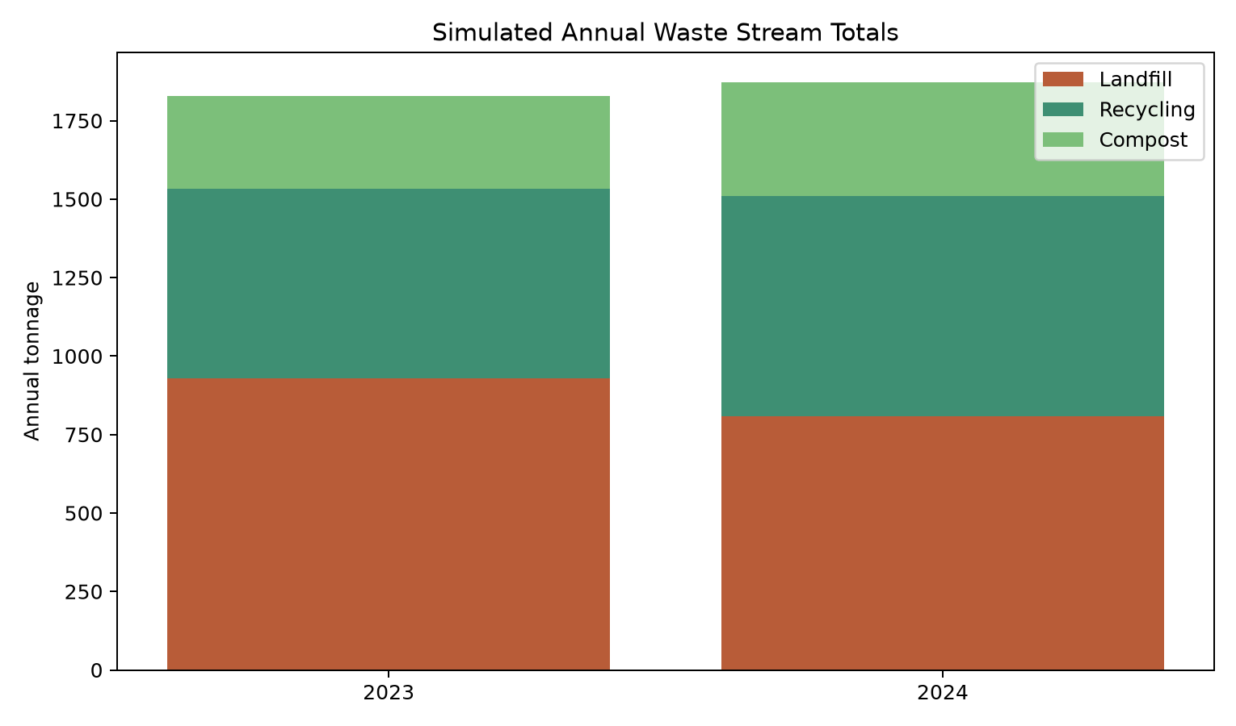
Figure 2. Simulated annual totals by waste stream for 2023 and 2024.
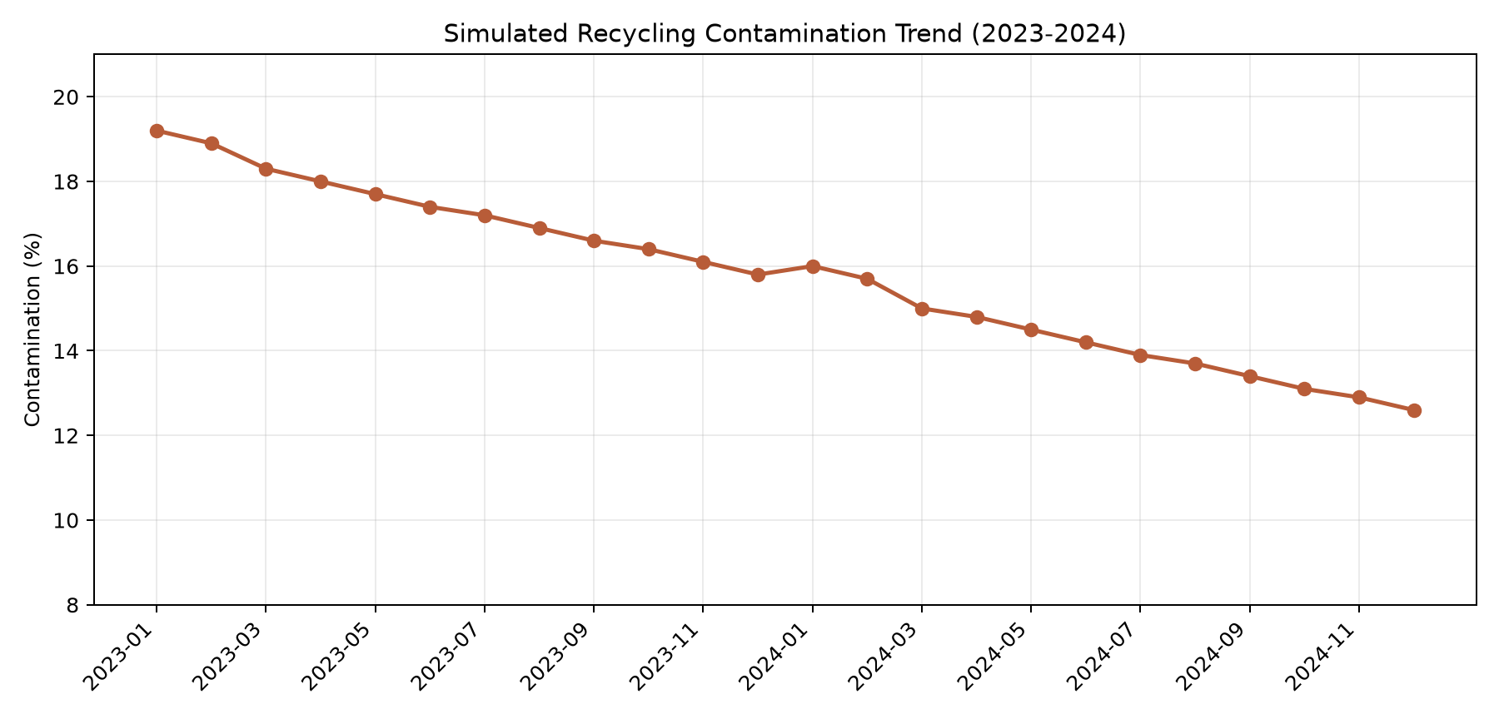
Figure 3. Simulated recycling contamination trend showing year-over-year decline.

Evidence-Based Recommendations
3. Use building-level feedback loops: Publish simple dashboard snapshots by building or zone each month to reinforce participation and accountability.
2. Launch contamination-focused communication cycles: Run short monthly campaigns using examples of common contamination errors and quick correction tips.
1. Standardize high-traffic bin stations: Pair landfill, recycling, and compost bins with consistent icon signage at dining halls and residence entries to reduce sorting friction.

Limitations
Recommendations should be treated as pilot candidates and validated with real audits before policy adoption.
Monthly values simplify real collection variability and do not represent day-level events, staffing constraints, or weather disruptions.
This analysis is based on simulated educational data, not measured operational records.

Source Notes
No external institution-specific operational records are represented in this paper.
Charts: diversion-rate-trend.png, waste-stream-annual-totals.png, contamination-trend.png generated directly from the simulated dataset.
Primary dataset: campus-waste-data-2023-2024-simulated.csv (created pre-recording for training and demonstration).

