Revision history

|  |  |  |
| --- | --- | --- |
| Revision # | Date of Revision | Changes Made |
| 1.0 | NA | First Release |
|  |  |  |

Reference documents

|  |  |  |
| --- | --- | --- |
| S.No | Document Title | Date |
| 1 |  | 05 Jun 2017 |

Glossary

| **Terms** | **Description** |
| --- | --- |
|  |  |
|  |  |
|  |  |
|  |  |
|  |  |
|  |  |
|  |  |
|  |  |
|  |  |
|  |  |
|  |  |
|  |  |
|  |  |
|  |  |
|  |  |

Table of contents

1 Installation Guide 6

1. JDK 6

2. Spring Tool Suite 6

3. Visual Studio Code 8

4. Node JS 8

5. AngularJS-2 9

6. Pivotal Cloud Foundry 9

7. Predix 10

THIS PAGE IS INTENTIONALLY LEFT BLANK

# Installation Guide

## JDK

* Download latest JDK 64 bit version from:

<http://www.oracle.com/technetwork/java/javase/downloads/index.html>

* Raise Software Installation request to IT Team at “Capgemini Talent Portal > IT Service Desk”
* Once, installation done, open command window and check JAVA version using command >Java -version

## Spring Tool Suite

* Download 64-bit windows version of latest Spring Tool Suite from: <https://spring.io/tools/sts/all>
* Unzip the package to your work directory and run ../sts-bundle/sts-3.8.4.RELEASE/STS.exe

### Configure Proxy in STS

* Configure proxy in STS as shown below, to work with Capgemini network.

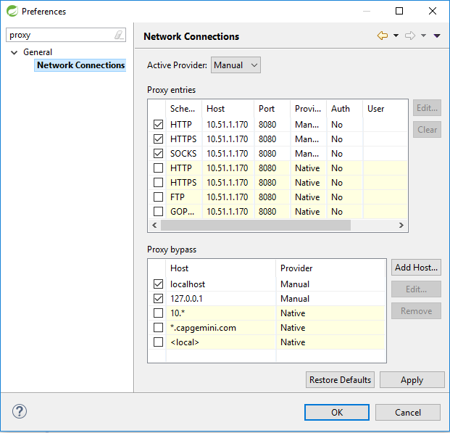

### Configure proxy for Maven

* Create “settings.xml” file in maven repository (/.m2)
* Open STS Menu bar > Preferences > Maven > User Settings > Browse > Select settings.xml file > Apply > click ‘Ok’

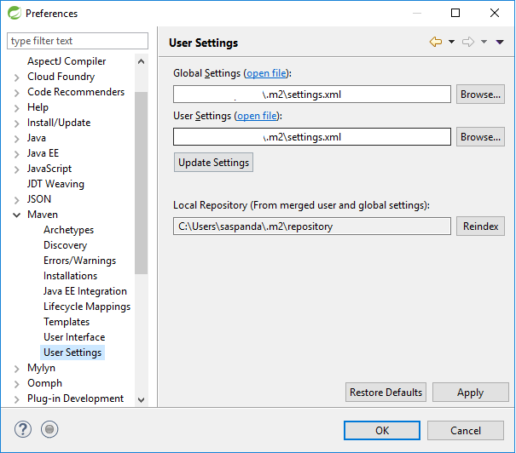

* Copy the below XML content into the “settings.xml” file.

<?xml version=*"1.0"* encoding=*"UTF-8"*?>

<settings xmlns=*"http://maven.apache.org/SETTINGS/1.1.0"*

xmlns:xsi=*"http://www.w3.org/2001/XMLSchema-instance"*

xsi:schemaLocation=*"http://maven.apache.org/SETTINGS/1.1.0 http://maven.apache.org/xsd/settings-1.1.0.xsd"*>

<proxies>

<proxy>

<active>true</active>

<protocol>http</protocol>

<host>10.51.1.170</host>

<port>8080</port>

<username></username>

<password></password>

<nonProxyHosts>www.google.com|localhost</nonProxyHosts>

</proxy>

</proxies>

</settings>

* Now, restart Spring Tool Suite.

## Visual Studio Code

* Raise Software Installation request to IT Team at “Capgemini Talent Portal > IT Service Desk” to install “Visual Studio Code – Version 1.12.2 or higher”.

## Node JS

* Download the platform specific node installer from: <https://nodejs.org/en/download/>

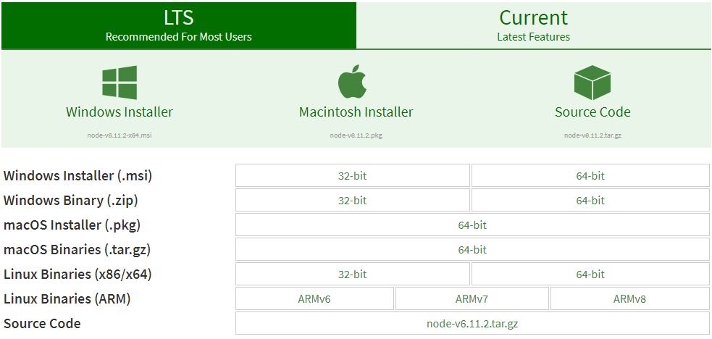

* Need admin rights to install Node.js
* Follow instructions in Node.js Setup wizard.
* Select the “npm package manager” feature to be installed, as shown below.

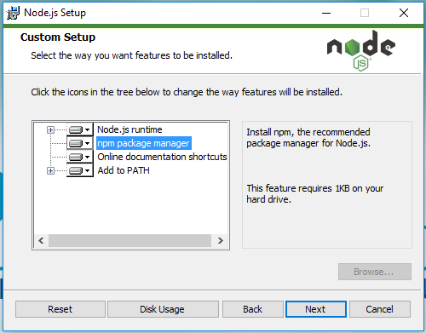

* Complete the installation and restart the machine.
* To test not installation, please open command prompt and execute below commands

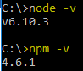

*Note: Please make sure, your node version should be 6.10.x or higher and npm version 3.x.x or higher.*

## AngularJS-2

* Pre-requisite: Before starting Angular CLI installation, please make sure Node.js and NPM installed on your machine.
* Please visit URL: <https://cli.angular.io/> for step by step instructions.
* Open command prompt and set npm proxy by executing below commands:
* npm config set proxy http://10.51.1.170:8080
* npm config set https-proxy http://10.51.1.170:8080
* npm config set registry http://registry.cnpmjs.org
* npm config set strict-ssl false
* Now run below command to install Angular CLI
* npm install -g @angular/cli

*Note: if this command not execute successfully, navigate to a specific directory, where you want to install angular-cli and run the above command by removing “-g”. “-g” instruct to install angular-cli globally so that ng command can execute from any of your directory.*

* In case if you have an older version of Angular-CLI installed on your machine, you need to upgrade by following the instructions of section “Updating Angular CLI“ at URL: <https://github.com/angular/angular-cli>
* To verify if successfully installed Angular-cli, please run below command
* ng –v

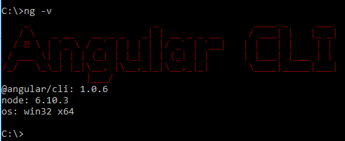

* To build and run any Angular2 project, navigate to the project directory from command prompt.
* Then, set the Angular-CLI path (which you have installed already) by executing below command
* set path=<Angular-CLI_Directory_Path>;%path%
* Install node-modules
* npm install
* Build angular-2 project
* ng build

Deploy angular-2 project

* ng serve

## Pivotal Cloud Foundry

* Create a Pivotal Account at: <https://account.run.pivotal.io/z/uaa/sign-up>
* Download Pivotal Cloud Foundry CLI from: <https://network.pivotal.io/products/pcfdev>

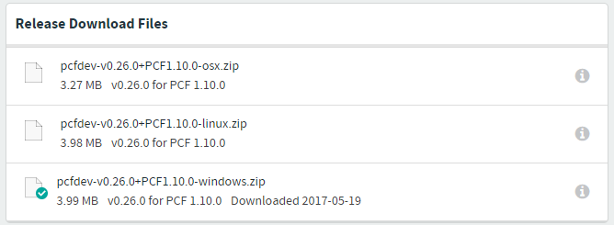

* Install pcfdev for windows.
* Now check if cf CLI works, using below command



* Now set proxy using below command



* Now, connect to pivotal web service using below command
* cf login -a https://api.run.pivotal.io
* For more details on cf CLI and its commands, please refer: <https://docs.cloudfoundry.org/cf-cli/>

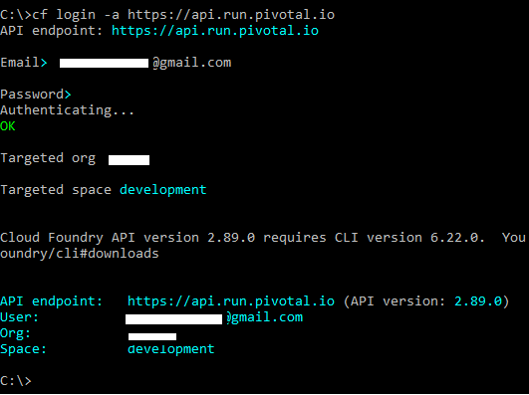

* To Deploy Spring Boot application, please use below command
* cf push sapp-ldv-poc2 -p target/ldv-poc2-0.0.1-SNAPSHOT.jar -b https://github.com/cloudfoundry/java-buildpack.git

## Predix

TBD