Revision history

|  |  |  |
| --- | --- | --- |
| Revision # | Date of Revision | Changes Made |
| 1.0 | NA | First Release |
|  |  |  |

Reference documents

|  |  |  |
| --- | --- | --- |
| S.No | Document Title | Date |
| 1 |  | 05 Jun 2017 |

Glossary

| **Terms** | **Description** |
| --- | --- |
|  |  |
|  |  |
|  |  |
|  |  |
|  |  |
|  |  |
|  |  |
|  |  |
|  |  |
|  |  |
|  |  |
|  |  |
|  |  |
|  |  |
|  |  |

Table of contents

1 Installation Guide 6

1.1 Download 6

1.2 Install 6

1.3 Start MongoDB 6

1.4 Connect mongoDB from Client 7

THIS PAGE IS INTENTIONALLY LEFT BLANK

# Installation Guide

## Download

1. Visit URL:
2. To download the latest version of MongoDB for Windows – 64 bit, click on “Download” button as shown below and it will download “mongodb-win32-x86_64-enterprise-windows-64-3.4.5.zip” file to your PC.

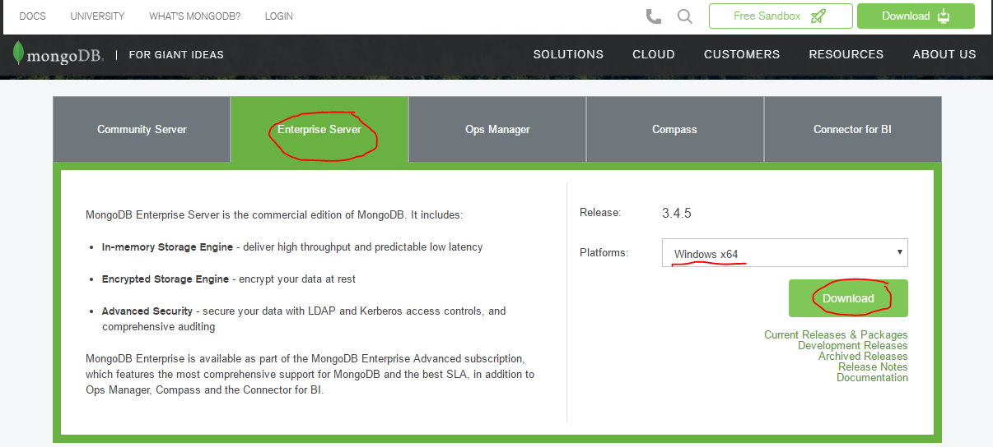

## Install

1. Unzip the downloaded file to your chosen directory. For Ex: “D:\ge\mongodb\mongodb-win32-x86_64-enterprise-windows-64-3.4.5”
2. MongoDB requires a [data directory](https://docs.mongodb.com/manual/reference/glossary/#term-dbpath) to store all data. MongoDB’s default data directory path is the absolute path \data\db on the drive from which you start MongoDB. So, create directory as: “D:\data\db”
3. **Optional**: If you want to choose different data directory for your mongoDB, you can specify an alternate path for data files using the --dbpath option to [mongod.exe](https://docs.mongodb.com/manual/reference/program/mongod.exe/#bin.mongod.exe), for example:

*"C:\Program Files\MongoDB\Server\3.4\bin\mongod.exe" --dbpath D:\data\db”*

1. **Optional**: You may also specify the dbpath in a [configuration file](https://docs.mongodb.com/manual/reference/configuration-options/). For more details please refer: <https://docs.mongodb.com/manual/reference/configuration-options/>
2. Installation Done.

## Start MongoDB

1. To start MongoDB, run [mongod.exe](https://docs.mongodb.com/manual/reference/program/mongod.exe/#bin.mongod.exe). For example, from the Command Prompt:

*"C:\Program Files\MongoDB\Server\3.4\bin\****mongod.exe****"*

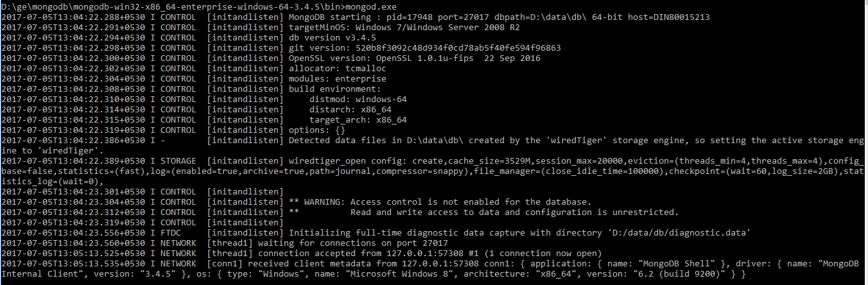

## Connect mongoDB from Client

1. To connect to MongoDB through the [mongo.exe](https://docs.mongodb.com/manual/reference/program/mongo/#bin.mongo) shell, open another Command Prompt.

*"C:\Program Files\MongoDB\Server\3.4\bin\****mongo.exe****”*

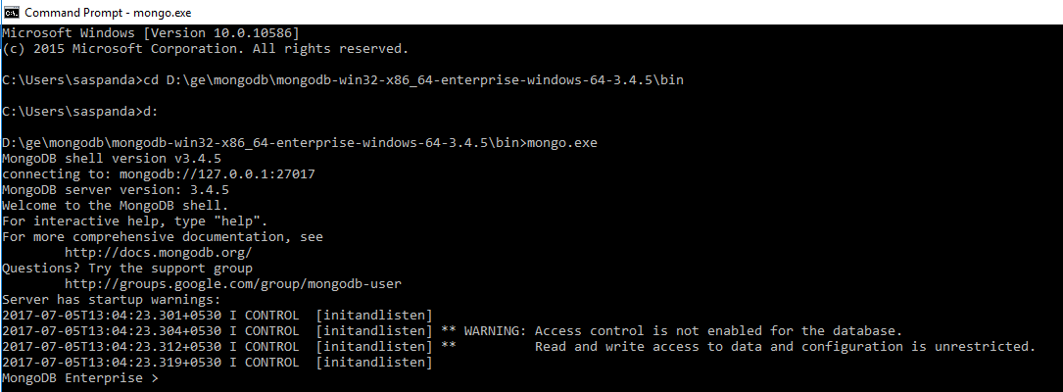

## Mongo Shell Commands