Chapter 1 - Introduction

1.1 Background of the study:

Hospitals are essential part of our lives, providing us with medical facilities. It is necessary for the hospitals to keep track of its daily activities & records of its patients, doctors, nurses, and other staff so that there will be smooth running of the institution.

Everyone knows that keeping records using traditional methods can be very challenging, cumbersome, time consuming, prone to errors and inefficient. Especially, when considering the fact the population is increasing and you have so much to keep track of. For this reason, there has to be a better way to handle this problem.

The following challenges that are facing our current hospitals highlighted above prompted this research work. Although some the problems mentioned have been addressed by other researchers, I still want to address a few issues that I think haven’t been done much justice to. The end product of this research is to have a working system that will help solve of the limitations faced by some of our medical institutions. I then decided to title it as “Hospital Management System Using Bingham University as Case Study”.

1.2 Statement of problem:

In Bingham University, on several occasions I witnessed patients (students) not being attended to because they have either forgotten their ‘clinic cards’ or have forgotten the number on the card. The patient would be forced to manually go through the registration book until he/she finds their record. You can imagine an ailing person being subjected to this unimaginable stress before being given attention. It has happened to me sometimes back and sadly enough, has also claimed the life of a friend of mine. I asked a sick student going through the record for her details how he was feeling and he said that he was feeling like hell. On the other hand, the workers can’t help the situation at that moment because according to their ethics, they need the card to trace your folder before administering medication to you. Throwing all critical skills out of the window, it is very clear that this is posing a big threat to the students, placing their lives on the line and must be addressed to.

1.3 Motivation:

With the above problem stated above, the reason for this research work is highly justified and is worth being given due consideration. We are talking about the lives of the potential leaders of tomorrow being at stake and shouldn’t be toyed with. Going outside Bingham University where the population is high, this problem can be by definition, very dangerous to the society at large. For that reason, I am motivated to help contribute as much as I can to help reduce some of this problems or peradventure even get rid of it completely.

1.4 Aims and objectives

The aim of this research is to have a working system that will automate almost up to 80% of the manual record keeping techniques that is currently in use in the clinic. This is of course the bottom-line for the whole project, and will greatly reduce the stress the staff undergo while searching for folders and likewise the trauma patients face going through the registration to get their records.

1.5 Purpose of the study

The purpose of this research is summarized below:

* Automate as many existing manual systems as possible
* Having a paperless record keeping system
* Have a reliable database backup in case of natural disasters
* Ease the stress patients face when they forget their card numbers
* Enhance communication among the staff for faster rendered services
* I have a burden for the patients who happen to be victims of this hapless exploitation

1.6 Significance of the study:

This study is of highly significant to Bingham University and the entire society at large. Considering the problems it addresses, there is surely no doubt that all my time, resources, energy and effort committed to this work is worth it. The study will contribute to human knowledge in many aspects, one of them is harnessing the power of technology to solve the issue of misplaced clinic cards which end patients in distress and trauma.

The research is also an evidence that what I’ve been taught in class was not in vain, because I am using the knowledge to solve a real life problem. For anybody that values and cherishes humanity, admittedly, it’s undoubtedly true that human life comes first in everything. As the slogan says “health is wealth”. The possibilities of this software is limitless as long as time and space remain defined, because it’s going to be constantly improved over time and not be dumped upon completion.

With that, I believe that my effort is very much rewarding, and somebody will one day add more to what I’ve done. The Bingham community is going to be greatly imparted and of course the society at large.

1.7 Organization of the work:

1.8 Definition of terms:

* CFD: – Context Flow Diagram
* DFD: – Data Flow Diagram
* IDE: – Integrated Development Environment
* SRS: – Software Requirement Specification.
* GUI: - Graphical User Interface
* JavaScript – A web programming language
* Node js - A JavaScript environment that allows JavaScript to be run on the server
* Express js – A Node js web framework
* MongoDB - A No-SQL database server
* JSON – Javascript Object Notation
* Sublime Text – A text editor

Chapter 2 – Literature Review

2.1 Overview

In order to understand the concepts associated with records management and or computer based records management systems, it is imperative to examine and analyze published material from experts regarding the field. The purpose of this review is to analyze and examine and obtain experience as regards the creation and archival processing of electronic records. The review is based on an exhaustive assessment of the literature on computerized electronic management and electronic records, and contains an overview of the main concepts associated with the creation of an electronic records management system from the perspective of published works by experts.

The use of computers in our medical centers today is very crucial. As highlighted earlier, computers greatly reduce stress and cost, at the same time improve performance. The following is a list of related works that have been done to improve the current existing system in the industry. Their valid reasons justify the fact that this research is worth my time.

2.2 Records

A record is recorded information produced or received in the initiation, conduct or completion of an institutional or individual activity and that comprises content, context and structure sufficient to provide evidence of the activity regardless of the form or medium.

According to the National Archives and Records Administration (NARA) records include, “… all books, papers, maps, photographs, machine-readable materials, or other documentary materials, regardless of physical form or characteristics, made or received ... or in connection with the transaction of public business and preserved or appropriate for preservation by that agency or its legitimate successor as evidence of the organization, functions, policies, decisions, procedures, operations, or other activities of the Government or because of the informational value of the data in them.”

2.3 Existing System

Hospitals currently use a manual system for the management and maintenance of critical information. The current system requires numerous paper forms, with data stores spread throughout the hospital management infrastructure. Often information (on forms) is incomplete, or does not follow management standards. Forms are often lost in transit between departments requiring a comprehensive auditing process to ensure that no vital information is lost. Multiple copies of the same information exist in the hospital and may lead to inconsistencies in data in various data stores.

Below we will study some of the existing systems and see some their strengths and weaknesses as well.

2.3.1 Computer use in the medical field

(Amber Weber and Morgan Swink 8 Sept. 2014) This research clearly states that a patient’s prescribed medications (past and present) can also be stored in a computer system in a hospital. This makes it much easier to transfer any prescriptions and data that a patient needs to local or national drug stores or hospitals. Past hospital visits and billing information can be stored and kept for further use or future hospital experience. For example, doctors keep a computer handy anytime they prescribe a medication. They can use the computer to find out what medicines the patient may be allergic to or what medicines may interfere with one another. Important information is at the tip of their fingers and this can be very helpful.

2.3.2 Improving Patient Records

(The Computer-Based Patient Record: An Essential Technology for Health Care National Academies Press, 1997 Don E. Detmer, Elaine B.) Computer-based patient records and the systems in which they function are becoming an essential technology for health care in part because the information management challenges faced by health care professionals are increasing daily.

Technological progress makes it possible for CPRs and CPR systems to provide total, cost-effective access to more complete, accurate patient care data and to offer improved performance and enhanced functions that can be used to meet those information management challenges. CPRs can play an important role in improving the quality of patient care and strengthening the scientific basis of clinical practice; they can also contribute to the management and moderation of health care costs.

2.3.3 The Computer-Based Patient Record System

(National Academy Press, 15 Jan 1997) Computer-based patient records, as defined by the committee, could positively affect the quality of patient care in at least four ways. First, they offer a means of improving both the quality of and access to patient care data. Second, they allow providers to integrate information about patients over time and between settings of care. Third, they make medical knowledge more accessible for use by practitioners when needed. Fourth, they provide decision support to practitioners.

Research efforts could also benefit from computer-based patient record keeping in two key ways. First, improved data and access to those data would be available to researchers. Second, research findings could be communicated to practitioners through computer-based patient record systems

2.3.4 Impact of a Computer-based Patient Record System on Data Collection, Knowledge Organization, and Reasoning

(J Am Med Inform Assoc. 2000 Nov-Dec; 7(6): 569–585.) The CPR system is one example of such a system.10 Computer-based patient record systems are designed to allow physicians to directly enter patient data, findings, and notes into a computer system that may be linked to hospital-wide databases and decision support systems.

The objectives of implementing such systems include replacing hand-written paper-based records with CPRs to improve access to information and quality of health care decision making. However, use of these systems may also affect, in unanticipated ways, fundamental cognitive processes involved in health care.

The user can also search for a section of the system by entering key words. The data entry method is based on a point-and-click or pick- list technology, where the user clicks on categories on the screen for which values (e.g., blood pressure) can be entered, either by typing in the value, clicking to indicate the presence or absence of a finding (and the level of severity of symptoms), or using the pen to enter a value or note. In addition, the system incorporates software for handwriting recognition to allow for data entry by pen.

The system can also display sections of the relevant clinical items to the user; for example, it will adjust the display of information slightly depending on the patient's particular complaint (the system has a number of “filters,” which are basically variations of a general template for the organization of medical findings, based on general medical conditions). Screenshot of the CPR system below:

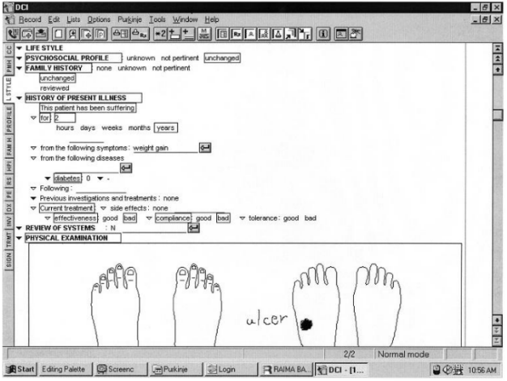

2.3.5 The Emergence of National Electronic Health Record Architectures in the United States and Australia: Models, Costs, and Questions

(J Med Internet Res. 2005 Jan-Mar; 7(1): e3.) The electronic record is at the center of the IOM's goal of eliminating most handwritten clinical data by the end of this decade. Electronic records are superior to paper records because they decrease error due to handwriting problems and ease physical storage requirements. Additionally, electronic records simultaneously leverage other error-reducing technologies and render them coherent.

EHR models present significant additional advantages because of their potential to deliver a longitudinal record that tracks all medical interactions by a particular patient and provide comprehensive data across populations. Thus, the IOM envisions a longitudinal collection of electronic health information for and about individuals and populations as feeding data into error-reducing “knowledge and decision support systems.”

2.3.6 Electronic health records not a panacea, researchers say

(By Diana Manos, December 14, 2009) In a study published Monday in the U.S. journal Milbank Quarterly, researchers at the University College of London (UCL) said they identified fundamental and often overlooked tensions in the design and implementation of EHRs. The study was based on findings from hundreds of previous studies from all over the world.

Researchers said their findings have implications for President Barack Obama’s election promise to establish electronic health records for every American by 2014, and for other large-scale EHR initiatives around the world.

Professor Trish Greenhalgh, lead author of UCL’s Department of Open Learning, said EHRs are often depicted as the cornerstone of a modern healthcare, capable of making care better, safer and cheaper. Yet, clinicians and managers the world over struggle to implement EHRs. "Depressingly, outside the world of the carefully-controlled trial, between 50 and 80 per cent of electronic health record projects fail – and the larger the project, the more likely it is to fail," Greenhalgh said.

"Our results provide no simple solutions to the problem of failed electronic patient records projects, nor do they support an anti-technology policy of returning to paper. Rather, they suggest it is time for researchers and policymakers to move beyond simplistic, technology-push models and consider how to capture the messiness and unpredictability of the real world,” according to Greenhalgh.

2.3.7 Designing a patient-centered personal health record to promote preventive care. Unpublished manuscript

(Krist AH, Rothemich SF, Loomis JF, et al) Greater provision of preventive services: A randomized controlled trial involving 2,250 patients in 8 primary care practices found that the proportion of IPHR users who were up-to-date with all recommended preventive services increased by 11.5 percent in the 16 months after implementation, well above the 2.2-percent increase among nonusers during the same time period.

The provision of many preventive services increased more for users than nonusers. For example, after 4 months, rates of colorectal, breast, and cervical cancer screening increased by 19.2, 15.0, and 11.7 percent, respectively, among IPHR users, compared to 3.9, 2.8, and 0.5 percent among nonusers. Similarly, rates of tetanus and pneumococcal immunization increased by 13.3 and 14.2 percent, respectively, among IPHR users, compared to increases of just 4.6 and 8 percent among nonusers. Both observational cohort analyses yielded similar findings; for example, one analysis found that, compared to nonusers, IPHR users were more likely to receive a tetanus vaccination (60 versus 38.9 percent) and screening for colon cancer (51.9 versus 33.6 percent), cervical cancer (58.1 versus 38.6 percent), elevated cholesterol (89 versus 64.8 percent), and diabetes (93.2 versus 80.8 percent).

2.3.8 Survey: Funding pressures are holding up the paperless NHS

(Claire 13 october, 2015) It explored the extent to which these leaders see digital healthcare as a priority – and revealed something of a mixed picture.

Take the creation of a paperless health service. While 87 per cent described it as high or very high priority, the remaining 13 per cent saw it as low or very low priority. Notably, even among those who did see it as important, there was concern about how realistic an aim it is.

“Not achievable by 2018,” said one acute trust chief executive in the North West. “It will be dependent on funding,” reported an acute trust information management and technology lead who nonetheless saw going paperless as a very high priority.

On electronic prescribing, the picture was even more varied. Mr. Kelsey argues: “The evidence is clear: electronic prescribing systems that support clinicians to ensure the right medicine is provided to the right person in the right quantity halve medication errors.”

Yet over half of those we surveyed said they had no such system in place at their organization, and that clinicians are still prescribing via pen and paper. Of those who did have such a system, only 29 per cent said it was fully implemented across their entire organization. Said one: “Lack of funds has prevented full rollout.”

This is the diagram for the survey:

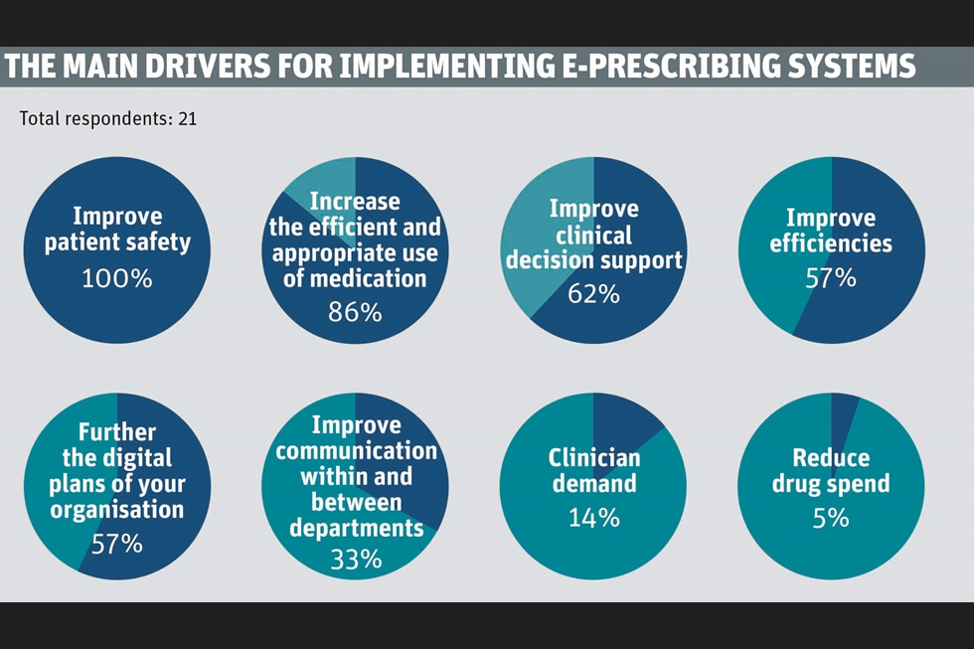

2.3.9 How developments in technology and data in the NHS are improving outcomes for patients

(Sir Jeremy Heywood, Cabinet Secretary and Head of the Civil Service, 12 December 2014) In other parts of our lives we take technology and its benefits for granted. We are able to book our holidays and manage our finances online. But although 61% of UK adults have a smartphone and 76% of us access the internet every day, only 2% of the population have any kind of digital interaction with the NHS. This needs to change, not only for patient care, but also to improve the efficiency of the NHS, and in order to support the integration with social care services.

It is very important that DH and its partner organizations across health and social care have made further commitments in the area of data and technology, with the publication of Personalized Health and Care 2020. This sets out a framework for how the health and care sector will use data and technology to transform outcomes for patients and citizens.

2.3.10 Electronic Medical Record/Electronic Health Record Systems of Office-based Physicians

(Chun-Ju Hsiao, et al, 2014) The estimate of all or partial EMR/EHR systems was obtained from the question, “Does this practice use electronic medical records or electronic health records (not including billing records)?” In addition to the question asking about all or partial EMR/EHR systems, physicians also reported the computerized functionalities of their practices. EMR/EHR systems were classified as basic or fully functional.

There has been an increasing trend in EMR/EHR use among office-based physicians from 2001 through the preliminary 2010 estimates (Figure 1). Combined data from the 2009 surveys (mail survey and in-person survey) showed that 48.3% of physicians reported using all or partial EMR/EHR systems in their office-based practices. About 21.8% of physicians reported having systems that met the criteria of a basic system, and about 6.9% reported having systems that met the criteria of a fully functional system, a subset of a basic system. Preliminary 2010 estimates from the mail survey showed that 50.7% of physicians reported using all or partial EMR/EHR systems, similar to the 2009 estimate. About 24.9% reported having systems that met the criteria of a basic system, and 10.1% reported having systems that met the criteria of a fully functional system, a subset of a basic system. Between 2009 and 2010, the percentage of physicians reporting having systems that met the criteria of a basic or a fully functional system increased by 14.2% and 46.4%, respectively. Due to questionnaire modifications in 2010, survey items used to define basic and fully functional systems are slightly different from 2009. The diagram for their findings is shown below:



2.3.11 Federal Health Architecture

(FHA pub., 2013) The CONNECT open source software enables health IT systems to securely communicate via nationally recognized standards. With CONNECT, information can be shared securely via the Internet among doctor’s offices, federal agencies, state agencies, disability organizations, public health organizations, pharmacies and other health stakeholders. This enables health professionals to request, send and receive medical records so critical information can follow patients as they navigate through the health care system.

CONNECT was developed by more than 20 federal agencies working together through FHA. Rather than each federal agency independently building its own separate Nationwide Health Information Network compliant gateway, they decided to collaborate and create a single platform to enable the secure exchange of health information.

The collaboration that led to CONNECT’s development was unprecedented in the federal government. It has saved the government an estimated $200 million in development costs versus each agency building its own solution. Equally as compelling is the result of this collaboration. Once the solution was built, federal agencies decided to release CONNECT to the entire healthcare industry to be used by any organization without any cost for the software license.

2.3.12 Patient Engagement within the Patient-Centered Medical Home Model

(Jed C. Constantz, July 2017) This research focused on what best practices might exist among patient-centered primary care delivery to highly-activate their patients. The problem that was studied was what specific aspects of primary care delivery, such as physician leadership, staffing models, staff training and development, and electronic tools and resources, support or undermines the successful high-level activation of patients. The research method used was a qualitative study using the Delphi Method of collecting subject matter expert (SME) opinions from among four classifications of primary care practice team members as study participants.

References:

* Journal of Ambulatory Care Management. 40(1):1, January/March 2017.

Chapter 3 – Research Methodology

3.1 Introduction

The system being developed is designed in such a way that it will accommodate changes along the way. Improvements are going to be made. Out of the numerous software development methodologies, I chose agile because of its features which exactly fit into my requirement.

3.1.1 Software Development Cycle

What is Agile Development?

Agile software development methodology is a process for developing software (like other software development methodologies – Waterfall model, V-Model, Iterative model etc.). In English, Agile means ‘ability to move quickly and easily’ and responding swiftly to change – this is a key aspect of agile software development as well. (Wikipedia)

Brief overview of Agile Methodology

* In traditional software development methodologies like Waterfall model, a project can take several months or years to complete and the customer may not get to see the end product until the completion of the project.
* At a high level, non-Agile projects allocate extensive periods of time for Requirements gathering, design, development, testing and User Acceptance Testing, before finally deploying the project.
* In contrast to this, agile projects have Sprints or iterations which are shorter in duration (Sprints/iterations can vary from 2 weeks to 2 months) during which pre-determined features are developed and delivered.
* Agile projects can have one or more iterations and deliver the complete product at the end of the final iteration. (Jonhy Moore, et. Al, 2014)

Why Agile?

Agile development methodology provides opportunities to assess the direction of a project throughout the development lifecycle. This is achieved through regular cadences of work, known as sprints or iterations, at the end of which teams must present a potentially shippable product increment. By focusing on the repetition of abbreviated work cycles as well as the functional product they yield, agile methodology is described as “iterative” and “incremental.” (The Agile Movement, 2008). As earlier stated, this software is going to encounter a lot of iterations and changes and hence agile is best suited for our need.

Characteristics of agile development

* Modularity
* Iterative
* Time-bound
* Incremental
* Convergent
* People-oriented
* Collaborative

Advantages of Agile development cycle

* .In agile methodology the delivery of software is unremitting.
* The customers are satisfied because after every Sprint working feature of the software is delivered to them.
* Customers can have a look of the working feature which fulfilled their expectations.
* If the customers has any feedback or any change in the feature then it can be accommodated in the current release of the product.
* In Agile methodology the daily interactions are required between the business people and the developers.
* In this methodology attention is paid to the good design of the product.
* Changes in the requirements are accepted even in the later stages of the development.

Disadvantages of Agile development cycle

* In Agile methodology the documentation is less.
* Sometimes in Agile methodology the requirement is not very clear hence it’s difficult to predict the expected result.
* In few of the projects at the starting of the software development life cycle it’s difficult to estimate the actual effort required.
* The projects following the agile methodology may have to face some unknown risks which can affect the development of the project.

Agile development stages

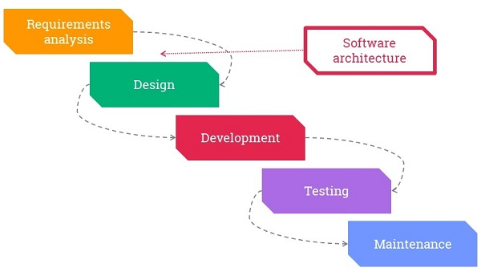

The Agile Process Flow

* Concept - Projects are envisioned and prioritized
* Inception - Team members are identified, funding is put in place, and initial environments and requirements are discussed
* Iteration/Construction - The development team works to deliver working software based on iteration requirements and feedback
* Release - QA (Quality Assurance) testing, internal and external training, documentation development, and final release of the iteration into production
* Production - Ongoing support of the software
* Retirement - End-of-life activities, including customer notification and migration

Chapter 4 – Implementation and Evaluation

* 1. Hardware Requirement
* Processor: Intel Dual CoreTM or above
* Processor Speed: 2.0 GHz or above
* RAM: 2 GB or above
* Hard Disk: 50 GB or above
  1. Software Requirement
* Windows 7 or above
* Node js server
* MongoDB database

Chapter 5 – Discussion and Conclusion