Instruction for Accessing and Understanding the ZIP File Content

This ZIP file contains three main folders: ***Student Mistakes***, ***Knowledge Point Analysis***, and ***New Paper***. Each folder holds files named with the student ID as the prefix, followed by additional descriptors. Here’s how to navigate each folder:

1. Student Mistakes Folder
   1. File Naming Format

Each file is named using the format: Student ID Test 1_mistakes. Example: 1155159595 Test 1_mistakes.

* 1. Content Description

These files contain a list of questions that students answered incorrectly, organized into two parts: **Part 1** and **Part 2**.

As is shown in Fig.1, students’ answer (学生の回答) and correct answer (正解) are included for each question.

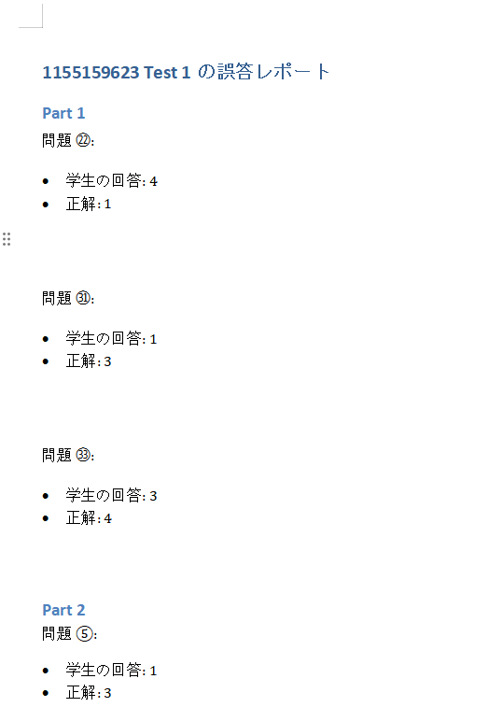

Fig.1 Example of Mistake Report

1. Knowledge Point Analysis Folder
   1. File Naming Format

Each file is named using the format: Student ID Test 1_mistakes_analysis. Example: 1155159595 Test 1_mistakes_analysis.

* 1. Content Description

These files provide a **Detailed Report on Student Errors in Japanese Language Learning**, divided into three sections:

1. **Analysis of Underlying Knowledge Points** associated with the errors.
2. **Summary of Specific Knowledge Points** where students made mistakes.
3. **Detailed Report** based on the analysis and summary.

Examples of the three parts are shown in Fig. 2, 3, and 4 (**Note: The reports are individualized for each student based on the type and number of errors they made**).

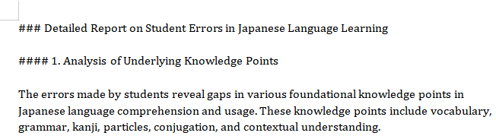

Fig.2 Example of Analysis of Underlying Knowledge Points

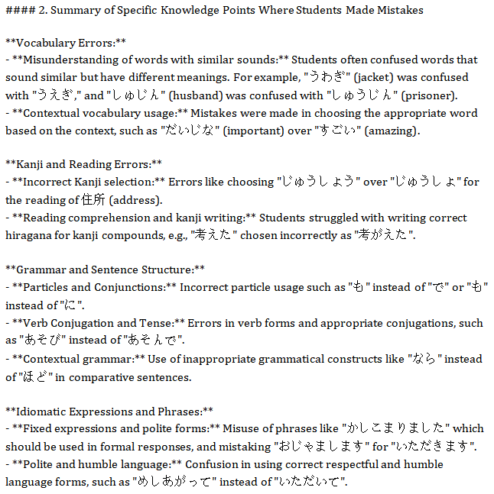

Fig.3 Example of Summary of Specific Knowledge Points Where Students Made Mistakes

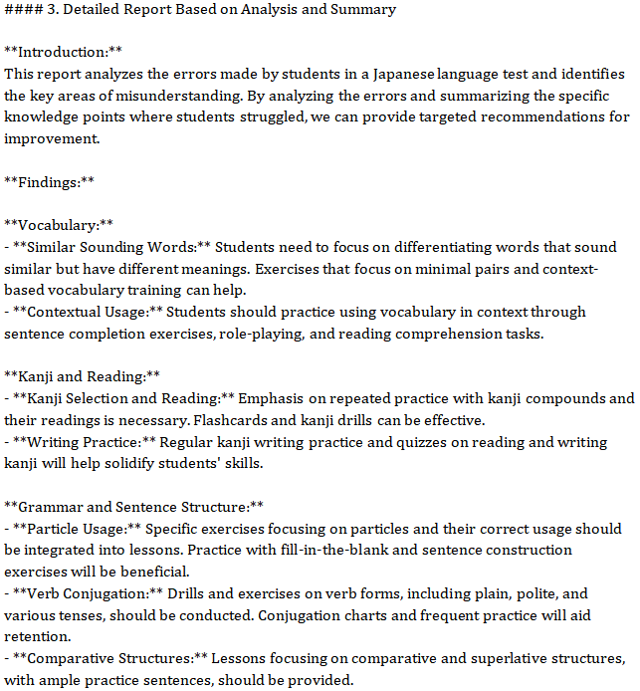

Fig.4 Example of Detailed Report Based on Analysis and Summary

1. New Paper Folder

3.1 File Naming Format

Each file is named using the format: Student ID Test 1_new_report. Example: 1155159595 Test 1_new_report.

3.2 Content Description

In these files, 20 new multiple-choice questions are generated targeting similar grammar or vocabulary points to help students strengthen their understanding. The answers are attached at the end of each file. Figures 5 and 6 are examples of the new question-answer format.

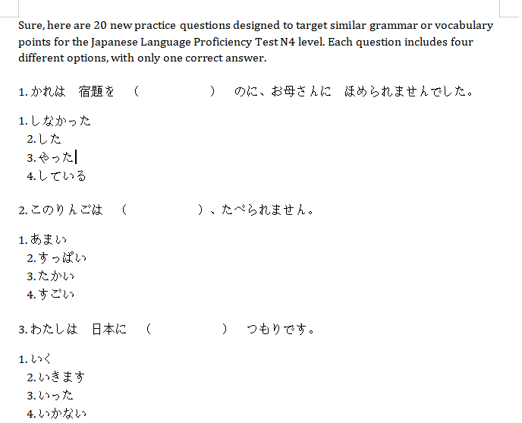

Fig.5 Example of New Questions

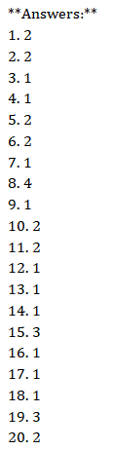

Fig.6 Example of the Answer

1. Final Instructions

Please review the contents of each folder carefully to ensure that the knowledge point analysis and the new questions meet your requirements (content, difficulty, relevance, etc.). If you have any suggestions or require further adjustments, feel free to contact us.