

**Project name**: Distributed Information System for Managing the Activity of a Owners' Association .

**Team members:** Popa Marius, Toropu Mihai-Bogsssdan, Tatulescu Alexandru-Mihaita.

**Faculty:** Automatics, Computer science and Electronics.

**Specialization:** Computer science.

**Year of study:** 3.

**Teacher tutor:** Spahiu-Stoica Cosmin.

Source code for this project was created in PHP language programming.

**1.Base entity.**

**1.1 User**

1.1.1 Parameters.

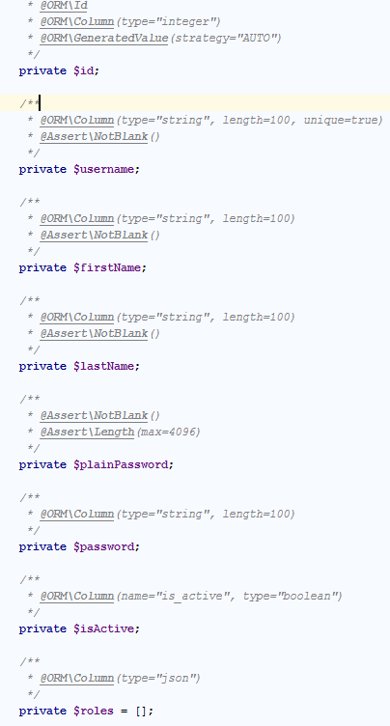

**1.1.2Methods**

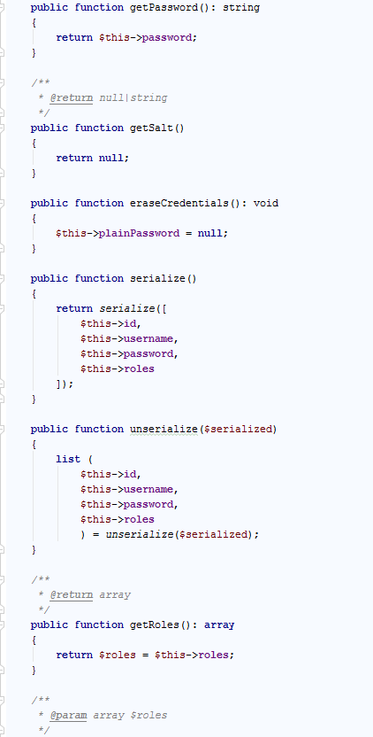

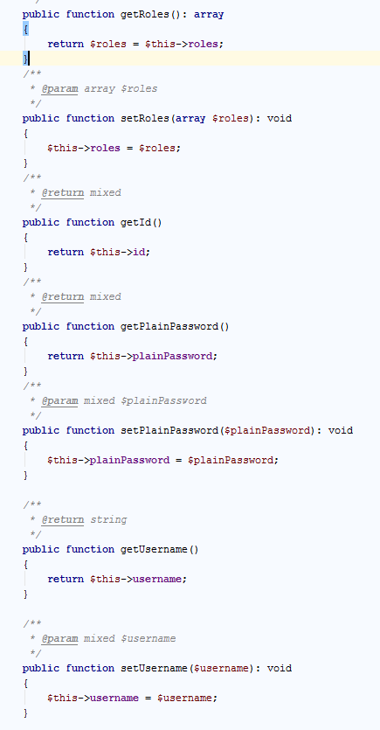

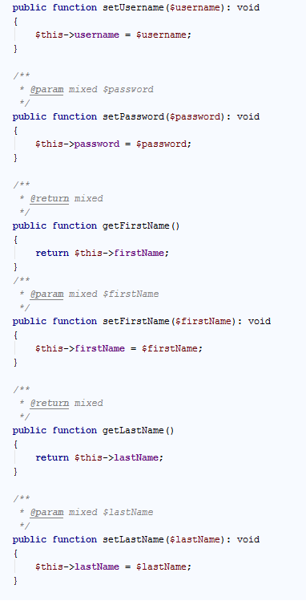

**1.2 Contact**

**1.2.1** Parameters.

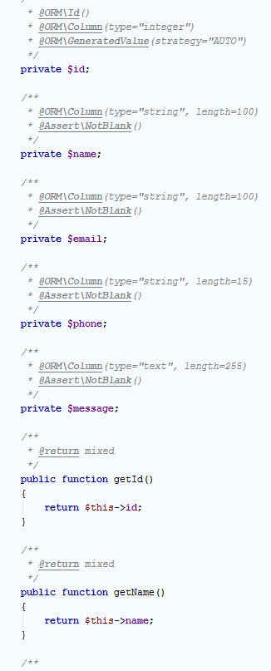

**1.2.2.Methods**

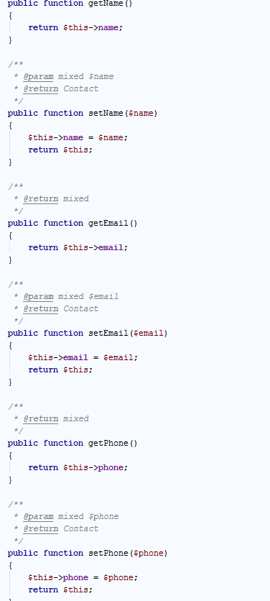

**1.3 Reset Password Trait**

1.3.1 Parameters

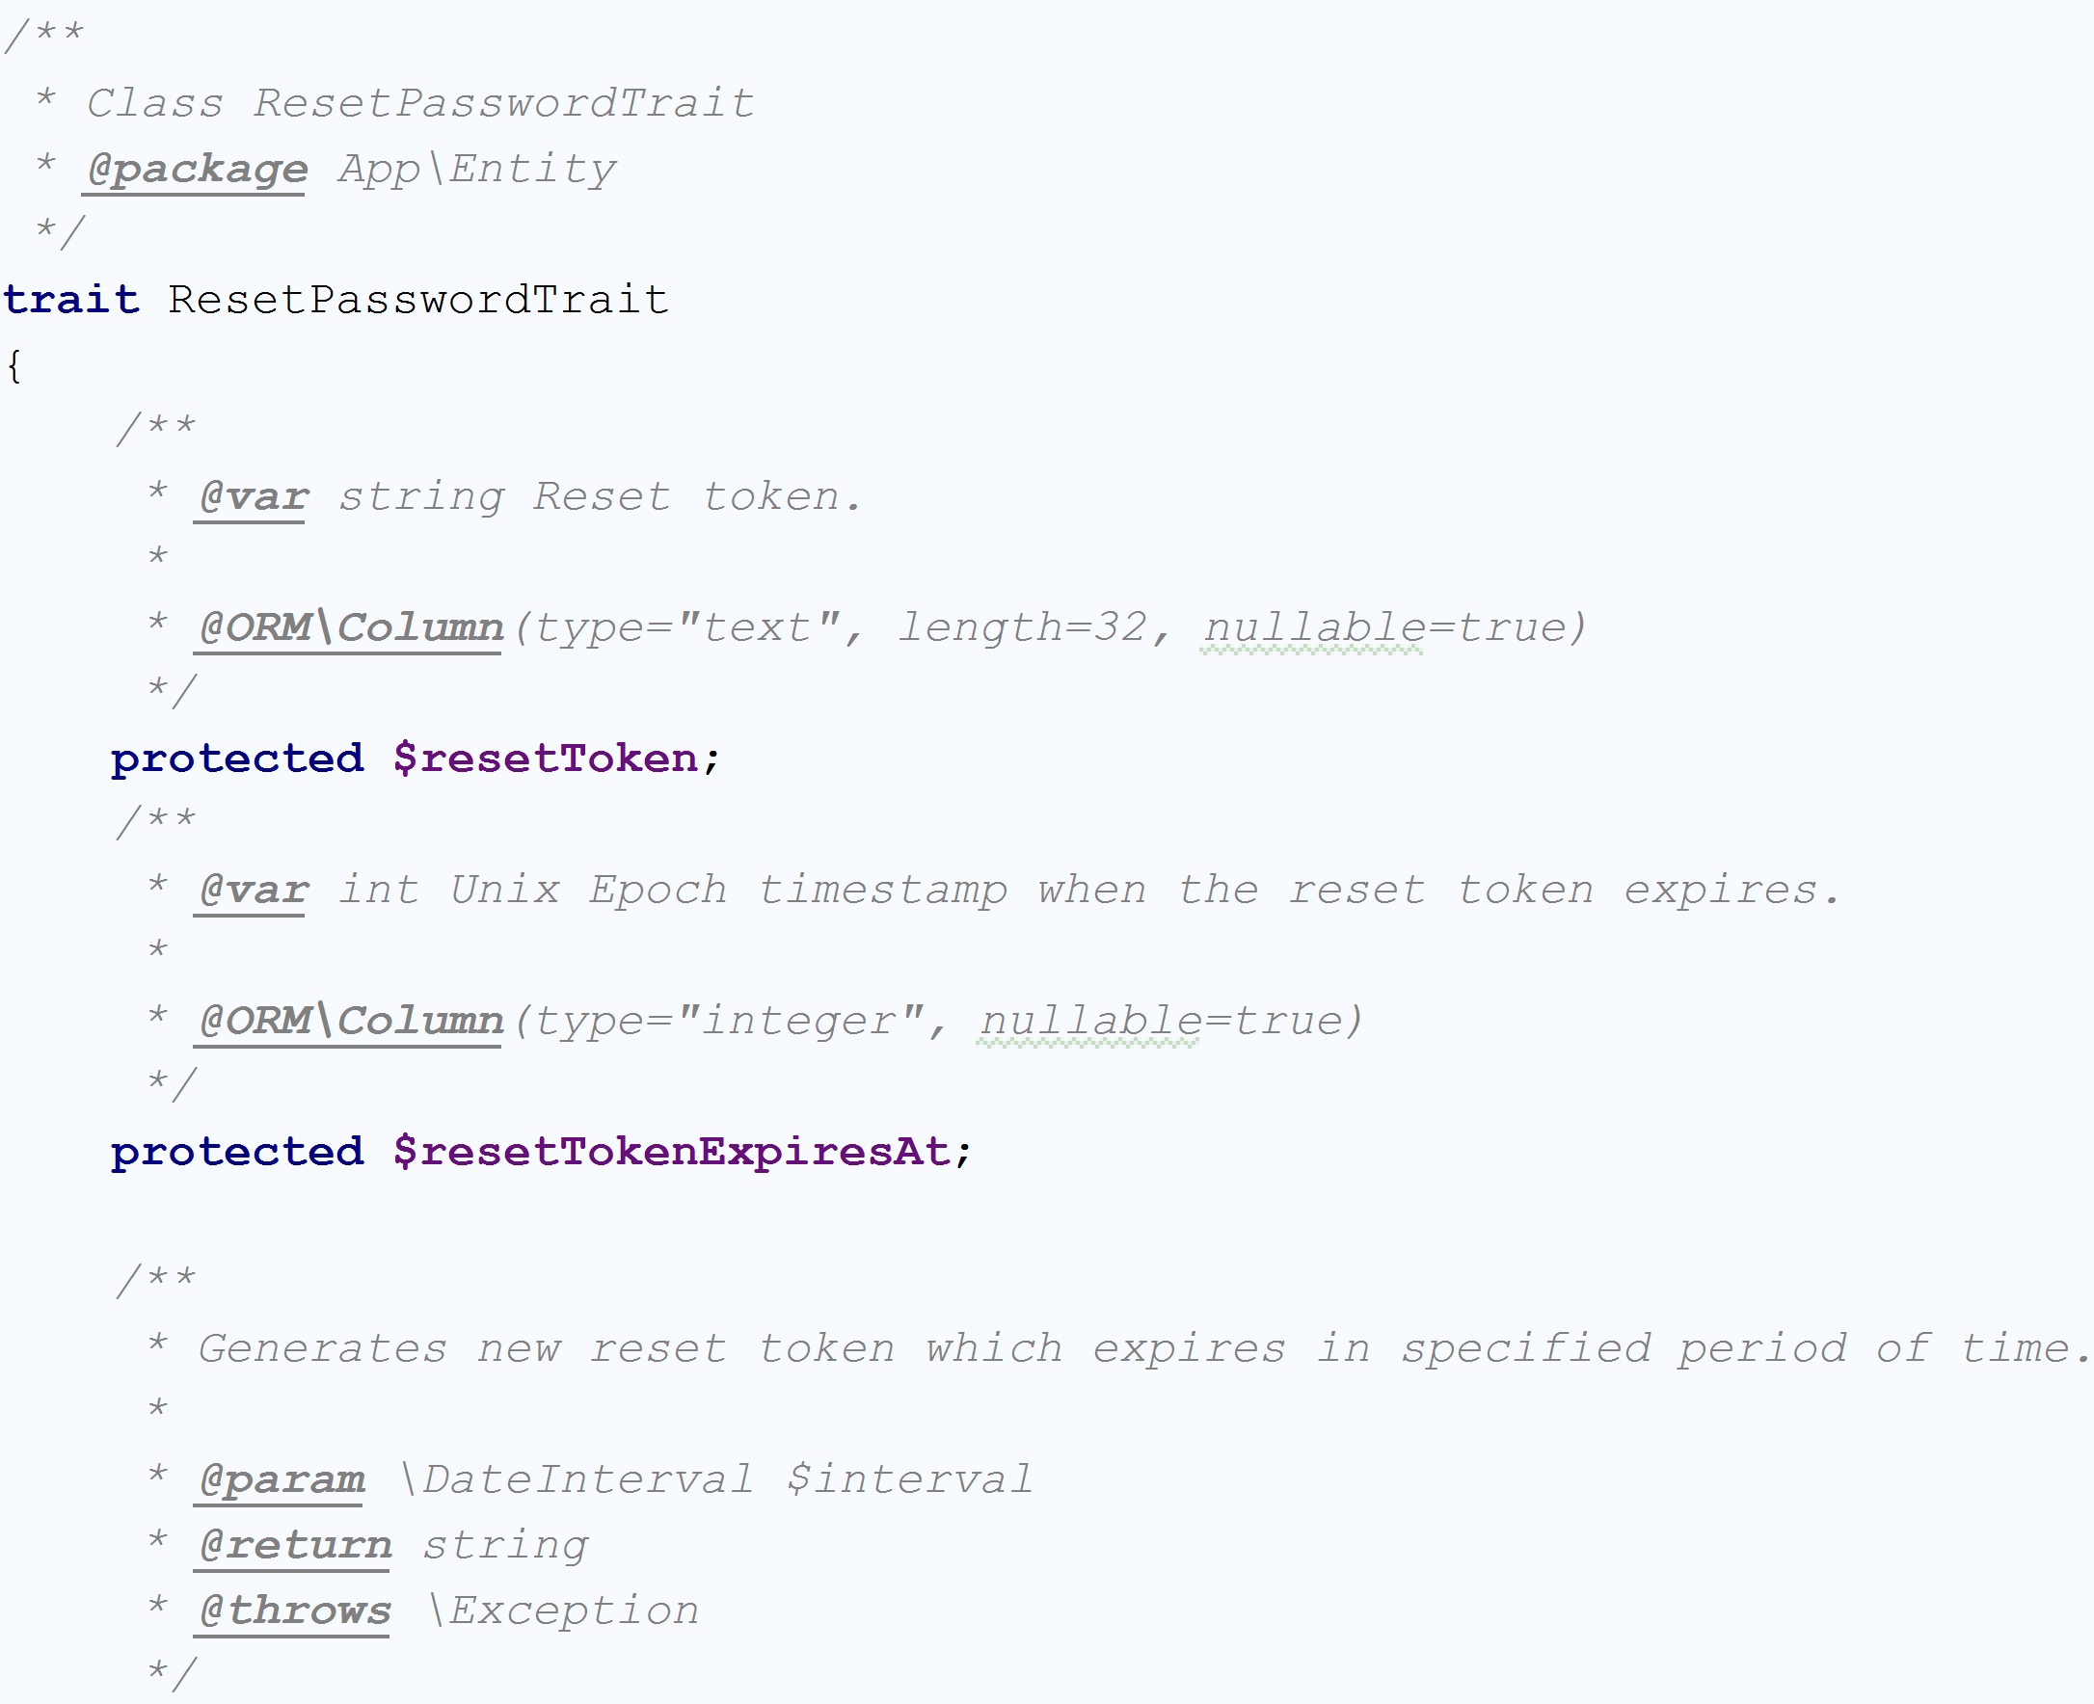

1.3.2 Methods

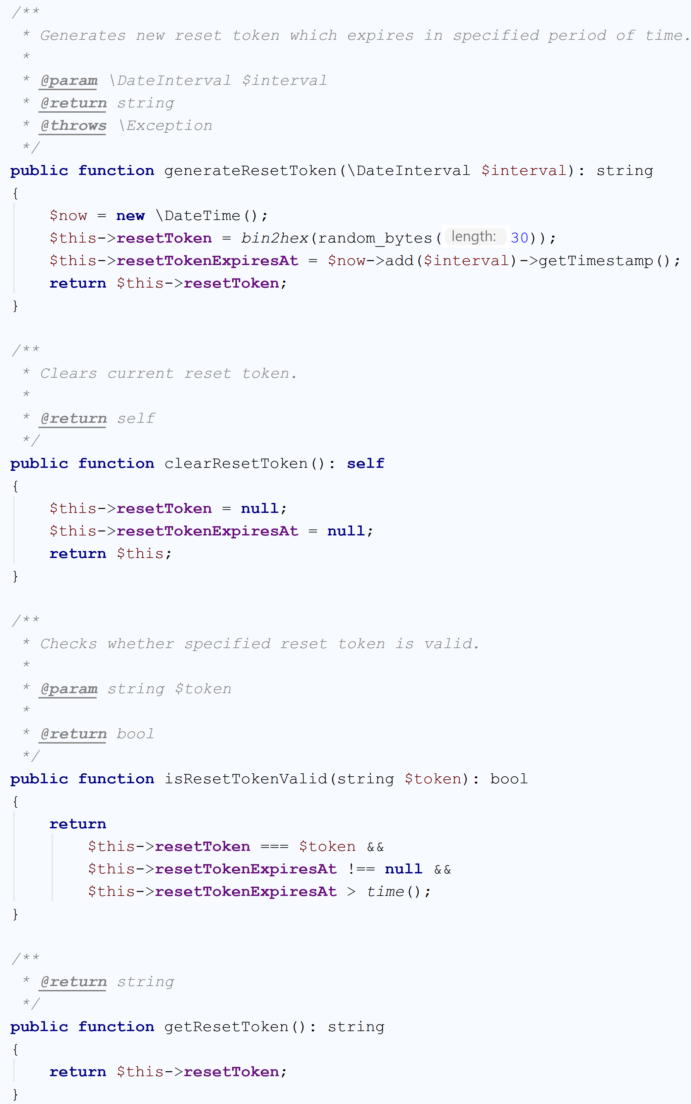

**2.Controllers**

**2.1 Administrator Controller**

**2.1.1 Methods**

This class contains the functions provided to the administrator for to manage the association.

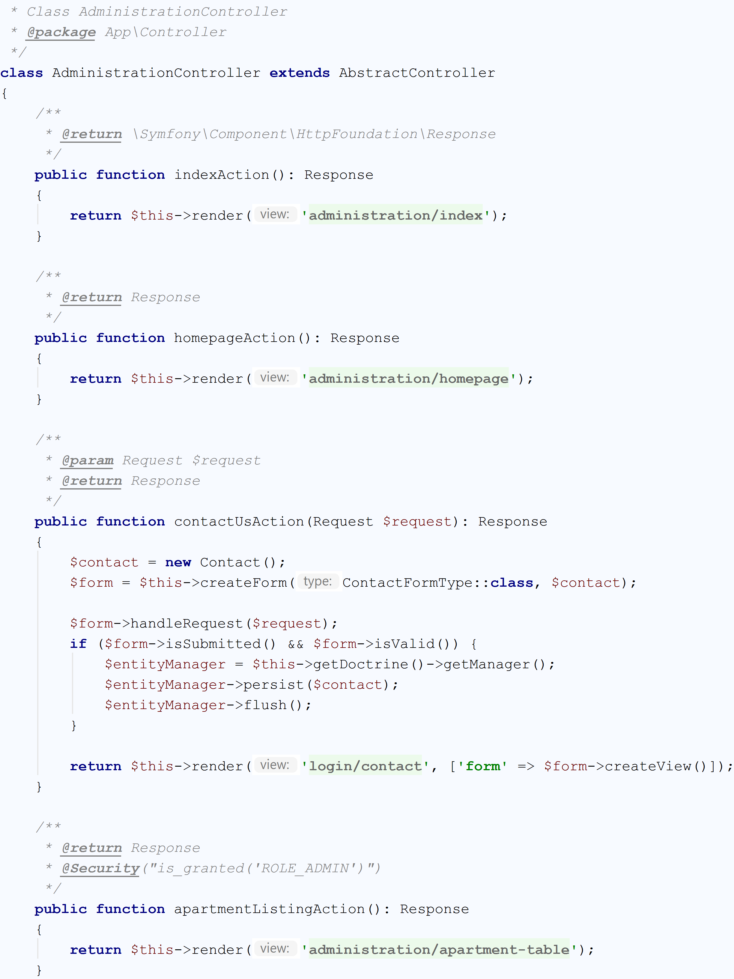

**2.2 Registration Controller**

**2.2.2Methods**

This class contains the functions for register the users.

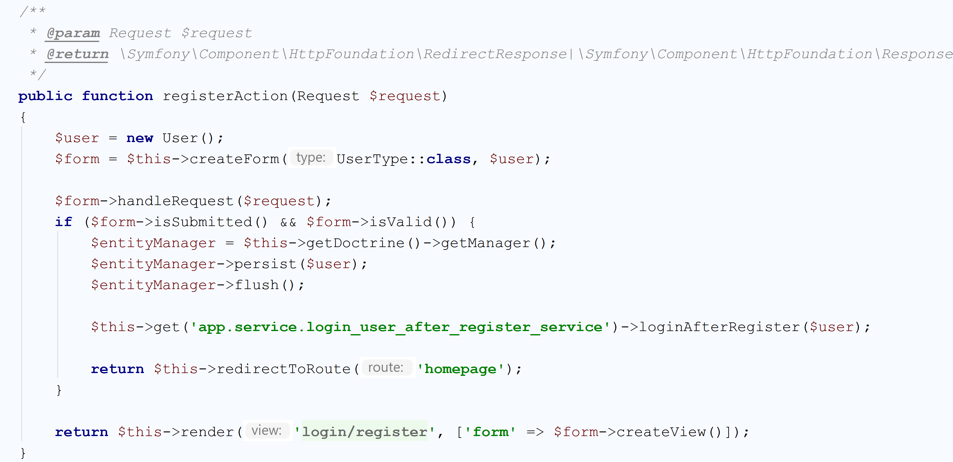

**2.3** **Security Controller**

**2.3.1 Methods**

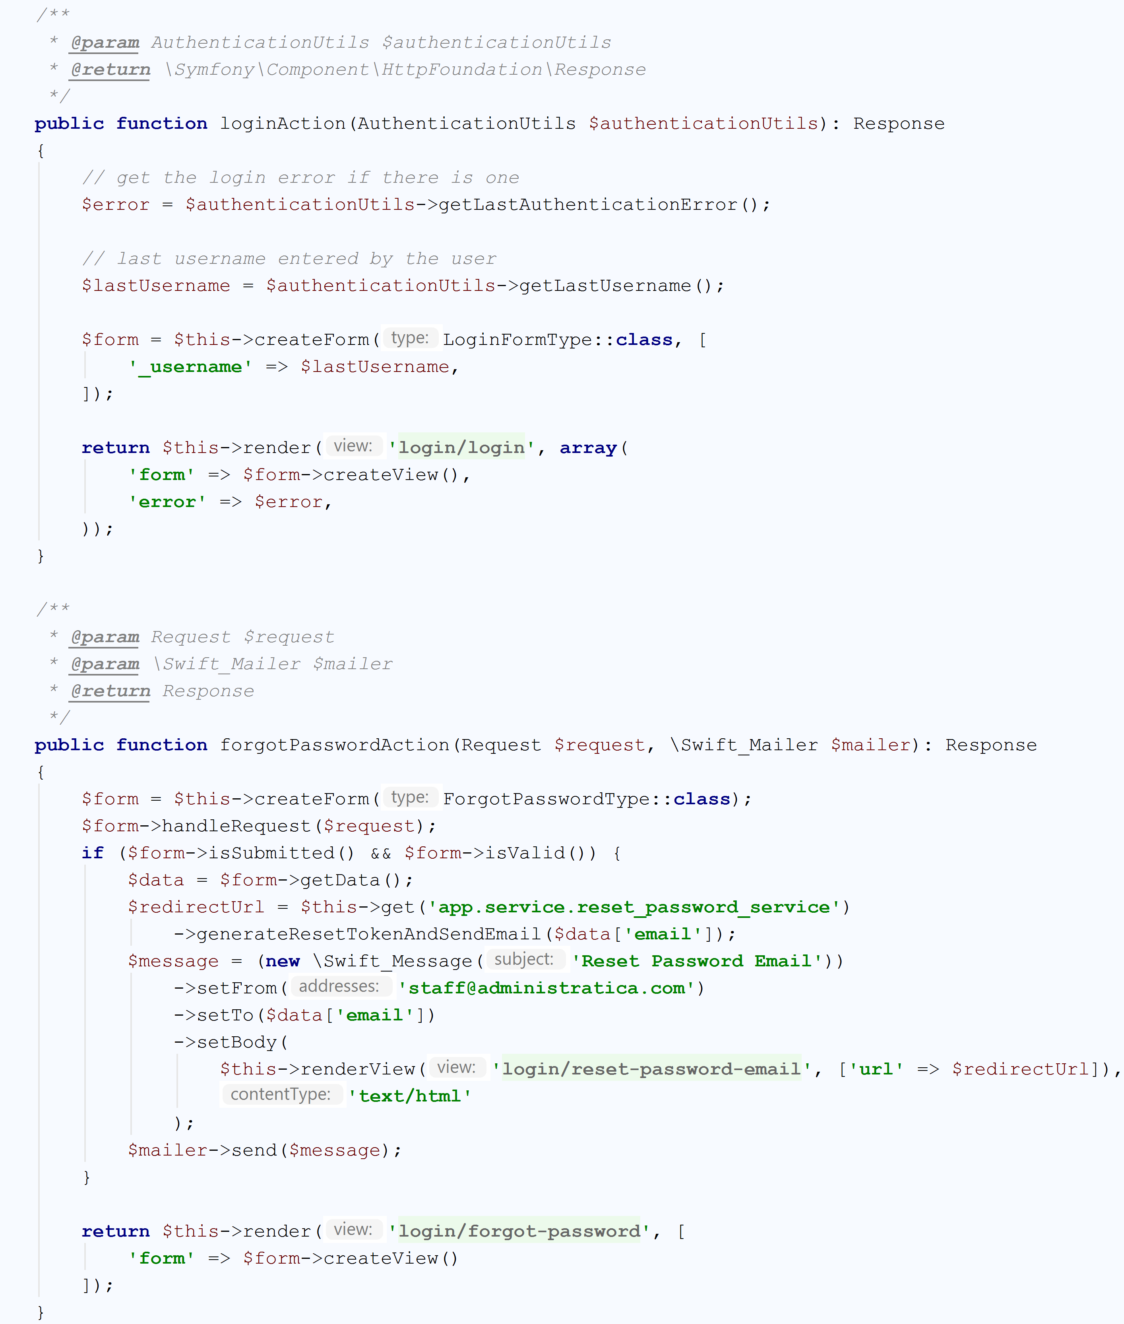

This class contains the functions for security this application. For example: login action, forgot password. The user enters his username and hits "forgot password". The system has a table password_change_requests with the columns ID, Time and UserID. When the new user presses the button, a record is created in the table. The Time column contains the time when the user pressed the "Forgot Password" button. The ID is a string. A long random string is created (say, a GUID) and then **hashed like a password** (which is a separate topic in and of itself). This hash is then used as the 'ID' in the table.The system sends an email to the user which contains a link in it. The link also contains the original ID string (before the hashing). The forgot password.jsp page should be able to retrieve the ID parameter.When the user clicks the link in the email, he is moved to your page. The page retrieves the IDfrom the URL, hashes it again, and checks against the table. If such a record is there and is no more than 24 hours old, the user **is presented with the prompt to enter a new password**.

**2.4 Invoice Controller**

**2.4.1 Methods**

This class contains functions for computing the resident invoices

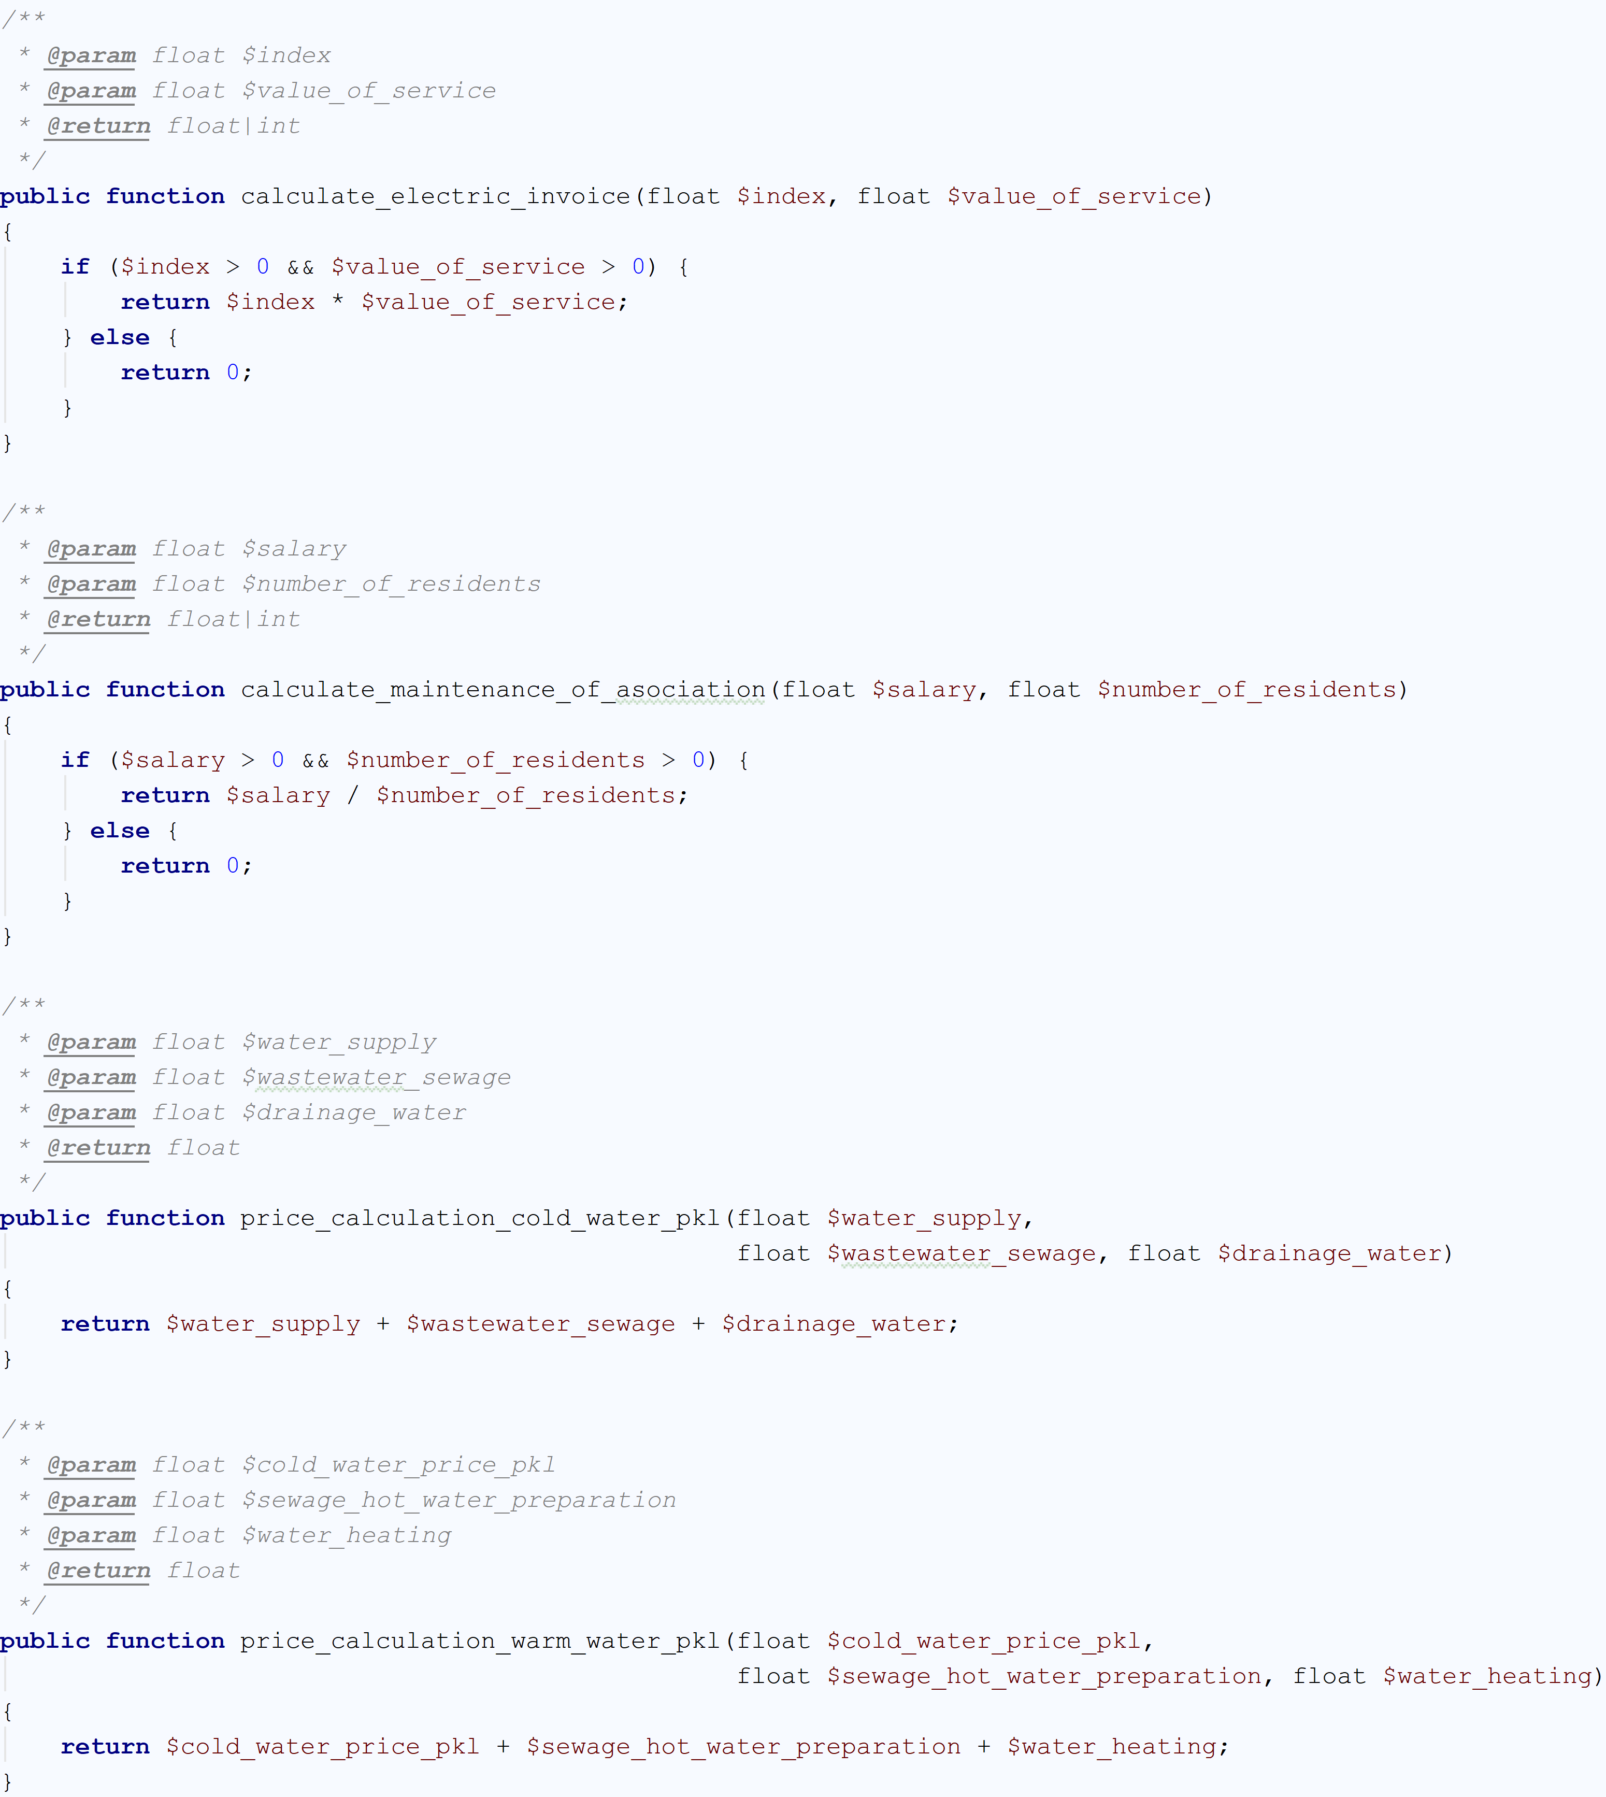

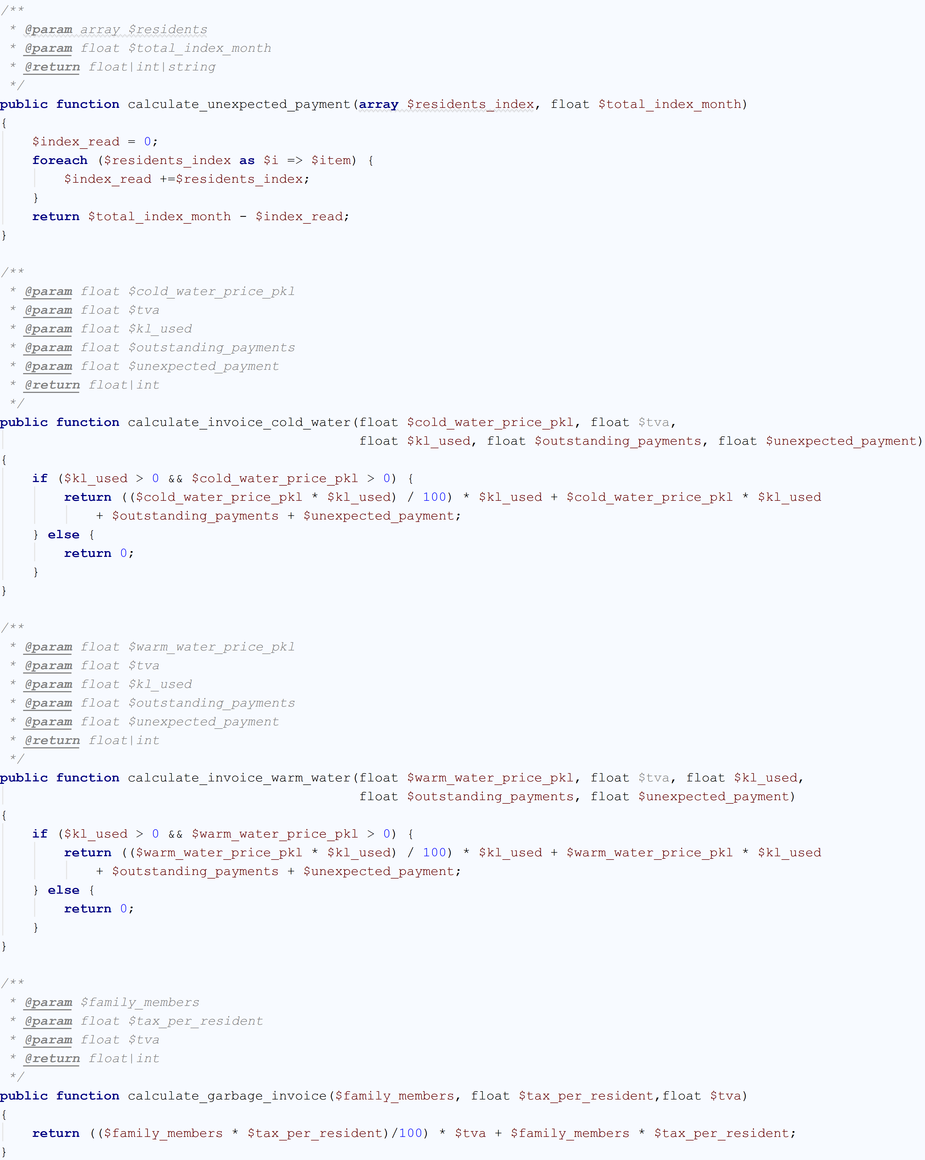

**2.5 Notification Controller**

**2.5.1 Sending notifications on email**

This method will receive a $notifiable entity and should return a Illuminate\Notifications\Messages\MailMessage instance. Mail messages may contain lines of text as well as a "call to action".

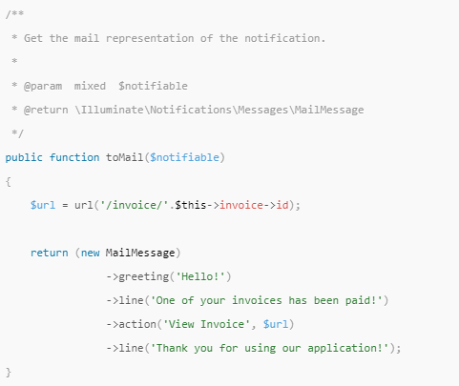

**2.5.2 Error payment**

Some notifications inform users of errors, such as a failed invoice payment. By calling the error method when building the message indicates that an e-mail refers to an error

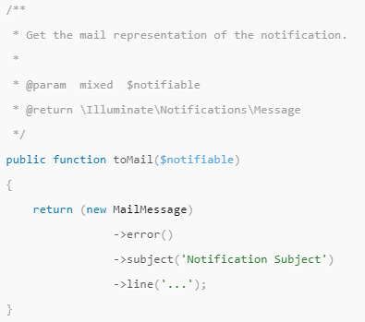

**2.5.3 Generating the message**

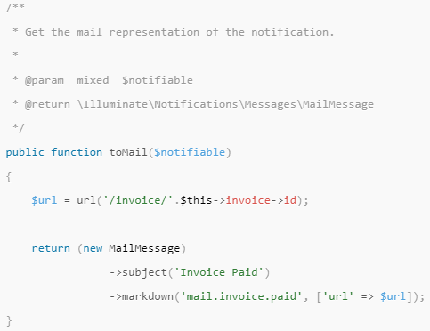

**2.5.4 Formatting Database Notifications**

This method will receive a $notifiable entity and should return a plain PHP array. The returned array will be encoded as JSON and stored in the data column of your notifications table.

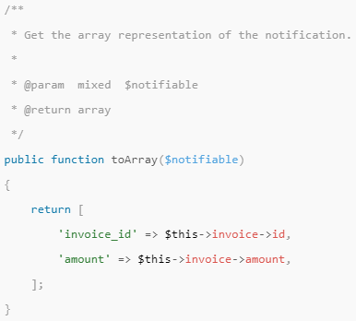

**3.Forms**

**3.1 Contact Form Type**

**3.1.1.** Methods

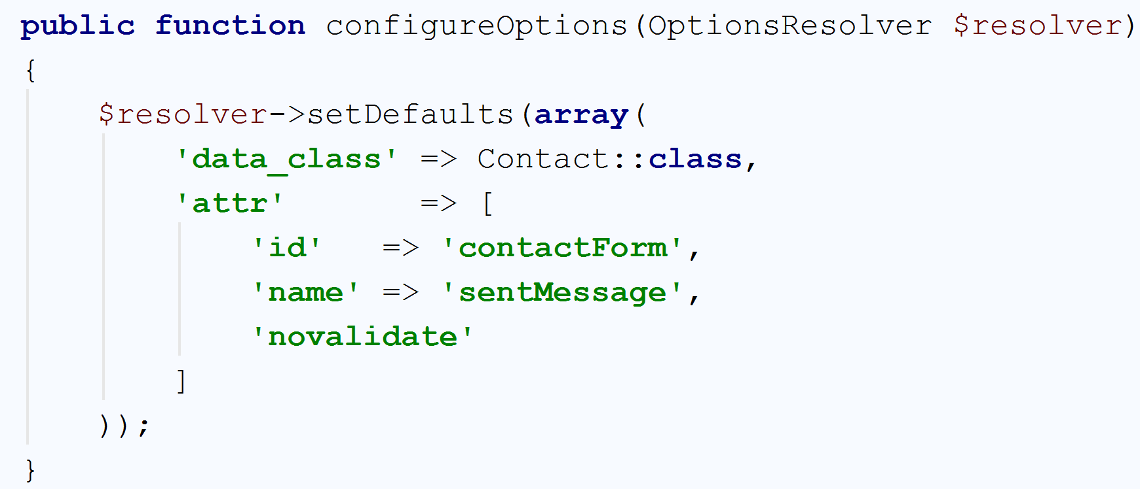

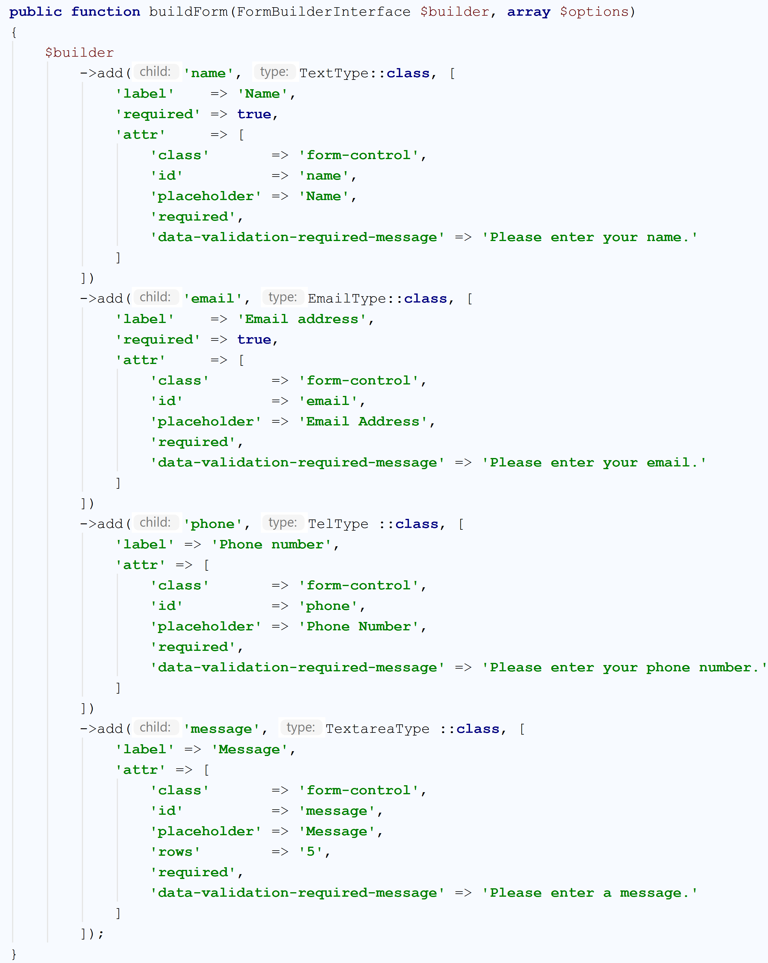

**3.2** **Forgot Password Type**

**3.2.1 Methods**

This class contains the functions for configure the type of forgot password.

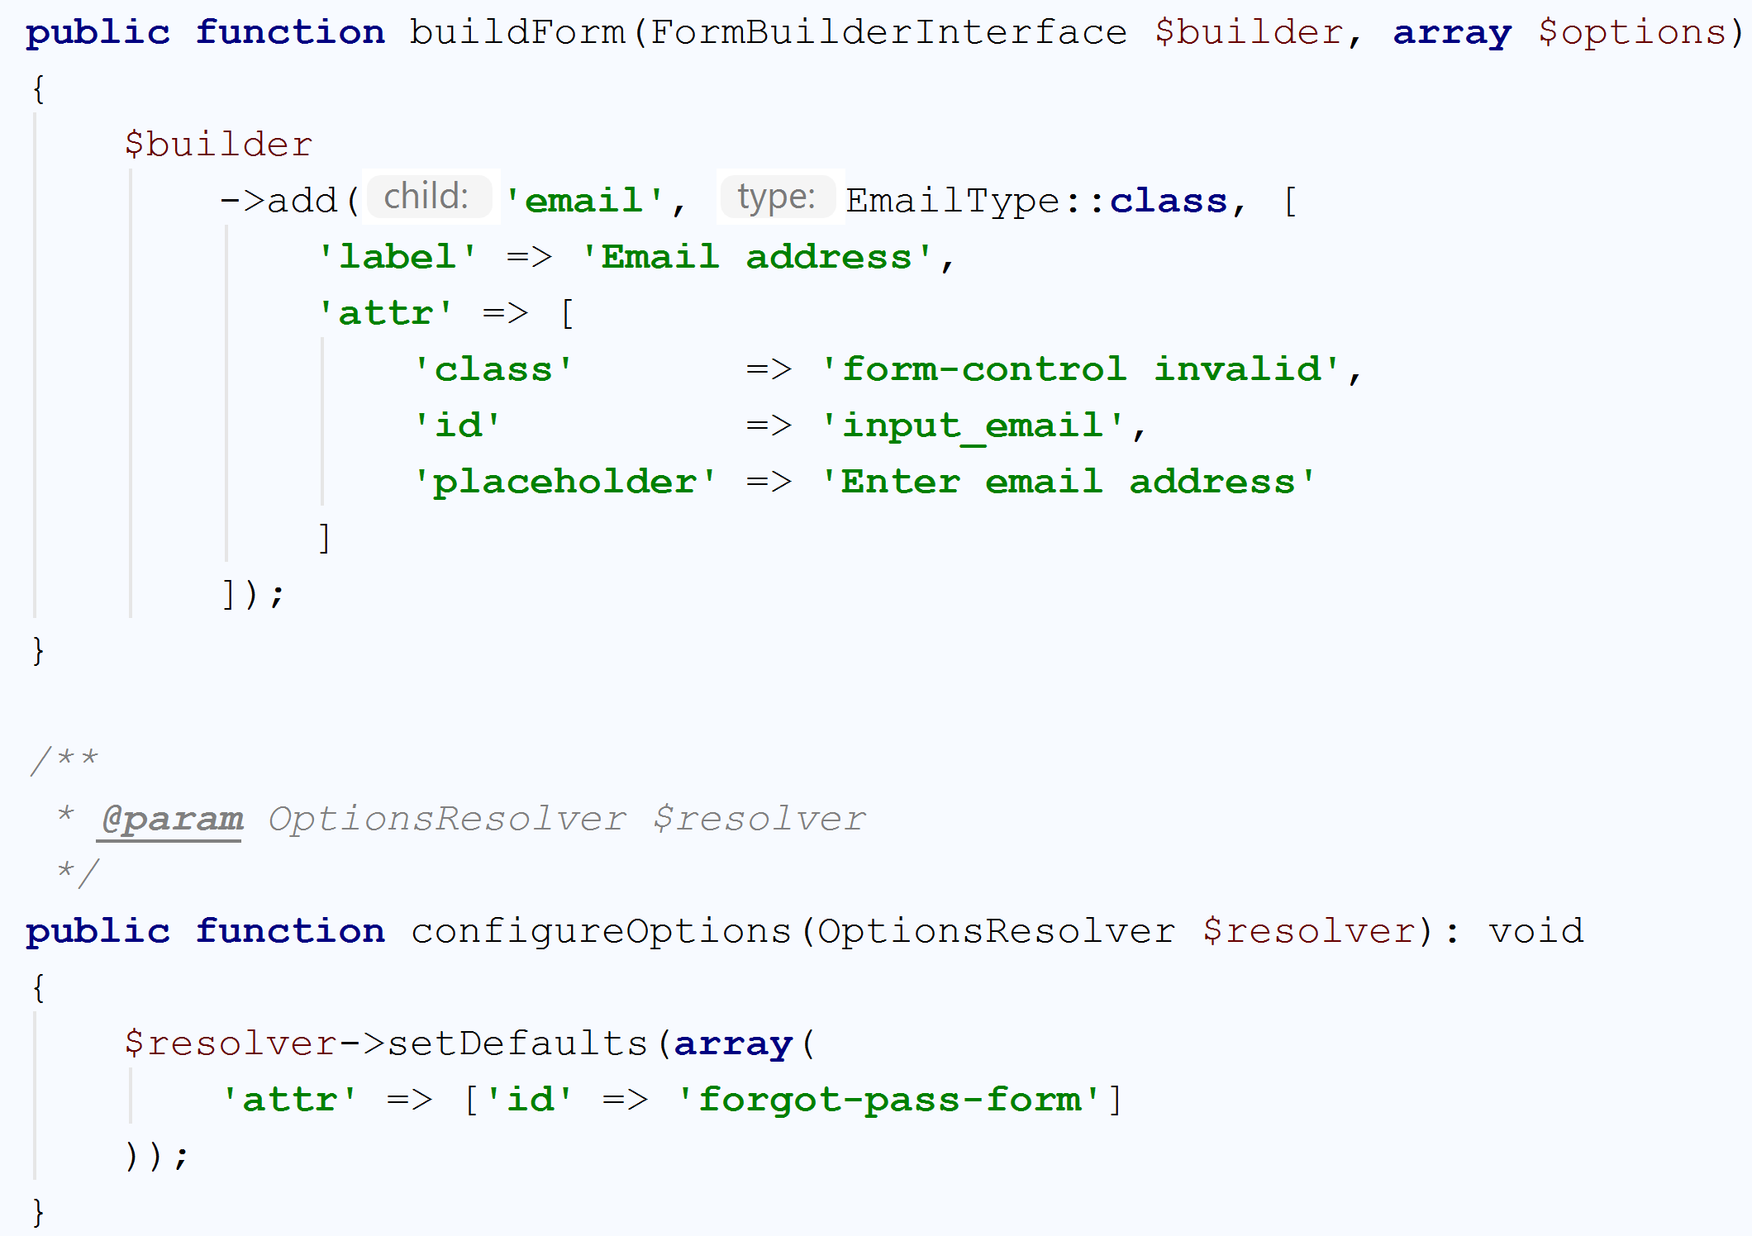

**3.3 Login Form Type**

**3.3.1 Methods**

This class contains the functions for configure the type of login form.

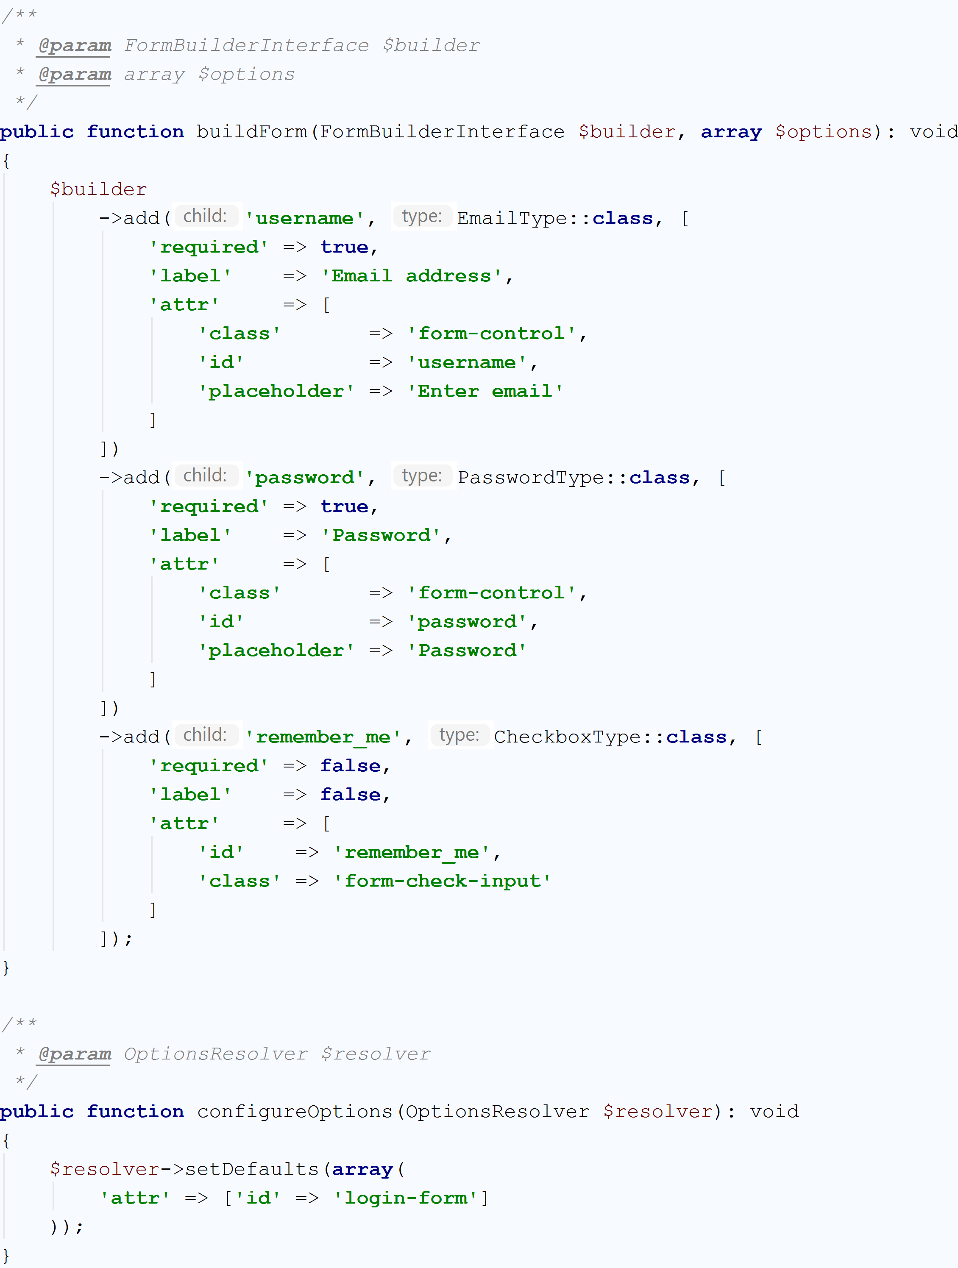

**3.4 Reset Password Form Type**

**3.4.1 Methods**

This class contains the functions for configure the type of reset password form.

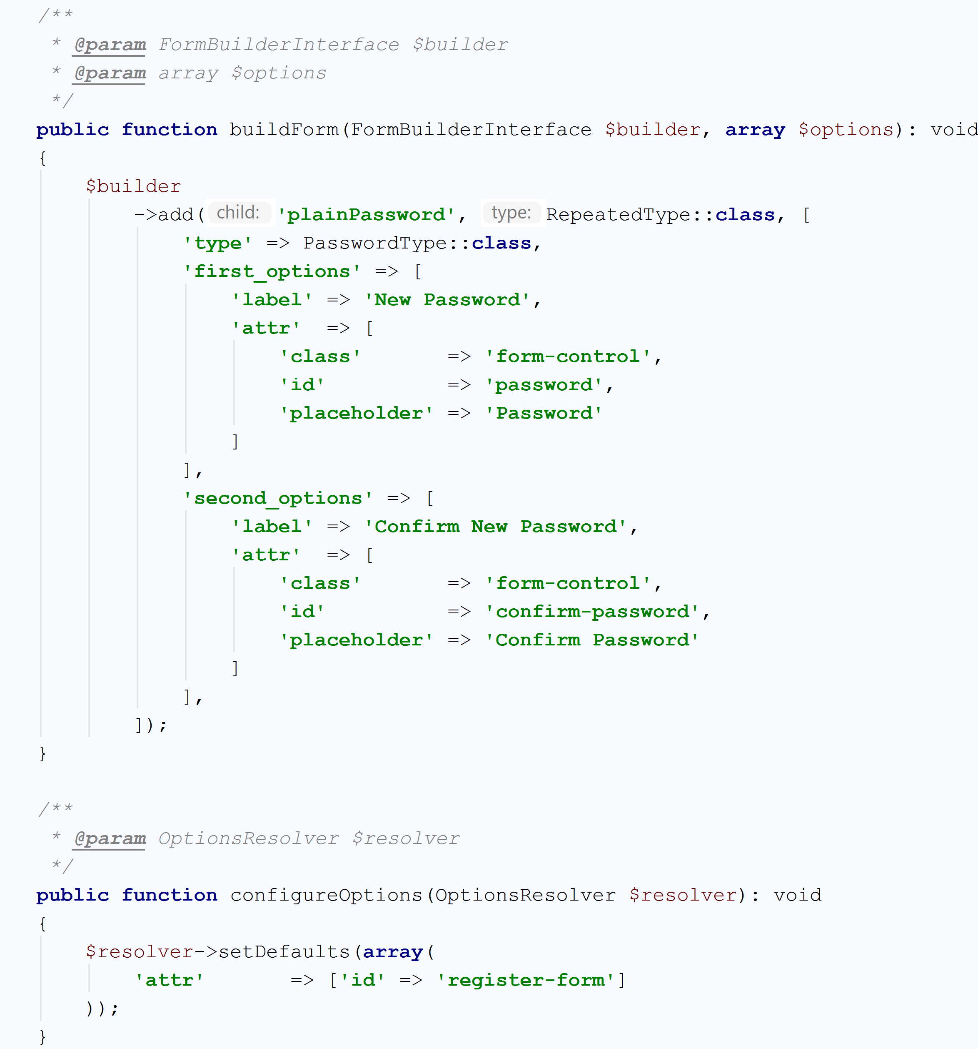

**3.5 User Type**

**3.5.1 Methods**

This class contains the functions for configure the user type form.

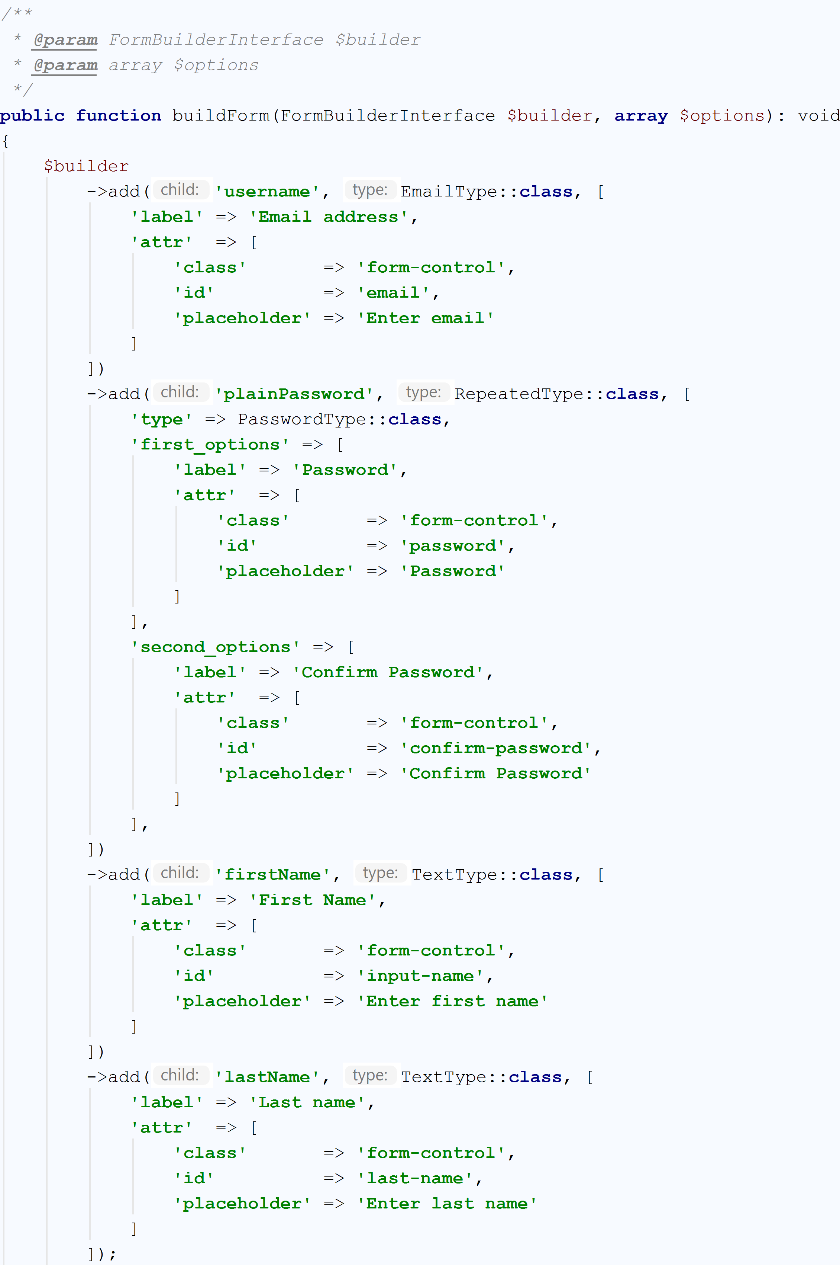

**4.Service**

**4.1 Hash Password Service Listener**

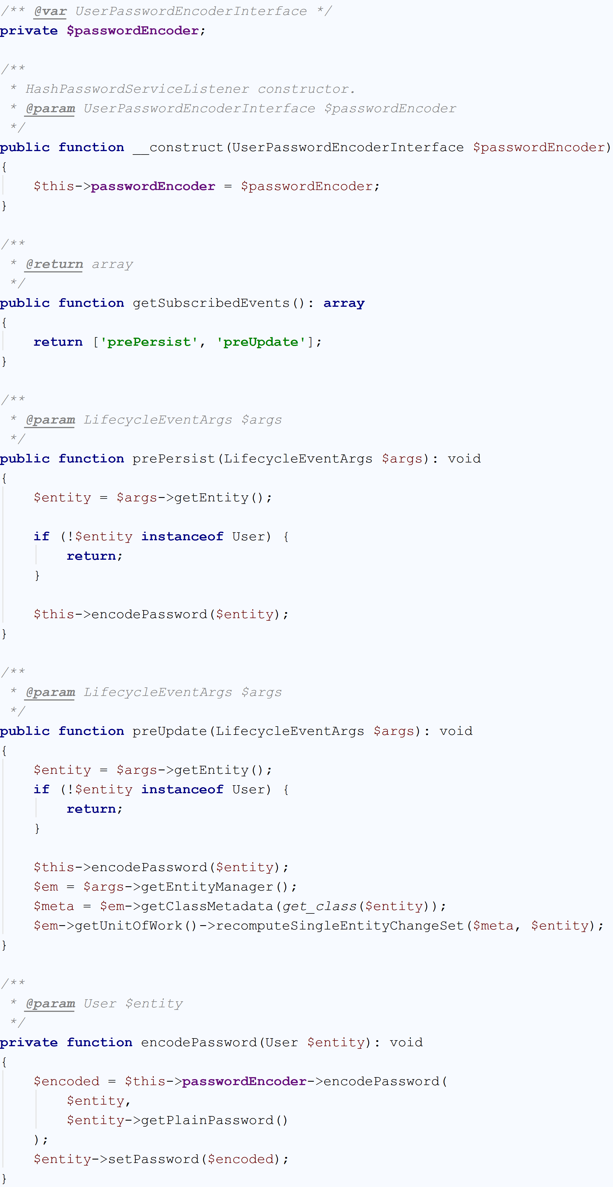

**4.2 Login After Register Service**

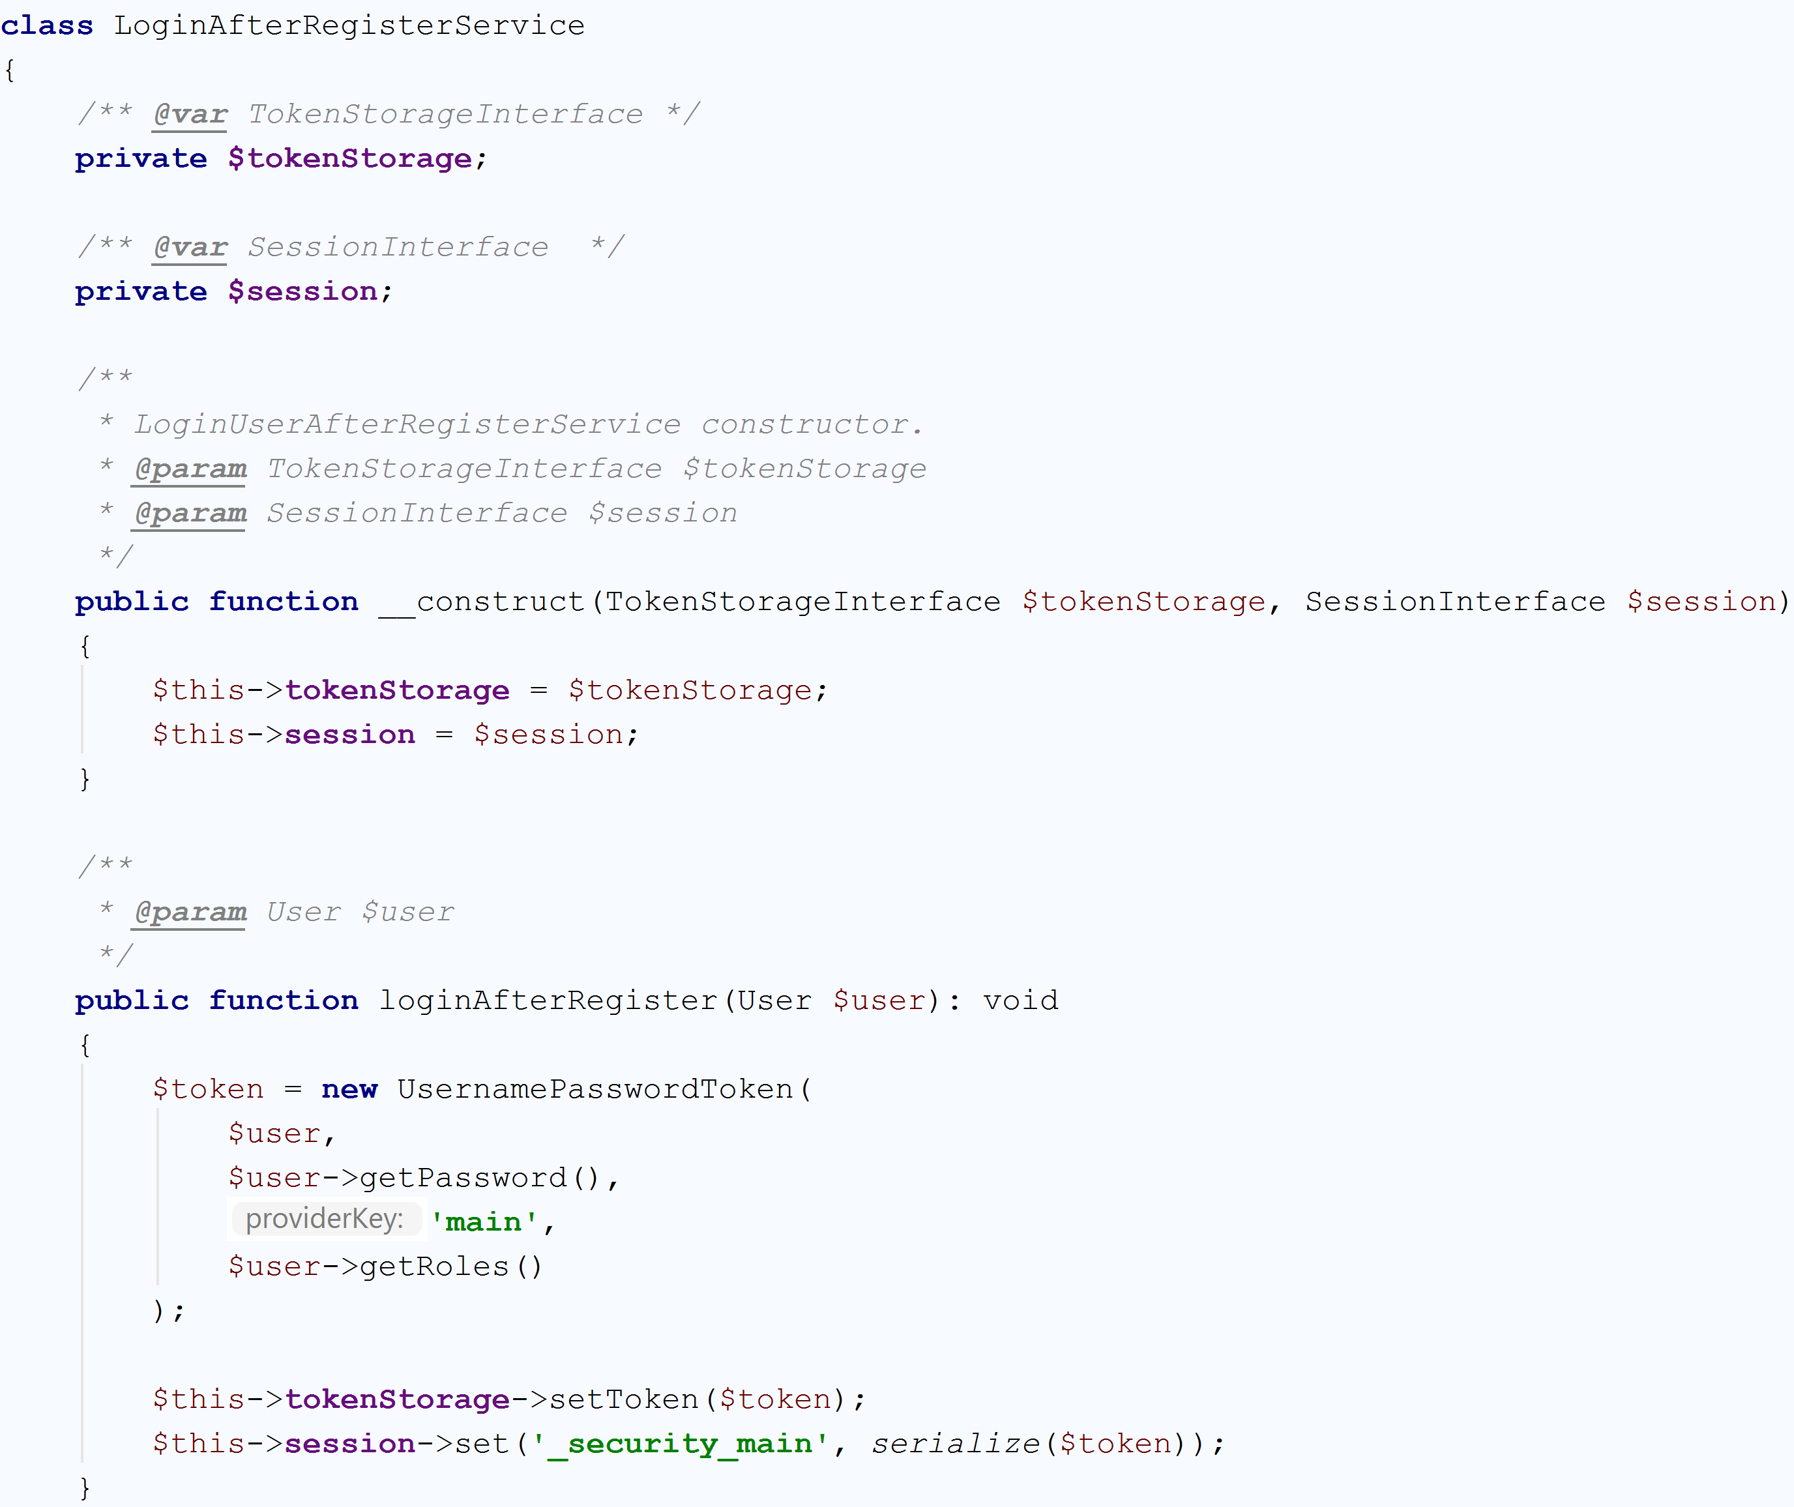

**4.3 Reset password service**

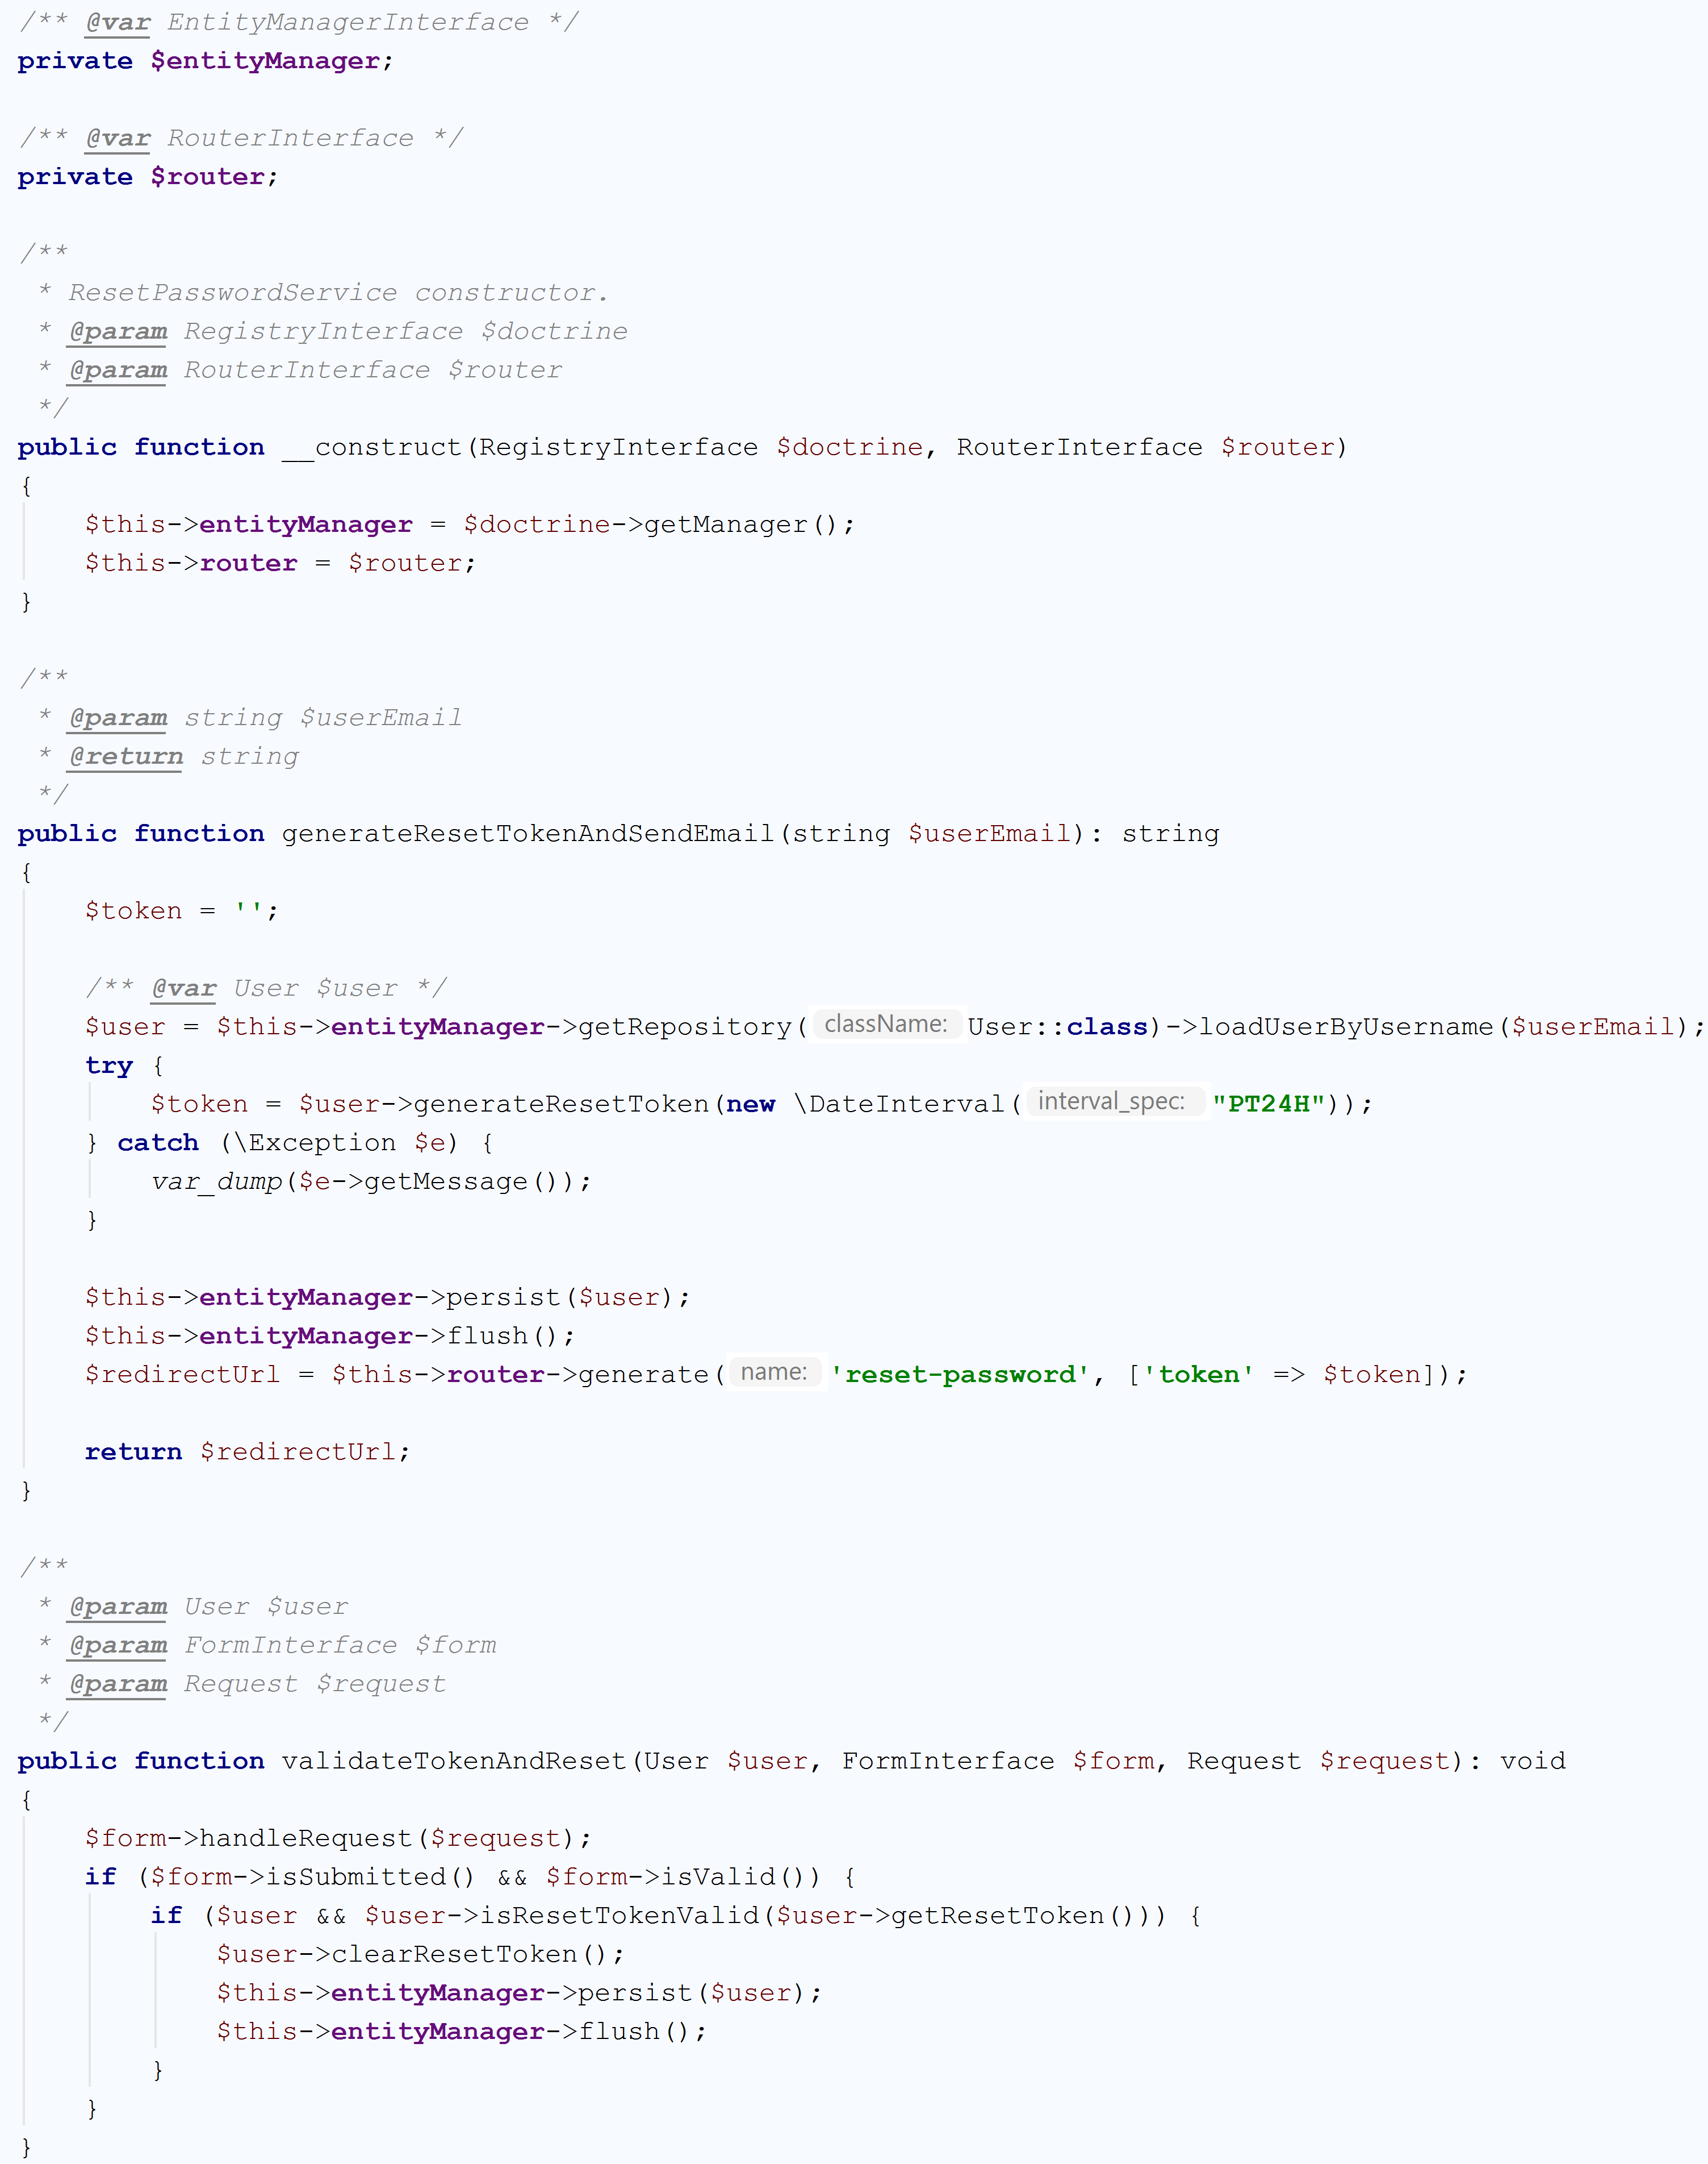

When user will click on the reset password link, it will determine which user wants to change the password after getting value of token by $_GET['token'] and compare this value to all available tokens. Now start a session and ask for new password to your user and store the password in encrypted format in database. After successful password reset token is marked as used.