Hello friends,

Join us!

I need your help to complete my dissertation in Litter Detection from images taken by drones.

As you know litter is a world-wide problem, and poses a problems of soil contamination, threat to marine wildlife, and ultimately to the food chain. The first step into mitigating this problem is monitoring litter locations to determine source/s of the problem. This dissertation in Computer Vision aims to automate the litter detection in these type of surveys.

A lot of entities have shown interest in this type of technology such as Environmental NGOs and University of Malta, Department of Geoscience.

Here is where I need you, this study requires human annotation of litter in aerial images, so that it can be used to train and test Deep Learning algorithms.

Thanks for you support,

Michael Schembri
email: michael.schembri.94@um.edu.mt
Faculty; Department of AI

User Interface:

Please follow the following links: http://annotation4mt.hopto.org/

The html page will contain a set of links for a subset of images. Once you click on the desired link.
The number near the link contains the number of litter items detected and tagged within that image. Choose a link with ‘0’ litter items.

Follow these three steps

Step 1: Select “Bounding Box” annotation method
Step 2: Search and annotate objects within images
Step 3: When ready with the image select Next Image and repeat Step 2:

Important:
Choose a random link from the list with 0 tagged items.
If you find the image has already been tagged move to the next image.

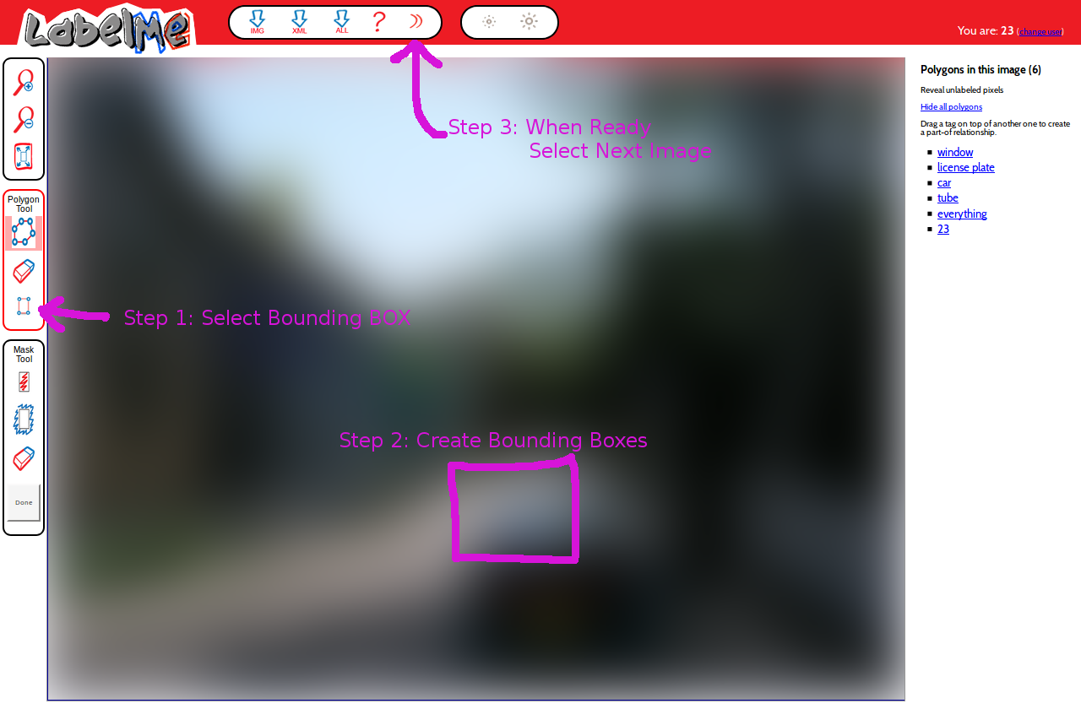

Annotation Instructions:

There are a number of images with litter, though not all images contain objects.

Litter is usually defined as objects that can be thrown away by people. Very heavy objects are not be tagged as litter.

Some notes on the annotation process:

- A bounding box needs to put around the required object,

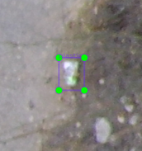

- Litter object/s are very small so zooming would be necessary,

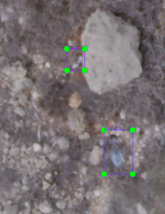

Some litter will be hard to find .

- Each object needs to be annotated separately except for shards and very small items,
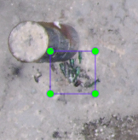
Very small items near each other can be tagged in a group.

The oil tank is not considered litter as it cannot be thrown away.

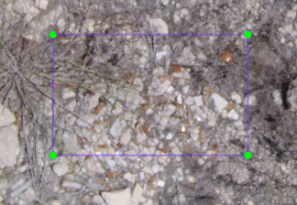

Shards of pottery.

- Only objects that are confidently litter will be tagged. Even though the shape is not recognizable,
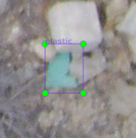

- Litter can be truncated,
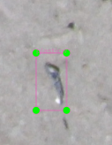

- Litter can be occluded,
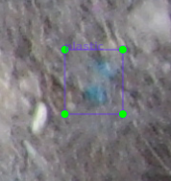
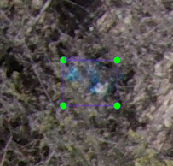

- There are different types of litter,
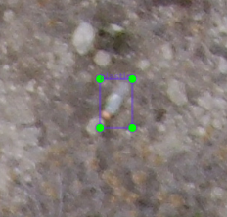
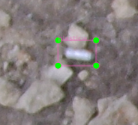
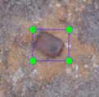
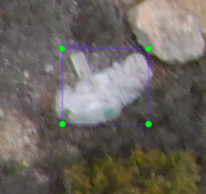

Plastic Bottles Aluminum Cans Rusted items Plastic Bags

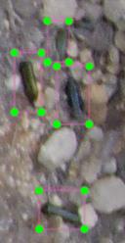
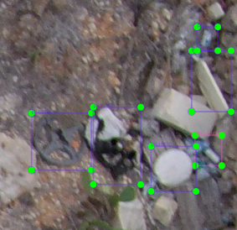
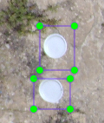
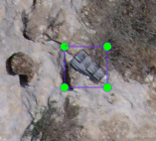

Glass Bottles General Litter Disposable Cutlery Paper
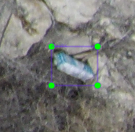
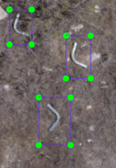

Cartons Pipes

Not to be considered litter :
- normal terrain,
- vegetation,
- roads,
- construction,
- cars,
- people ,
- signs,
- poles, and
- wood.
However litter on the items above should be tagged normally.

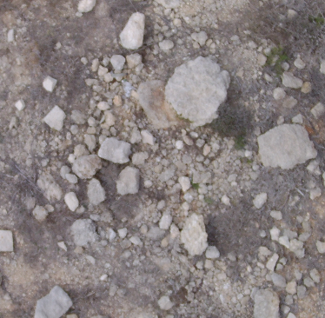
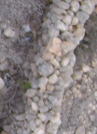
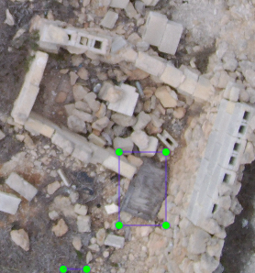
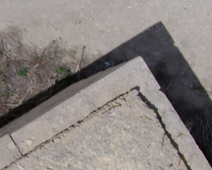

Stones Walls Rubble Construction

