**安装教程：**

<https://docs.openstack.org/newton/install-guide-ubuntu/overview.html>

**网络架构的设计：**

<https://docs.openstack.org/newton/install-guide-ubuntu/launch-instance-networks-provider.html>

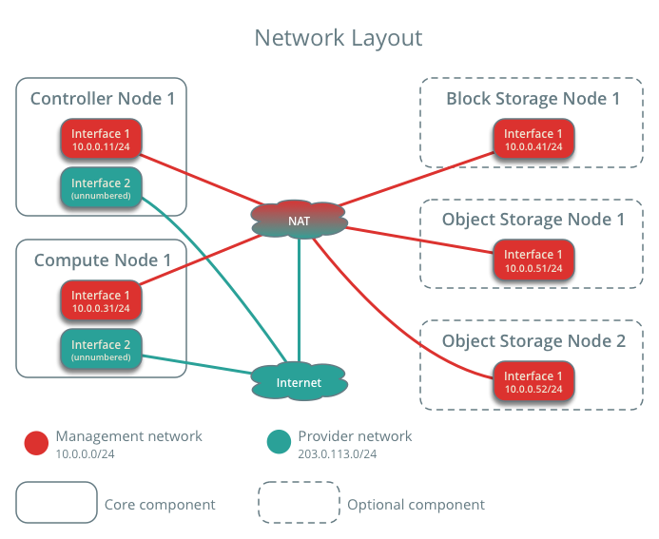

**虚拟机相关配置：**

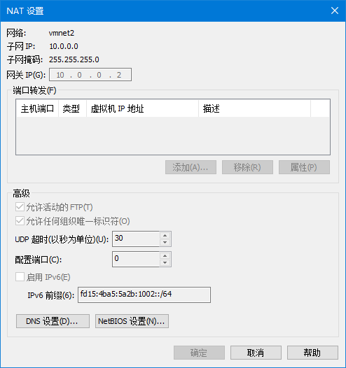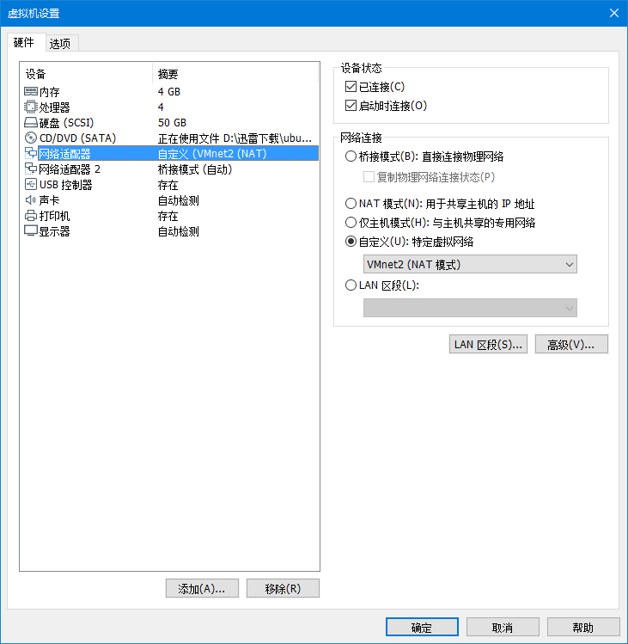

VMnet2：10.0.0.0/24 网关10.0.0.2

桥接模式作为Provider Network

**问题解决：**

**ubuntu-cloud源过于缓慢，使用宿主机代理进行提速**

**sudo** **apt-get** -o Acquire::http::proxy="http://10.0.0.1:1080/" update

**lvm动态分配导致根目录空间不够大**

<https://blog.moa.tw/2018/12/ubuntu-1804-root-lvm-volume.html>

容量

sudo lvresize -A n -l +100%FREE /dev/mapper/ubuntu--vg-ubuntu--lv

sudo resize2fs /dev/ubuntu-vg/ubuntu-lv

**重启后恢复服务：**

rabbitmqctl stop  
rabbitmq-server restart

service chrony restart

service mysql restart

service memcached restart

systemctl restart etcd

service apache2 restart

service glance-api restart

service nova-api restart

service nova-scheduler restart

service nova-conductor restart

service nova-novncproxy restart

service neutron-server restart

service openvswitch-switch restart

service neutron-openvswitch-agent restart

service neutron-dhcp-agent restart

service neutron-metadata-agent restart

service neutron-l3-agent restart

service nova-api restart

service cinder-scheduler restart

service nova-api restart

service apache2 restart

// service neutron-linuxbridge-agent restart

**计算节点恢复服务**

service nova-compute restart

service openvswitch-switch restart

service neutron* restart

**为cinder结点设立lvm卷以供使用：**

<https://www.aboutyun.com//forum.php/?mod=viewthread&tid=11681&extra=page%3D1&page=1&>

|  |
| --- |
| fdisk /dev/sdb1  #Type in the followings:  n  p  1  ENTER  ENTER  t  8e  w  #格式化分区  pvcreate /dev/sdb1  vgcreate cinder-volumes /dev/sdb1  #创建物理卷与逻辑卷 |

**设立swap分区**

<https://linux.cn/article-9579-1.html>

**lvreduce -L -1G /dev/ubuntu-vg/ubuntu-lv**

sudo lvcreate -L 3G -n swap1 ubuntu-vg

mkswap /dev/ubuntu-vg/swap1

/dev/sdb /swap swap defaults 0 0

/dev/mapper/ubuntu--vg-ubuntu—lv

**DVR路由网络的搭建**

<https://access.redhat.com/documentation/zh-cn/red_hat_enterprise_linux_openstack_platform/7/html/networking_guide/sec-dvr>

<https://docs.openstack.org/liberty/networking-guide/scenario-dvr-ovs.html>

<https://www.voidking.com/dev-ubuntu16-manual-openstack-openvswitch/>

[***https://zhuanlan.zhihu.com/p/25642405***](https://zhuanlan.zhihu.com/p/25642405)

<https://blog.51cto.com/99cloud/2286711>

https://www.ibm.com/developerworks/cn/cloud/library/1509_xuwei_dvr/index.html

手动选择结点

https://blog.csdn.net/hutiewei2008/article/details/86573504