When sigma is very small ( < 1), Harris keypoints are detected more than plenty meaning certain points along the edgels are also found as Harris keypoints when they only seem to be some random points along the region. When sigma gets larger, the algorithm does better at detecting the actual keypoints and the points themselves move a bit inward towards the center of the square as the Gaussian kernel gets larger.
A similar thing happens with SIFT, where bigger sigma doesn’t necessarily mean better detection but more “specific” detections, often too specific where the keypoints found with too large sigma are meaningless.

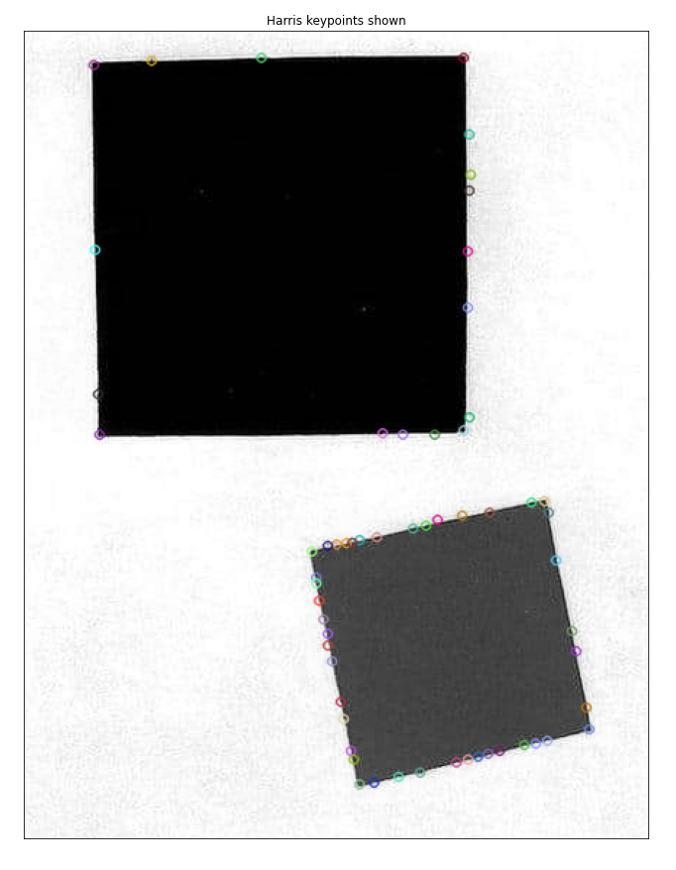
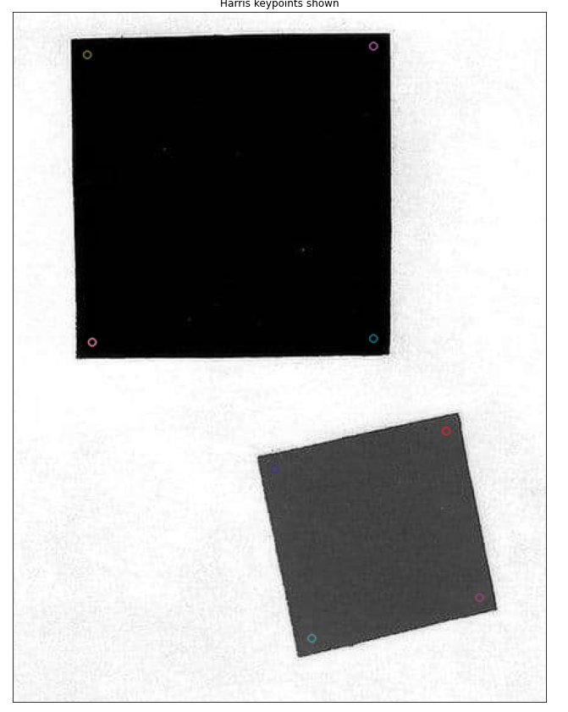

σ = 1 σ = 10

