Introduction

This is the QuickStart Guide to FRED (A Framework for Reconstructing Epidemiological
Dynamics), an open source agent-based modeling system developed by the University of
Pittsburgh Public Health Dynamics Laboratory in collaboration with the Pittsburgh
Supercomputing Center and the School of Computer Science at Carnegie Mellon University.
FRED supports research on the dynamics of infectious disease epidemics, and the interacting
effects of mitigation strategies, viral evolution, and personal health behavior. The system uses
agent-based modeling based on census-based synthetic populations that capture the
demographic and geographic distributions of the population, as well as detailed household,
school, and workplace social networks. Multiple circulating and evolving strains can be simulated.
Mitigation strategies in the framework include vaccination, anti-viral drugs, and school closure
policies. FRED supports models of health behavior change to facilitate the study of critical
personal health behaviors such as vaccine acceptance, personal hygiene and spontaneous social distancing. FRED is available through open source in the hopes of making large-scale agentbased epidemic models more useful to the policy-making community, the research community, and as a teaching tool for students in public health.

FRED Source Code

The repository hosting the source code to this version of FRED is located here: https://github.com/midas-isg/FRED

FRED Directory Structure

The following subdirectories are under $FRED_HOME:

bin/ : contains run-time scripts to manage FRED experiments. The FRED executable also gets
copied into here.

doc/ : FRED documentation files.

input_files/ : Contains the default parameters file params.default and example input files for
various features. These files should not be changed by the user. If you want to modify these
files, copy them to a new working directory and edit them as desired. Then add parameters to
your working params file to point to the new input files. See params.default for examples.

population/ : Contains synthetic population files for different regions.

src/ : Contains all of the sources files for FRED.

tests/: FRED regression tests.

Run‐time Parameters

The run-time parameters for FRED are contained in two parameter files. The first file is
$FRED_HOME/input_files/params.default and contains the default values of all defined runtime
parameters. This file should not be modified. The second file is usually called params
and contains any parameter values that override the default values. The params file may be
empty.

Both files have the same format. Lines that begin with a "#" character are considered comments
and are ignored. Parameters with scalar values are specified with lines of the form:
<name> = <value>

For example:
days = 100
diseases = 1
popfile = pop_Alleg.txt

Some parameters are vector valued, in which case the format is:
<name> = <size> v_1 v_2 ... v_size

For example:
# cdf of trip duration in days
travel_duration = 6 0 0.2 0.4 0.6 0.8 1.0

If a parameter appears more than once in a parameter file, the last setting takes precedence. If a
parameter appears in both params.default and params, the value in params overrides the value in params.default.

Running FRED

The FRED program takes an optional command line argument, the name of the run-time
parameters file:
% FRED parameter_file_name

If the argument is omitted the name “params” is assumed.

More information on the input and output files appears in the FRED User’s Guide. In addition, a
set of scripts is provided for managing the process of running a large number of simulations with
FRED. These scripts are illustrated below and are described fully in the User’s Guide Section
RUNTIME MANAGEMENTS SCRIPTS.

Simulation Information Management System

There are several options for running FRED. The FRED executable is copied to the $FRED/bin
directory after each make, so you can run FRED as follows from any working directory, assuming
that you have added $FRED_HOME/bin to your path:
% FRED [paramfile [run_number [directory]]]

The arguments are optional from right to left. If all three arguments are given, FRED uses the
given paramfile, runs a single replication with number "run_number", and writes output files to the
given directory. The output directory is relative to the current working directory.
If the third argument is omitted, the output directory is taken from the runtime parameter
"outdir", with default value OUT.

If both the second and third arguments are missing, run_number defaults to 1.

If all arguments are missing, paramfile defaults to "params".
Examples:
# run FRED on file params and write output files to ./OUT:
% FRED

# run FRED on file params.foo and write output files to ./OUT:
% FRED params.foo

# run FRED on file params with run number = 2
% FRED params 2

# run FRED on file params.foo

# with run number = 2 writing output files to ./OUT.foo:
% FRED params.foo 2 OUT.foo

Using the run_fred script for multiple realizations

The run_fred script is provided to perform multiple realizations (runs) in a local directory. Each
run uses a distinct seed for the random number generator, so the results will vary from run to run.
The format is:
% run_fred -p paramfile -d directory -s start_run -n end_run

The order of the arguments doesn't matter, and all arguments have default values:
-p "params"
-d ""
-s 1
-n 1

For example, the command:
% run_fred -p params -d FOO -s 1 -n 3

translates to a set of commands:
% FRED params 1 FOO > FOO/LOG1
% FRED params 2 FOO > FOO/LOG2
% FRED params 3 FOO > FOO/LOG3

after first creating directory FOO if necessary. The run_fred script also copies the params file into
the output directory, for future reference.

If -d is not specified on the command line, FRED writes output files to the output directory
specified in the outdir runtime parameters, which defaults to OUT. For example, if params does
not specify an output directory, then
% run_fred -n 3

translates to:
% FRED params 1 OUT > OUT/LOG1
% FRED params 2 OUT > OUT/LOG2
% FRED params 3 OUT > OUT/LOG3

The random seed for each run is set based on the both the seed value in the params file and on
the run number, so a collection of FRED runs can be executed in any order with the same results.

For example, you should get the same results in the output directory from
% run_fred -n 20

as from:
% run_fred -n 10
% run_fred -s 11 -n 20

FRED runtime management scripts

The $FRED_HOME/bin directory includes several commands to manage the process of running
FRED jobs. Commands exist for starting FRED jobs, reporting the status of those jobs, and
organizing and reporting the results files. The bin directory contains the following commands:

fred_job -- runs FRED and stores all associated data in a results database

fred_AR -- report on the attack rate of a simulation

fred_clear_all_results -- flush the results database

fred_delete -- delete a single job from the results database

fred_jobs -- show that status of all jobs in the results database

fred_plot -- display one or more curves

fred_status -- report the status of a single job

fred_sweep -- run a set of simulation changing the value of a variable

fred_tail -- show the tail of the current output file

get_distr -- show the distribution of infection locations

ch -- change a parameter value in a params file

p -- print out the current params file

rt -- run regression test

To use these commands, set the environmental variable $FRED_HOME to the location of your
FRED distribution. Then add $FRED_HOME/bin to your path. The following are most likely to be
the most useful commands when starting to use FRED. All commands are described in more
detail in the User’s Guide.

% fred_job [-p paramsfile | -k key]

Run FRED with the given parameter file in a working directory created in the
$FRED_HOME/RESULTS directory, and associate the working directory with the key. If the -p
option is omitted, the file "params" is assumed. If the -k option is omitted, an internally created
key is generated. In either case, a <key,id> pair is printed on standard output, where <id> is
the identifier of directory associated with the run (i.e. $FRED_HOME/RESULTS/JOB/<id>).
fred_job will terminate if the user supplied key has already been used. The script sets the
STATUS of the request (see fred_status below). When FRED finishes, fred_job runs stats
to collect data on the output variables in the outfile.

% fred_plot -k job_key [-k job_key …] -v var [-v var …]|-e|-f
fontsize|-x xmin|-X xmax|-y ymin|-Y ymax|--data|--norm

Create a plot of one or more of the indicated measures for the indicated job(s). The plot file (type
PNG) is stored in RESULTS under the run’s REPORT directory.

The order of options is ignored. Required options are:
-k job_key: Multiple jobs can be specified
-v variable: Multiple output variables can be specified

The following are optional:
-e: include errorbars on the plot
-f fontsize: Valid values are "small", "medium", "large" and "giant".
-x xmin -X xmax: Limit the range of the x-axis
-y ymin -Y ymax: Limit the range of the y-axis
--data: Prints the data for plotting the graph to standard output, in space delimited format:
day mean stdev
--norm: Normalize to counts per 100,000

% fred_jobs
Show that status of all jobs in the results database. The dates shown for FINISHED jobs reflect
the time that they finished.

% fred_status -k key [-s secs]
Print the status of the FRED run associated with the given key. If -s option is given, repeats
status report every secs seconds.

% ch param_name value [ paramfile ]
Edit the given paramfile (or “params” if no file is given) and add a line

param_name = value
First checks to see if the given param_name occurs in params.default.

% p
Print out the current params file.

% rt
Run regression test.

Tips for Creating FRED Working Directories

Users may find it convenient to create a new working directory when experimenting with FRED.
Assuming that you have created the environmental variables as described previously, FRED can
be executed in any directory. The only required file is params, which may be empty. For
convenience, you may want to copy the files in the directory $FRED_HOME/input_files to a
new FRED working directory:
% mkdir test
% cd test
% cp $FRED_HOME/input_files/params params.foo
<edit params.foo to includes the desired settings>
% fred_job –p params.foo –k test

Note also that some of the files provided in $FRED_HOME/input_files/ are specific to Allegheny
County, Pennsylvania, and may need to be revised for other locations. The location specific files
are:
• birth_rate.txt
• mortality_rate.txt
• seasonality_timestep

If you wish to modify any of the input files, copy them to your working directory and edit them, and
then set the appropriate parameters to tell FRED to use the new files. See examples of file
location parameters in params.default.

Tutorials

When running FRED from the command line, it is recommended that you use the scripts provided
in the directory $FRED_HOME/bin. These scripts will store all metadata associated with each job
in the FRED RESULTS database. This database is currently a directory-tree stored in the
directory $FRED_HOME/RESULTS.

It is recommended that you run FRED jobs in a working directory, for example
$FRED_HOME/work.

Tutorial A: Running a baseline epidemic for Allegheny County.

Here is a sample parameter file:
% cat params.baseline
days = 100

This will run FRED for 100 simulated days using the default influenza parameters for Allegheny
County. All runtime parameters not given in the parameter file will be given default values
specified in file params.default.

To execute FRED, use the command
% fred_job –p params.baseline –k baseline &

The –p argument is the parameter file and the –k argument gives a user-defined name for the job.

The run will run in the background.

You can check the status of the job using the fred_status command:
% fred_status –k baseline
RUNNING-00 Tue Nov 29 21:50:15 2011
% fred_status –k baseline
FINISHED Tue Nov 29 21:52:10 2011

The command fred_jobs shows the status of all jobs:
% fred_jobs
KEY = baseline JOB = 1 STATUS = FINISHED Thu Aug 4 14:28:23 2011
KEY = stay-0.2 JOB = 5 STATUS = FINISHED Wed Sep 21 14:52:57 2011
KEY = stay-0.25 JOB = 8 STATUS = FINISHED Wed Sep 21 15:22:14 2011
KEY = stay-0.3 JOB = 9 STATUS = FINISHED Wed Sep 21 15:46:36 2011
KEY = stay-0.35 JOB = 10 STATUS = FINISHED Wed Sep 21 16:10:50 2011

When the job is finished, you can display results. The variable(s) to be display are listed after the
–v flag.
% fred_plot –k baseline –v S –v E –v I –v R
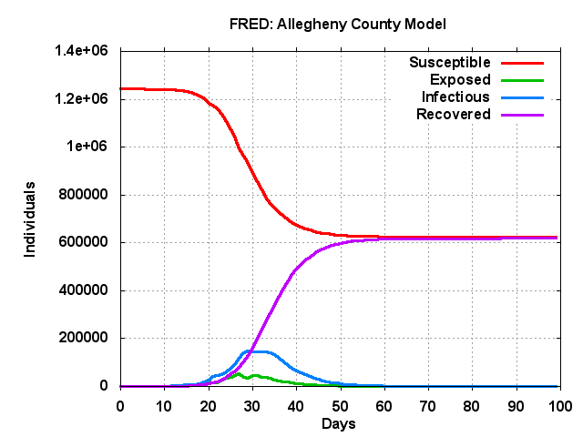

% fred_plot –k baseline –v AR
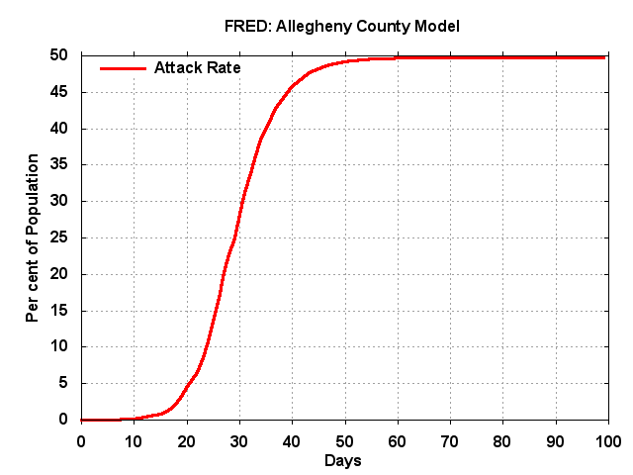

% fred_plot –k baseline –v RR
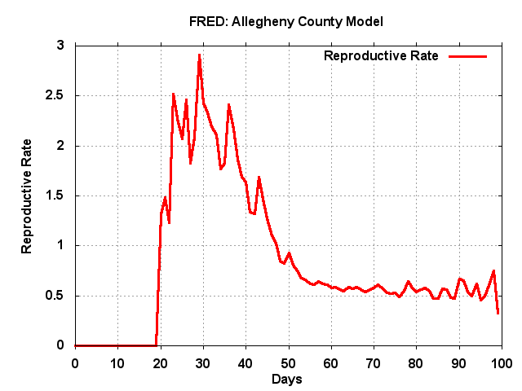

You can also get the data associated with a plot:
% fred_plot --data –k baseline –v AR
0 0.01 0
1 0.01 0
2 0.01 0
3 0.02 0
4 0.03 0
5 0.03 0
.
.
.
95 49.75 0
96 49.75 0
97 49.75 0
98 49.75 0
99 49.75 0

Tutorial B: Varying a behavioral parameter

As an example of varying the behavior of FRED agents, we will change the probability that agents stay home when sick. The default is that 50% of the agents stay home when sick. We will define two new parameter files:
% cat params.stay-40
days = 100
sick_day_prob = 0.4

% cat params.stay-60
days = 100
sick_day_prob = 0.6

The first file specifies that 40% of the agents will stay home when they have symptoms. The
second file says that 60% of the agents will stay home when sick.

Now run two more FRED jobs:
% fred_job –p params.stay-40 –k stay-40
% fred_job –p params.stay-60 –k stay-60

When the jobs are finished you can display the results:
% fred_plot –v AR –k stay-40 -k stay-60 -k baseline
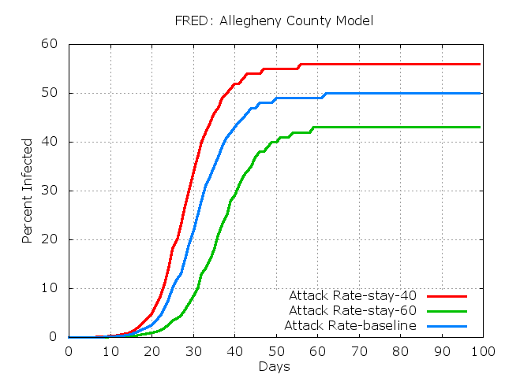

% fred_plot –v P –k stay-40 -k stay-60 -k baseline
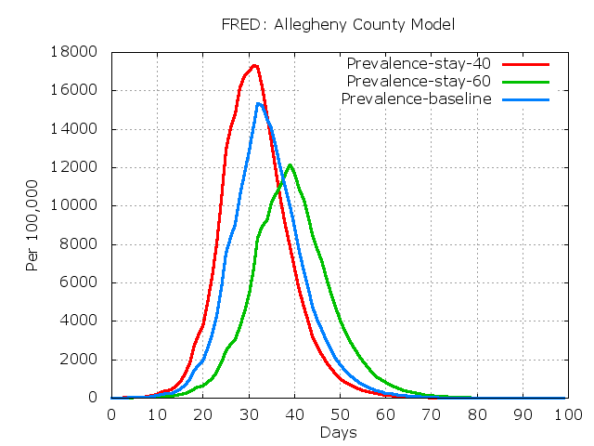

Further Exercises:

Explore combinations of FRED parameters by adding additional lines to the parameter files. See
the FRED Users Guide for discussions of FRED parameters.

