Tutorial A: Running a baseline epidemic for Allegheny County.

Here is a sample parameter file:
% cat params.baseline
days = 100

This will run FRED for 100 simulated days using the default influenza parameters for Allegheny
County. All runtime parameters not given in the parameter file will be given default values
specified in file params.default.

To execute FRED, use the command
% fred_job –p params.baseline –k baseline &

The –p argument is the parameter file and the –k argument gives a user-defined name for the job.

The run will run in the background.

You can check the status of the job using the fred_status command:
% fred_status –k baseline
RUNNING-00 Tue Nov 29 21:50:15 2011
% fred_status –k baseline
FINISHED Tue Nov 29 21:52:10 2011

The command fred_jobs shows the status of all jobs:
% fred_jobs
KEY = baseline JOB = 1 STATUS = FINISHED Thu Aug 4 14:28:23 2011
KEY = stay-0.2 JOB = 5 STATUS = FINISHED Wed Sep 21 14:52:57 2011
KEY = stay-0.25 JOB = 8 STATUS = FINISHED Wed Sep 21 15:22:14 2011
KEY = stay-0.3 JOB = 9 STATUS = FINISHED Wed Sep 21 15:46:36 2011
KEY = stay-0.35 JOB = 10 STATUS = FINISHED Wed Sep 21 16:10:50 2011

When the job is finished, you can display results. The variable(s) to be display are listed after the
–v flag.
% fred_plot –k baseline –v S –v E –v I –v R
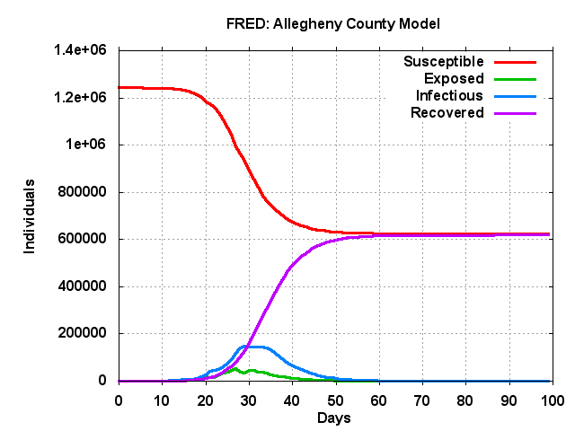

% fred_plot –k baseline –v AR
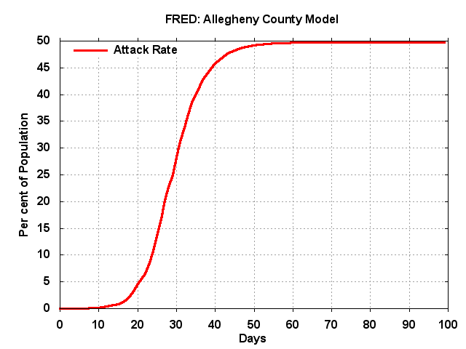

% fred_plot –k baseline –v RR
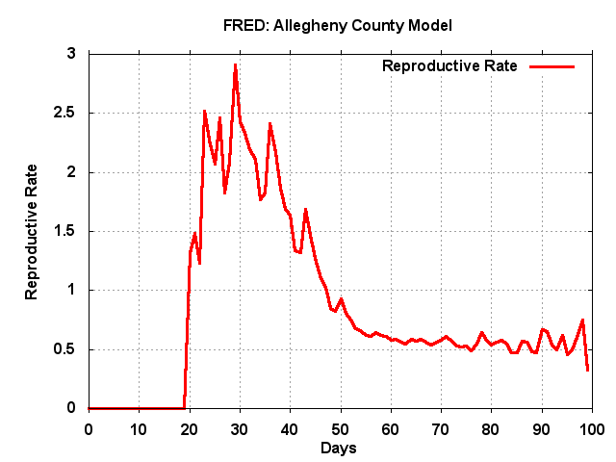

You can also get the data associated with a plot:
% fred_plot --data –k baseline –v AR
0 0.01 0
1 0.01 0
2 0.01 0
3 0.02 0
4 0.03 0
5 0.03 0
.
.
.
95 49.75 0
96 49.75 0
97 49.75 0
98 49.75 0
99 49.75 0

