Tutorial B: Varying a behavioral parameter

As an example of varying the behavior of FRED agents, we will change the probability that agents stay home when sick. The default is that 50% of the agents stay home when sick. We will define two new parameter files:
% cat params.stay-40
days = 100
sick_day_prob = 0.4

% cat params.stay-60
days = 100
sick_day_prob = 0.6

The first file specifies that 40% of the agents will stay home when they have symptoms. The
second file says that 60% of the agents will stay home when sick.

Now run two more FRED jobs:
% fred_job –p params.stay-40 –k stay-40
% fred_job –p params.stay-60 –k stay-60

When the jobs are finished you can display the results:
% fred_plot –v AR –k stay-40 -k stay-60 -k baseline
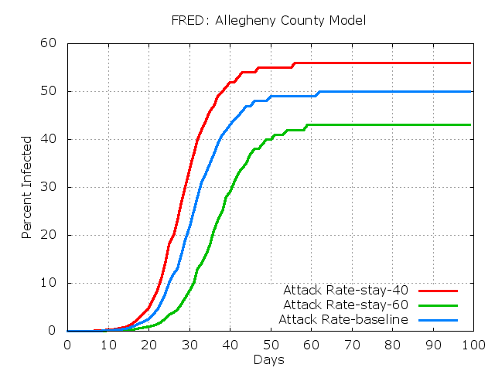

% fred_plot –v P –k stay-40 -k stay-60 -k baseline
