Reference: <https://www.terraform.io/docs/providers/aws/index.html>

**What is Terraform?**

Terraform is a tool made by Hashicorp for building, changing, and versioning infrastructure safely and efficiently. Terraform can manage existing and popular service providers ( aws, azure, Google cloud) as well as custom in-house solutions.

You can compare **Terraform** to **Cloudformation** . They are similar but at the same time have differences.

Use Vagrant file with any linux flavor you like for the terraform practice/ follow below steps to install terraform on your windows/desktop and execute the first terraform file to launch an ec2-instance.

Vagrant Setup:

1->To get started, go ahead and install these core tools:

* [VirtualBox](https://www.virtualbox.org/wiki/Downloads) (the software that creates virtual machines)
* [Vagrant](https://www.vagrantup.com/) (our hero, the software that deploys virtual machines and runs provisioning scripts) After installation “C:\HashiCorp\Vagrant\bin” gets added to the system path.
* [PuTTY and PuTTYGen](http://www.chiark.greenend.org.uk/~sgtatham/putty/download.html) (SSH client and a generator for security keys)

2->Create a project folder under which you want to create a test ubuntu environment ex: D:\Vagrant\Terraform

3-> Run below commands after cd D:\Vagrant\Terraform

vagrant init bento/ubuntu-16.04

vagrant up

vagrant status

vagrant stop to shutdown once you are done

vagrant destroy (to delete permanently)

Download the terraform binary file <https://www.terraform.io/downloads.html>

wget https://releases.hashicorp.com/terraform/0.11.11/terraform_0.11.11_linux_amd64.zip

If MAC users have homebrew installed on the machine: Just do: brew install terraform Go to step 5

1. Extract the zip file
2. You will see the terraform binary executable file
3. make sure that the terraform binary is available on the PATH.

For Mac/Linux. On the shell/terminal, go to the folder where terraform binary is extracted

echo $"export PATH=\$PATH:$(pwd)" >> ~/.bash_profile

source ~/.bash_profile

For Windows users : follow this to add Terraform to PATH <https://stackoverflow.com/questions/1618280/where-can-i-set-path-to-make-exe-on-windows>

1. make a new directory(can be named anything) and go inside the directory

mkdir terraform-practice && cd terraform-practice

1. Paste this following code to a file called ec2.tf ( can be anything.tf)

**minimal viable configuration**

First thing that terraform should know is which cloud provider libraries/supporting modules it should download (provider “aws” ‘”azurerm” “google”). To do this we use **terraform init**

provider "aws" {

access_key = "ACCESS_KEY_HERE"

secret_key = "SECRET_KEY_HERE"

region = "us-east-1"

}

resource "aws_instance" "example" {

ami = "ami-2757f631"

instance_type = "t2.micro"

}

**Note:**

Replace the access_key and secret_access with your AWS IAM user credentials with enough permissions attached. You can go to IAM console on AWS to do this. First, go to the IAM management console [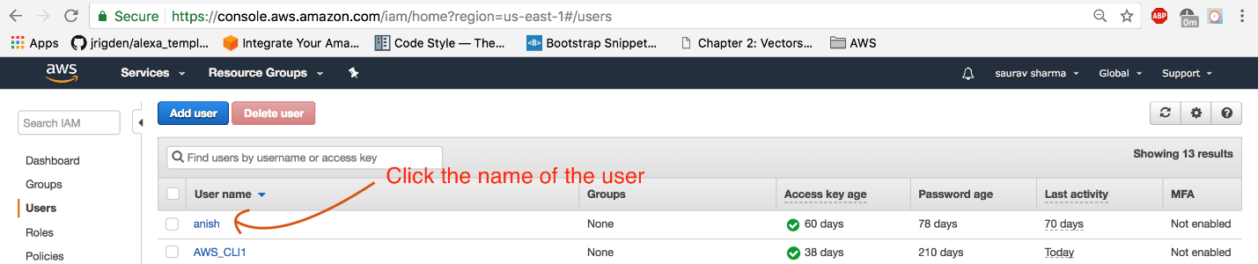](https://github.com/ravsau/aws-labs/blob/master/images/iam-console.png)

Then Click on the user's name and navigate to the security credentials tab. Click create access keys [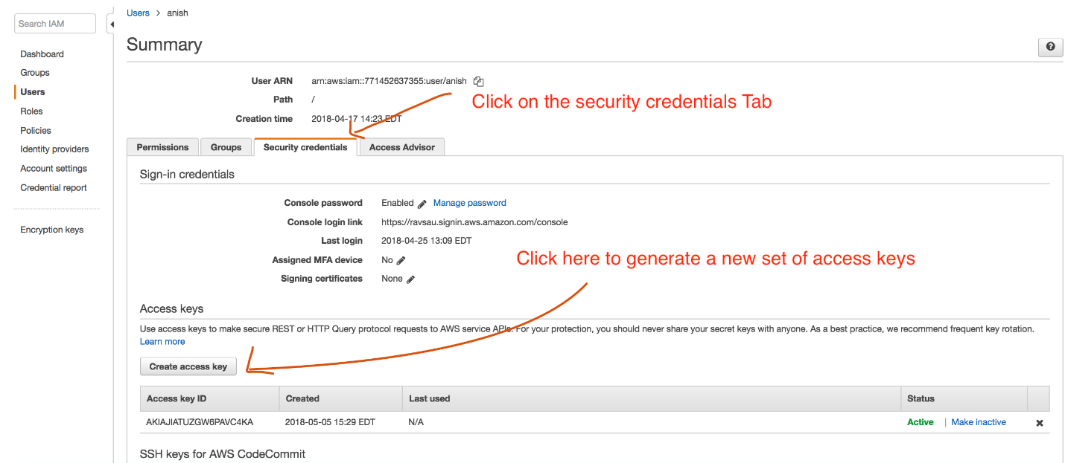](https://github.com/ravsau/aws-labs/blob/master/images/generate-access-keys.png)

Either download the csv file or, click show keys. Now you have both the access_key and secret_key required for the terraform code above. [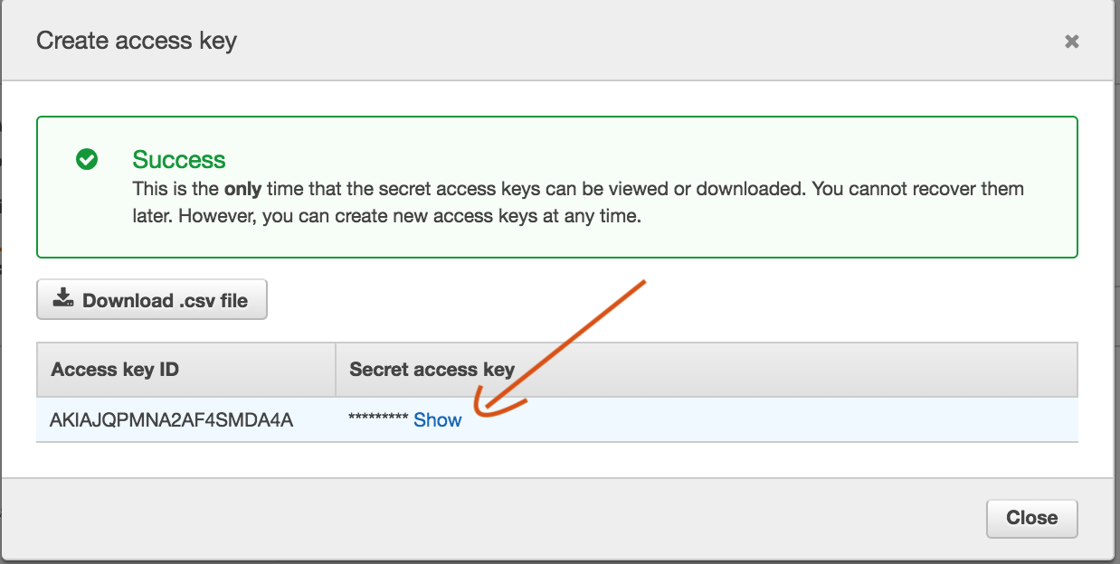](https://github.com/ravsau/aws-labs/blob/master/images/iam-generated-keys.png)

If you've setup the AWS CLI and have credentials stored , you may skip the credential portion. This is what Hashicorp says "If you simply leave out AWS credentials, Terraform will automatically search for saved API credentials (for example, in ~/.aws/credentials) or IAM instance profile credentials. This option is much cleaner for situations where tf files are checked into source control"

1. initialize the working directory for terraform

terraform init

"The terraform init command is used to initialize a working directory containing Terraform configuration files. This is the first command that should be run after writing a new Terraform configuration or cloning an existing one from version control. It is safe to run this command multiple times."

1. Provision the ec2 with this command

terraform apply

1. Login to the AWS management console and navigate to the EC2 management console. Check if an instance got provisioned
2. From your terminal/command prompt/ shell , destory the resources

terraform destroy

That's it! you installed Terraform and used it to provisioned an EC2 instance.