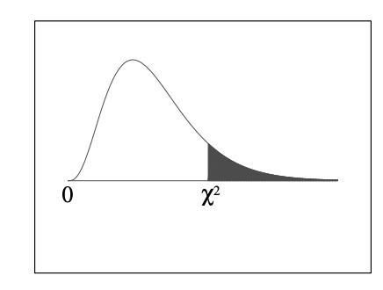
Chi-square table: quantiles
Column headers correspond to shaded area.

