Final Report in Marketing Research

“The importance of informal communication (word of mouth) in the process of purchase decisions concerning FMCG products among people under 21 years of age”

Group 1:
Anastasia Babkina 49752,
Bohatyrenko Mykola 49810,
Krzystof Ambrozko 49839,
Miras Bakhytzhan 50026,
Bogdanov Mykhailo 49809,
Kaja Blaszkiewicz 49963.

Table of Contents
Final Report in Marketing Research 1
Executive summary 3
Main part 4
Introduction 4
Methods of Research 6
A Qualitative approach using focus groups 6
Quantitative Approach: Online Survey 8
Results Summary 9
Limitations 10
Conclusions 10
Visualization of the Influence of Word-of-Mouth on FMCG Consumer Behavior 11
Pattern 1: High reliance on word-of-mouth in FMCG buying decisions 12
Pattern 2: Friends and family are the main sources of product recommendations 13
Pattern 3: Word-of-mouth matters more for personal and health-related FMCG 14
Pattern 4: Bad experiences increase dependence on recommendations 16
Summary of Key Patterns and Implications 17
Attachments 18

Executive summary
This research project examines the importance of informal communication, or word-of-mouth (WOM), in influencing the purchase decisions of individuals under 21 years of age regarding Fast-Moving Consumer Goods (FMCG). In a competitive market saturated with similar products, it is crucial to understand the nuances of consumer trust and recommendation channels for effective marketing strategies.
This study employed a mixed-methods approach to gather comprehensive insights. First, a review of existing academic literature helped establish a theoretical foundation, highlighting the recognized impact of WOM and electronic WOM on consumer behavior. Next, a qualitative phase was conducted, involving focus group discussions with 14 participants from the target demographic. These discussions explored personal experiences, sources of trust, and the emotional impact of recommendations. Next, a quantitative phase was conducted via an online survey, garnering responses from over 50 individuals. After cleaning the data and filtering it for age-appropriate participants, the survey data provided quantitative measures of reliance on word-of-mouth, trusted sources, product categories most affected by recommendations, and the impact of purchase regret.
Key findings indicate that young consumers rely heavily on WOM when making FMCG purchase decisions. Friends and family emerged as the most trusted sources of recommendations, significantly outweighing online influencers or general social media content in terms of perceived reliability. Word-of-mouth has a particularly strong influence on personal care, health-related products, and electronics, where the perceived risk or personal impact is higher. Furthermore, negative purchase experiences, often resulting from a lack of prior consultation, tend to increase future reliance on WOM, positioning it as a protective mechanism.
The study concludes that word-of-mouth advertising, driven by trust and authenticity, remains a central and powerful force in the purchasing journey of young consumers of fast-moving consumer goods. Traditional advertising often takes a backseat to genuine peer advice and experiences shared within trusted networks.
Recommendations stemming from this research encourage FMCG marketers targeting younger demographics to:
- Build real trust with your customers and make it easy for them to share their honest opinions.
- Use programs that encourage word-of-mouth advertising, such as referral bonuses to help happy customers spread positive reviews about your brand.
- Keep in mind that personal recommendations are especially important for certain products, such as skincare and electronics. Adjust the way you talk about these items to put customers at ease.
- Monitor online reviews and participate in customer discussions. Even negative reviews demonstrate why people value trusted advice when making purchases.

Main part

Introduction
In today's dynamic marketplace, people have tons of shopping choices, especially for things we use every day – often called Fast-Moving Consumer Goods (FMCG), like our morning coffee, shampoo, snacks, or cleaning supplies. With so many options, what really helps us decide what to buy? While eye-catching ads and well-known brand names have their place, it's usually the more personal, subtle influences that matter most. We buy these products often, and even if each one isn't expensive, the small things influencing these regular choices really add up. One of the strongest of these influences is "word-of-mouth" (WOM) – when people share information, advice, and opinions with each other, whether they're chatting in person, on the phone, or, more and more, online.
A big reason WOM works so well is that people trust it. Unlike regular ads, which many feel are just trying to sell something, advice from friends, family, or even trusted online groups usually feels more real and honest. This feeling of authenticity makes word-of-mouth a very powerful tool, especially when people don't have much time, don't feel like, or maybe don't know enough to do a lot of research on their own. For FMCG products, which we buy often and usually don't spend a lot of time thinking about, WOM can be a quick and dependable way to make a good choice.
Our study looks at how important these informal chats are when young people under 21 make decisions about buying FMCG products. We started by thinking about some key problems businesses face. For example, how can companies best connect with young people who are often wary of normal advertising and really count on what their peers say? How much does trust matter when they choose everyday items, and how is this trust created and used through these informal talks? Thinking about these points helped us create the specific research questions for our study. We then focused on the main topic – the impact of WOM – breaking it down into smaller parts to plan our investigation.
An important first step was to look at what experts and other researchers had already written. By studying what was already known about word-of-mouth, its different types (like online WOM or eWOM), and how it affects FMCG shopping, we got a good starting point. This initial work helped us find existing ideas and key information, which then helped us design our own research and make sure our study added to what was already out there, instead of just repeating it.
After this groundwork, we started our own research, using a mix of methods to get a deep and broad understanding. For the qualitative part, we held focus group discussion with 14 young people, mostly under 21. Our moderator made sure these talks were relaxed and open, so everyone felt comfortable sharing their real experiences. These chats gave us a lot of insight into how much young consumers, like students or those living on their own for the first time, depend on advice from friends, family, and even online creators they see as genuine. People talked about how much they value personal advice, particularly for things like skincare, makeup, and snacks, because it feels more real. They also mentioned asking for more advice on products that affect their health or looks, and how WOM often feels like a "safety net" to help them avoid bad buys.
Using these rich stories and insights, we then created an online survey. This part of our research was to see if the patterns we saw in the small groups were also true for a larger number of young people. We thought carefully about what we wanted to find out, who we needed to ask, and how to make our questions clear. The information we gathered from the survey, and how we analyzed it (which we'll explain in the "Methods of Research" section), was all about getting a clearer, number-backed picture of how trust and these informal conversations influence what young people buy in the FMCG world. In this report, we aim to clearly show the main steps of our research, what we discovered, and what we think it all means.

Methods of Research
To truly understand how informal conversations shape our everyday shopping choices for FMCG products, we decided a multi-faceted approach was necessary. Therefore, this study utilized a mixed-methods research design. This means we combined both qualitative (exploring 'why' and 'how') and quantitative (measuring 'how much' and 'how often') techniques. By integrating these two approaches, we aimed to gain a fuller, more comprehensive picture of word-of-mouth's influence on the purchase decisions of consumers under 21 years of age. This combination allowed us to not only identify patterns but also to understand the stories and motivations behind them.

Qualitative approach using focus groups
Our first step in gathering primary data involved a qualitative approach through focus group discussions. We chose this method because focus groups are excellent for uncovering a wide range of opinions, experiences, and the underlying reasons for certain behaviors in a dynamic, interactive setting. The goal was to hear directly from our target demographic in their own words.

Participants and Setting
We organized and conducted discussion with a total of 14 young individuals. While participants came from varied backgrounds and had different shopping styles, the majority were under the age of 21, aligning with our study's focus. To ensure open and honest dialogue, we steered clear of formal interview structures. Instead, we cultivated a relaxed, conversational atmosphere where participants felt comfortable sharing their real-life experiences and opinions without feeling like they were being formally questioned or judged.
While the conversations were fluid, they were guided by a semi-structured discussion guide (a transcript of which can be found in the Attachments section). This guide included open-ended questions and prompts designed to encourage participants to reflect on their actual shopping moments and the role of recommendations. Key questions included:
- "Can you tell us about a time a recommendation from someone led you to try a completely new product?"
- "When you're in a store unsure about which product to choose, who is the first person you'd typically ask for advice?"
- "Are you someone who actively seeks out opinions before buying, or do you usually just decide on the spot?"
Gathered Insights
The real value of these sessions emerged as participants began sharing their personal stories. We heard about the excitement of discovering a great new product thanks to a friend's suggestion, the frustration of ignoring a warning and later regretting a purchase, and those familiar moments of standing in a supermarket aisle, texting friends for quick advice. These weren't just data points; they were rich narratives that shed light on the emotions, trust factors, and thought processes that truly drive the shopping decisions of young consumers. The focus groups provided invaluable context and depth that numbers alone often cannot convey.
Data Analysis
The discussions were carefully documented (transcribed or thoroughly noted), and a thematic analysis approach was subsequently applied. This involved identifying recurring themes, key opinions, and significant patterns in the participants' responses to understand the core aspects of WOM influence.

Quantitative Approach: Online Survey
For our research we also used Google Forms questionnaire which was sent to participants of the survey online. Forms included closed and open-ended questions and was designed to measure:
    - Frequency of which people buy FMCG products
    - Are they consulting their purchases with anybody?
    - Which source of information they trust the most? (friends, family, online reviews, influencers etc.)
    - Did they experience regret after buying due to lack of advice?
    - Whether those regrets influenced their future behavior
To gather as many information and in various ways, in our questionnaire we included:
- Multiple choice questions (e.g. Who do you consult most often before buying an FMCG product?)
- Open-ended questions (e.g. Describe a time you regretted not asking for advice before buying something.)
- Likert scale ratings (e.g. How much do you rely on recommendations when shopping? from 1 to 10)

Data Collection and Cleaning
The survey was distributed online to reach participants within our target demographic. Once the data collection period ended, all responses were compiled into an Excel spreadsheet for analysis. An important step was data cleaning; we carefully reviewed the collected data to identify and remove any invalid, incomplete, or clearly nonsensical entries. This process ensured that our dataset was consistent and meaningful, leading to more reliable findings.
Ethical Considerations
Throughout both the qualitative and quantitative phases, we adhered to ethical research practices. Participation was entirely voluntary, and individuals were informed that they could withdraw at any time without penalty. Anonymity and confidentiality of responses were assured to all participants, with data being used solely for the purposes of this academic research.
By combining these qualitative and quantitative methods, we aimed to create a robust and well-rounded understanding of the subject. The focus groups provided the "why" – the deeper, personal context and motivations – while the survey offered the "how much" – measurable data and trends from a wider group of young consumers. This dual approach allowed us to triangulate our findings, enhancing the overall validity and richness of our research.

Results Summary
The data which we have collected from our survey gave us insights into the role of informal communication when buying fast-moving consumer goods. Here are some key takeaways we managed to gather:
- High reliance on opinions of others': More than 80% of participants answered that they rely on opinions of other people such as friends, family and online reviews when making decisions about FMCG purchases. We can conduct from this that even when buying everyday, relatively low-cost items people often seek reassurance or confirmations from others.
- Moderate influence of word-of-mouth: When asked to rate on scale from 1 to 10, how much participants rely on recommendations, the participant's average score was 5.4. It shows that while not being the dominant force when buying FMCG products, word-of-mouth still plays an important role in shaping buying behavior. Also it shows us that consumers do not rely entirely or solely on personal preferences.
- The most trusted source of recommendation: Our participants identified that friends and family are their most trusted source of informal communication. It shows a strong preference for close relationships when seeking product advice. The second most chosen option was online reviews. The trust in friends and family stems from belief that these individuals offer honest, experience based feedback contrary to not always honest opinions which we can find on the internet.
- Regret from not seeking advice: It is interesting that more than 70% of participants reported that they had regretted purchasing a product because they didn't ask or they didn't check opinions about the product. This highlights a consequence of neglecting informal communication. Consumers often look back on those experiences as missed opportunities to make better decisions.

Limitations
Although the findings are significant and offer a solid basis for comprehending how informal communication affects FMCG purchasing behavior, it is important to recognize a number of limitations:
- Incomplete, inconsistent, or obviously nonserious survey responses were common (e.g., open-ended responses loaded with irrelevant content). We eliminated these items using a simple data cleaning procedure, but it's likely that a few minor discrepancies persisted, which could compromise the accuracy of the findings as a whole.
- Restricted sample size and diversity: A comparatively small and potentially homogeneous group was the target of the survey. Consequently, there was little diversity in the population. Since different age groups, ethnic backgrounds, or income levels may display different shopping patterns or attitudes toward word-of-mouth, this could have an impact on the findings' generalizability.
- There might have been situations when group dynamics in focus group might have influenced how openly people shared their views.

Conclusions
The research employed a comprehensive methodology beginning with the identification of three potential Management Decision Problems and corresponding Marketing Research Problems. Following careful evaluation, we selected one for in-depth investigation and conducted a literature review to establish theoretical foundations. A focus group provided additional insights that informed our survey design and approach.
The structured survey targeted specific respondent groups through a carefully crafted questionnaire designed for clarity and relevance to our research objectives. Data collection yielded sufficient responses for meaningful analysis, with raw data cleaned, structured, and coded using a detailed codebook. Social Network Analysis (SNA) further revealed clustering patterns in trust-based communication and highlighted the significance of peer networks in purchase behavior.
Summarizing, our research confirmed that informal communication, both in person and digital, plays an important role in shaping consumer choices. We got confirmation that consumers from really diverse backgrounds value social proof over traditional advertising, even more when the recommendations come from people they trust. The word of mouth remains a consistent and meaningful factor in the decision making process. The core factor appears to be trust. Consumers are more likely to act on information from sources they consider honest and relatable. This doesn't apply only to close contacts but also to anonymous reviews on the internet provided they are perceived as authentic.

Visualization of the Influence of Word-of-Mouth on FMCG Consumer Behavior

This section explores how informal communication, particularly word-of-mouth, influences consumer behavior in the context of Fast-Moving Consumer Goods. Drawing on the results of a targeted survey, several key patterns were identified that demonstrate the significant role of interpersonal recommendations in shaping purchase decisions. These insights have implications for both consumer psychology and marketing strategy.
To deepen our understanding of these behavioral dependencies, we also conducted a Social Network Analysis (SNA). This method was used to visualize and analyze the relationships between consumers, recommendation sources, and product categories. The resulting network diagrams helped uncover the strength and structure of informal communication channels, highlighting how information flows within consumer networks and which nodes (sources or product types) are most influential in shaping decisions.

Pattern 1: High reliance on word-of-mouth in FMCG buying decisions
Respondents were asked to rate, on a scale of 1 to 10, how much they rely on recommendations from others (friends, family, etc.) when buying FMCG products. The results show that most people gave scores between 7 and 9, with only a small number rating below 4. This clearly indicates that informal recommendations play a major role in shaping consumer behavior.
Why this is important:
Such strong reliance on others shows that people often do not make decisions based solely on advertisements or their own research. Trust and familiarity are crucial. For marketers, this emphasizes the value of creating products and experiences that are easy to recommend.
What it can lead to:
If companies focus on building brand trust and encourage users to share honest opinions, this could significantly boost product adoption through natural word-of-mouth.
Visualization:
This histogram shows how frequently respondents rely on recommendations when making FMCG purchases, using a scale from 1 (never) to 10 (always). The majority of responses fall between 6 and 10, indicating a generally high level of trust in personal recommendations.

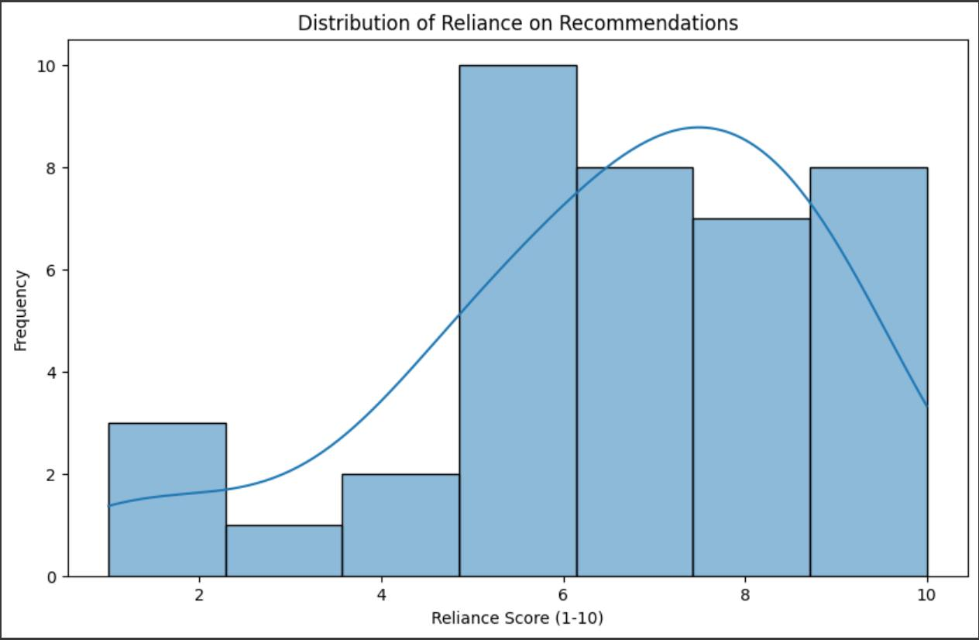

Pattern 2: Friends and family are the main sources of product recommendations
When asked who they typically ask for product advice, the vast majority of participants mentioned friends (35) and family (31). In contrast, online reviews (15), social media (14), and influencers (9) were mentioned far less.
Why this is important:
Despite the rise of digital platforms, people still trust real-life relationships more than internet strangers or paid promoters. This suggests that face-to-face conversations remain a dominant force in FMCG product influence.
What it can lead to:
Brands should consider encouraging referrals, creating user communities, and engaging with micro-advocates who share sincere opinions without being seen as commercial.
Visualization:
A bar chart comparing sources of recommendations confirms that friends and family significantly outweigh digital influencers, emphasizing the importance of personal trust over online popularity.

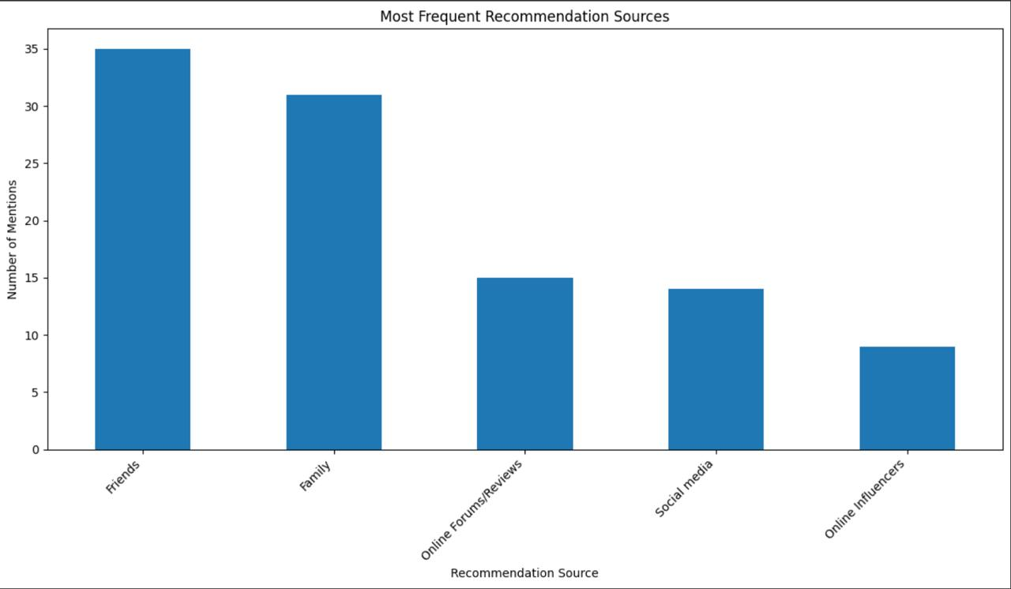

Pattern 3: Word-of-mouth matters more for personal and health-related FMCG
From both survey and focus group data, we noticed that people rely more on recommendations for products like:
      - Skincare and cosmetics
      - Vitamins and supplements
      - Hygiene products
Conversely, food and beverage choices were more often based on personal habits and taste preferences.
Why this is important:
This distinction helps marketers know where word-of-mouth matters most. Personal care and health-related categories carry higher risk for consumers — they want reassurance before buying.
What it can lead to:
Companies in these categories should focus more on testimonials, real-user stories, and social proof to reduce purchase anxiety.
Visualization:
A bar chart illustrates which product types are most affected by WOM influence, with personal care items clearly leading.

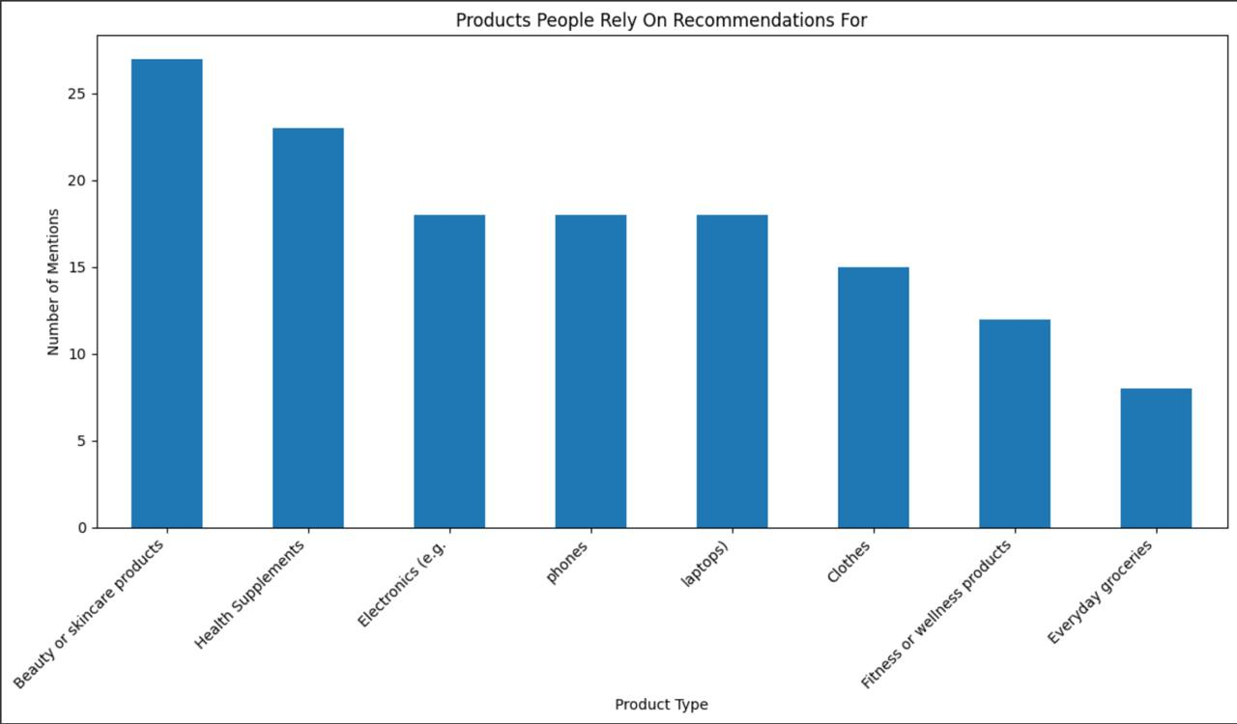

Pattern 4: Bad experiences increase dependence on recommendations
Participants who regretted purchases without asking others first reported changing their future behavior — “I now ask friends or family for advice before buying” was a common follow-up. This shows a learning effect based on past mistakes.
Why this is important:
People don’t want to repeat bad experiences. Word-of-mouth becomes a kind of protection mechanism. Even one bad purchase can push consumers to rely more on others.
What it can lead to:
Brands need to monitor negative feedback closely and encourage satisfied customers to share positive opinions, so their message isn’t lost to bad experiences.
Visualization:
A pie chart reveals that 64% of respondents now read online reviews more often, 24% seek advice from close contacts, and only 12% made no change — confirming a clear shift in behavior due to prior regret.
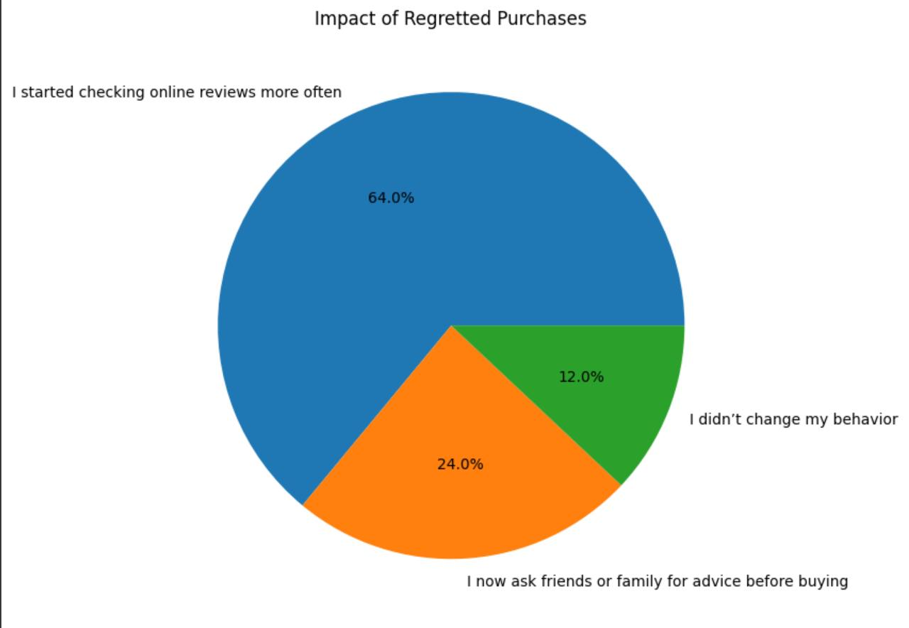

Summary of Key Patterns and Implications
The detailed exploration of word-of-mouth influence through the identified patterns provides a clearer understanding of its significant role in shaping the FMCG purchase decisions of consumers under 21. Several core insights emerge from this analysis:
1) The foundational finding is the profound reliance young consumers place on personal recommendations, particularly from friends and family (as illustrated in Pattern 1 and Pattern 2). These close relationships are overwhelmingly seen as the most trustworthy sources, highlighting that for this demographic, authenticity and personal connection often outweigh other forms of marketing influence when choosing everyday goods.
2) Furthermore, the impact of WOM is not uniform across all FMCG categories. Our analysis reveals that its influence is notably stronger for products perceived as having higher personal relevance or risk, such as personal care and health-related items (Pattern 3). This suggests that while routine purchases might be driven by habit, decisions concerning well-being or appearance prompt a greater need for trusted advice.
3) A critical behavioral insight is how negative purchasing experiences act as a catalyst, significantly increasing future dependence on WOM (Pattern 4). Young consumers demonstrate a clear learning curve, turning to peer advice as a protective mechanism to avoid repeating past disappointments. This underscores the lasting impact of a single bad purchase and the proactive role WOM plays in risk mitigation.
Collectively, these patterns paint a picture of a young consumer who is discerning, values genuine opinions over overt advertising, and actively uses informal communication networks to navigate their FMCG choices. For marketers, these insights are pivotal. Strategies that genuinely build user trust, encourage organic sharing of experiences, and leverage authentic peer-to-peer endorsements are likely to be far more effective in engaging this audience than traditional marketing approaches alone. Investing in creating positive product experiences that naturally generate positive word-of-mouth is not just beneficial, but essential for brands aiming to connect meaningfully with today's youth.

Attachments

        - Questioner
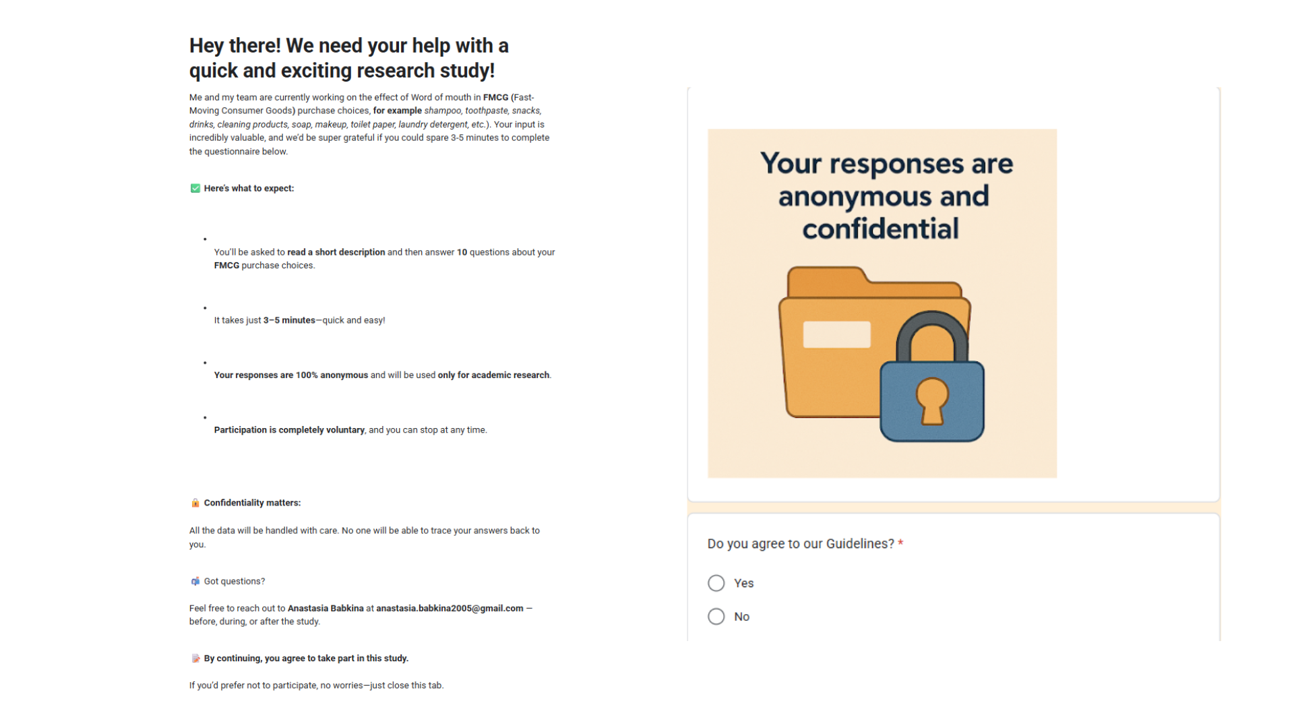
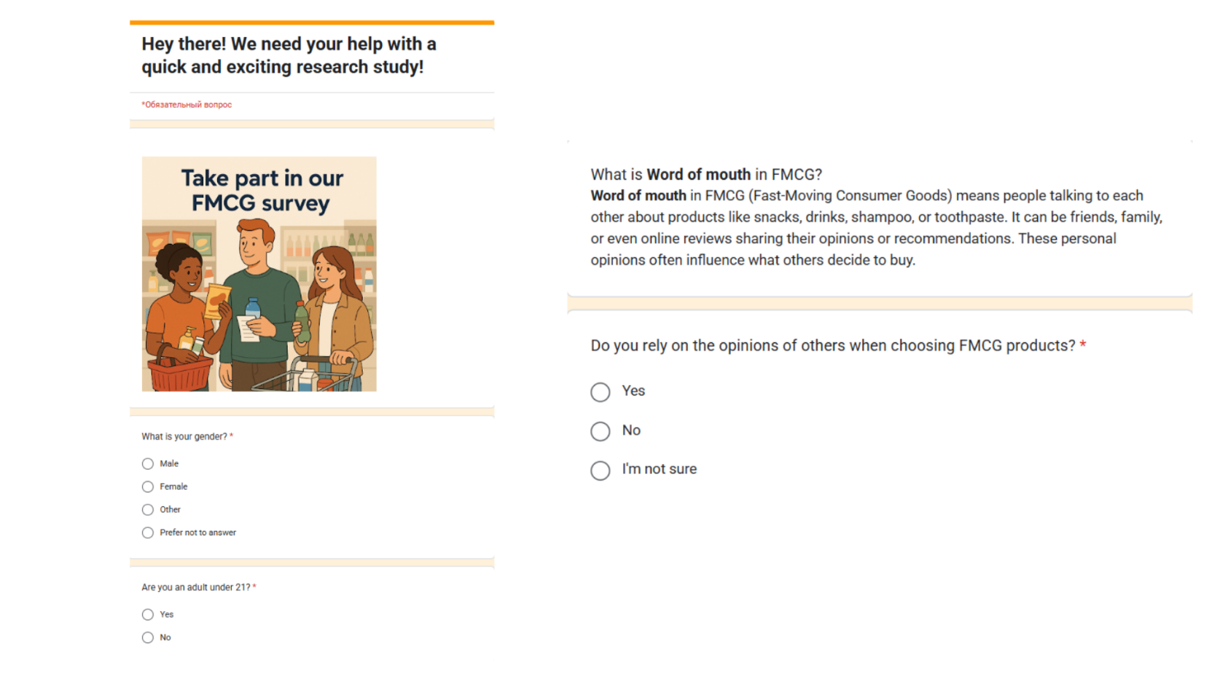
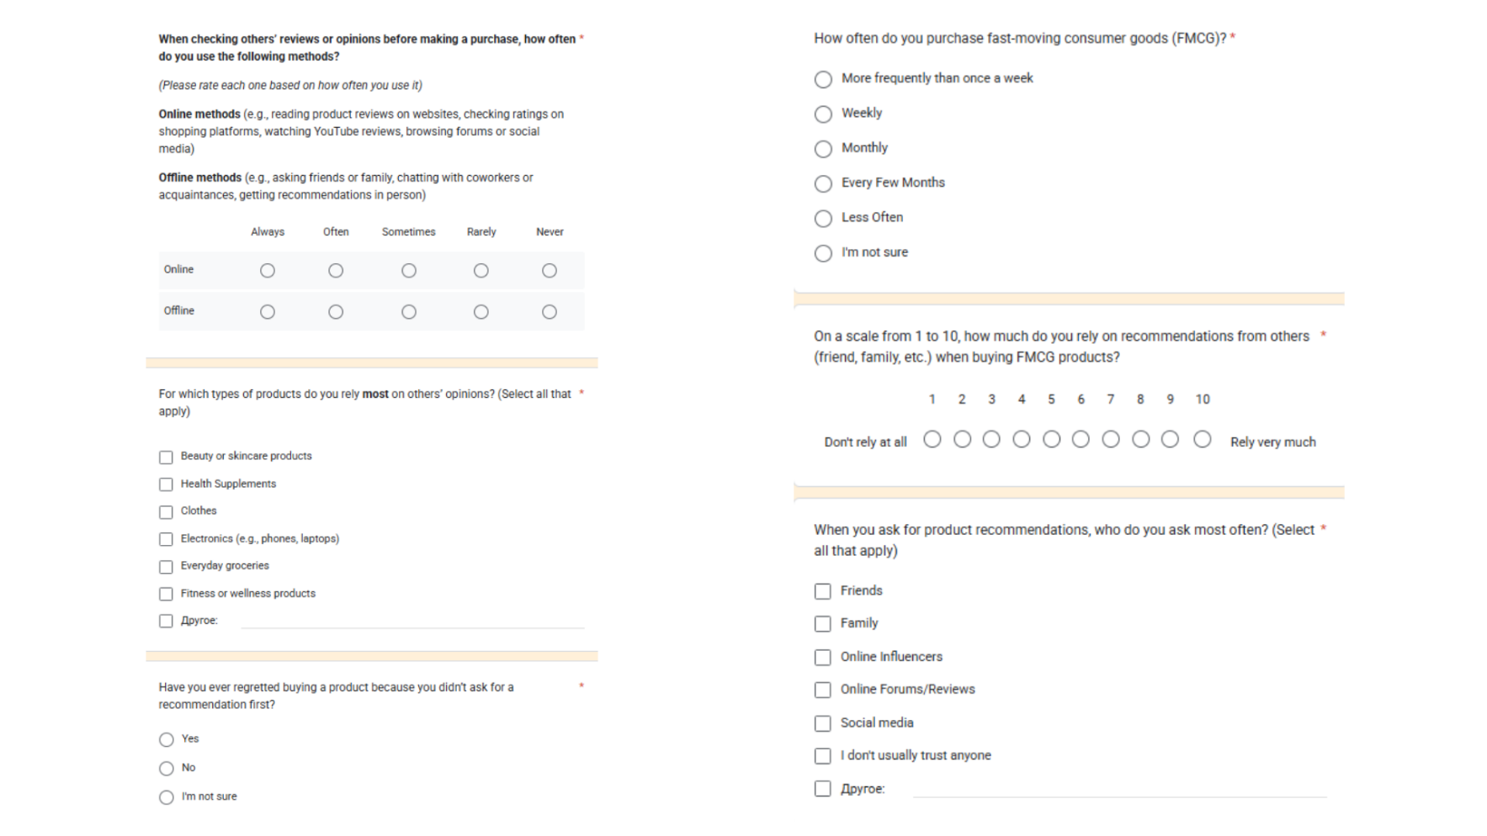

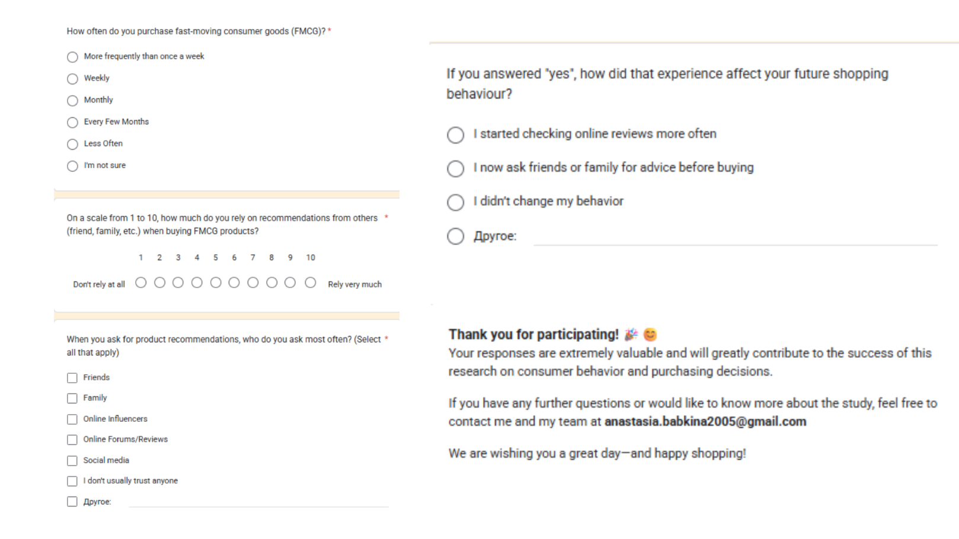
        - Sorted and completed Codebook and Coded Data in Excel Format
Marketing-Answers_sorted (1).xlsx
        - Transcript for the Focus Group Meeting
Transcriptioin_Marketing (1).docx
        - Bibliography
- "Seeding as Part of the Marketing Mix: Word-of-Mouth Program Interactions for Fast-Moving Consumer Goods"
Authors: Florian Dost, Ulrike Phieler, Michael Haenlein, and Barak Libai
Published in: Journal of Marketing, March 2019
Link: https://journals.sagepub.com/doi/10.1177/0022242918817000

- "The Influence of Social Media eWOM Information on Purchase Intention of New Flavored Bubble Tea"
Authors: Hsin-Hsuan Meg Lee and Yu-Kai Huang
Published in: Frontiers in Psychology, August 2021
Link: https://pmc.ncbi.nlm.nih.gov/articles/PMC8379055/

- "Influence of Word of Mouth on Consumer Buying Decision: Evidence from Bangladesh Market"
Authors: Md. Rashedul Hasan, Md. Mahbubur Rahman, and Md. Nazmul Hasan
Published in: International Journal of Business and Management Invention, May 2017
Link: https://www.researchgate.net/publication/317041087_Influence_of_Word_of_Mouth_on_Consumer_Buying_Decision_Evidence_from_Bangladesh_Market

- "Product Usage and Firm-Generated Word of Mouth: Some Results from FMCG Product Trials"
Authors: Renana Peres and Barak Libai
Published in: International Journal of Research in Marketing, September 2010
Link: https://www.researchgate.net/publication/46016009_Product_Usage_and_Firm-Generated_Word_of_Mouth_Some_Results_from_FMCG_Product_Trials

- "Effect of Word-of-Mouth Communication and Consumers’ Purchase Decisions for Remanufactured Products: An Exploratory Study"
Authors: Chia-Hsing Huang, Chien-Hung Liu, and Ching-Chow Yang
Published in: Sustainability, May 2022
Link: https://www.mdpi.com/2071-1050/14/10/5963
- "Impact of Word of Mouth Communication on Consumer Purchase Decision: A Study on Television Brands"
Authors: Anshu Rani and Anil Kumar
Published in: Journal of Business Thought, 2021
Link: https://www.informaticsjournals.co.in/index.php/jbt/article/view/30023/21341

