1、委托例子：
1 using System; 2 using System.Collections.Generic; 3 using System.Linq; 4 using System.Web; 5 using System.Web.UI; 6 using System.Web.UI.WebControls; 7 8 namespace WebApplication1 9 {10 public partial class WebForm1 : System.Web.UI.Page11 {12 protected void Page_Load(object sender, EventArgs e)13 {14 15 }16 17 protected void Button1_Click(object sender, EventArgs e)18 {19 UserInfo userinfo = new UserInfo();20 userinfo.Email = "kerry@advancehk.com";21 userinfo.RegTime = DateTime.Now;22 userinfo.UserName = "kerry";23 userinfo.UserPass = "123456";24 //这个book_shop3Entities 是在Model1.edmx中的Model1.Context.cs25 book_shop3Entities db = new book_shop3Entities();26 db.UserInfo.Add(userinfo);//将数据添加到EF并且添加了标记27 db.SaveChanges();28 29 }30 }31 }
2、实体框架（Entity Framework）:
简称：EF NH
与ASP.Net MVC 关系与ADO.NET关系
ADO.NET Entity Framework是微软以ADO.NET为基础所发展出来的对象关系对应（D/R Mapping）解决方案。
实体框架Entity Framework是ADO.NET中的一组支持开发面向数据的软件应用程序的技术，是微软的一个ORM（Object Releations Mapping）框架。
3、怎么建立：
1）、新建项--数据--ADO.NET 实体数据模型
2）、设置完成后要导入命名空间：EntityFramework（dll文件的路径：C:\Users\mike.mike-PC\Desktop\Code\EFmodel\packages\EntityFramework.6.2.0\lib\net45）、System.Data.Enity
上面额操作完成之后就会多了一个文件夹packages
4、引用dll文件的时候，右键单击引用，点击管理NuGut程序包。
5、添加数据：（在aspx添加一个按钮）
1 protected void Button1_Click(object sender, EventArgs e) 2 { 3 UserInfo userinfo = new UserInfo(); 4 userinfo.Email = "kerry@advancehk.com"; 5 userinfo.RegTime = DateTime.Now; 6 userinfo.UserName = "kerry"; 7 userinfo.UserPass = "123456"; 8 //这个book_shop3Entities 是在Model1.edmx中的Model1.Context.cs 9 book_shop3Entities db = new book_shop3Entities();10 db.UserInfo.Add(userinfo);//将数据添加到EF并且添加了标记11 db.SaveChanges();//只有执行这段语句的时候，才能够执行12 }
6、插入这条语句之后想要拿这条语句的主键ID
1）第一种方式：
Insert into 表名 (数据字段名) output
inserted.ID values(字段值)
2）第二种方式：（用EF）
1 protected void Button1_Click(object sender, EventArgs e) 2 { 3 UserInfo userinfo = new UserInfo(); 4 userinfo.Email = "kerry@advancehk.com"; 5 userinfo.RegTime = DateTime.Now; 6 userinfo.UserName = "kerry"; 7 userinfo.UserPass = "123456"; 8 //这个book_shop3Entities 是在Model1.edmx中的Model1.Context.cs 9 book_shop3Entities db = new book_shop3Entities();10 db.UserInfo.Add(userinfo);//将数据添加到EF并且添加了标记11 db.SaveChanges();//只有执行这段语句的时候，才能够执行12 Response.Write(userinfo.ID);13 }
7、在EF中的实体数据类型（EDM）由以下三种模型和具有相应的文件扩展的映射文件进行定义。
1）概念架构定义语言文件（.csdl）--定义概念模型
2）存储架构定义语言文件（.ssdl）--定义存储模型
3）映射规范语言文件（.nsl）--定义存储模型与概念模型之间的映射M。
8、用EF进行查询：
1 protected void Button2_Click(object sender, EventArgs e) 2 { 3 book_shop3Entities db = new book_shop3Entities(); 4 //Ling表达式 5 var userinfolist = from u in db.UserInfo 6 where u.ID == 94 7 select u; 8 foreach (var userinfo in userinfolist) 9 {10 Response.Write(userinfo.UserName);11 }12 }
9、EF里面有个延迟加载机制0：当数据用到的时候才会去数据库查询，不用的时候是不用查询的。
10、用EF进行删除数据：
1 protected void Button3_Click(object sender, EventArgs e) 2 { 3 book_shop3Entities db = new book_shop3Entities(); 4 var userinfolist = from u in db.UserInfo 5 where u.ID == 94 6 select u; 7 UserInfo userinfo= userinfolist.FirstOrDefault();//返回序列中的带个元素；如果序列中不包含任何元素，则返回NULL 8 if (userinfo != null) 9 {10 db.UserInfo.Remove(userinfo);11 db.SaveChanges();12 Response.Write("删除成功");13 }14 else15 {16 Response.Write("要删除的数据不存在");17 }18 }
另外一个删除语句：
1 protected void Button3_Click(object sender, EventArgs e)2 {3 book_shop3Entities db = new book_shop3Entities();4 UserInfo userinfo = new UserInfo() { ID = 95 };5 db.Entry<UserInfo>(userinfo).State = System.Data.EntityState.Deleted;6 db.SaveChanges();7 }
11、更新：
1 protected void Button4_Click(object sender, EventArgs e) 2 { 3 book_shop3Entities db = new book_shop3Entities(); 4 var userinfolist = from u in db.UserInfo 5 where u.ID == 93 6 select u; 7 var userinfo = userinfolist.FirstOrDefault(); 8 userinfo.UserPass = "6666"; 9 db.Entry<UserInfo>(userinfo).State = System.Data.EntityState.Modified;10 db.SaveChanges();11 }
ModelFirst
跟上面添加模型一样，不过这一次选择的是空模型。（记得加上那个最长字段）
建立模型的步骤：
1、新建空的模型
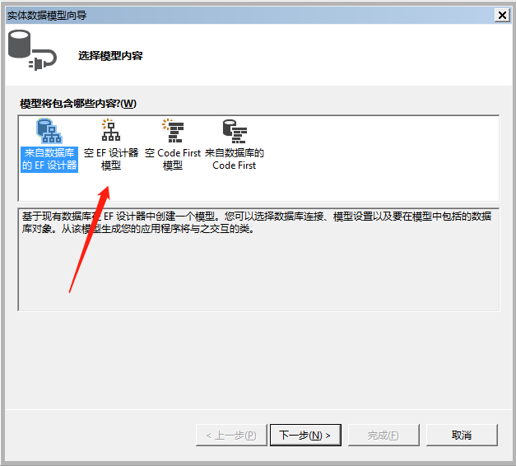
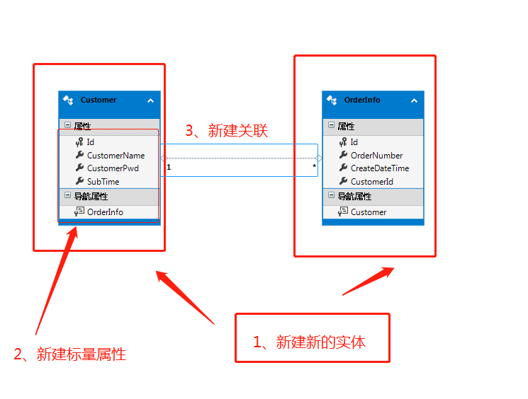
最后一步是根据模型生成数据库
2、一般拿book_shop3Entities（这个是上面的new的那个）都是在以下的地方进行找的
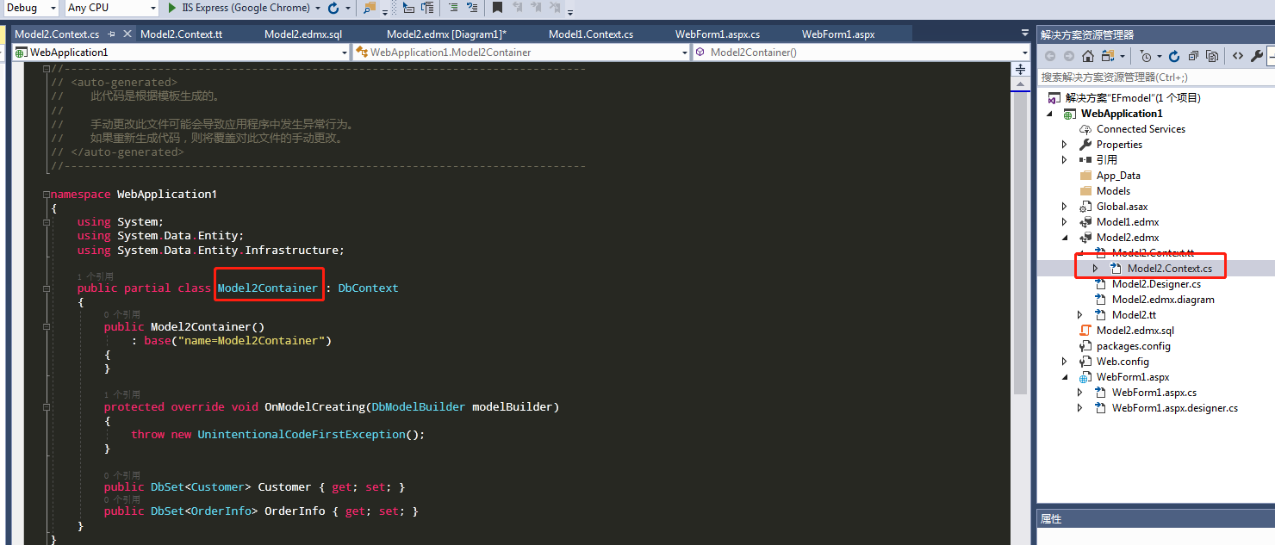

3、 SaveChanges:默认已经开启了事务。工作单元模式（unitofwork）
4、空模型代码：
1 protected void Button5_Click(object sender, EventArgs e) 2 { 3 Model2Container db = new Model2Container(); 4 Customer customer = new Customer() 5 { CustomerName = "kerry", CustomerPwd = "123456", SubTime = DateTime.Now }; 6 OrderInfo orderInfo = new OrderInfo() 7 { Id = Guid.NewGuid(), OrderNumber = "1001", CreateDateTime = DateTime.Now, Customer = customer }; 8 OrderInfo orderinfo1 = new OrderInfo() 9 { Id = Guid.NewGuid(), OrderNumber = "1002", CreateDateTime = DateTime.Now, Customer = customer };10 db.Customer.Add(customer);11 db.OrderInfo.Add(orderInfo);12 db.OrderInfo.Add(orderinfo1);13 db.SaveChanges();14 }
查询：
protected void Button2_Click(object sender, EventArgs e)
{
Model3Container db = new Model3Container();
var customerlist = from c in db.Customer
select c;
foreach (var customer in customerlist)
{
Response.Write(customer.CustomerName + ":");
foreach (var order in customer.OrderInfo)
{
Response.Write(order.OrderNumber);
}
}
}

5、 Linq To EF:
简单查询：
var result=from c Customer select c;
条件查询：
1）普通linq写法：
var result=from c in Customer where c.Gender=="w" select c;
2）Lambda表达式写法：
var result=from c in customer where <Customer>(c=>c.Gender=="w");
3）排序分页写法：
IQueryable<Customer> cust10=(from c in customers order by c.CustomerID select c).Skip(0).Take(10);
4）左外连接：可以的连接有Join和GroupJoin方法。GroupJoin组联接等效于左外部联接，它返回第一个（左侧）数据源的每个元素（即使其他数据源中没有关联元素）
var query= from d in ed,.orderdetail join order in edm.orders
on d.orderid equals order.orderid select new
{
oderid=order.orderid,
productid=d.produceid,
unitprice=d.unitprice
}
6、查询当用户的ID为1的：
protected void Button3_Click(object sender, EventArgs e)
{
Model3Container db = new Model3Container();
//var customerinfolist = from c in db.Customer
// where c.Id == 1
// select c;
//下面这段是获取customerinfolist的信息
//var customerinfo = customerinfolist.FirstOrDefault();
//foreach(var orderinfo in customerinfo.OrderInfo)
//{
// Response.Write(orderinfo.OrderNumber);
//}
//也可这样写，直接查询orderinfo表
var orderinfolist = from o in db.OrderInfo
where o.CustomerId1 == 1
select o;
foreach (var orderinfo in orderinfolist)
{
Response.Write(orderinfo.OrderNumber);
}
}
7、通过Customer的num查找orderinfo的name：
protected void Button4_Click(object sender, EventArgs e)
{
Model3Container db = new Model3Container();
var orderinfolist = from c in db.OrderInfo
where c.OrderNumber =="1001"
select c;
var orderinfo = orderinfolist.FirstOrDefault();
Customer customer = orderinfo.Customer;
Response.Write(customer.CustomerName);
}
8、删除表orderlist中，customerid=1
protected void Button5_Click(object sender, EventArgs e)
{
Model3Container db = new Model3Container();
var customer = (from c in db.Customer
where c.Id == 1
select c
).FirstOrDefault();
var orderinfolist = customer.OrderInfo;
while (orderinfolist.Count > 0)
{
var orderinfo = orderinfolist.FirstOrDefault();
db.Entry<OrderInfo>(orderinfo).State = System.Data.EntityState.Deleted;
}
db.SaveChanges();
}
9、查询部分列：
1 protected void Button6_Click(object sender, EventArgs e) 2 { 3 book_shop3Entities db = new book_shop3Entities(); 4 var userinfolist = from u in db.UserInfo 5 where u.ID == 92 6 select new { Uname = u.UserName, Upwd = u.UserPass }; 7 foreach (var userinfo in userinfolist) 8 { 9 Response.Write(userinfo.Uname + ":" + userinfo.Upwd);10 }11 }
10、lamada表达式进行查询：
protected void Button7_Click(object sender, EventArgs e)
{
book_shop3Entities db = new book_shop3Entities();
var userinfolist = db.UserInfo.Where<UserInfo>(u => u.ID == 92);
foreach (var userinfo in userinfolist)
{
Response.Write(userinfo.UserName);
}
}
11、进行分页排序的例子：
1 protected void Button8_Click(object sender, EventArgs e) 2 { 3 book_shop3Entities db = new book_shop3Entities(); 4 //var userinfolist = db.UserInfo.Where<UserInfo>(u => u.ID == 92); 5 //升序排序 6 // var userinfolist = db.UserInfo.Where<UserInfo>(u => true).OrderBy<UserInfo, int>(u => u.ID); 7 //降序排序 8 // var userinfolist = db.UserInfo.Where<UserInfo>(u => true).OrderByDescending(u => u.ID); 9 //分页10 int pageindex = 2;11 int pagesize = 2;12 //var userinfolist = (from u in db.UserInfo13 // where u.ID > 014 // orderby u.ID descending15 // select u).Skip<UserInfo>((pageindex - 1) * pagesize).Take<UserInfo>(pagesize);16 //skip：表示跳过多少条记录，take取多少条记录17 var userinfolist = db.UserInfo.Where<UserInfo>(u => true).OrderByDescending(u => u.ID).Skip<UserInfo>((pageindex - 1) * pagesize).Take<UserInfo>(pagesize);18 19 20 foreach (var userinfo in userinfolist)21 {22 Response.Write(userinfo.UserName);23 }24 }

